EXPERIMENT No: 1

|  |  |  |
| --- | --- | --- |
| Objective : To implement java basic programs. | |  |
| Scheduled Date | Compiled Date | Submission Date |
| 22-Apr-2022 | 22-Apr-2022 | 22-Apr-2022 |

**Program 1:** Write a Java program to insert 3 numbers from keyboard and find out greater number among 3 numbers.

**Program :-**

import java.util.Scanner;

public class greater3 {

public static void main(String args[]) { int a, b, c;

Scanner num = new Scanner(System.in); System.out.print("Enter the value of a = "); a = num.nextInt();

System.out.print("Enter the value of b = "); b = num.nextInt();

System.out.print("Enter the value of c = "); c = num.nextInt();

if (a > b && a > c)

System.out.println("This value is greatest = " + a); if (b > a && b > c)

System.out.println("This value is greatest = " + b); else

System.out.println("This value is greatest = " + c);

}

}

**Output Screen:**

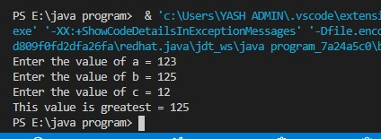

**Program 2:** Write a Java program to find out the sum of command line arguments.

**Program:**

class cmdline {

public static void main(String[] args) {

System.out.println("value using command line");

int a=Integer.parseInt(args[0]); int b=Integer.parseInt(args[1]);

int res=a+b;

System.out.println(res);

}

}

**Output Screen:**

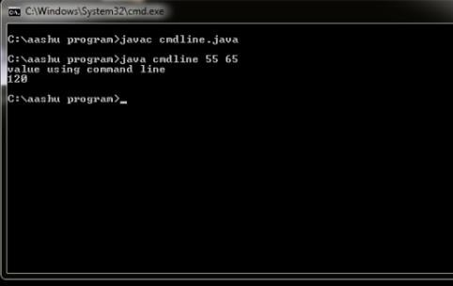

**Program 3:** Write a Java program to create a Room class, the attributes of this class is roomno, roomtype, roomarea and ACmachine. In this class the member functions are setData and displayData. Use member function to set data and display that data using displayData() method.

**Program :**

class room

{

int roomNO;

String roomType,acMachine,roomArea;

void setData(int a,String s,String s1,String s2)

{

roomNO=a; roomType=s1; acMachine=s2;

roomArea=s;

}

void Display()

{

System.out.println("\n roomNO

="+roomNO+"\nromType="+roomType+"\nacMachine="+acMachine+"\nroomAre a="+roomArea);

}

}

public class room1 {

public static void main(String args[]){

room r1=new room();

r1.setData(121,"254sqft" ,"Ac","Available"); r1.Display();

}

}

**Output Screen :**

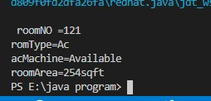

**Program 4:** Write a Java program to create a class “SimpleObject” and display message by using constructor of this class.

**Program :**

public class SimpleObject {

SimpleObject()

{

System.out.println("Hello I am Constructor");

}

public static void main(String []as)

{

SimpleObject obj=new SimpleObject();

}

}

**Output Screen :**

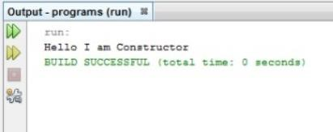

**Program 5:** Write a program to demonstrate static variables, methods, and blocks. **Program:**

public class stat { static int i=2;

static void message()

{

System.out.println("Hello Static Method "+i);

} static {

System.out.println("Hello i am static block");

}

public static void main(String as[])

{

message();

}

}

**Output Screen:**

