1. Create a directory ‘project_dir’ &amp; cd to ‘project_dir’.

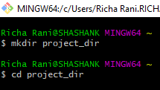

2 Initialize git version database. (git init)

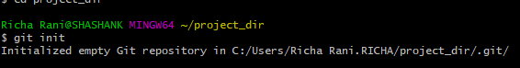

3. Create a new file index.html.



4. Check the git status. You should find index.html as untracked file.

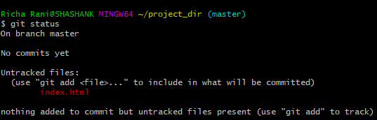

5. Stage the index.html file.



6. Stage the index.html file.

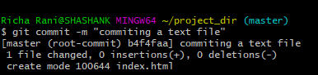

7. Make few changes in index.html &amp; create a new file info.txt file.