Title: Retail Sales Data Processing and Business Insights Generation
Company: ABC Retail Solutions
Name: Shashank K R
USN: 1CR22CS175
Branch: Computer Science Engineering
College Name: CMR Institute of Technology
Submission Date: 2 June 2026

Table of Contents
1. Project Overview
2. Architecture Diagram
3. Data Flow Diagram
4. Data Description
5. Data Cleaning Strategy
6. Transformation Logic
7. KPI Summary
8. Visual Insights
9. Assumptions
10. Conclusion

Section 1: Project Overview
ABC Retail Solutions operates across multiple cities through online and offline sales channels. The company collects transactional data from two source systems which contain inconsistencies such as duplicates, missing values, invalid quantities, and inconsistent naming conventions. This project builds an end-to-end data pipeline using Python that ingests, cleans, transforms, and loads retail transaction data into a cleaned dataset. The cleaned data is then visualized using a Power BI dashboard to generate business insights and KPIs.

Section 2: Architecture Diagram

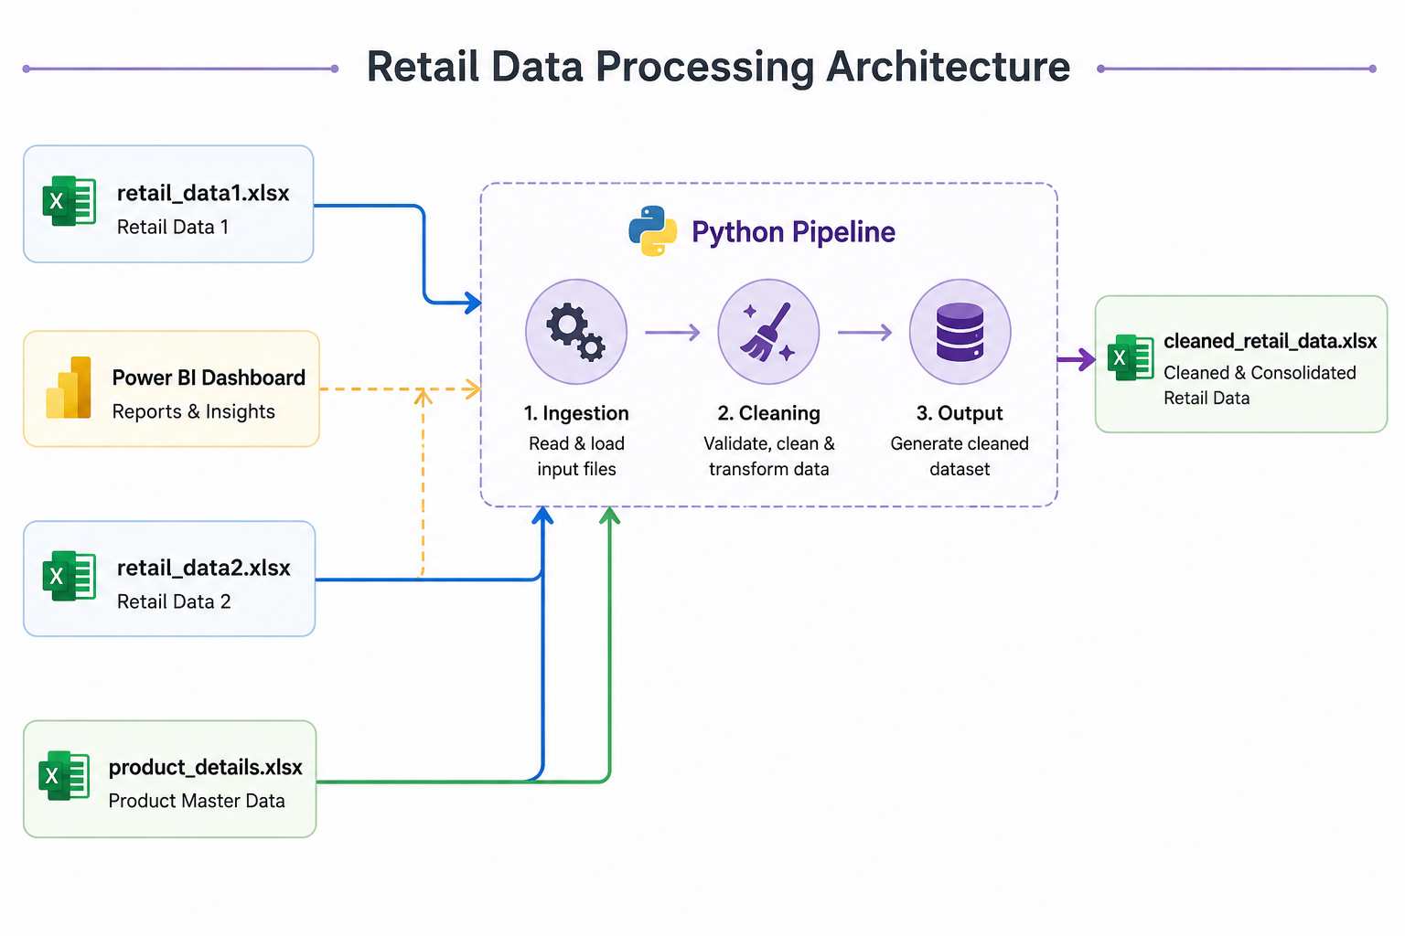

Section 3: Data Flow Diagram
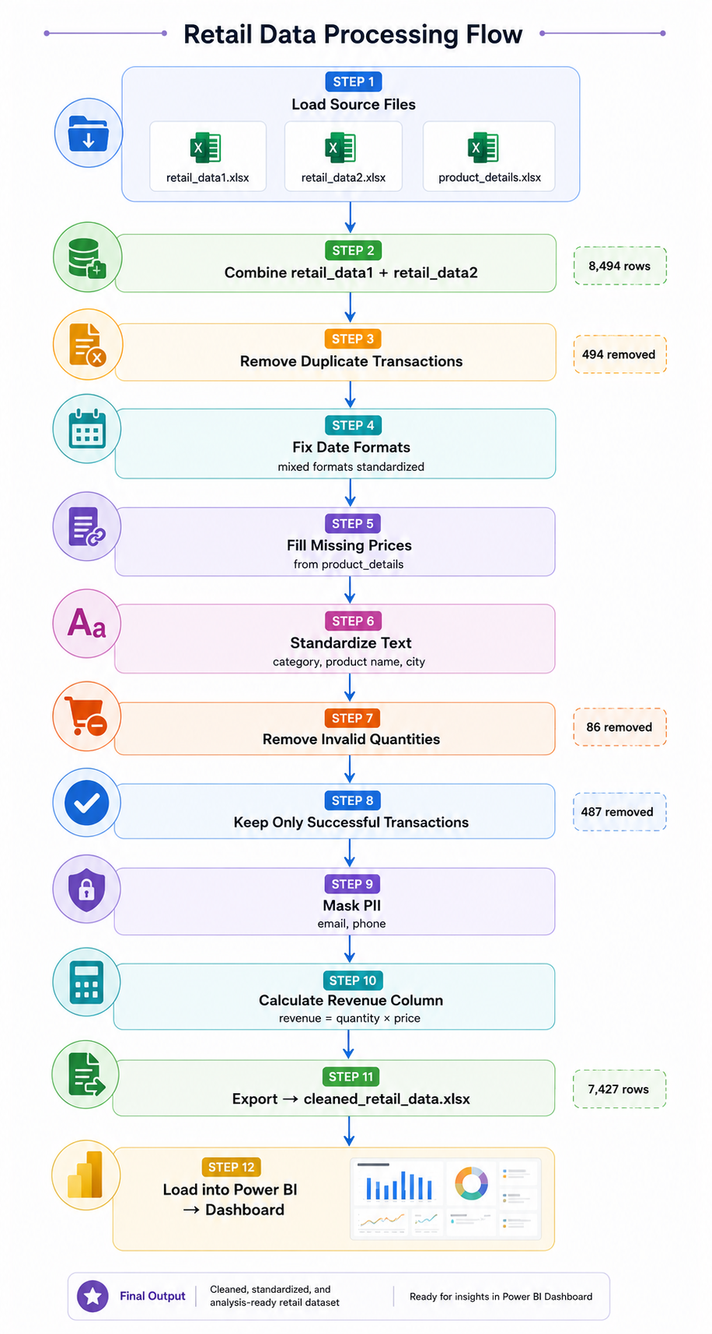
Section 4: Data Description
Dataset | Rows | Columns | Description
retail_data1 | 4,243 | 16 | First transaction source system
retail_data2 | 4,251 | 16 | Second transaction source system
product_details | 10 | 4 | Reference/dimension table
cleaned_retail_data | 7,427 | 21 | Final cleaned dataset

Section 5: Data Cleaning Strategy
Issue Found | Count | Fix Applied
Duplicate transactions | 494 | Removed, kept successful payment record
Missing prices | Several | Filled from product_details using product_id
Invalid quantities (0 or negative) | 86 | Rows dropped
Failed/pending transactions | 487 | Rows dropped
Mixed date formats | Multiple | Converted using pd.to_datetime
Inconsistent category names (ELEC, FURN, CLOTH) | Multiple | Mapped to standard names
Inconsistent product names (LAPTOP, laptop) | Multiple | Converted to Title Case
PII data (email, phone) | All rows | Email masked, phone hashed
Section 6: Transformation Logic
1. REVENUE CALCULATION
Formula: revenue = price × quantity × (1 - discount)
Example: ₹70,000 × 2 × (1 - 0.10) = ₹1,26,000

2. PII MASKING
Email : First 2 characters shown, rest masked
Example: JohnDoe@gmail.com → Jo****@gmail.com
Phone : Hashed using SHA-256 algorithm
Example: 9876543210 → a3f8c2d1e4

3. DATE STANDARDIZATION
Mixed formats like 7/21/2025 and 02-19-2026
All converted to standard format: YYYY-MM-DD

4. CATEGORY STANDARDIZATION
ELEC / electronics → Electronics
FURN / furniture → Furniture
CLOTH / clothing → Clothing
HOME / home appliances → Home Appliances
Section 7: KPI Summary
KPI | Value
Total Revenue | ₹1,08,88,54,335
Total Orders | 7,427
Average Order Value | ₹1,46,607
Total Units Sold | 22,125
Top Category | Electronics (₹62.72 Cr)
Top City | Chennai (₹23.28 Cr)
Top Product | Laptop (₹43.18 Cr)
Top Payment Method | Card
Section 8: Visual Insights
1. Electronics dominates revenue contributing 57% of
total revenue, driven mainly by Laptop sales.

2. Chennai leads all cities in revenue followed closely
by Delhi and Hyderabad.

3. Online and Offline channels are almost equal showing
balanced sales across both channels.

4. Laptop is the single highest revenue product at
₹43.18 Crores, far ahead of all other products.

5. Card and Cash are the most preferred payment methods
among customers.

6. Revenue peaks during certain months showing clear
seasonal trends useful for planning promotions.
Section 9: Assumptions
1. Missing prices were filled using the product_details
reference table based on product_id.

2. Where duplicate transaction_id existed with both
successful and failed status, only the successful
record was kept.

3. Rows with quantity = 0 or negative were considered
invalid and removed.

4. Only transactions with payment_status = successful
were included in revenue calculations.

5. Category names were standardized based on the
product_details reference table.

6. All revenue figures are in Indian Rupees (₹).

Section 10: Conclusion
The end-to-end data pipeline successfully ingested,
cleaned, and transformed 8,494 raw retail transactions
into 7,427 high-quality records ready for analysis.

Key business insights reveal that Electronics is the
top-performing category, Laptop is the bestselling
product, and Chennai generates the highest regional
revenue.

The Power BI dashboard provides interactive exploration
of revenue trends, product performance, category analysis,
and regional insights enabling data-driven decision making
for ABC Retail Solutions.

