**Normal unweighted logistic Regression**

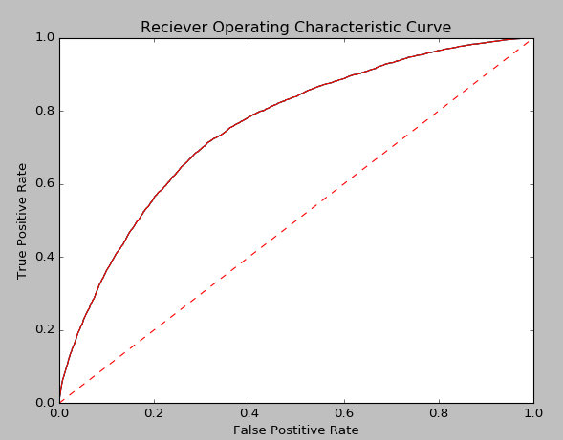

AUC = 0.756913087216

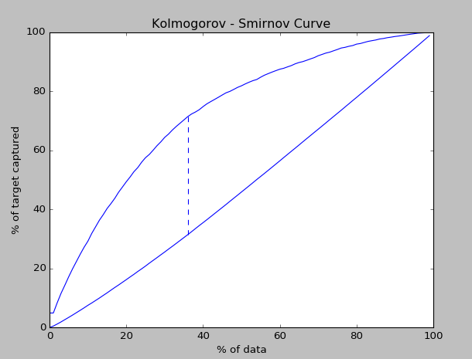

K-S Point = 0.399

**Weighted - balanced Logistic Regression**

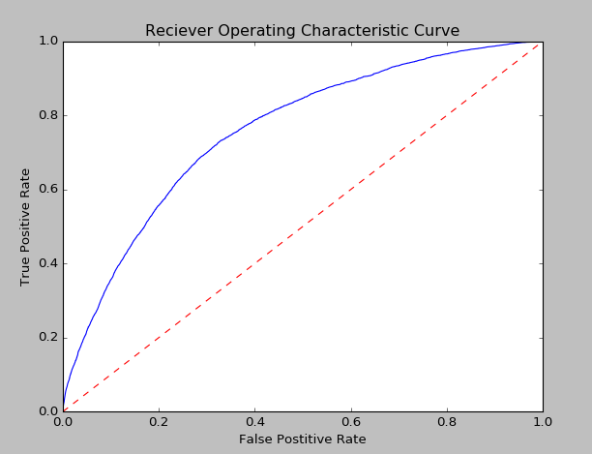

Area under the curve: 0.757971406736

**Weighted ( 1:8) Logistic Regression**

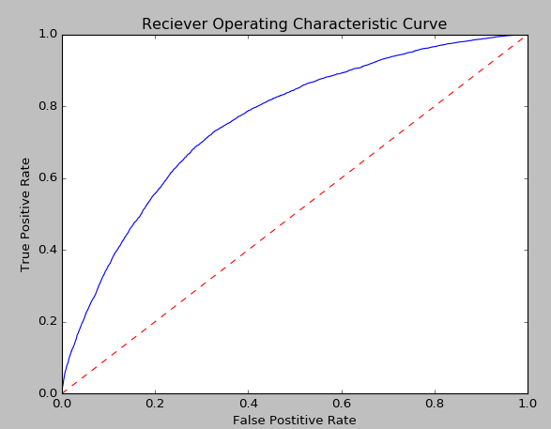

Area under the curve: = 0.757987102185

Cumulative gains with ordinary and weighted logistic regression

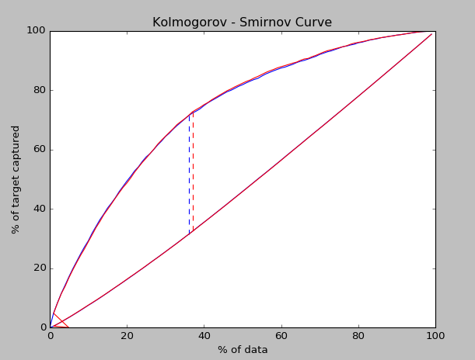

K- S Point after weighted logistic regression = 0.4031

Bootstrap aggregation on original data( pos=1000, neg=8000, n_sim=2000)

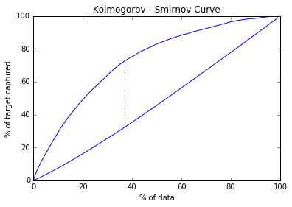

K-S point = 40.427

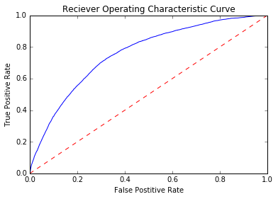

AUC = 0.7597

Bootstrap aggregation on original data( pos=1000, neg=8000, n_sim=4000)

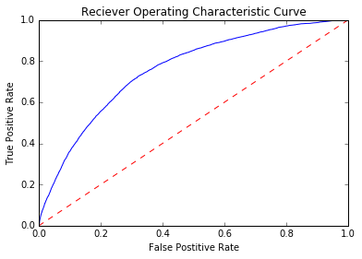

AUC = 0.7597

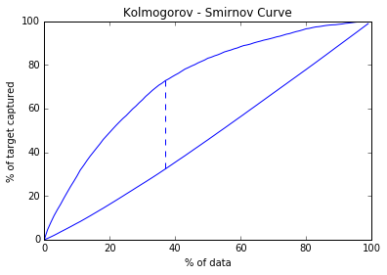

K-S point = 40.44

Bootstrap aggregation on original data( pos=500, neg=4000, n_sim=4000)

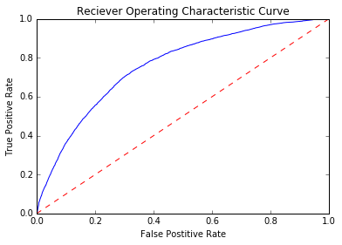

AUC = 0.7597

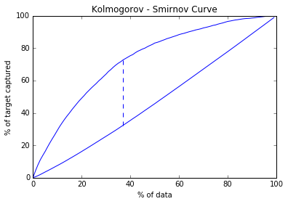

K-S point = 40.36

Bootstrap aggregation on original data( pos=1000, neg=4000, n_sim=4000)

AUC = 0.7596

K-S point = 40.38

Bootstrap aggregation on smoted data( pos=4000, neg=16000, n_sim=4000)

AUC = 0.7276

K-S point = 33.52

Bootstrap aggregation on smoted data( pos=1000, neg=8000, n_sim=4000)

no improvement