ABSTRACT

THE ROBOTICS CLUB

INDUCTION’21

TEAM NO - 09

**AIM:**

The major motivation of this project is to reduce the traffic congestion in pubs,drive in, multi-storeyed buildings and malls due to unavailability of parking spaces .The project displays the nearest empty slot if present with respect to user location. Our project aims to make efficient use of parking spaces. We track vacant slots in the parking space and assign that to the user and also help’s to clear the parking space lots due to jams.

**THE PROBLEM:**

In our daily life we are seeing a lot of traffic in parking areas,drive-in’s,pubs,many malls in these areas many cars and other vehicles are rushed and a less area will be allotted for parking and a lot of time is wasted for many people.

**THE TEAMS APPROACH TO THE PROBLEM: -**

This smart parking system project consists of Arduino, five IR sensor , one servo motor, and one LCD display. Where the Arduino is the main microcontroller that controls the whole system. Two IR sensors are used at the entry and exit gates to detect vehicle entry and exit in the parking area. And other three IR sensors are used to detect the parking slot availability. The servo motor is placed at the entry and exit gate that is used to open and close the gates. Also, an LCD display  is placed at the entrance, which is used to show the availability of parking slots in the parking area.When a vehicle arrives at the gate of the parking area, the display continuously shows the number of empty slots. If there have any empty slots then the system opens the entry gate by the servo motor. After entering the car into the parking area, when it will occupy a slot, then the display shows this slot is full. If there is no empty parking slot then the system displays all slots are full and does not open the gate.

**BLOCK DIAGRAM:**

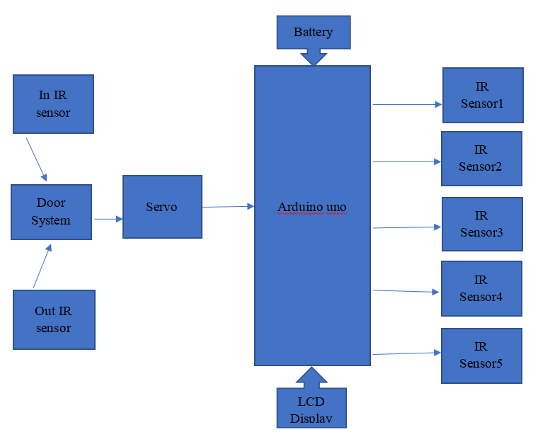

**TITLE OF THE PROJECT**: - STABLER

**WHAT INSPIRED YOU TO SELECT** **THE PROBLEM** ?

In our daily life we are seeing a lot of traffic in parking areas,drive-in’s,pubs,many malls in these areas many cars and other vehicles are rushed and a less area will be allotted for parking and a lot of time is wasted for many people. so,to overcome this problem we have chosen this bot

**WHAT DO YOU FEEL IS THE MOST INNOVATIVE PART OF THE PROBLEM ?**

The most innovative part of our bot is we can provide security to the vehicles in the absence of user thus if any theft happen we can inform to user and also working of IR sensor, servo motor, LCD display. We feel that opening and closing of a gate in our bot is difficult when both the vehicles approached in opposite direction.

**SPECIFICATIONS**:

• Provides Security to the Vehicles.

• Automatic Opening and Closing Gate.

• Smart Parking

• Reduces Man Work