Model Evaluation Report

# Training Metrics

|  |  |  |
| --- | --- | --- |
| RMSE | MAE | R² |
| 11199.9350 | 2240.9988 | 0.1274 |

# Test Metrics

|  |  |  |
| --- | --- | --- |
| RMSE | MAE | R² |
| 16149.1116 | 4199.9497 | 0.0670 |

## Training SHAP Summary

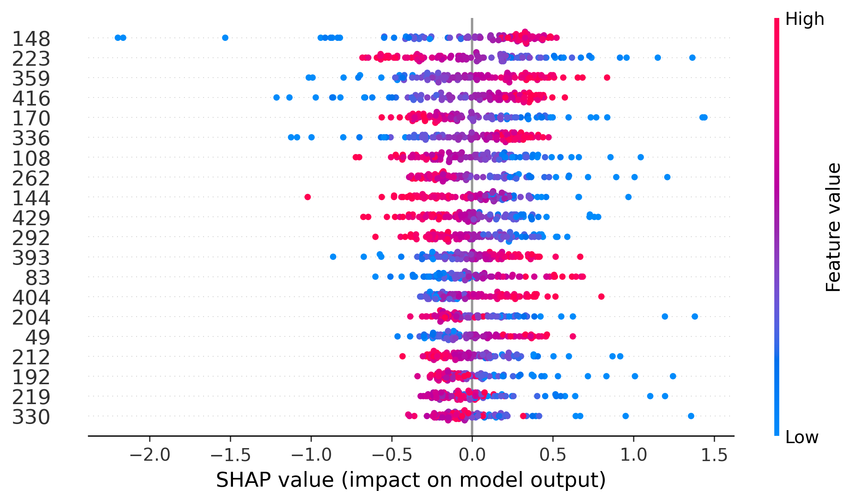

BASE SHAP VALUE [0.02543002]

## Test SHAP Summary

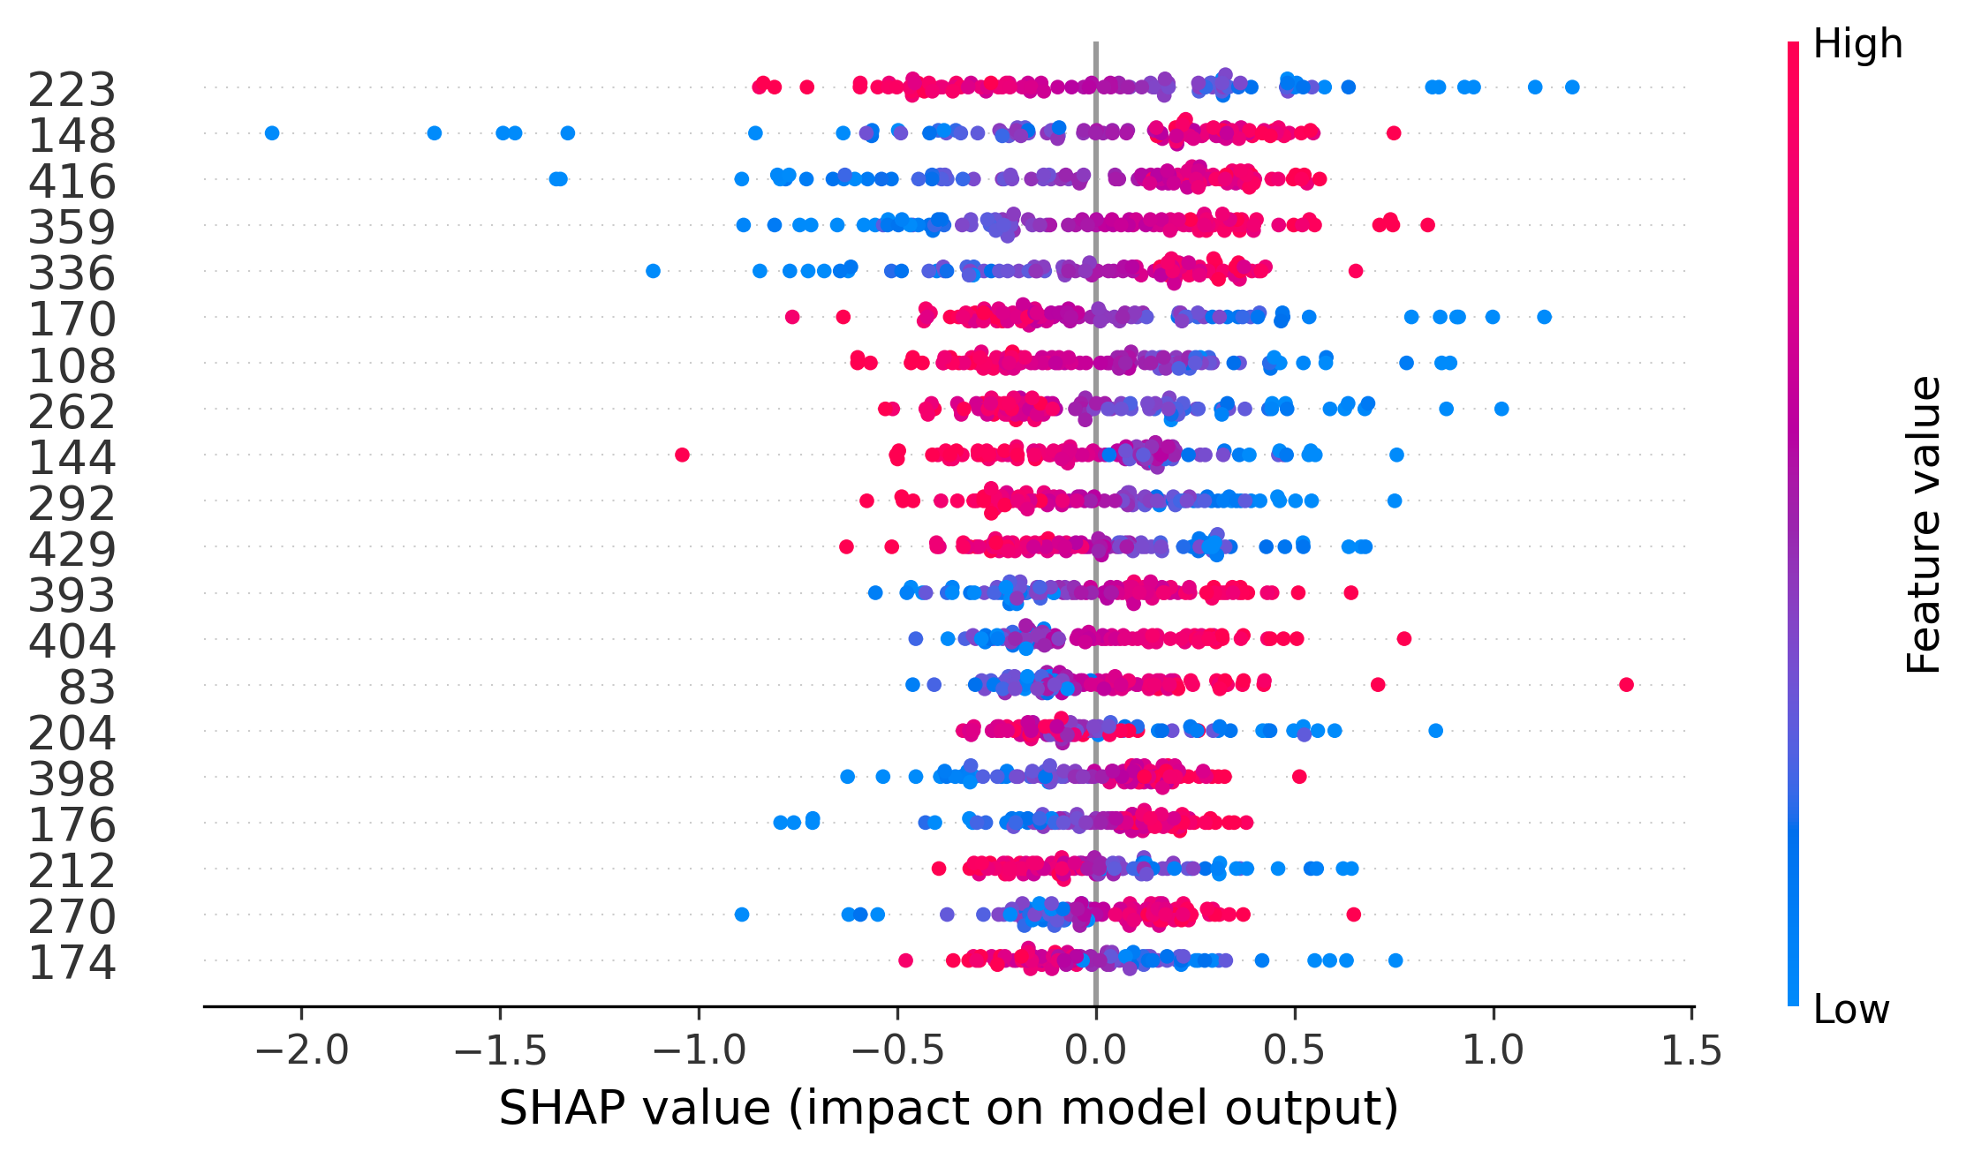

BASE SHAP VALUE [0.08279491]

## Train MIR

|  |  |
| --- | --- |
| Feature | MI Score |
| 174 | 0.1227 |
| 64 | 0.1121 |
| 257 | 0.1088 |
| 267 | 0.1043 |
| 384 | 0.1015 |
| 288 | 0.0995 |
| 33 | 0.0946 |
| 254 | 0.0945 |
| 144 | 0.0941 |
| 145 | 0.0913 |
| 434 | 0.0900 |
| 223 | 0.0865 |
| 192 | 0.0837 |
| 436 | 0.0836 |
| 416 | 0.0824 |
| 227 | 0.0809 |
| 86 | 0.0809 |
| 360 | 0.0787 |
| 423 | 0.0771 |
| 83 | 0.0763 |
| 237 | 0.0748 |
| 262 | 0.0735 |
| 7 | 0.0721 |
| 170 | 0.0719 |
| 284 | 0.0718 |
| 149 | 0.0705 |
| 301 | 0.0683 |
| 119 | 0.0677 |
| 413 | 0.0658 |
| 249 | 0.0635 |
| 66 | 0.0628 |
| 393 | 0.0612 |
| 88 | 0.0608 |
| 53 | 0.0593 |
| 25 | 0.0590 |
| 437 | 0.0577 |
| 302 | 0.0564 |
| 122 | 0.0537 |
| 404 | 0.0537 |
| 398 | 0.0519 |
| 336 | 0.0511 |
| 41 | 0.0507 |
| 311 | 0.0506 |
| 140 | 0.0504 |
| 176 | 0.0477 |
| 219 | 0.0470 |
| 90 | 0.0463 |
| 94 | 0.0455 |
| 212 | 0.0452 |
| 368 | 0.0433 |
| 4 | 0.0397 |
| 292 | 0.0362 |
| 23 | 0.0360 |
| 345 | 0.0354 |
| 49 | 0.0345 |
| 410 | 0.0340 |
| 21 | 0.0329 |
| 204 | 0.0308 |
| 293 | 0.0299 |
| 198 | 0.0297 |
| 222 | 0.0276 |
| 3 | 0.0266 |
| 424 | 0.0260 |
| 359 | 0.0255 |
| 376 | 0.0241 |
| 220 | 0.0239 |
| 108 | 0.0237 |
| 80 | 0.0214 |
| 330 | 0.0203 |
| 270 | 0.0198 |
| 382 | 0.0169 |
| 110 | 0.0163 |
| 361 | 0.0153 |
| 306 | 0.0152 |
| 148 | 0.0129 |
| 310 | 0.0110 |
| 163 | 0.0110 |
| 261 | 0.0101 |
| 15 | 0.0008 |
| 103 | 0.0000 |
| 446 | 0.0000 |
| 115 | 0.0000 |
| 429 | 0.0000 |
| 156 | 0.0000 |
| 126 | 0.0000 |
| 133 | 0.0000 |
| 186 | 0.0000 |
| 102 | 0.0000 |
| 69 | 0.0000 |

