# Finding markers using distance transform

# Malaria_cropped.tif

Original RGB image

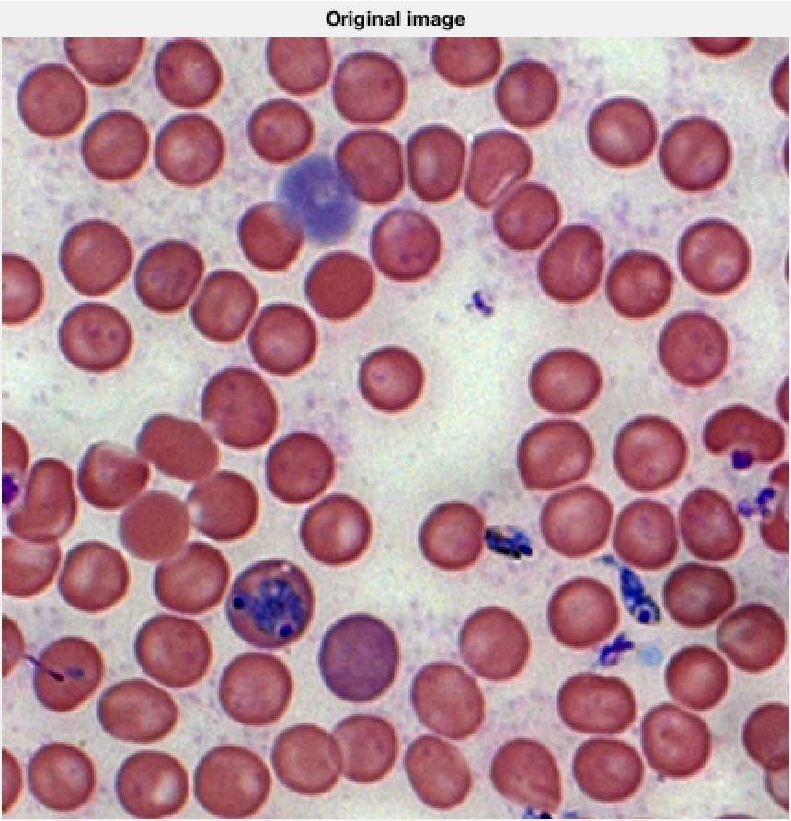

I converted the rgb image to grayscale image and processed those grayscale images.

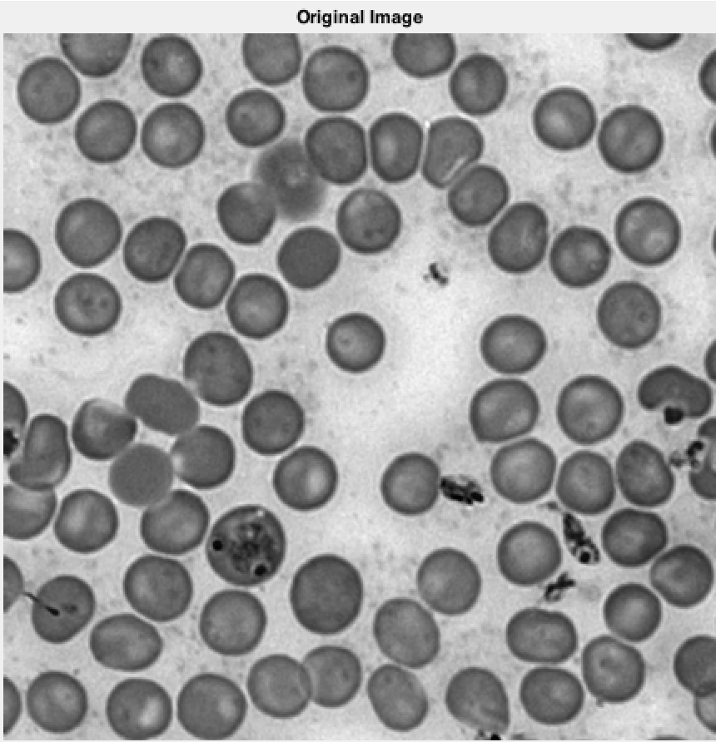

I applied morphological erosion followed by reconstruction to filter the noise.

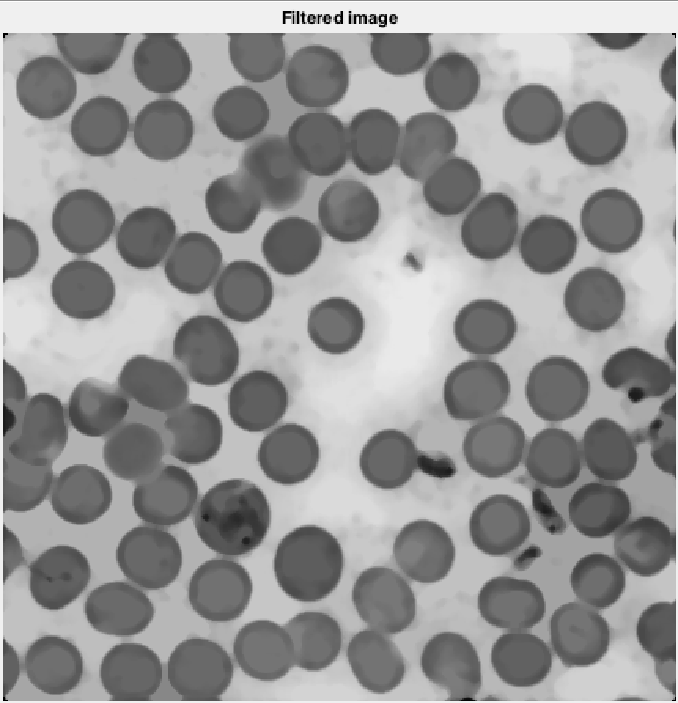

Global thresholding is applied to the image instead of kmeans or meanshift as the assignment’s focus is not on segmentation. Here is how the segmented image looks

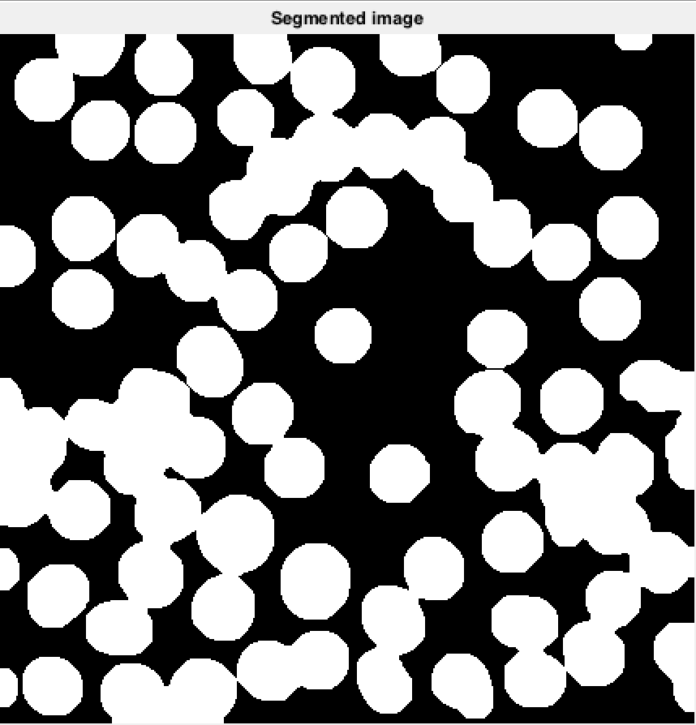

Foreground markers are found by applying imregionalmin on the distance transform segmented image.

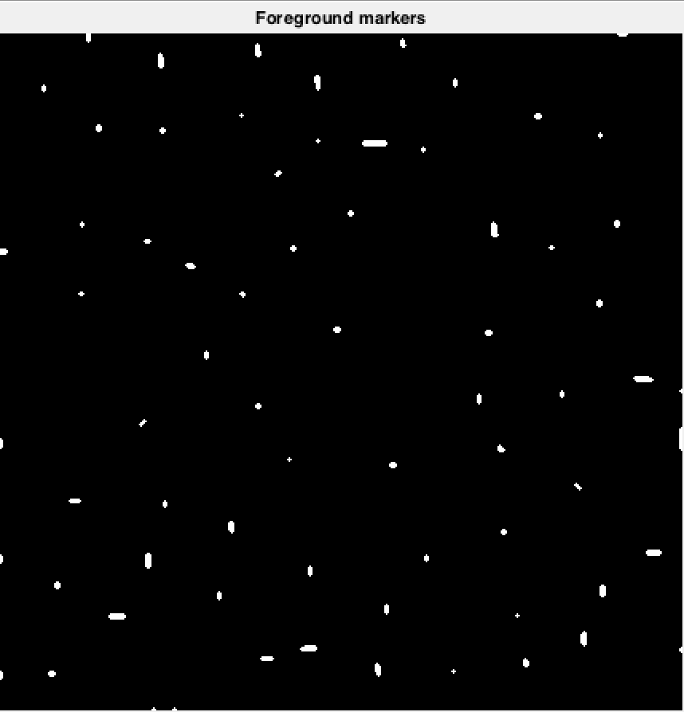

Foreground markers are overlayed on the original image with red color.

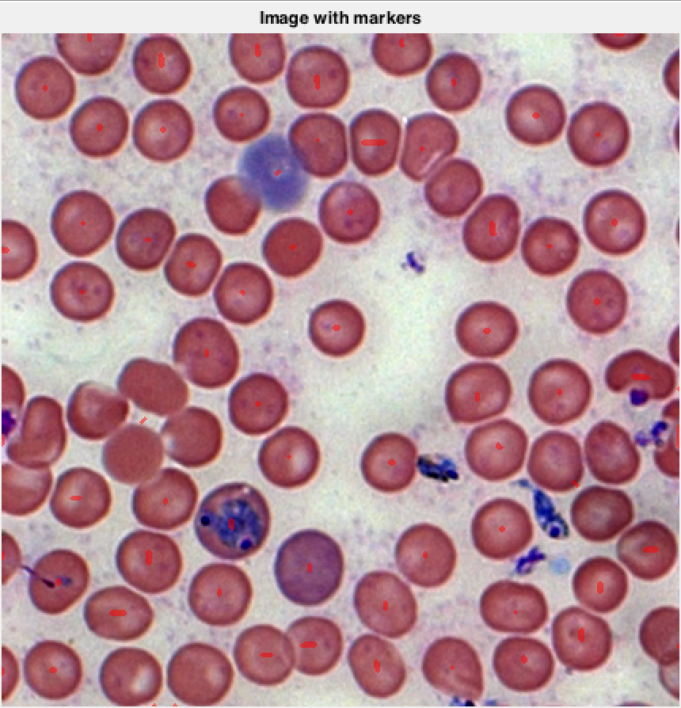

Separated cells after marker controlled watershed

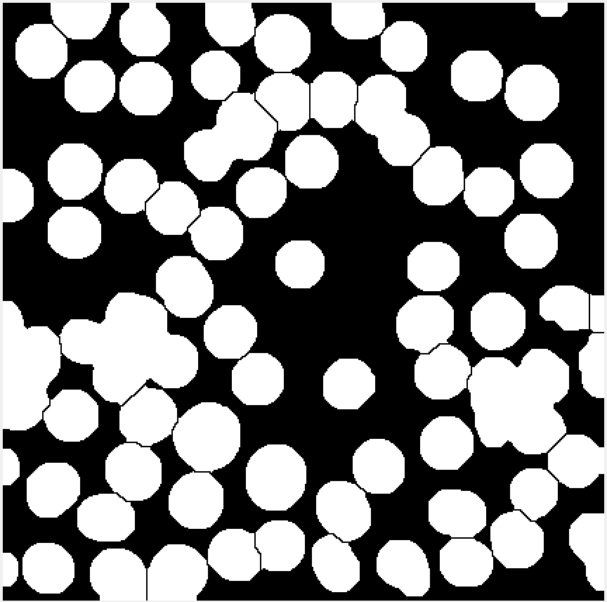

Watershed boundaries obtained though marker controlled watershed transform

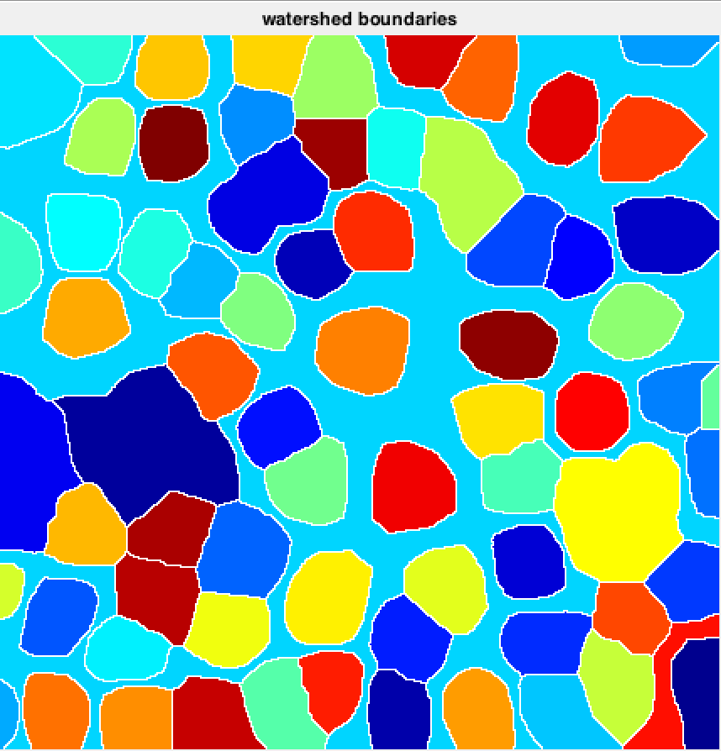

Histogram of areas of cells present in the cells

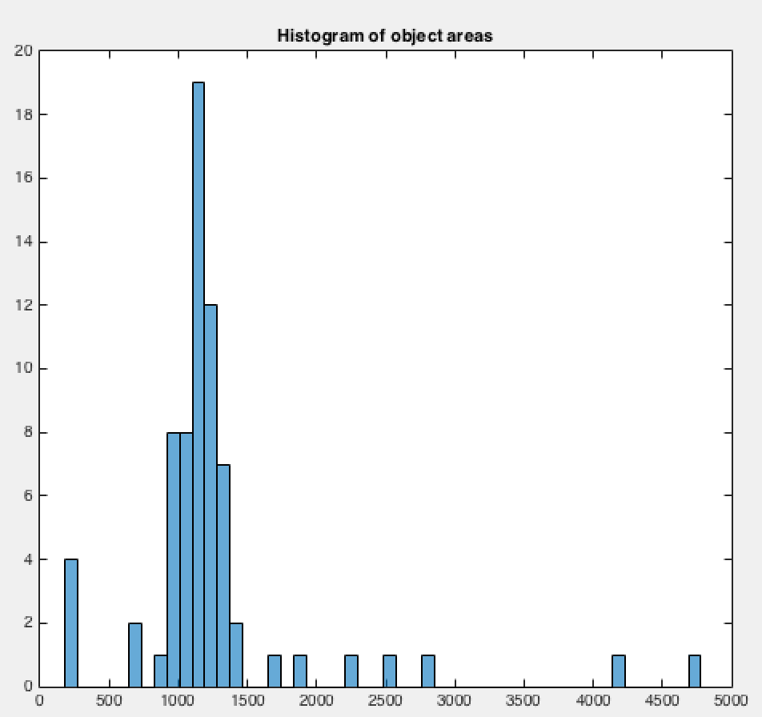

# ProstateCancer_grade4_cropped.tif

I converted the rgb image to grayscale image and processed those grayscale images.

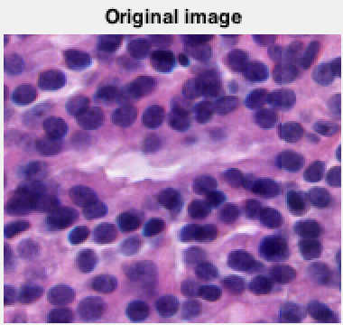

I applied morphological erosion followed by reconstruction to filter the noise.

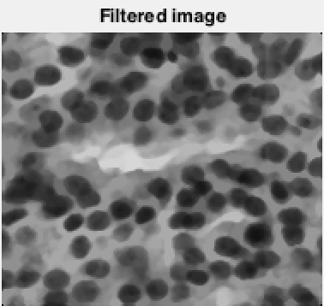

Global thresholding is applied to the image instead of kmeans or meanshift as the assignment’s focus is not on segmentation. Here is how the segmented image looks

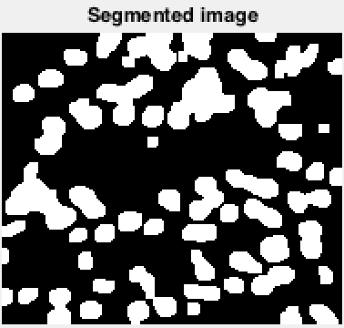

Foreground markers are found by applying imregionalmin on the distance transform segmented image.

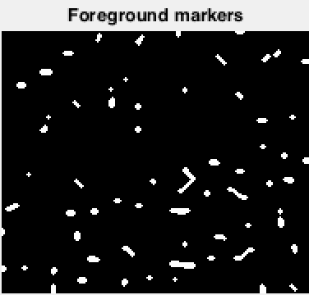

Foreground markers are overlayed on the original image with red color.

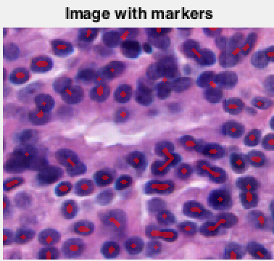

Separated cells after marker controlled watershed

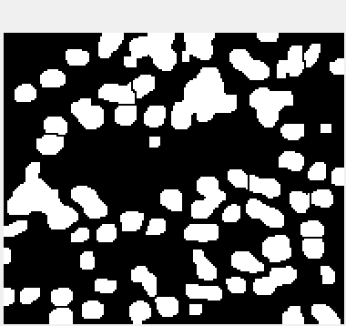

Watershed boundaries obtained though marker controlled watershed transform

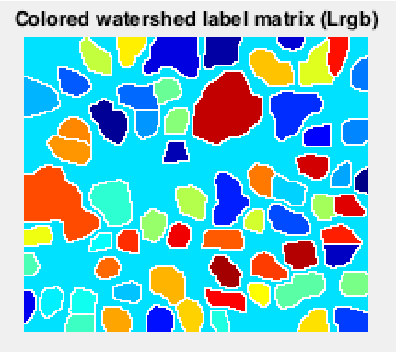

Histogram of areas of cells present in the cells

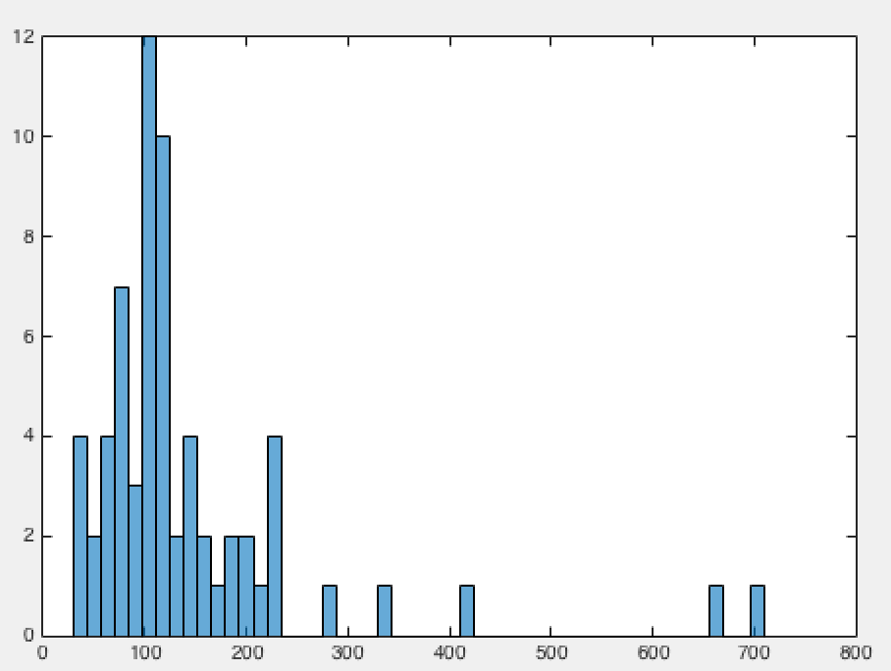

# Finding Markers Using Blob Detection

# Malaria_cropped.tif



I converted the rgb image to grayscale image and processed those grayscale images.



I applied morphological erosion followed by reconstruction to filter the noise.

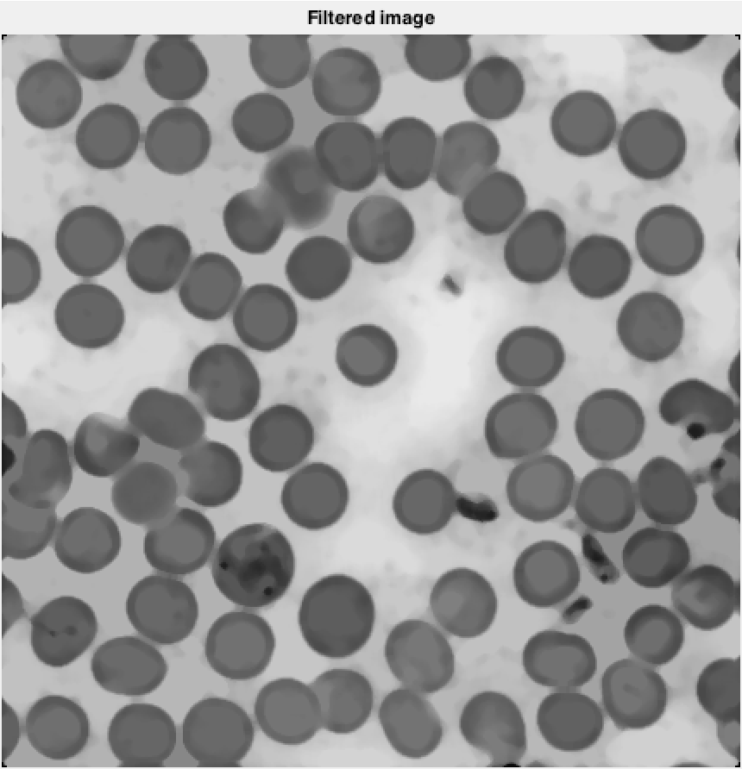

Foreground markers are found by locating the centers of the blobs though scale invariant Laplacian of Gaussian and imregionalmax

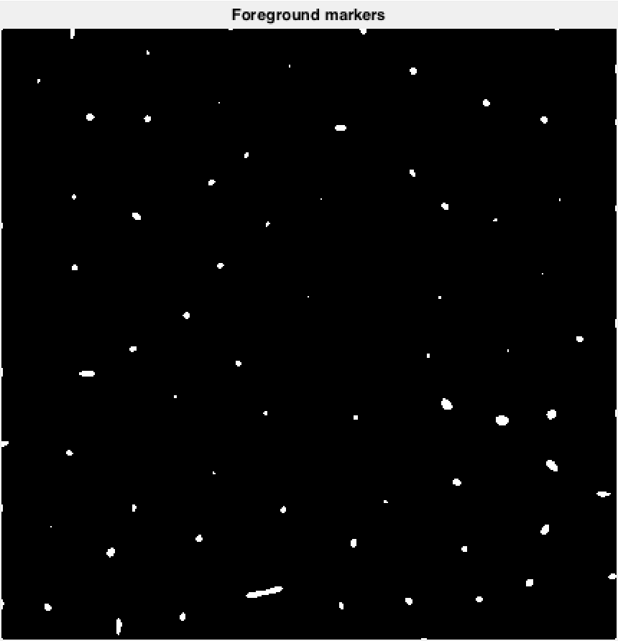

Original image with markers overlayed in red color

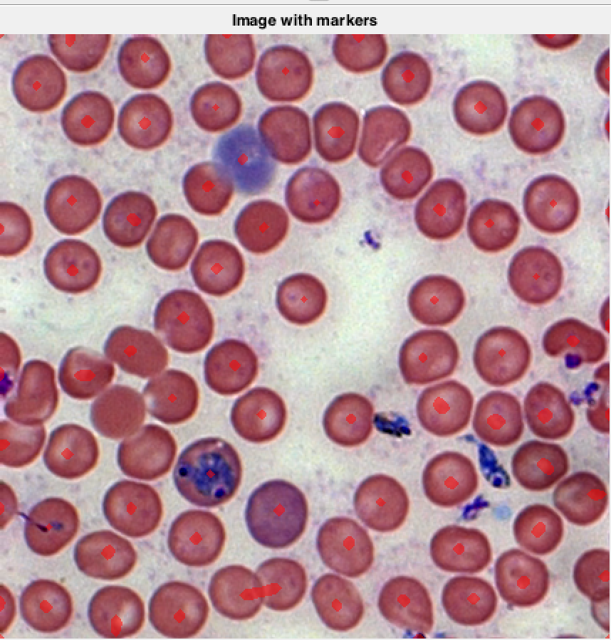

Watershed boundaries

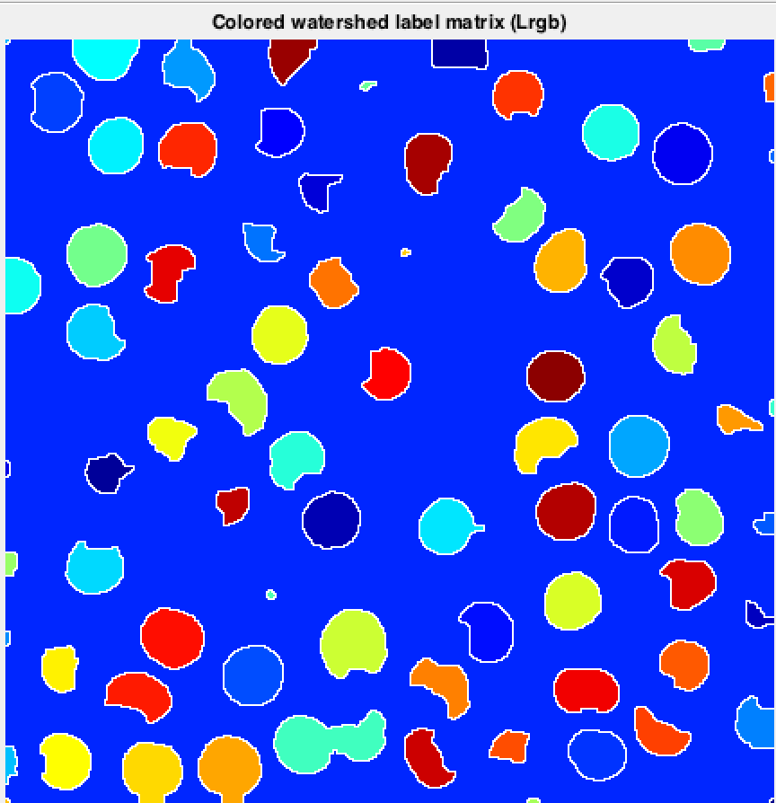

# ProstateCancer_grade4_cropped.tif

I converted the rgb image to grayscale image and processed those grayscale images.



I applied morphological erosion followed by reconstruction to filter the noise.



Foreground markers are found by locating the centers of the blobs though scale invariant Laplacian of Gaussian and imregionalmax

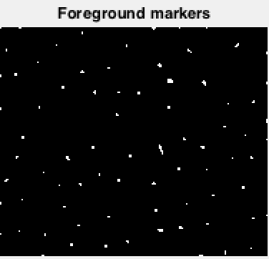

Original image with markers overlayed in red color

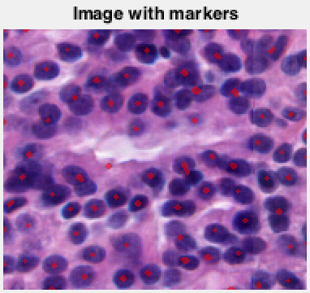

Watershed boundaries

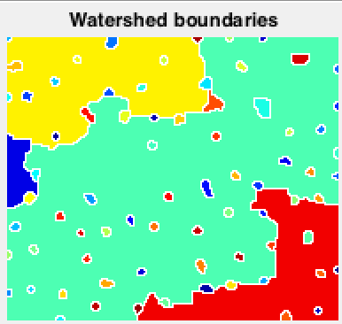

When I use Euclidean distance for distance transform, there were too many local minimas with in some cells especially for the ones which are not in a completely circular shape. This resulted in over segmentation of those cells. I had to use city block as distance metric and dilate the result of imregionlamin to create single local minima per cell. This reduced over segmentation.