1. Underwriting is raising fund for corporations and governments by issuing new debt or equity securities.
2. Underwriting, Corporate Advisory and merchant banking distinguish Investment Banks from other banking groups like Commercial Banks and Securities Brokers.
3. The cost of underwriting is called as the **gross underwriting spread.**
4. An LBO (Leveraged BuyOut) fund buys public companies and takes them private with the use of substantial leverage. May maintain their holdings long-term, or may later bring these companies public via an IPO (initial public offering) or sell them to another acquirer.
5. Following are the investment bank business criteria:

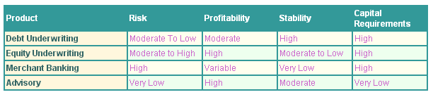

1. Money Markets are for funds with maturity of one year or less while Capital markets for permanent equity investments or for debt with a maturity of more than one year.

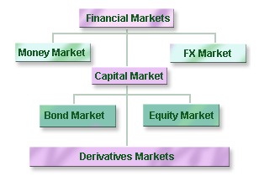

1. Interest Factor = (1+i*t) and Discount Factor = 1/(1+i*t)=v
2. Regular payments normally occur at the end of the interest period, these are called ordinary annuities. If the regular payment occurs at the beginning of the interest period, it is called an annuity due. If regular payments continue forever, then it is called a **perpetuity**.

P = A * (1-v^n)/i*t and F=A*((1/v^n)-1)/i*t

1. Day Count Fraction = Assumed number of days in period (D)/ Assumed number of days in year(B)
2. Here are some of the conventions that you need to be aware of:

* Spot Date
* Standard Maturities (like one month, two month)
* Following Business Day
* Modified Following Business Day (rolling back if rolling forward rolls into next month)
* End-End Rule

1. To determine the fair price of CD (Certificate of Deposite) can be calculated as:

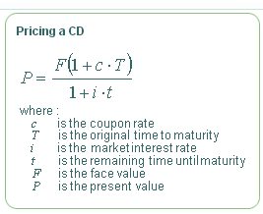

1. T-bill is money-market security issued by a government, paying no interest. It always trades at a discount to its face value, and investors receive a return from the difference between the discounted purchase price and the face value payable at maturity.

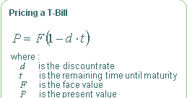

1. To calculate average annual return for investors over a period of years, the observation averaged are [1 plus the annual return] for each year and then 1 is subtracted from the geometric average return.

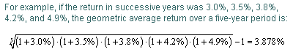

1. Most observation lie within a range of one or two standard deviations around mean. Only a small percentage (may be 5%) lie outside this range.
2. With a positive skew, the arithmetic mean will be biased upward by the right-hand tail.
3. If daily volatility is 1% and there are 256 working days in a year, then annual volatility is sqrt(256)*1%=16%.