**Itinerary for Our Romantic Trip of Europe : Part-1:**

Day-1: Live your romance in most romantic city Paris (Sunday)

Fly with British Airline from LHR @7:05 and reach Orly Paris by 9:30. Take **Route 1 Air France buses** from Orly Airport's Orly Sud (Sortie/Exit L) and Orly Ouest (Sortie/Exit H) terminals to **Hôtel des Invalides**. Buses depart the airport every 20 minutes from 06:00 am to 22:40. The journey takes about 35 to 50 minutes and costs 12.50€ one-way/single. After check in the **Hotel Eiffel Turenne** (20 Avenue de Tourville, 75007 Paris, France Phone: +33 1 47 05 99 92), explore Paris Museums (including Mona Lisa) by **Bato Bus Paris** River-Boat Shuttle Service. In the evening, enjoy Paris beauty from **Arc de Triomphe** and enjoy shopping at **Champs-Elysées**. Get high with Paris night life and enjoy haka-haka in room. Be prepared for next day.

Day-2: Romance and history in Air (Monday)

Board train from Paris Gare Lyon @ 9:53 to Lucerne via Basel. Enjoy beauty for Switzerland highlands. After reaching to Lucerne, check in **ibis Styles** **Luzern City** (Friedenstrasse 86004 LUZERN, SWITZERLAND (+41)41/4184848) and enjoy hot water bath. In evening, explore **Lion Monument**, **Lucerne Lake** and one of the oldest wooden bridges in the world, **the Chapel Bridge.**

Day-3: Enjoy romantic trip to Mount Pilatus (Tuesday)

Purchase **Tell-Pass Central Switzerland** at Lucerne Railway Station for 2 days and head to **Mount Pilatus**, south of Lucerne via a steamer to **Alpnachstad @ 8:00** and take gondola to the peak. Enjoy beautiful view from Mount Pilatus Peak. By 1 PM, come back on a personal gondola (a small cable car) for a 30m drop to **Kriens**. Walk 5 minutes down to the bus stop (well-signposted). Take #1 bus back to **Luzern** Banhof (station). 15 minutes. In Afternoon, we will visit **Mt. Rigi**, 24km (15 miles) east of Lucerne. SGV boats run up to hourly from Lucerne to Weggis and **Vitznau**, depending on the season. The journey takes roughly 45 minutes to Weggis, about an hour to Vitznau. rom Vitznau, **Rigi Bahnen** take you up the steep line to Mount Rigi, all the way to the summit station Rigi Kulm at 1752 metres above sea level. For best views over Lake Lucerne, take a seat on the left-hand side of the train. After about 15 minutes the train reaches Kaltbad-First station, with connection to the aerial cableway down to Weggis. It would make for a nice round trip from Lucerne to take the railway from Vitznau up to Rigi and then the cableway down to Weggis for the boat back to Lucerne.

Day-4: Relive romance of Raj and Simran (Wednesday)

Ascend 10,000ft to the summit of Mt. Titlis. Take the world’s first revolving cable car, the Titlis Rotair. Enjoy breathtaking panoramic views of the surrounding Swiss landscapes. At Mt. Titlis have free time to play in the snow, visit the ice caves or take a professional photo in traditional Swiss outfits and with DDLJ hoarding. In the evening enjoy Lucence lake.

Luzern – Engelberg (train) 7:06 am – 07.53 am (or at every hour at :06) The car rides at Engelberg start operating at 8.30 am. The way back:Engelberg – Hergiswil 1.00 pm – 1.41 pm by train. Hergiswil – Luzern 2.09 pm – 3.06 pm by boat.

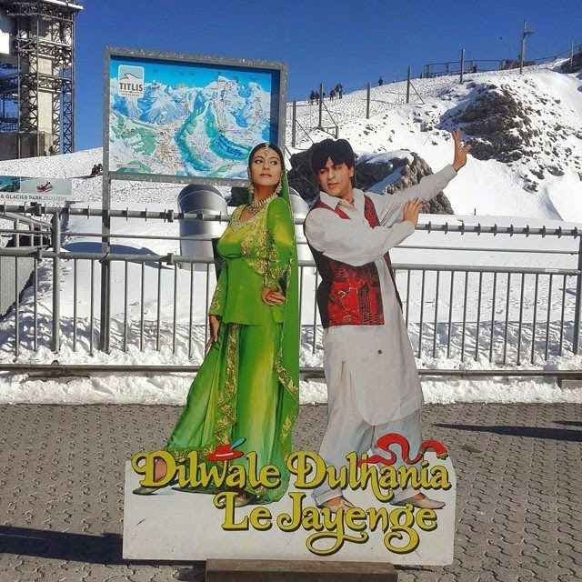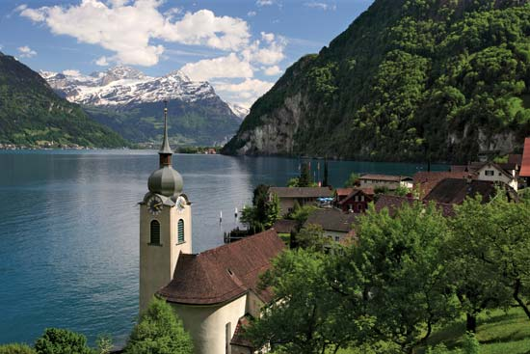

Day-5: Explore the strangest culture of Europe (Thursday)

Leave Lucerne to Venice @ 7:15. Enjoy the Swiss alps with Italy. After reaching to Venice @ 14:50, check in the hotel and refresh for some time. Enjoy the city streets in night and take rest in Night.

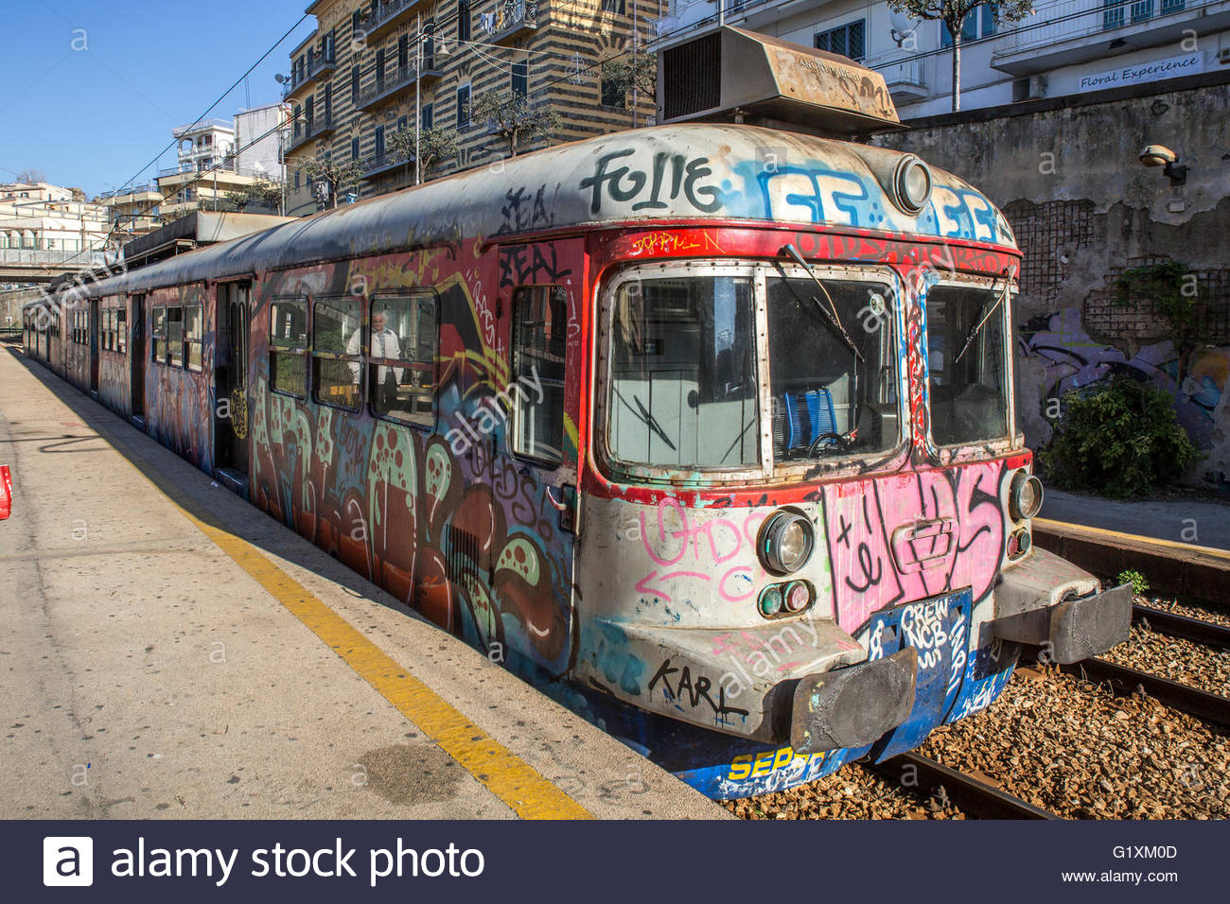

Day-6: Dharavi of Europe (Friday)

Begin with a boat ride to St Mark’s Square, one of the most elegant squares in the world. See the famous Bridge of Sighs and the Basilica di San Marco. Visit the Murano Glass Showroom and purchase some beautiful Murano glass items. Finally enjoy a romantic gondola ride while enjoying the ambience of Venice. Leave Venice for Florence @ 7:30 and reach there by @9:30 and spend night in hotel.

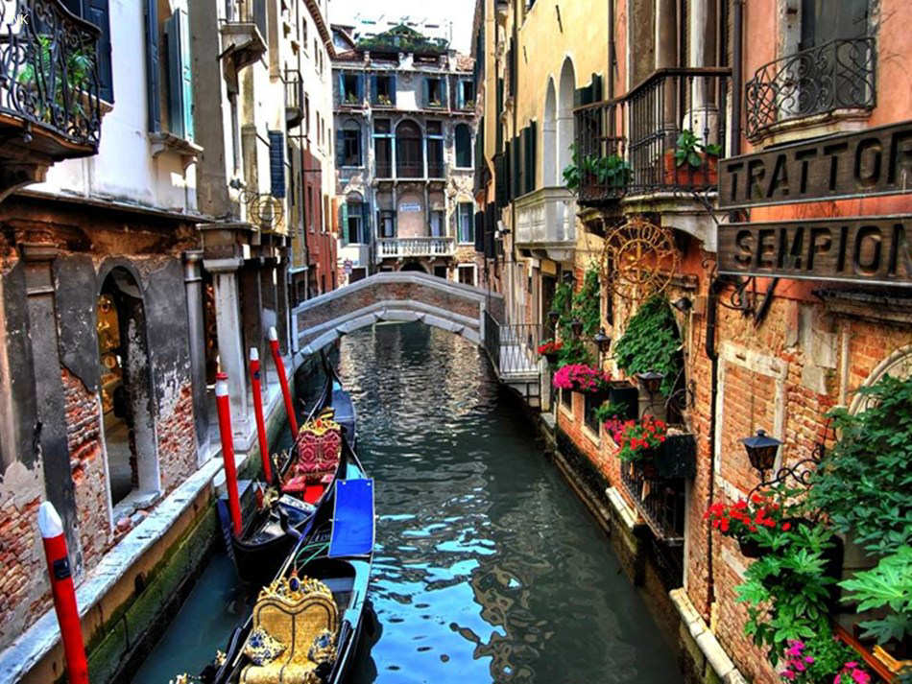

Day-7: Have some Fun on Scooter and explore some world heritage (Saturday)

Start your morning with exploring Florence on our favorite vehicle Scooter. Take a spin through Tuscany on a vintage Vespa with this 4-hour tour from Florence. A local guide will lead the way up through the scenic hills, where you’ll pass the famous Piazzale Michelangelo and the Church of San Miniatoal Monte. Afterward, head back to Florence for a traditional Italian meal to top off your journey. Head towards Pisa in afternoon and explore Leaning Tower. Enjoy city in the night.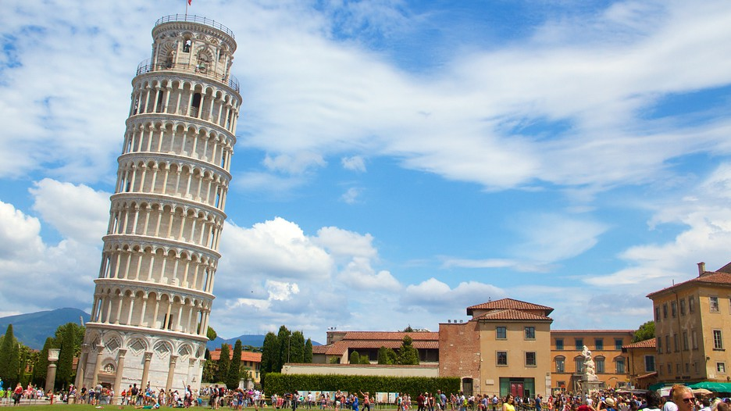

Day-8: Time to say ‘Phir Milenge’ (Sunday)

Take flight from Flurence to London in the morning and say good bye in the afternoon.

