- These are the different type to Modules present in J2EE container:
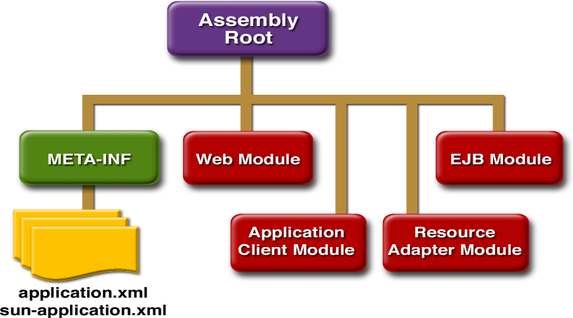
Resource Adapter is are packed as .rar

- An XML file can also contain processing instructions that give commands or information to an application that is processing the XML data. Processing instructions have the following format:
<?target instructions?>
target is the name of the application that is expected to do the processing and instructions is a string of characters that embodies the information or commands for the application to process.

- An entity reference can be created like this:
&entityName;
A character reference such as &#147; contains a hash mark (#) followed by a number. The number is the Unicode value for a single character. When you are handling large blocks of XML that include many special characters, you should use <![CDATA[ ]]>.

- Following is the example for DTD:
<!ELEMENT slideshow (slide+)>
<!ELEMENT slide (title, item*)>
<!ELEMENT title (#PCDATA)>
<!ELEMENT item (#PCDATA | item)* >
The first line you added says that a slide consists of a title followed by zero or more item elements. The next line says that a title consists entirely of parsed character data (PCDATA). That’s known as “text” in most parts of the country, but in XML-speak it’s called “parsed character data.” (The # that precedes PCDATA indicates that what follows is a special word rather than an element name). The last line introduces the vertical bar (|), which indicates an or condition. In this case, either PCDATA or an item can occur. The asterisk at the end says that either element can occur zero or more times in succession. The result of this specification is known as a mixed-content model, because any number of item elements can be interspersed with the text. Such models must always be defined with #PCDATA specified first, followed by some number of alternate items divided by vertical bars (|), and an asterisk (*) at the end.

- In DTD ‘?’ means zero or one elements, * means zero or more and + means One or more.

- To reference the DTD file add the following highlighted line to xml file:
<!-- A SAMPLE set of slides -->
<!DOCTYPE slideshow SYSTEM "slideshow.dtd">
<slideshow
The DTD tag starts with <! and the tag name is DOCTYPE, says that the document is a slideshow. The DOCTYPE tag occurs after the XML declaration and before the root element. The SYSTEM identifier specifies the location of the DTD file. A PUBLIC identifier can also be used to specify the DTD file using a unique name.

- Add the following highlighted text to define the attributes for element:
<!ELEMENT slideshow (slide+)>
<!ATTLIST slideshow
title CDATA #REQUIRED
date CDATA #IMPLIED
author CDATA "unknown"
>
- The DTD tag ATTLIST begins the series of attribute definitions. In this case, the element is the slideshow element. Each attribute is defined by a series of three space-separated values. The first element in each line is the name of the attribute. The second element indicates the type of the data. The following are the supported types

Attribute Type | Specifies
(value1 | value2 | ...) | A list of values separated by vertical bars
CDATA | Unparsed character data (a text string)
ID | A name that no other ID attribute shares
IDREF | A reference to an ID defined elsewhere in the document
IDREFS | A space-separated list containing one or more ID references
ENTITY | The name of an entity defined in the DTD
ENTITIES | A space-separated list of entities.
NMTOKEN | A valid XML name composed of letters, numbers, hyphens, underscores, and colons
NMTOKENS | A space-separated list of names
NOTATION | The name of a DTD-specified notation, which describes a non-XML data format, such as those used for image files.

The last entry in the attribute specification determines the attribute’s default value, if any, and tells whether or not the attribute is required. Table shows the possible choices.

Specification | Specifies
#REQUIRED | The attribute value must be specified in the document.
#IMPLIED | The value need not be specified in the document. If it isn’t, the application will have a default value it uses.
“defaultValue” | The default value to use if a value is not specified in the document.
#FIXED “fixedValue” | The value to use. If the document specifies any value at all, it must be the same.

- To reference an internal/external entity, add the following text to the DOCTYPE statement in your XML file:
<!DOCTYPE slideshow SYSTEM "slideshow.dtd" [
<!ENTITY product "WonderWidget">
<!ENTITY copyright SYSTEM "copyright.xml">
]>
- The following lines define a parameter entity that references an external DTD file and used it:
<!ENTITY % refEntity SYSTEM "xhtml.dtd">
<!ELEMENT title (%refEntity;)*>;.

- The SAX/DOM factory APIs let you plug in an XML implementation offered by another vendor without changing your source code using System.setProperties() in the code, <sysproperty key="..." value="..."/> in an Ant build script or -DpropertyName="..." on the command line. The default values point to Sun’s implementation.
- The following diagram shows SAX architechture:
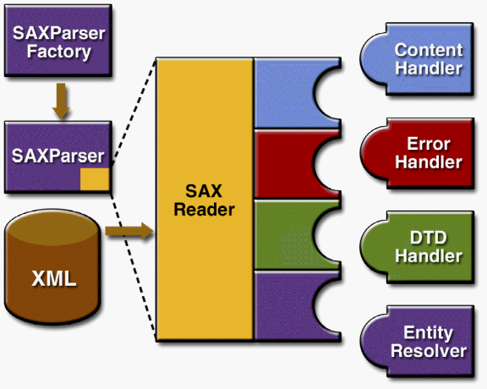
DefaultHandler implements the ContentHandler, ErrorHandler, DTDHandler, and EntityResolver interfaces (with null methods), so you can override only the ones you’re interested in. ErrorHandler’s Methods error, fatalError, and warning are invoked in response to various parsing errors. The default error handler throws an exception for fatal errors and ignores other errors (including validation errors). The DTDHandler is invoked when the DTD encounters an
unparsed entity or a notation declaration. The EntityResolver comes into play when a URN (public ID) must be resolved to a URL (system ID).

- A locator is an object that contains the document’s location and public identifier as well as it gives the column and line number of the most recently processed event. The setDocumentLocator method, however, is called only once: at the beginning of the parse. While processingInstruction() can be used to get processing targets and data.

- A nonfatal error occurs when an XML document fails a validity constraint, given a DTD or schema. While Warnings are informative can only be generated in the presence of a DTD or schema. For example, if an element is defined twice in a DTD, a warning is generated. It’s not illegal, and it doesn’t cause problems. These error can be handled by error() and waring() method of ErrorHandler.

- To process the ignorable whitespace that the parser is seeing, ignorableWhitespace method is being invoked before and after comments and root elements whereas characters method is being invoked before there was a DTD. The default implementation of method ignorableWhitespace doesn’t do anything.

- To be notified of validation errors in an XML document, the following must be true:
  - The appropriate properties must be set on the SAX parser.
  - The appropriate error handler must be set.
  - The document must be associated with a schema.
To configure the parser factory to generate a parser that is namespace aware as well as validating:
SAXParserFactory factory = SAXParserFactory.newInstance();
factory.setNamespaceAware(true);
factory.setValidating(true);
try {
saxParser.setProperty(“http://java.sun.com/xml/jaxp/properties/schemaLanguage”, “http://www.w3.org/2001/XMLSchema”);
}catch (SAXNotRecognizedException x) {
}

If the parser is not 1.2-compliant and therefore does not support XML Schema, it can throw a SAXNotRecognizedException.
- Comments, CDATA tags, and references to parsed entities constitute lexical information—that is, information that concerns the text of the XML itself, rather than the XML’s information content. To be informed when the SAX parser sees lexical information, you configure the XmlReader that underlies the parser with a LexicalHandler. The LexicalHandler interface defines comment(), startCDATA(), endCDATA(), startEntity(), endEntity(), startDTD(), endDTD() event-handling methods.
- If you are dealing with simple data structures and if XML Schema isn’t a big part of your plans, then you may find that JDOM and dom4j is better. But if the data is Mixed-Content Model, DOM is the solution. Like:
<sentence>This is an <bold>important</bold> idea.</sentence>
For the first element node, nodeName() returns sentence, while nodeValue() returns null. For the first text node, nodeName() returns #text, and nodeValue() returns This is an . The important point is that the value of an element is not the same as its content.
- You use the DocumentBuilder’s setErrorHandler method to supply it with an object that implements the SAX ErrorHandler interface and setEntityResolver method you can use to supply entity resolver.
- Table is adapted from specification for Node.
Node | nodeName() | nodeValue() | Attribute | nodeType()
Attr | Name of attribute | Value of attribute | null | 2
CDATASection | #cdata-section | Content of  the CDATA  section | null | 4
Comment | #comment | Content of the  comment | null | 8
Document | #document | null | null | 9
DocumentFragment | #documentfragment | null | null | 11
DocumentType | Document type name | null | null | 10
Element | Tag name | null | NamedNodeMap | 1
Entity | Entity name | null | null | 6
EntityReference | Name of  entity referenced | null | null | 5
Notation | Notation name | null | null | 12
ProcessingInstruction | Target | Entire content  excluding the  target | null | 7
Text | #text | Content of the  text node | null | 3

- The following DocumentBuilderFactory methods give you control over the lexical information you see in the DOM:
  - setCoalescing(): To convert CDATA nodes to Text nodes and append to an adjacent Text node (if any)
  - setExpandEntityReferences(): To expand entity reference nodes
  - setIgnoringComments(): To ignore comments
  - setIgnoringElementContentWhitespace(): To ignore whitespace that is not a significant part of element content
The default values for all these properties are false, which preserves all the lexical information necessary to reconstruct the incoming document in its original form.
- You can declare the multiple schemas like this:
<documentRoot xmlns:xsi="http://www.w3.org/2001/XMLSchema-instance"
xsi:noNamespaceSchemaLocation="employeeDatabase.xsd"
xsi:schemaLocation=
”http://www.irs.gov/ fullpath/w2TaxForm.xsd
http://www.ourcompany.com/ relpath/hiringForm.xsd“
xmlns:tax="http://www.irs.gov/"
xmlns:hiring="http://www.ourcompany.com/"
>
The xsi:schemaLocation declaration consists of entry pairs, where the first entry in each pair is a fully qualified URI that specifies the namespace, and the second entry contains a full path or a relative path to the schema definition.
- XPath uses a single period (.) which indicates the current node and uses following expressions to broaden the scope of the pattern matching.
Wildcard | Meaning
* | Matches any element node (not attributes or text)
node() | Matches any node of any kind: element node, text node, attribute node, processing instruction node, namespace node, or comment node
@* | Matches any attribute node

- Following table lists the operators that can be used in an Xpath expression
Operator | Meaning
| | Alternative. For example, PARA|LIST selects all PARA and LIST elements.
or, and | Returns the or/and of two Boolean values.
=, != | Equal or not equal, for Booleans, strings, and numbers.
<, >, <=, >= | Less than, greater than, less than or equal to, greater than or equal to, for numbers.
+, -, *, div, mod | Add, subtract, multiply, floating-point divide, and modulus (remainder) operations (e.g., 6 mod 4 = 2)

- XSLT can be written as:
<?xml version="1.0" encoding="ISO-8859-1"?>
<xsl:stylesheet xmlns:xsl="http://www.w3.org/1999/XSL/Transform"
version="1.0">
<xsl:output method="html"/>
- If output is not defined, by default its XML and you can add the indent attribute to produce nicely indented XML output. The specification looks like this:
<xsl:output method="xml" indent="yes"/>
When you specifying output as html, generated test is escaped. On the other hand if output is defined as text, generated text is not escaped. For example, if the stylesheet includes the &lt; entity reference, it will appear as the < character in the generated text.

- Servlet Life-Cycle Events and respective listeners are as follows:
Object | Event | Listener Interface and Event Class
Web context | Initialization and destruction | javax.servlet.  ServletContextListener and  ServletContextEvent
Web context | Attribute added,  removed, or  replaced | javax.servlet.  ServletContextAttributeListener and  ServletContextAttributeEvent
Session | Creation,  invalidation,  activation,  passivation, and  timeout | javax.servlet.http.  HttpSessionListener,  javax.servlet.http.  HttpSessionActivationListener, and  HttpSessionEvent
Session | Attribute added,  removed, or  replaced | javax.servlet.http.  HttpSessionAttributeListener and  HttpSessionBindingEvent
Request | A servlet request  has started being  processed by web  components | javax.servlet.  ServletRequestListener and  ServletRequestEvent
Request | Attribute added,  removed, or  replaced | javax.servlet.  ServletRequestAttributeListener and  ServletRequestAttributeEvent

- Following are the list of Scope objects
Scope Object | Class | Accessible From
Web context | javax.servlet.ServletContext | Web components within a web context. See Accessing the Web Context
Session | javax.servlet.http.HttpSession | Web components handling a request that belongs to the session. See Maintaining Client State
Request | subtype of javax.servlet.ServletRequest | Web components handling the request.
Page | javax.servlet.jsp.JspContext | The JSP page that creates the object. See Using Implicit Objects.

- Response headers must always be set before the response has been committed. Any attempt to set or add headers after the response has been committed will be ignored by the web container.
- You can get a RequestDispatcher object from either a request or the web context. However, the two methods have slightly different behaviour. The method takes the path to the requested resource as an argument. A request can take a relative but the web context requires an absolute path. If the resource is not available or if the server has not implemented a RequestDispatcher object for that type of resource, getRequestDispatcher will return null.
- Following are Constrain how the filter will be applied to requests by choosing one of the enumerated dispatcher options:
  - REQUEST: Only when the request comes directly from the client
  - FORWARD: Only when the request has been forwarded to a component
  - INCLUDE: Only when the request is being processed by a component that has been included.
  - ERROR: Only when the request is being processed with the error page mechanism
- An included web component has access to the request object, but it is limited in what it can do with the response object:
  - It can write to the body of the response and commit a response.
  - It cannot set headers or call any method (for example, setCookie) that affects the headers of the response.
- The forward method should be used to give another resource responsibility for replying to the user. If you have already accessed a ServletOutputStream or PrintWriter object within the servlet, you cannot use this method; doing so throws an IllegalStateException.
- If cookies are turned off, the session is encoded in the Check Out URL as follows:
http://localhost:8080/bookstore1/cashier;jsessionid=c0o7fszeb1
If cookies are turned on, the URL is simply
http://localhost:8080/bookstore1/cashier
- The server calls the destroy method only after all service requests have returned or after a server-specific grace period, whichever comes first. If servlet has operations that take a long time to run, the operations could still be running when destroy is called.
- When a request is mapped to a JSP page, the web container first checks whether the JSP page’s servlet is older than the JSP page. If the servlet is older, the web container translates the JSP page into a servlet class and compiles the class.
- Both the translation and the compilation phases can yield errors that are observed only when the page is requested for the first time. If an error is encountered during either phase, the server will return JasperException and a message that includes the name of the JSP page and the line where the error occurred.
- The web container evaluates a variable that appears in an expression by looking up its value according to the behavior of PageContext.findAttribute(String). For example, when evaluating the expression ${product}, the container will look for product in the page, request, session, and application scopes and will return its value. If product is not found, null is returned.
- JSP page contain following types of directives
  - A page directive (<%@page ... %>) can be used to configure following:
    - When a JSP page is executed, output written to the response object is automatically buffered. Size of the buffer can be configured as:
<%@ page buffer="none|xxxkb" %>
    - To specify that the web container should forward control to an error page if an exception occurs,
<%@ page errorPage="errorpage.jsp"%>
    - To indicate that the page is serving as an error page:
<%@ page isErrorPage="true" %>
This directive makes an object of type javax.servlet.jsp.ErrorData with ${pageContext.errorData.statusCode} is used to retrieve the status code, and ${pageContext.errorData.throwable} retrieves the exception and ${pageContext.errorData.throwable.rootCause} retrieves the root cause of the exception.
    - The default content type is HTML in jsp. If you want to use a format other than HTML with specifying the encoding of the response.
<%@ page contentType="text/html; charset=UTF-8" %>
    - To set the source encoding of the page itself:
<%@ page pageEncoding="UTF-8" %>
    - The conditions affecting concurrent access to shared objects:
<%@ page isThreadSafe="true|false" %>
If isThreadSafe is set to false, requests are dispatched one at a time in the order they were received and JSP page’s generated servlet will implement the javax.servlet.SingleThreadModel interface.
    - To deactivate the evaluation of EL expressions, you specify the isELIgnored attribute of the page directive:
<%@ page isELIgnored ="true|false" %>
  - Tag library directives (<%@taglib ... %>) import custom tag libraries.
  - The include directive is processed when the JSP page is translated into a servlet class. The effect of the directive is to insert the text contained in another file—either static content or another JSP page—into the including JSP page. The syntax for the include directive is as follows:
<%@ include file="filename" %>
- An expression language makes it possible to easily access application data stored in JavaBeans components. For example, the JSP expression language allows a page author to access a bean using simple syntax such as ${name} for a simple variable or ${name.foo.bar} for a nested property.
- If the static text appears in a tag body, note that an expression will not be evaluated if the body is declared to be tagdependent.
- The JSP expression language defines a set of implicit objects:
- pageContext, servletContext, session, request, response, param (Maps a request parameter name to a single value), paramValues (Maps a request parameter name to an array of values), header, headerValues, cookie, initParam (Maps a context initialization parameter name to a single value), pageScope (Maps page-scoped variable names to their values), requestScope, sessionScope and applicationScope.
- Empty: The empty operator is a prefix operation that can be used to determine whether a value is null or empty.
- You can transfer control to another web component from a JSP page using the jsp:forward element:
<jsp:forward page="/main.jsp" />
Note that if any data has already been returned to a client, the jsp:forward element will fail with an IllegalStateException.
- JSP Document has .jspx extension. Following is Standard JSP Syntax Versus XML Syntax:
Syntax Elements | Standard Syntax | XML Syntax
Comments | <%--.. --%> | <!-- .. -->
Declarations | <%! ..%> | <jsp:declaration> .. </jsp:declaration>
Directives | <%@ include .. %> | <jsp:directive.include .. />
Directives | <%@ page .. %> | <jsp:directive.page .. />
Directives | <%@ taglib .. %> | xmlns:prefix="tag library URL"
Expressions | <%= ..%> | <jsp:expression> .. </jsp:expression>
Scriptlets | <% ..%> | <jsp:scriptlet> .. </jsp:scriptlet>

- Although the jsp:root element is not required in JSP Document, it is still useful in these cases:
  - When you want to identify the document as a JSP document to the JSP container without having to add any configuration attributes to the deployment descriptor or name the document with a .jspx extension
  - When you want to generate—from a single JSP document—more than one XML document or XML content mixed with non-XML content
<jsp:root version="2.0" >
<books ...>
...
</books>
<jsp:directive.include file="magazine.jspx" />
</jsp:root>
- You can also use EL expressions with jsp:element to generate tags dynamically rather than hardcode them. This example could be used to generate an HTML header tag with a lang attribute:
<jsp:element name="${content.headerName}"
xmlns:jsp="http://java.sun.com/JSP/Page">
<jsp:attribute name="lang">${content.lang}</jsp:attribute>
<jsp:body>${content.body}</jsp:body>
</jsp:element>
The output of this example jsp:element could be
<h1 lang="fr">Heading in French</h1>
- The jsp:output element specifies the XML declaration or the document type declaration in the request output of the JSP document. The XML declaration and document type declaration that are declared by the jsp:output element are not interpreted by the JSP container. Instead, the container simply directs them to the request output.
<jsp:output doctype-root-element="books" doctype-system="books.dtd" />
The resulting output is:
<!DOCTYPE books SYSTEM "books.dtd" >
- JSTL is exposed as multiple tag libraries. The URIs for these libraries are as follows:
  - Core: http://java.sun.com/jsp/jstl/core
  - XML: http://java.sun.com/jsp/jstl/xml
  - Internationalization: http://java.sun.com/jsp/jstl/fmt
  - SQL: http://java.sun.com/jsp/jstl/sql
  - Functions: http://java.sun.com/jsp/jstl/functions
- The object that implements a custom tag is called a tag handler. JSP technology defines two types of tag handlers: simple and classic. Simple tag handlers can be used only for tags that do not use scripting elements in attribute values or the tag body. Classic tag handlers must be used if scripting elements are required.
- The following snap shows how to pass attributes to custom tags:
<%@ attribute name="greeting" required="true" %>
<%@ attribute name="name" required="true" %>
<h2><font color="black">${greeting}, ${name}!</font></h2>
- The following are the directives defined in custom tag file:
Directive | Description
taglib | Identical to taglib directive JSP pages.
include | Identical to include directive for JSP pages. Note that if the included file contains syntax unsuitable for tag files, a translation error will occur.
tag | Similar to the page directive in a JSP page, but applies to tag files instead of JSP pages. As with the page directive, a translation unit can contain more than one instance of the tag directive. All the attributes apply to the complete translation unit. However, there can be only one occurrence of any attribute or value defined by this directive in a given translation unit. With the exception of the import attribute, multiple attribute or value (re)definitions result in a translation error.
attribute | Declares an attribute of the custom tag defined in the tag file.
variable | Declares an EL variable exposed by the tag to the calling page.

- dynamic-attributes Indicates whether this tag supports additional attributes with dynamic names. The value identifies a scoped attribute in which to place a Map containing the names and values of the dynamic attributes passed during invocation of the tag. A translation error results if the value of the dynamicattributes of a tag directive is equal to the value of a name given of a variable directive or the value of a name attribute of an attribute directive
- The scope of the variable can be either AT_BEGIN, AT_END or NESTED. Default to NESTED.
- Following is the Variable Synchronization behaviour:
Tag File Location | AT_BEGIN | NESTED | AT_END
Beginning | Not sync. | Save | Not sync.
Before any fragment invocation via jsp:invoke or jsp:doBod | Tag > page | Tag > page | Not sync.
End | Tag > page | Restore | Tag > page

- To create custom tag class, we would use the SimpleTagSupport classes as a base class. The heart of a simple tag handler is a single method—doTag—which gets invoked when the end element of the tag is encountered. The entry point to the API is the JSP context object (javax.servlet.jsp.JspContext). The JspContext object provides access to implicit objects (request, session, and application). If the tag is nested, a tag handler also has access to the handler (called the parent) that is associated with the enclosing tag.
- Table summarizes a variable’s availability according to its declared scope:
Value | Availability
NESTED | Between the start tag and the end tag.
AT_BEGIN | From the start tag until the scope of any enclosing tag. If there’s no enclosing tag, then to the end of the page.
AT_END | After the end tag until the scope of any enclosing tag. If there’s no enclosing tag, then to the end of the page.

- If you wish to use a scripting language other than the default, java, you must specify it in the language attribute of the page directive at the beginning of a JSP page:
<%@ page language="scripting language" %>
- EJB container may write a stateful session bean for secondary storage. However, stateless session beans are never written to secondary storage. Therefore, stateless beans may offer better performance than stateful beans. A stateless session bean can implement a web service, but other types of enterprise beans cannot.
- Because the client interacts (“talks”) with its bean, this state is often called the conversational state.
- The local/remote/web service endpoint interface defines the business methods that are specific to the bean. While the local home/home interface defines the bean’s life-cycle methods: create and remove. For entity beans, the home interface also defines finder methods and home methods.
- With remote calls/web service clients, the client and bean operate on different copies of a parameter object.
- The client initiates the life cycle by invoking the create method. The EJB container instantiates the bean and then invokes the setSessionContext and ejbCreate methods in the session bean:
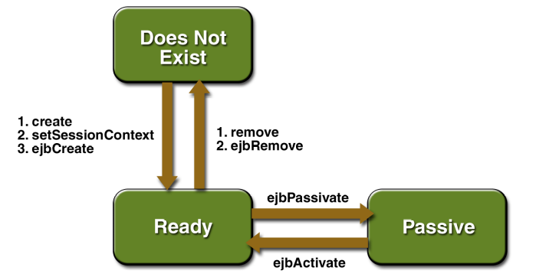
- Because a stateless session bean is never passivated:
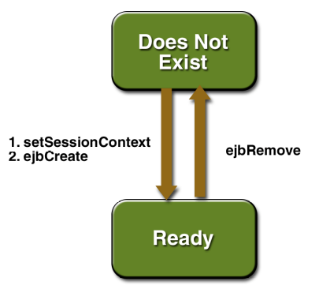
- The life cycle of entity bean:
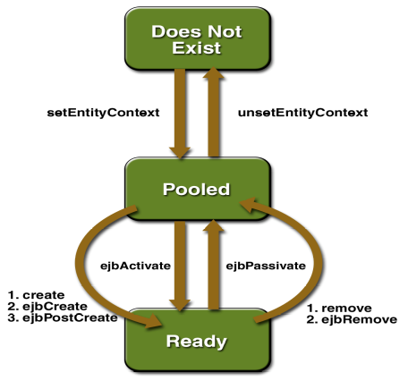
- The session bean class must meet these requirements:
  - It implements the SessionBean interface.
  - The class is defined as public.
  - The class cannot be defined as abstract or final.
  - It implements one or more ejbCreate methods.
  - It implements the business methods.
  - It contains a public constructor with no parameters.
  - It must not define the finalize method.
- An enterprise bean must have one or more ejbCreate methods. The signatures of the methods must meet the following requirements:
  - The access control modifier must be public.
  - The return type must be void.
  - If the bean allows remote access, the arguments must be legal types for the Java Remote Method Invocation (Java RMI) API.
  - The modifier cannot be static or final.
- The signature of a business method must conform to these rules:
  - The method name must not conflict with one defined by the EJB architecture. For example, you cannot call a business method ejbCreate or ejbActivate.
  - The access control modifier must be public.
  - If the bean allows remote access, the arguments and return types must be legal types for the Java RMI API.
  - The modifier must not be static or final.
- The signatures of the ejbCreate and create methods are similar, but they differ in important ways. The rules for defining the signatures of the create methods of a home interface follow:
  - The number and types of arguments in a create method must match those of its corresponding ejbCreate method.
  - The arguments and return type of the create method must be valid RMI types.
  - A create method returns the remote interface type of the enterprise bean. (But an ejbCreate method returns void.)
  - The throws clause of the create method must include the java.rmi.RemoteException and the javax.ejb.CreateException.
- A client can determine whether two stateful session beans are identical by invoking the isIdentical method. Because stateless session beans have the same object identity, the isIdentical method always returns true when used to compare them.
- If you want to pass the reference of the current bean, you can’t pass the ‘this’ reference because it points to the bean’s instance, which is running in the EJB container. Only the container can directly invoke methods on the bean’s instance. Clients access the instance indirectly by invoking methods on the object whose type is the bean’s remote interface. It is the reference to this object (the bean’s remote reference) that the first bean would pass to the second bean. A session bean obtains its remote reference by calling the getEJBObject method of the SessionContext interface. An entity bean would call the getEJBObject method of the EntityContext interface.
- A TimerHandle object cannot be passed as an argument of a method defined in a remote or web service interface. In other words, remote clients and web service clients cannot access a bean’s TimerHandle object. Local clients, however, do not have this restriction.
- You can create an unidentified producer by specifying null as the argument to createProducer and use an overloaded send method that specifies the destination as the first parameter.
- A JMS message has three parts: a header, properties, and a body. Only the header is required.
- JMS Message can contain following message types:
Message Type | Body Contains
TextMessage | A java.lang.String object (for example, the contents of an Extensible Markup Language file).
MapMessage | A set of name-value pairs, with names as String objects and values as primitive types in the Java programming language. The entries can be accessed sequentially by enumerator or randomly by name. The order of the entries is undefined.
BytesMessage | A stream of unnterpreted bytes. This message type is for literally encoding a body to match an existing message format.
StreamMessage | A stream of primitive values in the Java programming language filled and read sequentially.
ObjectMessage | A Serializable object in the Java programming language.
Message | Nothing. Composed of header fields and properties only. This message type is useful when a message body is not required.
- The three possible argument values for session commit are as follows:
  - Session.AUTO_ACKNOWLEDGE: The session automatically acknowledges a client’s receipt of a message either when the client has successfully returned from a call to receive or when the MessageListener it has called to process the message returns successfully. A synchronous receive in an AUTO_ACKNOWLEDGE session is the one exception to the rule that message consumption is a three-stage process as described earlier. In this case, the receipt and acknowledgment take place in one step, followed by the processing of the message.
  - Session.CLIENT_ACKNOWLEDGE: A client acknowledges a message by calling the message’s acknowledge method. In this mode, acknowledgment takes place on the session level: Acknowledging a consumed message automatically acknowledges the receipt of all messages that have been consumed by its session. For example, if a message consumer consumes ten messages and then acknowledges the fifth message delivered, all ten messages are acknowledged.
  - Session.DUPS_OK_ACKNOWLEDGE: This option instructs the session to lazily acknowledge the delivery of messages. This is likely to result in the delivery of some duplicate messages if the JMS provider fails, so it should be used only by consumers that can tolerate duplicate messages. (If the JMS provider redelivers a message, it must set the value of the JMSRedelivered message header to true.) This option can reduce session overhead by minimizing the work the session does to prevent duplicates.
- The ten levels of priority range from 0 (lowest) to 9 (highest). If you do not specify a priority level, the default level is 4. If the specified timeToLive value is 0, the message never expires.
- If you try to use a request/reply mechanism, whereby you send a message and then try to receive a reply to the sent message in the same transaction, the program will hang, because the send cannot take place until the transaction is committed.
- Any component within an EJB or web container must have no more than one JMS session per JMS connection. This rule does not apply to application clients.
- In 3.0 you have the interceptor facility available which is similar to the Servlet filters. The interceptors can be defined for Session beans and Message Driven beans, and can be used to intercept the request and do some kind of preprocessing such as logging. In 3.0, using annotations you can expose 'Stateless Session Bean' as a Webservice by using the @Webservice annotation, and by using the @Webmethod to expose certain public methods as a webservice API. The tehcnology used here is JAX-WS and the parameters used in the exposed methods must be JAXB compliant.
- A test is an behaviour test (also called interaction test) if it does not validate the result of a method call, but checks if certain methods were called with the correct input parameters. State testing is about validating the result also.
- To create a test suite:
@RunWith(Suite.class)
@SuiteClasses({ MyClassTest.class, MySecondClassTest.class })
- @BeforeClass and @AfterClass method need to be defined as static.
- JUnit allows you to use parameters in a tests class. This class can contain one test method and this method is executed with the different parameters provided. You mark a test class as a parameterized test with the @RunWith(Parameterized.class) annotation. Such a test class must contain a static method annotated with @Parameters that generates and returns a collection of arrays. Each item in this collection is used as parameter for the test method. You also need to create a constructor in which you store the values for each test. The number of elements in each array provided by the method annotated with @Parameters must correspond to the number of parameters in the constructor of the class. The class is created for each parameter and the test values are passed via the constructor to the class.
- Via the @Rule annotation you can create objects which can be used and configured in your test methods like ExpectedException if you are expecting any exception or TemporaryFolder for creating temp folder and file.
- Mockito has certain limitations. It can’t test the following constructs:
  - final classes
  - anonymous classes
  - primitive types

