**PROGRAM 3: SUPPLIER DATABASE**

**Consider the following schema:**

**SUPPLIERS(sid: integer, sname: string, address: string)**

**PARTS(pid: integer, pname: string, color: string)**

**CATALOG(sid: integer, pid: integer, cost: real)**

**The Catalog relation lists the prices charged for parts by Suppliers.**

**Write the following queries in SQL:**

1. Find the pnames of parts for which there is some supplier.
2. Find the snames of suppliers who supply every part.
3. Find the snames of suppliers who supply every red part.
4. Find the pnames of parts supplied by Acme Widget Suppliers and by no one else.
5. Find the sids of suppliers who charge more for some part than the average cost of that part (averaged over all the suppliers who supply that part).
6. For each part, find the sname of the supplier who charges the most for that part.

**Schema Diagram**

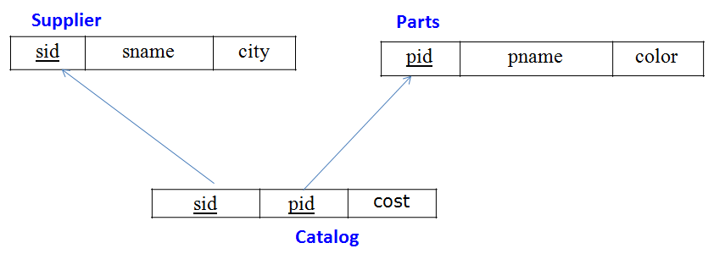

**Table Data**

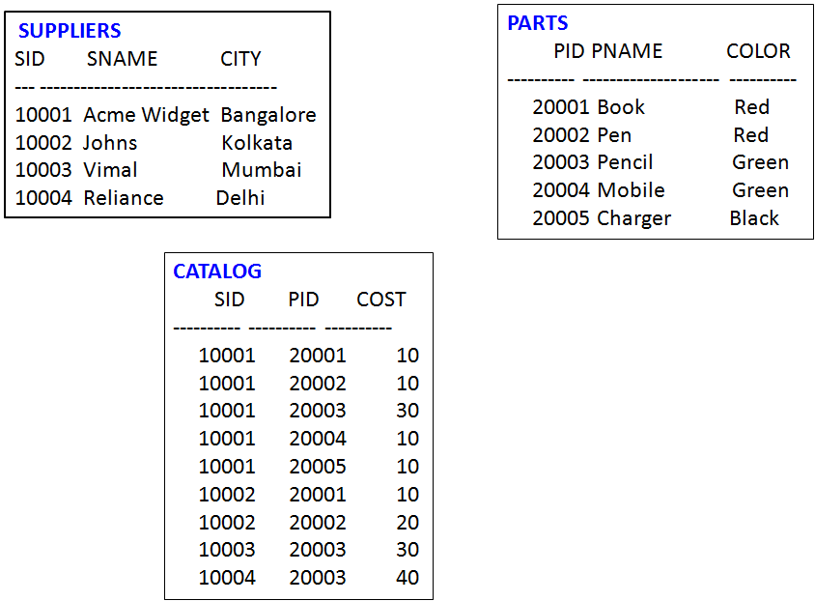

**CREATION of Tables:**

**SQL> create table SUPPLIERS(sid number(5) primary key, sname varchar(20), city varchar(20));**

Table created.

**SQL> desc SUPPLIERS;**

Name Null? Type

----------------------------------------- -------- ----------------------------

SID NOT NULL NUMBER(5)

SNAME VARCHAR2(20)

CITY VARCHAR2(20)

**SQL> create table PARTS(pid number(5) primary key, pname varchar(20), color varchar(10));**

Table created.

**SQL> desc PARTS;**

Name Null? Type

----------------------------------------- -------- ----------------------------

PID NOT NULL NUMBER(5)

PNAME VARCHAR2(20)

COLOR VARCHAR2(10)

**SQL> create table CATALOG(sid number(5), pid number(5), foreign key(sid) references SUPPLIERS(sid), foreign key(pid) references PARTS(pid), cost float(6), primary key(sid, pid));**

Table created.

**SQL> desc CATALOG;**

Name Null? Type

----------------------------------------- -------- ----------------------------

SID NOT NULL NUMBER(5)

PID NOT NULL NUMBER(5)

COST FLOAT(6)

**INSERTION OF DATA:**

**SQL> insert into suppliers values(&sid, '&sname','&city');**

Enter value for sid: 10001

Enter value for sname: Acme Widget

Enter value for address: Bangalore

old 1: insert into suppliers values(&sid, '&sname','&city')

new 1: insert into suppliers values(10001, 'Acme Widget','Bangalore')

1 row created.

SQL> /

Enter value for sid: 10002

Enter value for sname: Johns

Enter value for address: Kolkata

old 1: insert into suppliers values(&sid, '&sname','&city')

new 1: insert into suppliers values(10002, 'Johns','Kolkata')

1 row created.

SQL> /

Enter value for sid: 10003

Enter value for sname: Vimal

Enter value for address: Mumbai

old 1: insert into suppliers values(&sid, '&sname','&city')

new 1: insert into suppliers values(10003, 'Vimal','Mumbai')

1 row created.

SQL> /

Enter value for sid: 10004

Enter value for sname: Reliance

Enter value for address: Delhi

old 1: insert into suppliers values(&sid, '&sname','&city')

new 1: insert into suppliers values(10004, 'Reliance','Delhi')

1 row created.

SQL> /

Enter value for sid: 10005

Enter value for sname: Mahindra

Enter value for address: Mumbai

old 1: insert into suppliers values(&sid, '&sname','&city')

new 1: insert into suppliers values(10005, 'Mahindra','Mumbai')

1 row created.

**SQL> select * from SUPPLIERS;**

SID SNAME CITY

---------- -------------------- --------------------

10001 Acme Widget Bangalore

10002 Johns Kolkata

10003 Vimal Mumbai

10004 Reliance Delhi

**SQL> commit;**

Commit complete.

**SQL> insert into PARTS values(&pid, '&pname','&color');**

Enter value for pid: 20001

Enter value for pname: Book

Enter value for color: Red

old 1: insert into PARTS values(&pid, '&pname','&color')

new 1: insert into PARTS values(20001, 'Book','Red')

1 row created.

SQL> /

Enter value for pid: 20002

Enter value for pname: Pen

Enter value for color: Red

old 1: insert into PARTS values(&pid, '&pname','&color')

new 1: insert into PARTS values(20002, 'Pen','Red')

1 row created.

SQL> /

Enter value for pid: 20003

Enter value for pname: Pencil

Enter value for color: Green

old 1: insert into PARTS values(&pid, '&pname','&color')

new 1: insert into PARTS values(20003, 'Pencil','Green')

1 row created.

SQL> /

Enter value for pid: 20004

Enter value for pname: Mobile

Enter value for color: Green

old 1: insert into PARTS values(&pid, '&pname','&color')

new 1: insert into PARTS values(20004, 'Mobile','Green')

1 row created.

SQL> /

Enter value for pid: 20005

Enter value for pname: Charger

Enter value for color: Black

old 1: insert into PARTS values(&pid, '&pname','&color')

new 1: insert into PARTS values(20005, 'Charger','Black')

1 row created.

**SQL> select * from PARTS;**

PID PNAME COLOR

---------- -------------------- ----------

20001 Book Red

20002 Pen Red

20003 Pencil Green

20004 Mobile Green

20005 Charger Black

**SQL> commit;**

Commit complete.

**SQL> insert into CATALOG values(&sid, '&pid','&cost');**

Enter value for sid: 10001

Enter value for pid: 20001

Enter value for cost: 10

old 1: insert into CATALOG values(&sid, '&pid','&cost')

new 1: insert into CATALOG values(10001, '20001','10')

1 row created.

SQL> /

Enter value for sid: 10001

Enter value for pid: 20002

Enter value for cost: 10

old 1: insert into CATALOG values(&sid, '&pid','&cost')

new 1: insert into CATALOG values(10001, '20002','10')

1 row created.

SQL> /

Enter value for sid: 10001

Enter value for pid: 20003

Enter value for cost: 30

old 1: insert into CATALOG values(&sid, '&pid','&cost')

new 1: insert into CATALOG values(10001, '20003','30')

1 row created.

SQL> /

Enter value for sid: 10001

Enter value for pid: 20004

Enter value for cost: 10

old 1: insert into CATALOG values(&sid, '&pid','&cost')

new 1: insert into CATALOG values(10001, '20004','10')

1 row created.

SQL> /

Enter value for sid: 10001

Enter value for pid: 20005

Enter value for cost: 10

old 1: insert into CATALOG values(&sid, '&pid','&cost')

new 1: insert into CATALOG values(10001, '20005','10')

1 row created.

SQL> /

Enter value for sid: 10002

Enter value for pid: 20001

Enter value for cost: 10

old 1: insert into CATALOG values(&sid, '&pid','&cost')

new 1: insert into CATALOG values(10002, '20001','10')

1 row created.

SQL> /

Enter value for sid: 10002

Enter value for pid: 20002

Enter value for cost: 20

old 1: insert into CATALOG values(&sid, '&pid','&cost')

new 1: insert into CATALOG values(10002, '20002','20')

1 row created.

SQL> /

Enter value for sid: 10003

Enter value for pid: 20003

Enter value for cost: 30

old 1: insert into CATALOG values(&sid, '&pid','&cost')

new 1: insert into CATALOG values(10003, '20003','30')

1 row created.

SQL> /

Enter value for sid: 10004

Enter value for pid: 20003

Enter value for cost: 40

old 1: insert into CATALOG values(&sid, '&pid','&cost')

new 1: insert into CATALOG values(10004, '20003','40')

1 row created.

**SQL> select * from CATALOG;**

SID PID COST

---------- ---------- ----------

10001 20001 10

10001 20002 10

10001 20003 30

10001 20004 10

10001 20005 10

10002 20001 10

10002 20002 20

10003 20003 30

10004 20003 40

9 rows selected.

1. **Find the pnames of parts for which there is some supplier.**

**SQL> SELECT DISTINCT P.pname**

**2 FROM Parts P, Catalog C**

**3 WHERE P.pid = C.pid;**

PNAME

--------------------

Book

Charger

Mobile

Pen

Pencil

1. **Find the snames of suppliers who supply every part.**

**SQL> SELECT S.sname**

**2 FROM Suppliers S**

**3 WHERE NOT EXISTS ((SELECT P.pid FROM Parts P)**

**4 MINUS (SELECT C.pid FROM Catalog C**

**5 WHERE C.sid = S.sid));**

SNAME

--------------------

Acme Widget

1. **Find the snames of suppliers who supply every red part.**

**SQL>SELECT S.sname**

**FROM Suppliers S**

**WHERE NOT EXISTS (( SELECT P.pid**

**FROM Parts P**

**WHERE P.color = ‘Red’ )**

**MINUS**

**( SELECT C.pid**

**FROM Catalog C, Parts P**

**WHERE C.sid = S.sid AND**

**C.pid = P.pid AND P.color = ‘Red’ ));**

SNAME

--------------------

Acme Widget

Johns

1. **Find the pnames of parts supplied by Acme Widget Suppliers and by no one else.**

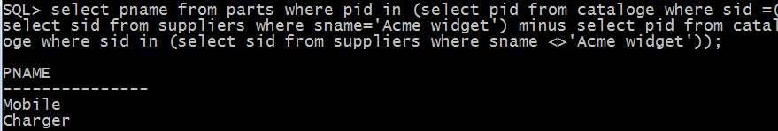

PNAME

--------------------

Mobile

Charger

1. **Find the sids of suppliers who charge more for some part than the average cost of that part (averaged over all the suppliers who supply that part).**

**SQL> SELECT DISTINCT C.sid FROM Catalog C**

**2 WHERE C.cost > ( SELECT AVG (C1.cost)**

**3 FROM Catalog C1**

**4 WHERE C1.pid = C.pid );**

SID

----------

10002

10004

1. **For each part, find the sname of the supplier who charges the most for that part.**

**SQL>SELECT P.pid, S.sname**

**FROM Parts P, Suppliers S, Catalog C**

**WHERE C.pid = P.pid**

**AND C.sid = S.sid**

**AND C.cost = (SELECT MAX (C1.cost)**

**FROM Catalog C1**

**WHERE C1.pid = P.pid);**

PID SNAME

---------- --------------------

20001 Acme Widget

20004 Acme Widget

20005 Acme Widget

20001 Johns

20002 Johns

20003 Reliance

6 rows selected.