**PROGRAM 5: AIRLINE FLIGHT DATABASE**

**Consider the following database that keeps track of airline flight information:**

**FLIGHTS(flno: integer, from: string, to: string, distance: integer, departs: time, arrives: time, price: integer)**

**AIRCRAFT(aid: integer, aname: string, cruisingrange: integer)**

**CERTIFIED(eid: integer, aid: integer)**

**EMPLOYEES(eid: integer, ename: string, salary: integer)**

Note that the Employees relation describes pilots and other kinds of employees as well; Every pilot is certified for some aircraft, and only pilots are certified to fly.

**Write each of the following queries in SQL.**

i. Create above mentioned tables

ii. Insert records into each of the tables

i. Find the names of aircraft such that all pilots certified to operate them have salaries more than Rs.80,000.

ii. For each pilot who is certified for more than three aircrafts, find the eid and the maximum

cruisingrange of the aircraft for which she or he is certified.

iii. Find the names of pilots whose salary is less than the price of the cheapest route from

Bengaluru to Frankfurt.

iv. For all aircraft with cruising range over 1000 Kms, find the name of the aircraft and the

Average salary of all pilots certified for this aircraft.

v. Find the names of pilots certified for some Boeing aircraft.

vi. Find the aids of all aircraft that can be used on routes from Bengaluru to New Delhi.

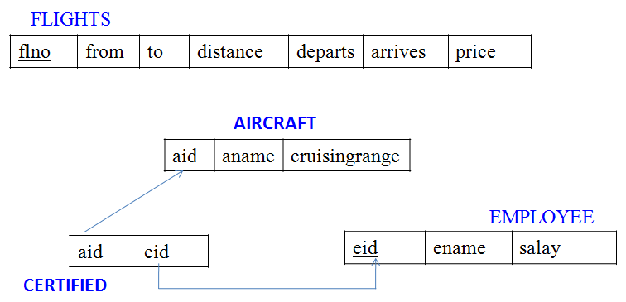

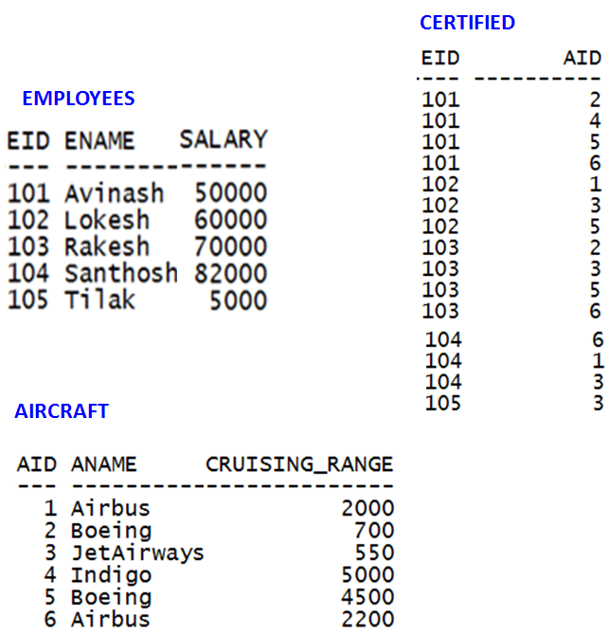

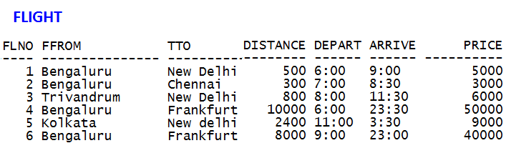

**CREATION OF TABLES:**









**Insert records into tables**

**Aircraft table**

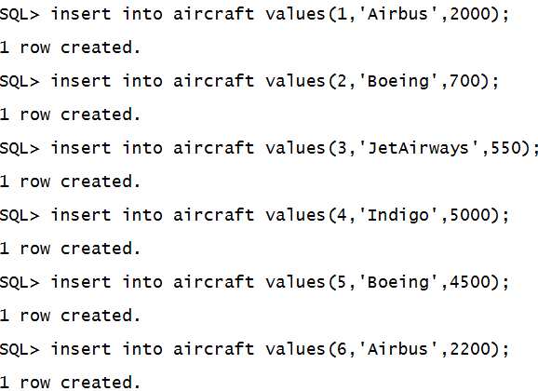

**Employees table**

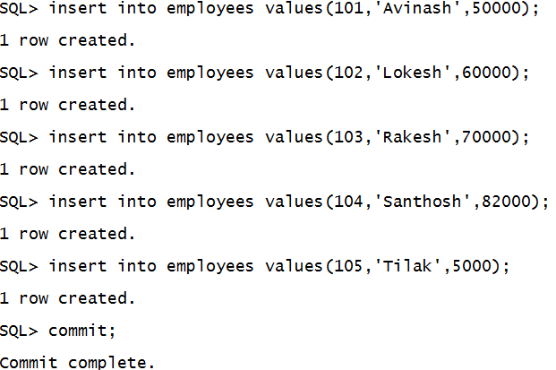

**Certified table**

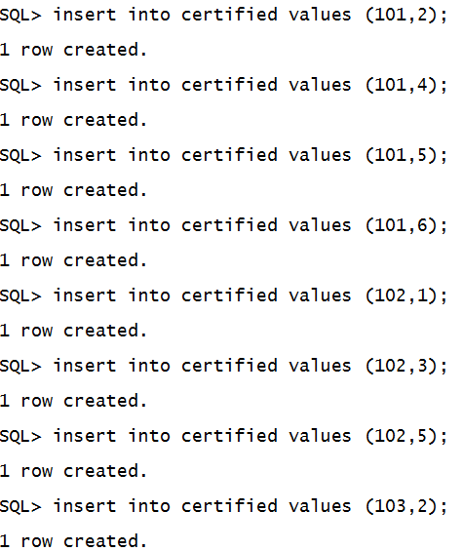

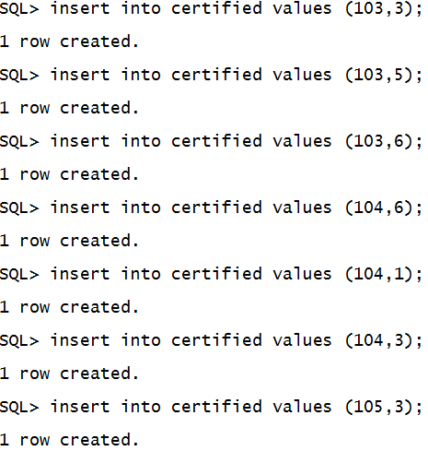

**Flights table**

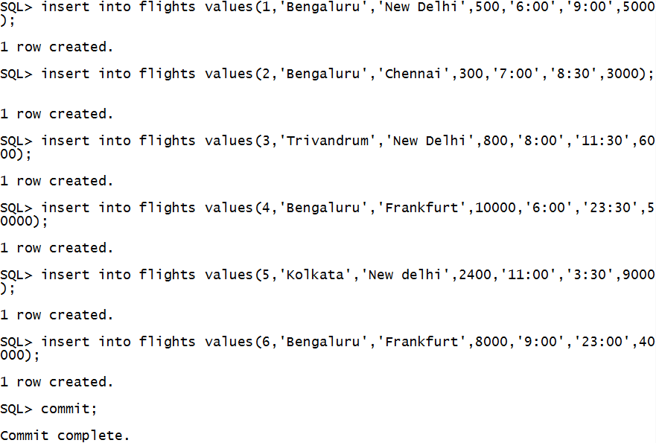

**i. Find the names of aircraft such that all pilots certified to operate them have salaries more than Rs.80,000.**

Select aname

from aircraft

where aid in

(select aid

from certified

where eid in (select eid from employees where salary >=80000));

**ii. For each pilot who is certified for more than three aircrafts, find the eid and the maximum cruising range of the aircraft for which she or he is certified**

SELECT C.eid, MAX(A.cruising_range)

FROM Certified C, Aircraft A

WHERE A.aid = C.aid

GROUP BY C.eid

**HAVING** COUNT(C.aid) > =3 ;

iii. Find the names of pilots whose salary is less than the price of the cheapest route from Bengaluru to Frankfurt.

SELECT ename FROM employees

WHERE salary < ( SELECT MIN(price)

FROM Flights

WHERE ffrom = 'Bengaluru‘

AND tto = 'Frankfurt' ) ;

iv. For all aircraft with cruising range over 1000 Kms, find the name of the aircraft and the average salary of all pilots certified for this aircraft.

SELECT a.aid, a.aname, AVG (e.salary)

FROM aircraft a, certified c, employees e

WHERE a.aid = c.aid AND

c.eid = e.eid AND

a.cruising_range > 1000

GROUP BY a.aid, a.aname ;

v. Find the names of pilots certified for some Boeing aircraft

SELECT DISTINCT e.ename

FROM employees e, certified c, aircraft a

WHERE e.eid = c.eid AND

a.aid = c.aid AND

a.aname = 'Boeing' ;

vi. Find the aids of all aircraft that can be used on routes from Bengaluru to New Delhi.

SELECT DISTINCT a.aid FROM aircraft a

WHERE a.cruising_range > ( SELECT MIN(f.distance)

FROM flights f

WHERE f.ffrom = 'Bengaluru' AND

f.tto = 'New Delhi' );