OSSP

Topic 1: Basic Linux Commands
- pwd

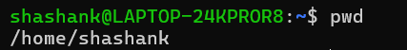

- history
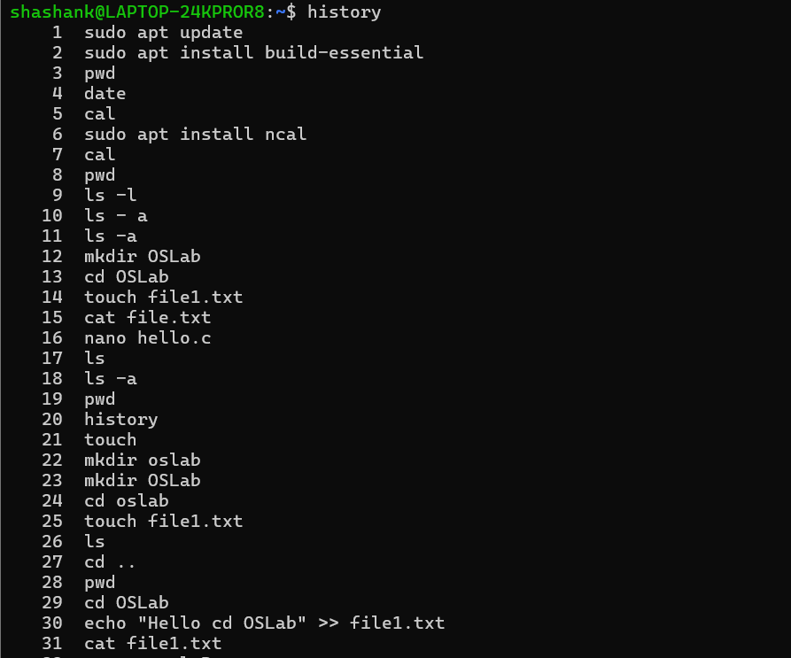

- whoami
- date
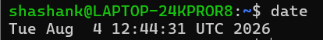
- cal
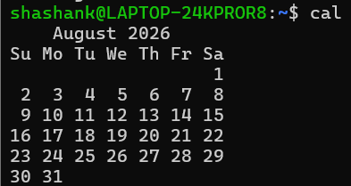
- hostname
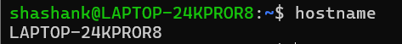
- uname -a

Topic 2: Directory Management

- ls
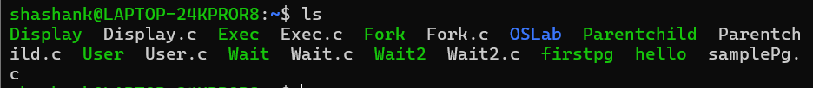

- ls -l
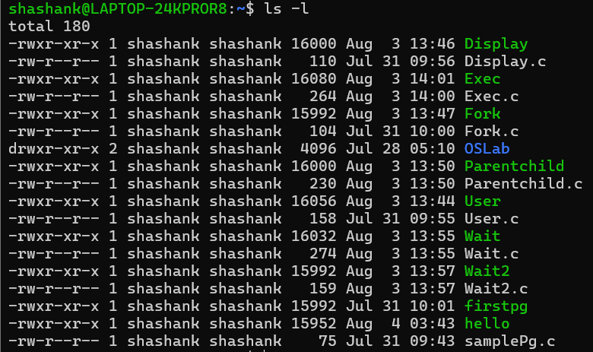

- ls -a
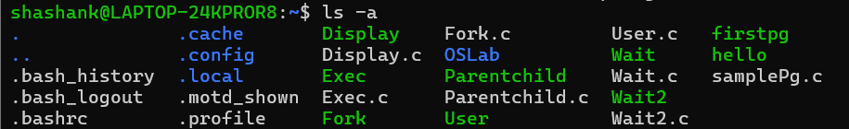

- cd
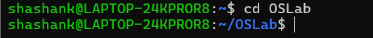

- cd..
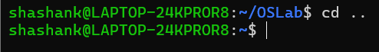

- mkdir & rmdir

- find
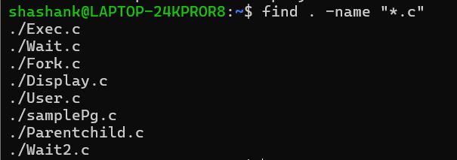

- locate

Topic 3: File Management

- cat

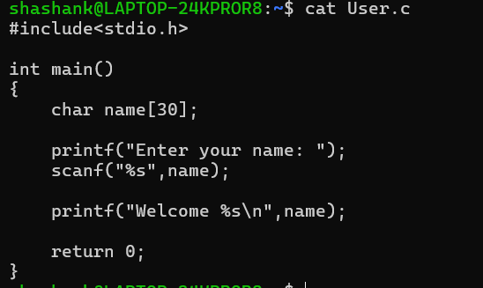

- head

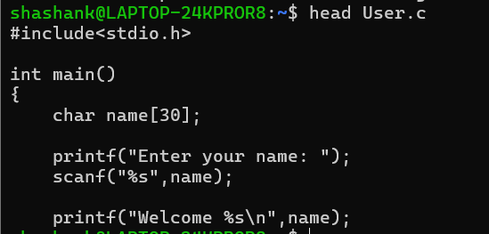

- tail

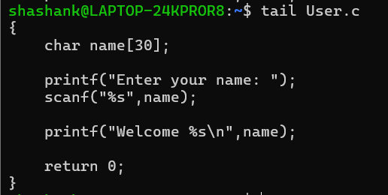

- more

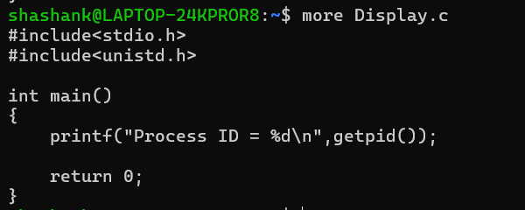

- less

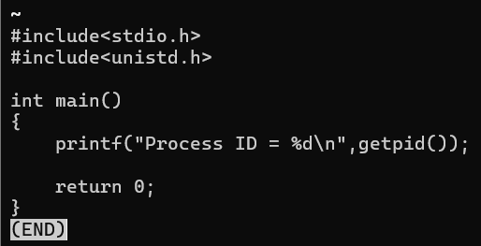

- wc
- diff
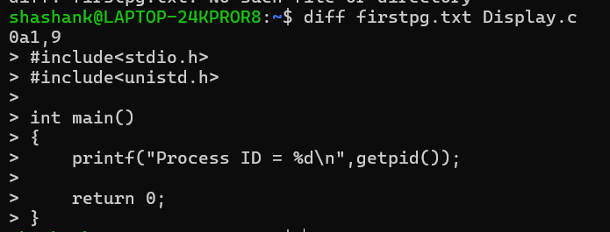

- sort
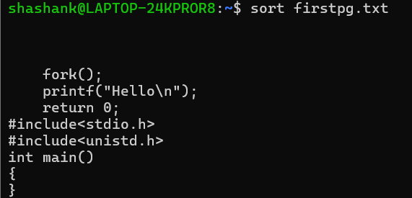
- uniq
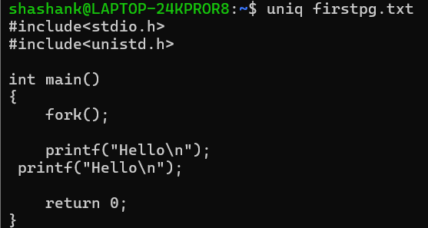
- grep

Topic 4 : File handling

- nano
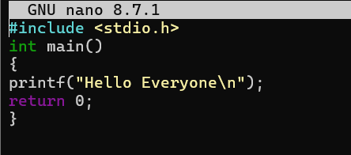
- vi
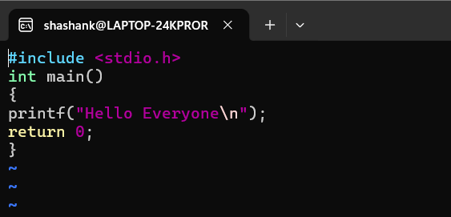
- gcc & ./program
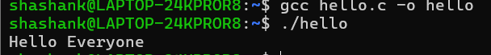
- which
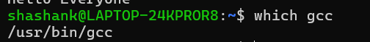
- whereis
Topic 6: Process Management

- ps
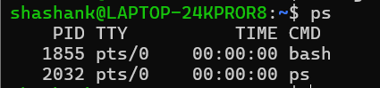

- ps -ef
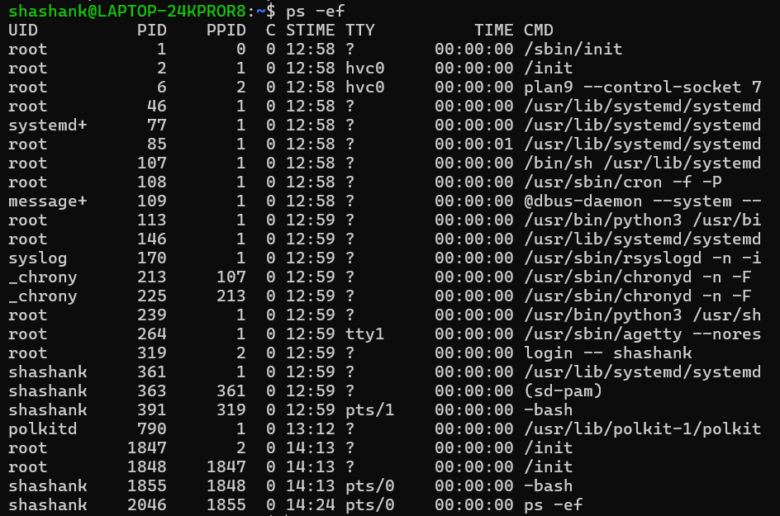

- top
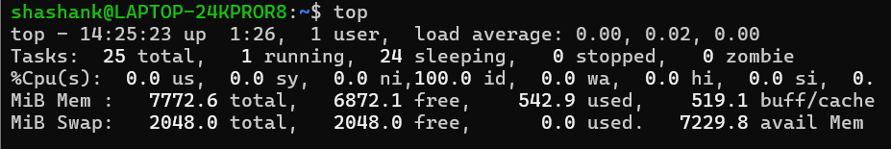

- kill

- kill -9

Topic 7: Job Control

- jobs & bg

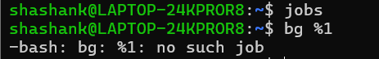

- fg



 

