**Name: Adkeshwar Shashank Ashok**

**Dept: Computer Science**

**Roll No: 19075004**

**Intelligent Computing(CSE - 342)**

**Q1.**

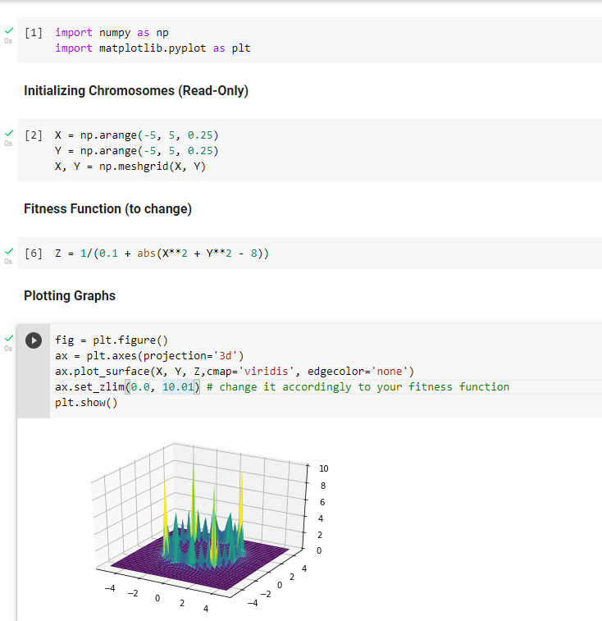

The Fitness function used is

Z = 1 / ( abs(X**2 + y**2 - 8 ) + 0.1 )

Here, according to the surface plot for the above fitness function, there population will converge to the optimal solution faster and the best optimal solution will be calculated. As the absolute values X and Y get close to 2, there will be fitter individuals.

There will be selection of better individuals and the next generation would be much closer to the optimal solution space and the algorithm will be robust and fast in finding the solution.

Hence this Fitness function is used.

**Q3.**

Fitness Selection Techniques:

1. Roulette Wheel Selection

2. Rank Based Selection Technique

3. Steady-State Selection Technique

4. Tournament Selection Technique

5. Canonical Selection Technique

Criteria to compare Fitness Selection Techniques:

1. Selection Pressure:

This is the degree to which the fitter individual is preferred over other individual in selection process. Higher the selection Pressure more is the chances of selection of the best fit individual.

2. Population Diversity:

This is the extent to which the diversity is being created in the offspring generation compared to the parent generation.

**Roulette Wheel Selection**:

* In roulette wheel selection, the probability that an individual gets selected in the mating pool depends on the percentage of its Fitness value out of the total fitness value of all the individuals.
* From here, we can see that if the Fitness value of any particular individual is very high, then the chances of that individual getting selected for the mating pool is high.
* One drawback of this selection technique is the issue of overshadowing lower fitness values and faster convergence.
* The individual with higher fitness values tend to be selected for the next generation and cause less population diversity.
* Also this is costlier computationally than other selection techniques like Tournament selection.
* *Hence it has high selection pressure and in turns causes low population diversity.*

**Rank-Based Selection:**

* In rank based selection, instead of using the percentage of fitness value of individual among the total, the individuals are assigned rank starting from lowest to highest fitness and then the percentages of getting selected in the mating pool is calculated.
* This solves the issue of premature convergence and local optimum solution and gives the best optimum solution.
* This is a turnaround of the roulette wheel and is based on rank assigned rather than probability.
* Also it is computationally costly similar to Roulette wheel technique
* *Hence it has high Population diversity and in turn low selection pressure.*

