# MICROCONTROLLERS

# LAB

## MINI PROJECT

**DATE: 17/03/2023**

|  |  |  |  |
| --- | --- | --- | --- |
| ROLL NUMBER | REGISTRATION NUMBER | SECTION | NAME |
| 24 | 210906196 | EEE – B | PIYUSH PARIPRAKASH DAS |
| 25 | 210906202 | EEE – B | SHAURYA PANDEY |
| 26 | 210906204 | EEE - B | SHASHANK PANDEY |
| 27 | 210906206 | EEE - B | TITHI MISHRA |
|  |  |  |  |

# **Aim**

The main aim of this project is to calculate and monitor the surrounding temperature and change the speed of the fan as temperature changes i.e. the speed should increase with a rise in temperature and should decrease with a drop in temperature. The temperature would be displayed through the LCD which is interfaced by the 8051 microcontroller. The FAN is controlled by a PWM wave given to it by the microcontroller, the power given to the fan is lesser in low temperature and greater in high temperature.​

# **Objective**

The objective of this project is to make a Fan whose speed is controlled by temperature. The idea behind the project is that we have a temperature sensor which senses the temperature and give the output in analog form which then is fed to ADC to convert it to digital signal (with values in HEX format), the output of ADC is given to the microcontroller. Now according to the temperature we are going to control speed of the dc fan which depends on the technique Pulse width modulation, as the width varies, the delay varies as a result of that the speed of the fan varies accordingly.​

**Benefits​**

A temperature controlled fan made using 8051 microcontroller offers several benefits. It operates at the optimal speed to maintain the desired temperature range, which reduces energy consumption and cost. It also improves comfort, enhances safety, and increases fan life by reducing wear and tear. The microcontroller automatically adjusts the fan speed based on the temperature measurements, making it more convenient for users. Overall, a temperature controlled fan made using 8051 microcontroller provides energy efficiency, cost savings, improved comfort, and enhanced safety.

**Engineering Systems, Variables & Parameters**

​

**Engineering Systems** ​

* Temperature Sensing Subsystem: This subsystem consists of the temperature sensor, which is responsible for measuring the temperature of the environment in which the fan operates.
* Microcontroller Subsystem: This subsystem consists of the 8051 microcontroller, which receives the temperature data from the sensor and uses it to control the fan speed.
* Motor Control Subsystem: This subsystem consists of the motor driver circuit and the fan, which work together to adjust the fan speed based on the temperature measurements received by the microcontroller.

**Variables**

* Ambient Temperature: This is the variable that is being controlled by the system. The temperature sensor measures the temperature and sends the data to the microcontroller.
* Fan Speed: This is the variable that is adjusted based on the temperature measurements. The microcontroller receives the temperature data from the sensor, and based on the programmed instructions, it adjusts the fan speed accordingly.

**Parameters**

* Temperature Range: The temperature range is an important parameter that must be considered when designing a temperature-controlled fan. The system should be designed to operate within a specific temperature range.
* Fan Speed Range: The fan speed range is another important parameter that must be considered when designing a temperature-controlled fan. The fan should be capable of operating within a specific speed range to effectively control the temperature.
* Set Point: The set point is the desired temperature that the system is designed to maintain. The microcontroller receives the temperature data from the sensor, and based on the programmed instructions, it adjusts the fan speed to maintain the set point temperature.
* Control Algorithm: The control algorithm is the set of instructions that the microcontroller follows to adjust the fan speed based on the temperature measurements. The algorithm must be carefully designed to ensure that the fan speed is adjusted in a smooth and effective manner to maintain the desired temperature.

**Proteus Simulation**

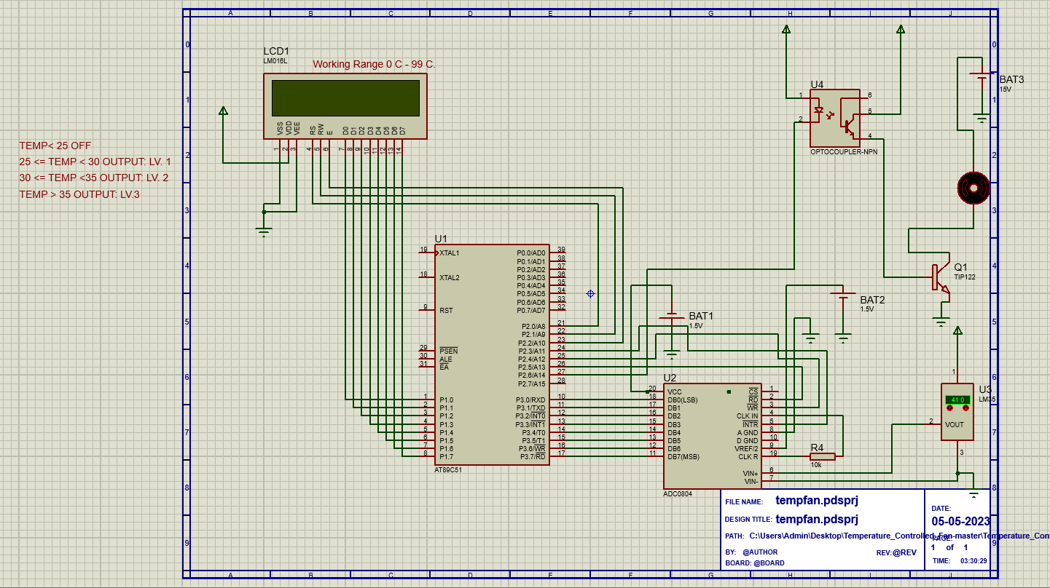

**Hardware Implementation**

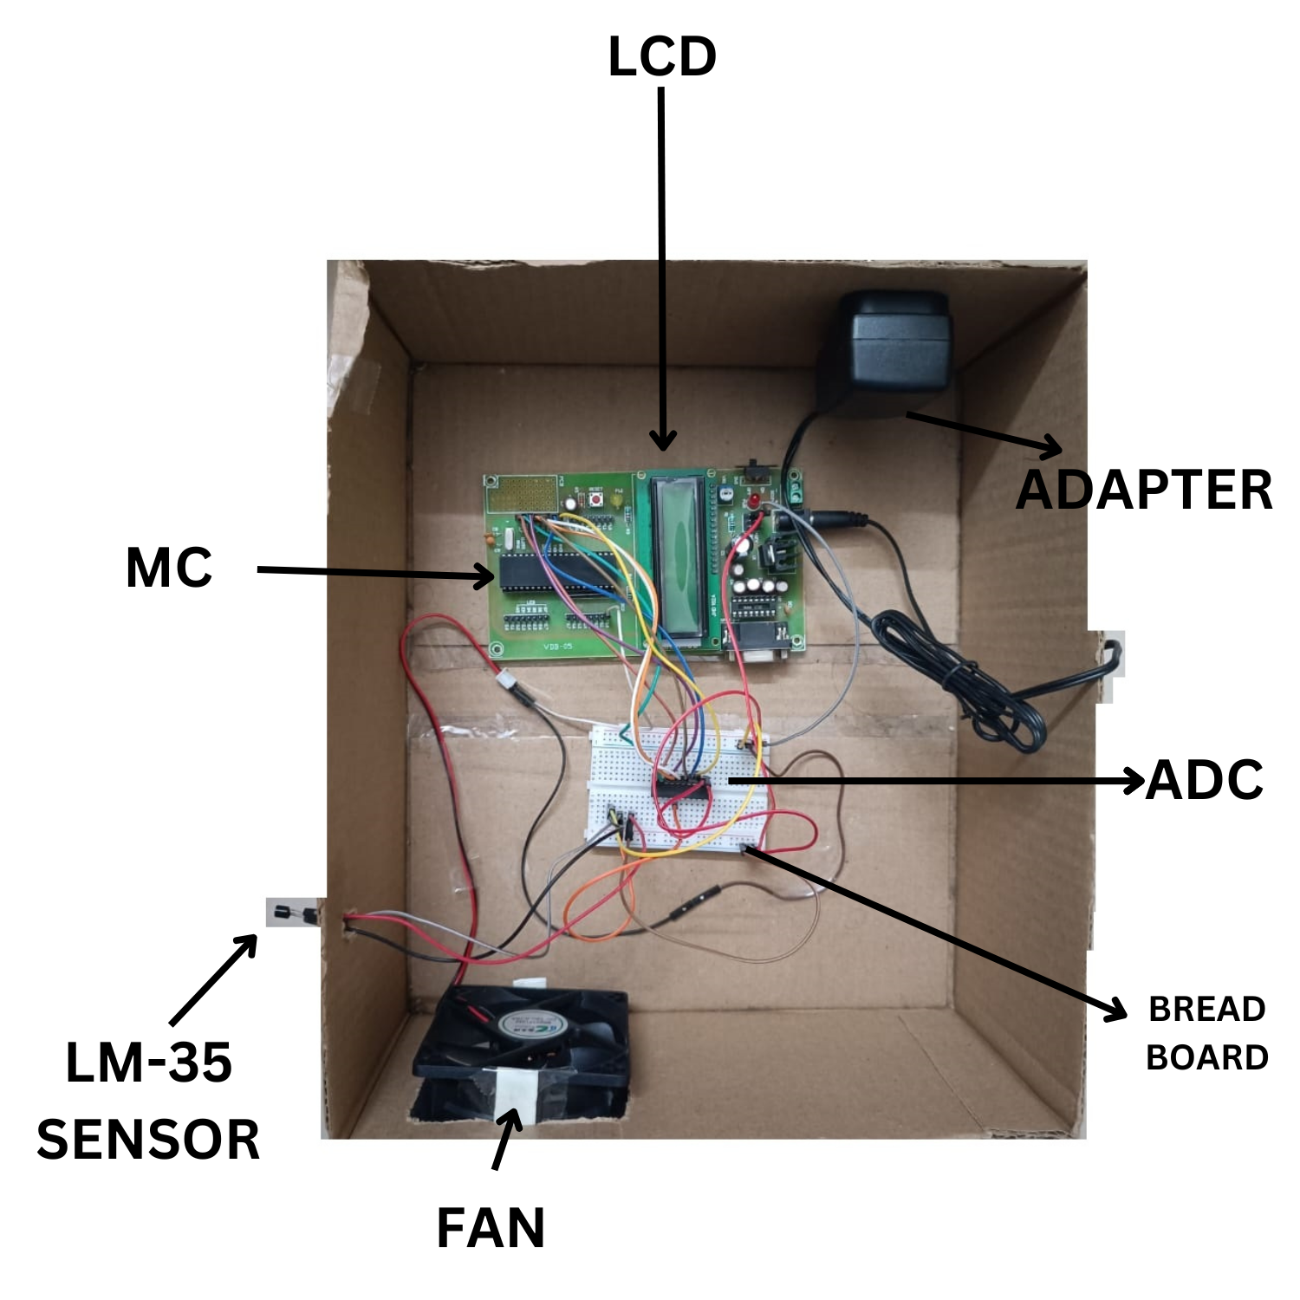

**Existing Processes/Solution**

Various existing processes/solution methods can be used to design a temperature controlled fan using 8051 microcontroller. These methods include PID control, fuzzy logic control, artificial neural network control, bang-bang control, and threshold control. PID control involves using feedback to maintain the desired temperature range, while fuzzy logic control uses rules. Artificial neural network control learns from past data, while bang-bang control turns the fan on and off based on the temperature measurements. Threshold control adjusts the fan speed based on a predetermined threshold value.

**Limitations**

1. Limited Temperature Range: The temperature control range of the system is limited by the accuracy and range of the temperature sensor used.
2. Limited Accuracy: The accuracy of the temperature sensor used can affect the accuracy of the temperature measurements and hence the control of the fan speed.
3. Limited Response Time: The response time of the temperature controlled fan may be slower than desired due to the delay in sensing temperature changes and adjusting the fan speed.
4. Cost: The cost of the components required to build a temperature controlled fan using 8051 microcontroller is a lot higher than that of traditional fixed-speed fans.Top of Form

**Modern Engineering Tools and Techniques**

Modern engineering tools and techniques that can improve the project include using advanced sensors such as thermocouples or infrared sensors for more accurate temperature measurements. The implementation of IoT and machine learning techniques can significantly improve the performance of a temperature-controlled fan made using 8051 microcontroller. By integrating IoT technology, the temperature-controlled fan can be remotely monitored and controlled using a smartphone or computer, providing greater convenience and flexibility. Machine learning algorithms can also be used to predict temperature changes and adjust the fan speed, accordingly, leading to faster response times and greater accuracy. Together, these modern engineering techniques can enhance the functionality and usability of the temperature-controlled fan, improving its overall performance and user experience.

**Alternative Design Solution**

An alternative design for a temperature controlled fan could involve using a Raspberry Pi microcontroller instead of the 8051 microcontroller. In this design, a temperature sensor would be connected to the Raspberry Pi, which would run a Python script to read the temperature and adjust the speed of the fan accordingly. The script could utilize machine learning algorithms to predict temperature changes and adjust the fan speed in real-time, providing faster and more accurate temperature control. The Raspberry Pi could also be connected to the internet, allowing for remote monitoring and control of the fan using a web interface or mobile app.

**Impact On Consideration For Environment**

A temperature controlled fan can be more energy-efficient than traditional fixed-speed fans, as it only operates at higher speeds when necessary. This can lead to energy savings and reduced greenhouse gas emissions, which can be beneficial for the environment. Additionally, by incorporating energy-efficient components and materials, the overall carbon footprint of the temperature controlled fan can be further reduced.

**Bill of Materials**

