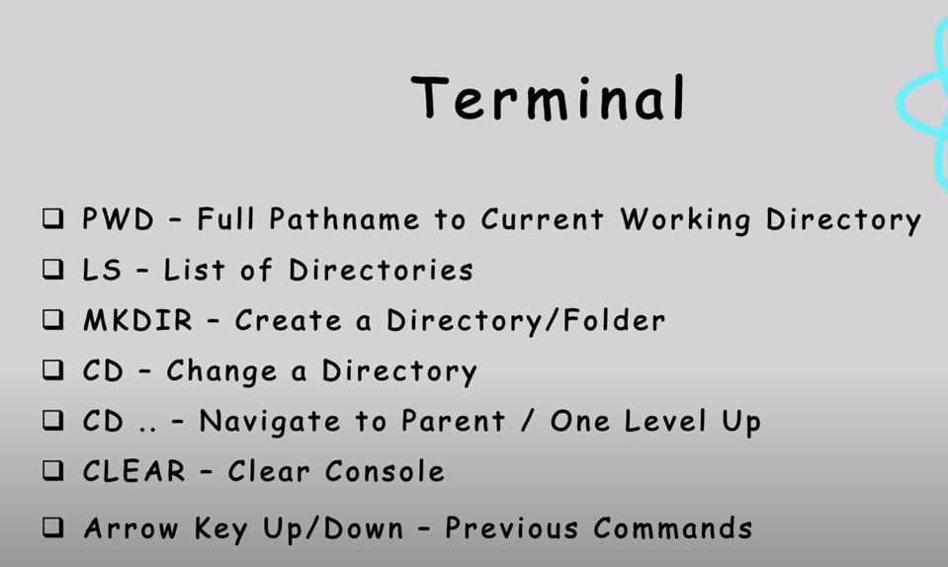

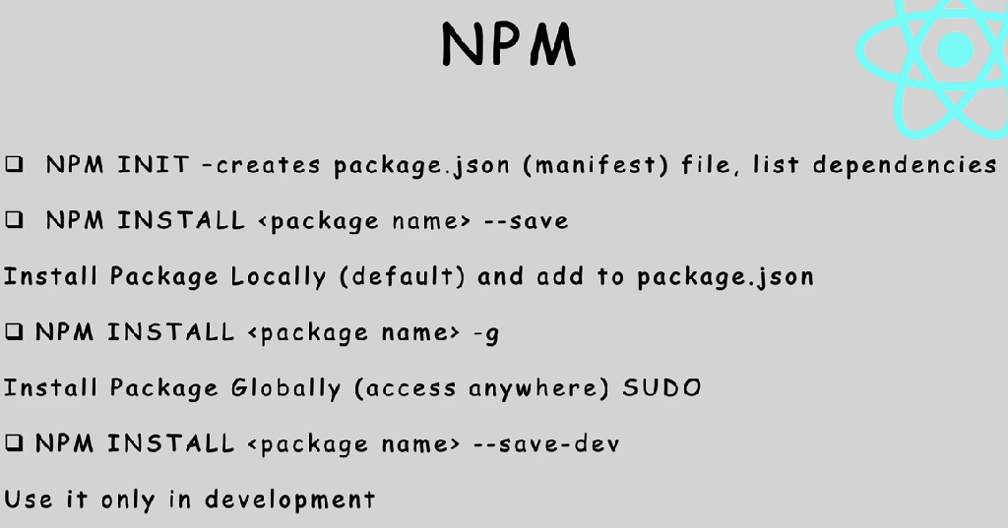

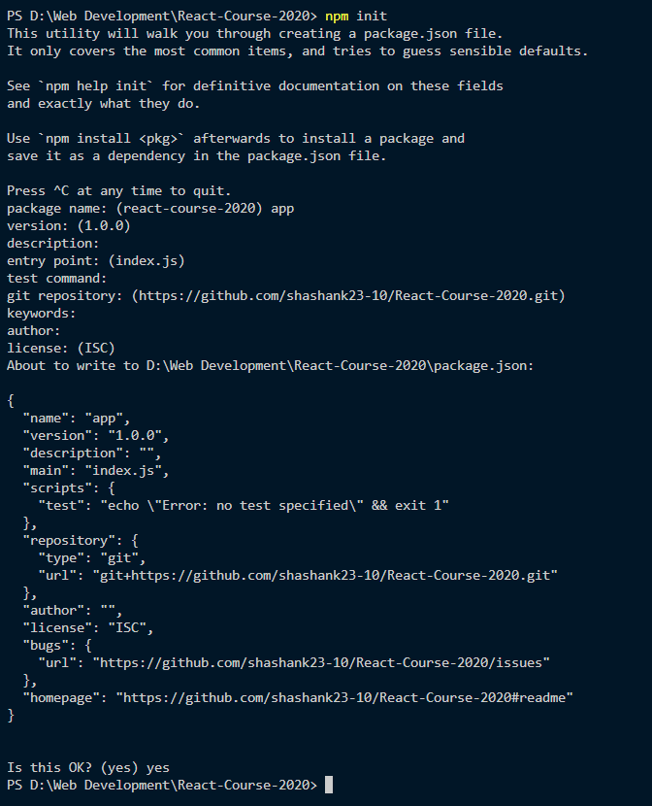

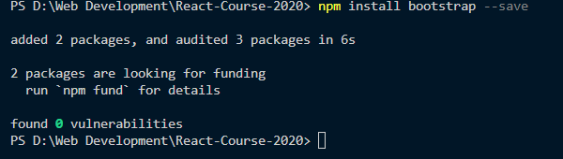

Its your choixe to do the setup entirely on your own/ use crete-react-app but the later is faster.

<https://github.com/facebook/create-react-app>

Repo for Create react app is given above.

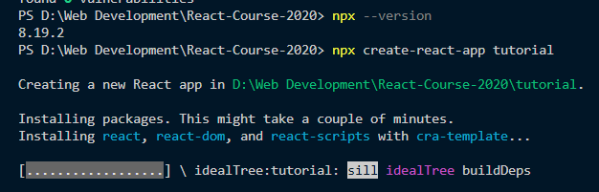

Straight way copy the first 3 lines from the readme of this repo to avoid any errors.

Also always make a new folder for react files outside of the main directory

FOLDER STRUCTURE

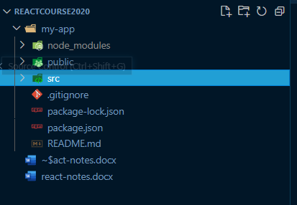

Node modules – consist of all dependencies

If that’s deleted, npm start would stop working

Public folder – has index.html file

Srx folder – we have css, app.js, etc

This html is call .jsx coz it doesn’t have only .html functions

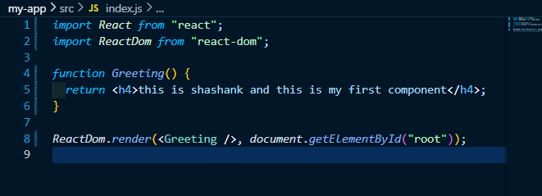

JSX RULES

* Can’t return more than single element, i.e. no 2 divs in the same function

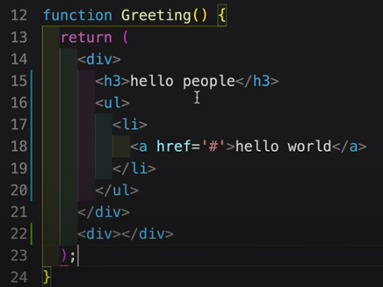

* We can also use React.Fragment or proper HTML sementics

To start from Props Destructing