Mongo DB Expts

Expt-1:

1. Create a collection called students

>db.createCollection(‘student’);



1. Insert an element into the collection which has name, grade, hobbies

>db.student.insertOne({

name: 'Sharan S Pai',

grade: 'S',

hobbies: ['Reading', 'Travelling', 'Coding']

});

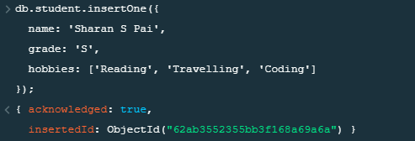

1. Insert the document for “AryanDavid” in to the Students collection only if it does not already exist in the collection. However, if it is already present in the collection, then update the document with new values. (Update his Hobbies from “Skating” to “Chess”.

>db.student.updateOne({name: 'AryanDavid',grade:'A',hobbies:['Reading','Skating']},{$set:{

'hobbies.1':'Playing Chess',

}},{upsert: true});

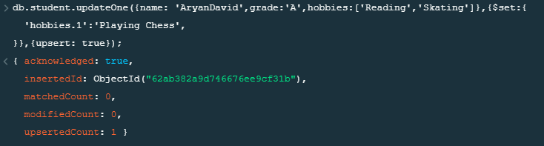

1. Find collection based on some search criteria

>db.student.find({grade: ‘S’},{name:1,hobbies:1,_id:0});

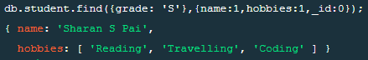

1. To find those documents from the Students collection where the Hobbies is set to either ‘Travelling’ or is set to ‘Skating’.

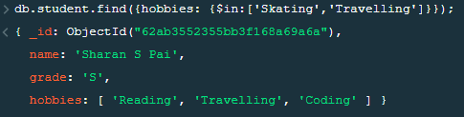

1. To find documents from the Students collection where the StudName begins with “A”.



1. To find the number of documents in the Students collection.



1. To sort the documents from the Students collection in the descending order of StudName

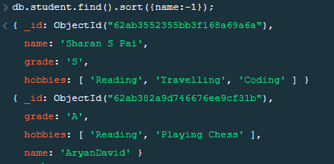

1. Add a new field to existing document

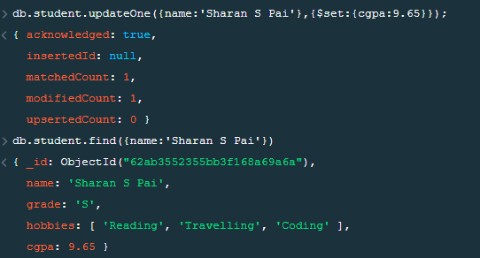

1. Remove a field from existing document

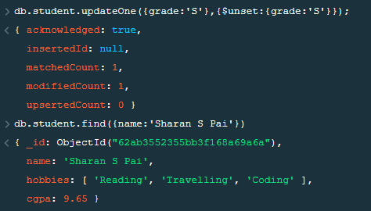

1. Count the document that have travelling as their hobby



1. Read only 1st document

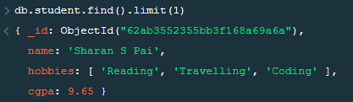

1. Read all documents by skipping over 1st document

