1)Consider the Insurance database given below. The primary keys are underlined and the data types are specified.

PERSON (driver-id #: String, name: String, address: String)

CAR (Regno: String, model: String, year: int)

ACCIDENT (report-number: int, date: date, location: String)

OWNS (driver-id #: String, Regno: String)

PARTICIPATED (driver-id: String, Regno: String, report-number: int, damage-amount: int)

DEPARTMENT OF CSE

1. Create the above tables by properly specifying the primary keys and the foreign keys.

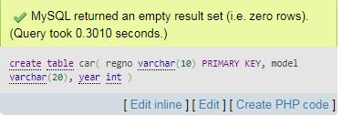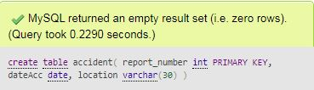

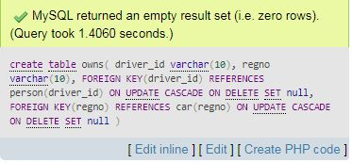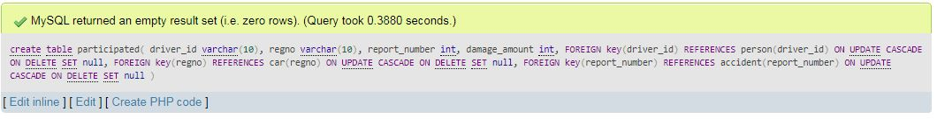

Output:

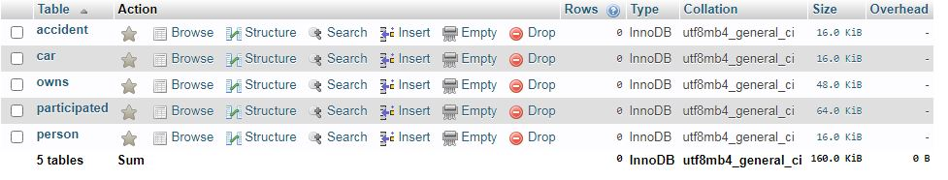

1. Enter at least five tuples for each relation.

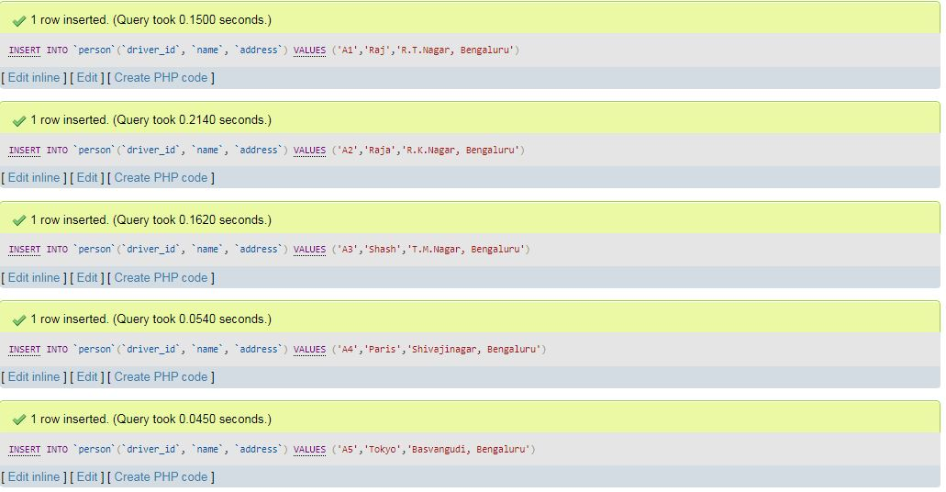

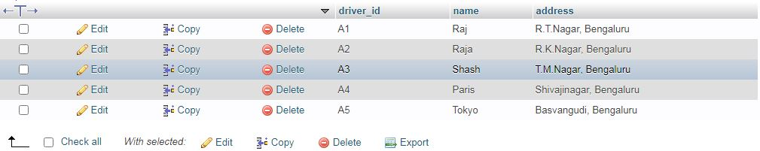

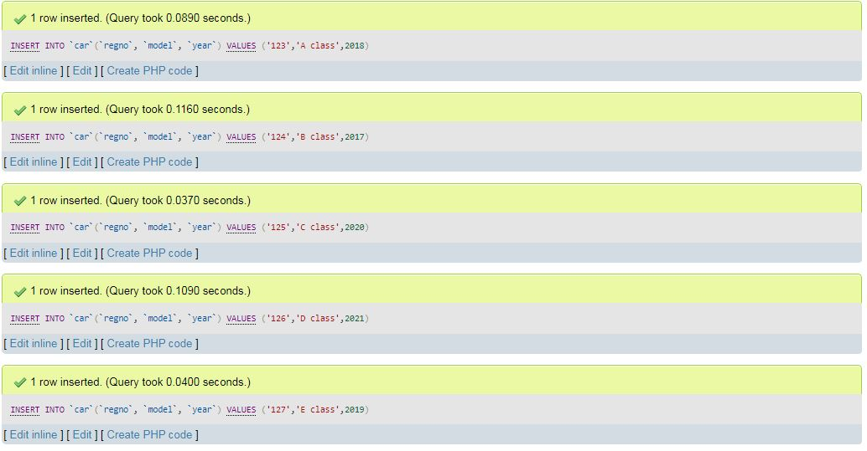

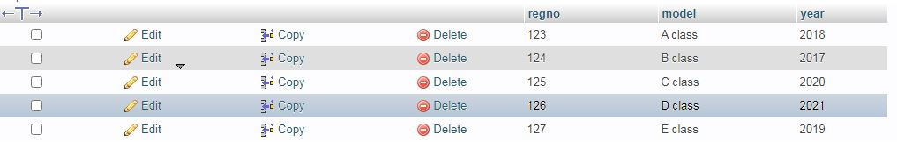

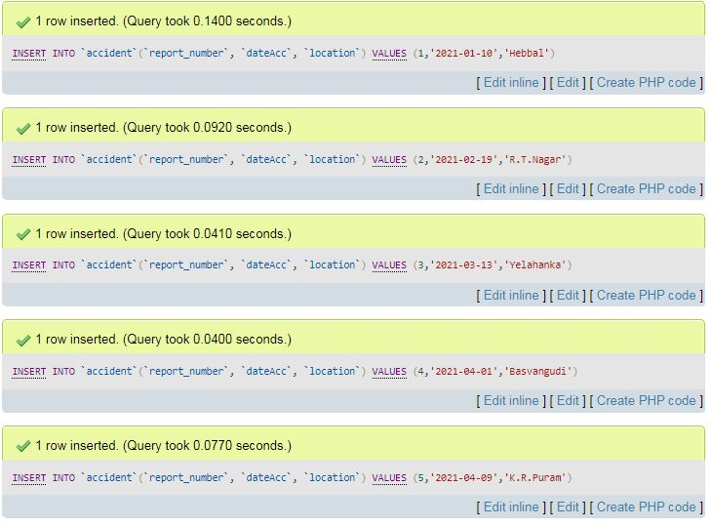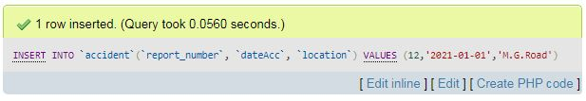

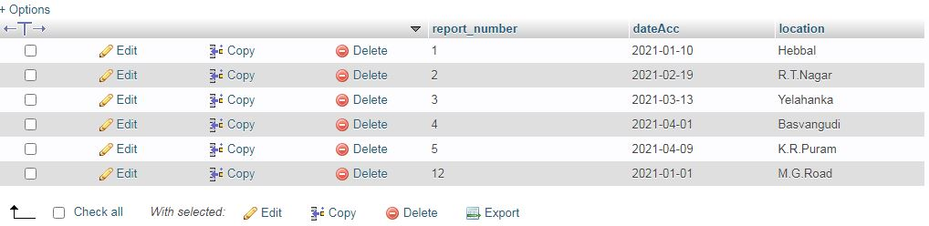

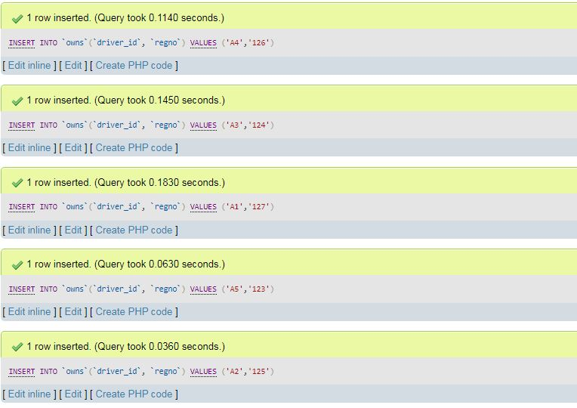

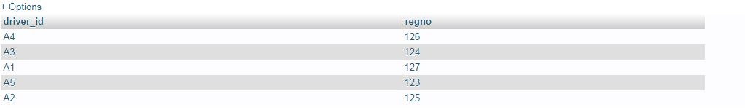

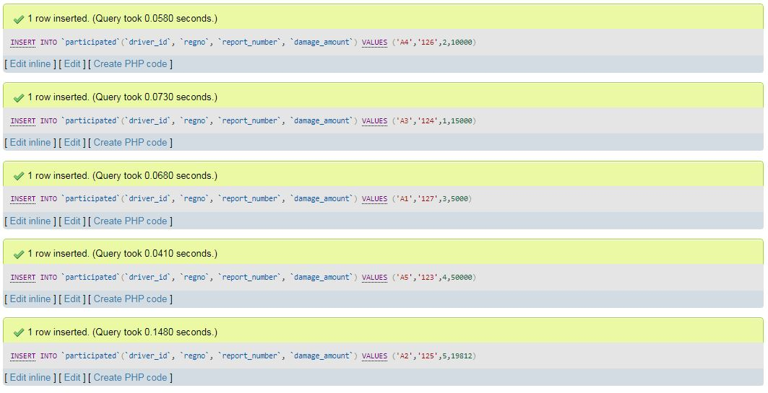

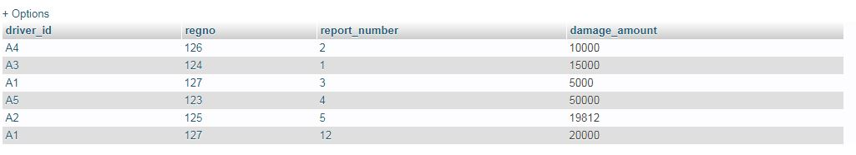

iii.Demonstrate how you

a.Update the damage amount for the car with a specific Regno in the accident with report number 12 to

25000.

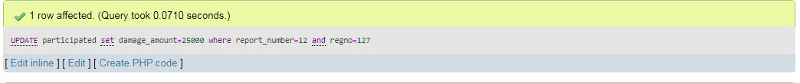

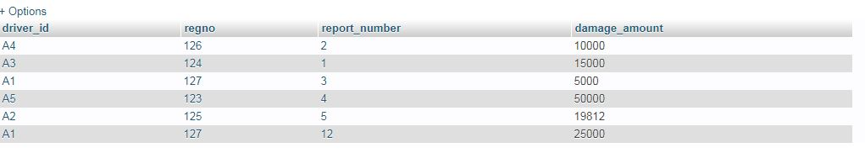

b) Add a new accident to the database.

