INTRODUCTION

Monetary Management System is a web application designed for financial enthusiasts to keep track of their Investments and Expenditures spread across various Banks, Stocks, Loans and various other Financial Institutions.

There are mainly 4 types of Investments and Expenditures:

* Stocks
* Loans
* Expenditures
* Savings Account

In this following web application, we can make entries into the Stocks, Loans, Expenditures, Savings Account and their associated details. We can also see the market rates which is plotted onto a graph and their behaviour over the entire financial year. The user is restricted to view only his data by accessing through his unique ID and password.

EXISTING SYSTEM

Systems analysis the process of observing systems for troubleshooting or development purposes. It is applied to information technology, where computer-based systems require defined analysis according to their makeup and design. Here, the main question is -does any problems exist in the current system? And also what is being done to solve the problem? Analysis begins when a user or manager begins to study the program using the existing system.

During analysis, data collected on the various investments, decision variables and transactions are handled by the present system. The commonly used tools in the system are Data Flow Diagram, Graphs, etc. Training and Experience are required for collection of relevant information needed to develop the system. A good analysis model should provide not only the mechanisms of problem understanding but also the framework of the solution. Thus, it should be studied by collecting data provided by the initial existing system. Then the proposed system will be analysed in accordance with the needs and the problems that had arose due to the existing system.

System analysis can be categorized into 4 parts:

* System planning and initial investigation
* Information Gathering
* Analysing the existing problems
* Creating a structural framework for the proposed solution
* Cost and Benefit Analysis

In the current system all the various investments are spread out through a number of different number of platforms and it is a tedious job to keep track of which transaction goes where. This is time consuming as you will have to switch between different platforms and keep in track of which transaction you are currently dealing with.

PROPOSED SYSTEM

In this proposed system we have brought together ideas of all the different platforms and merged into one. The user can create as many transactions as he wants and also choose what type of transaction it is before entering it into the server. Due to this collaboration of all the platforms into one, now the user can be sure of what type of transaction he is entering and also view all the transactions in one place. This reduces the overhead time of confusion between the type of platforms and also viewing of this data all in one place.

This proposed system has multiple advantages:

* Fast access to database
* User-friendly interface
* Quick and Unlimited Transactions
* Less space for error

All the problems posed by the existing system are solved in the proposed system by collaborating all the platforms into one by implementing computerization.

FEASIBILITY ANALYSIS

Whatever we think may not be feasible. It is wise to think of the feasibility of any problem we undertake. Feasibility id the study of impact, which happens in the organisation by the development of a program. The impact can be either positive or negative. When the positives overpower the negatives, then the system is considered feasible. We can study feasibility in two ways now:

1. Economic Feasibility
2. Technical Feasibility

ECONOMIC FEASIBILITY

Development of this Web Application is economically feasible. The user already has invested some of his finances on too many platforms just to keep track of this finances. This can be reduced by investing in only one platform now. So, the user can also attain maximum possible resources on this Web Application. So, it would be wise of him to reduces his financial investments on different platforms. We an conclude now that this Web Application is now economically feasible.

TECHNICAL FEASIBILITY

We can also say that this Web Application is technically feasible as we are just collaborating all the platforms already present. The User Interface is also very similar and the user can get used to it very easily. The maintenance cost is also very low when compared to all the existing platforms combined together.

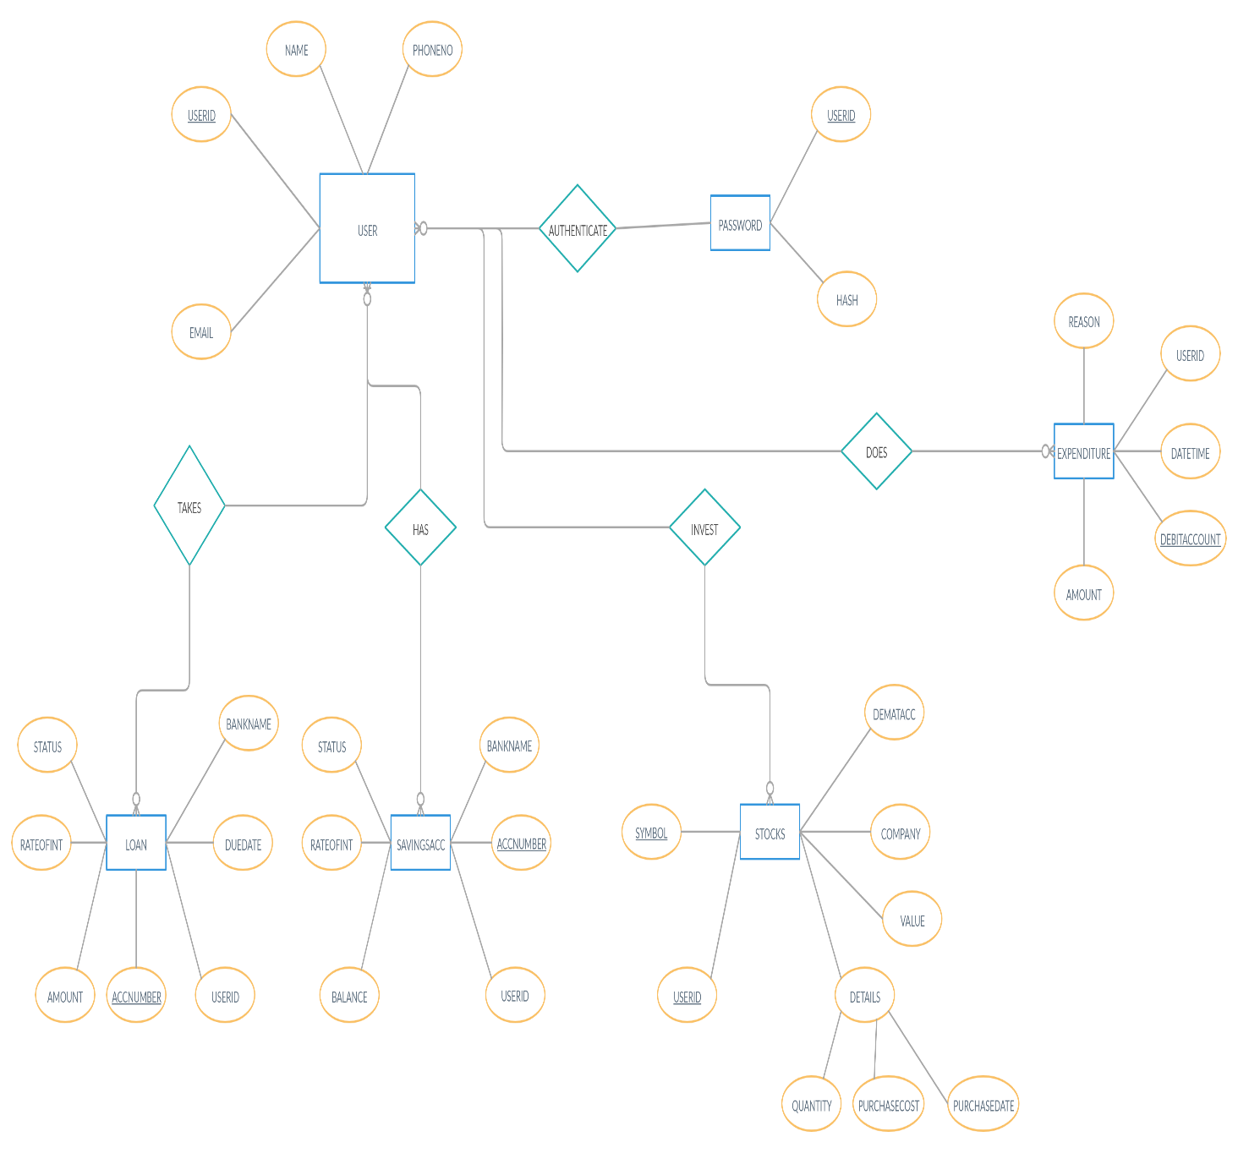ER DIAGRAM

NORMALISED DESIGN

DATABASE DESIGN

Database design is the organization of data according to a database model. The designer determines what data must be stored and how the data elements interrelate. A database is a collection of interrelated data stored with minimum redundancy to serve many end users quickly and effectively. The general theme behind a database is to handle information as an integrated whole.  Database management system manages the data accordingly. After designing input and output, the analyst must concentrate on database design or how data should be organized around user requirements. The general objective is to make information access, easy quick, inexpensive and flexible for the end users. During database design the following objectives are to be kept in mind:

* Controlled Redundancy
* Data independence
* More resources at low cost
* Recovery from failure
* Privacy and security
* Performance
* Effective user interface

SYSTEM IMPLEMENTATION

Implementation is the stage in the project where the theoretical design is turned into a working system. The implementation phase constructs, installs and operates the new system. The most crucial stage in achieving a new successful system is that it will work efficiently and effectively. System implementation is the process of:

1. defining how the information system should be built,
2. ensuring that the information system is operational and used,
3. ensuring that the information system meets required quality standard.

CONCLUSION

This project is a very good exposure to build on our knowledge of Database Systems and its Implementation. This Web Application has served its purpose of integrating all the different platforms into one and helping the end user to manage his financial investments in a better way. We believe this Web Application will be helpful and most of the present generation people will be benefited from this.

Lastly, We would like to thank all the people who made this project happen. Thanks to M.Venkatesan Sir ,C Aishwarya Ma’am for giving us this project. I would also like to thank The ALMIGHTY for his blessings in completing this project.

BIBLIOGRAPHY

* <https://www.w3schools.com/html>/
* <https://www.w3schools.com/sql>/
* <https://docs.djangoproject.com/en/3.0/>