- Frontend development includes designing the overall UI/UX part of a website, for example – Buttons, menu, options in Amazon’s website.
Backend development handles logic, database and servers, for example while placing an order backend handles the database.
Full-stack development works with both frontend and backend development, for example the whole Amazon’s website.

- [Client/Browser] ---> [Web Server] ---> [Database]
↑ ↓
<------- Response --------
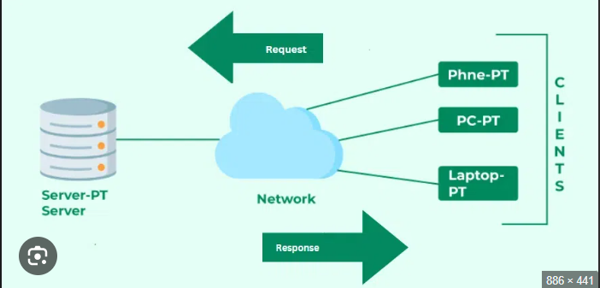
- When you type a URL, the browser sends a request to the web server. The server finds the page and sends it back. The browser reads the HTML, CSS, and JS, then shows it as a complete webpage.
- Tools for web development -
VS Code – Code Editor
Git & GitHub – Version Control
Browser Devtools – Debug and test web pages
Live Server - Instantly previews web pages
- A web server delivers web pages to browsers.
Examples: Apache, Nginx, Microsoft IIS, LiteSpeed
- Role of -
Frontend Developer – Designs UI using HTML, CSS, JSS
Backend Developer – Handles logic, data flow, servers & APIs
Database Administrator – Maintains and secures the database
- Install VS Code, add extensions such as Live Server, Prettier, and JavaScript snippets.
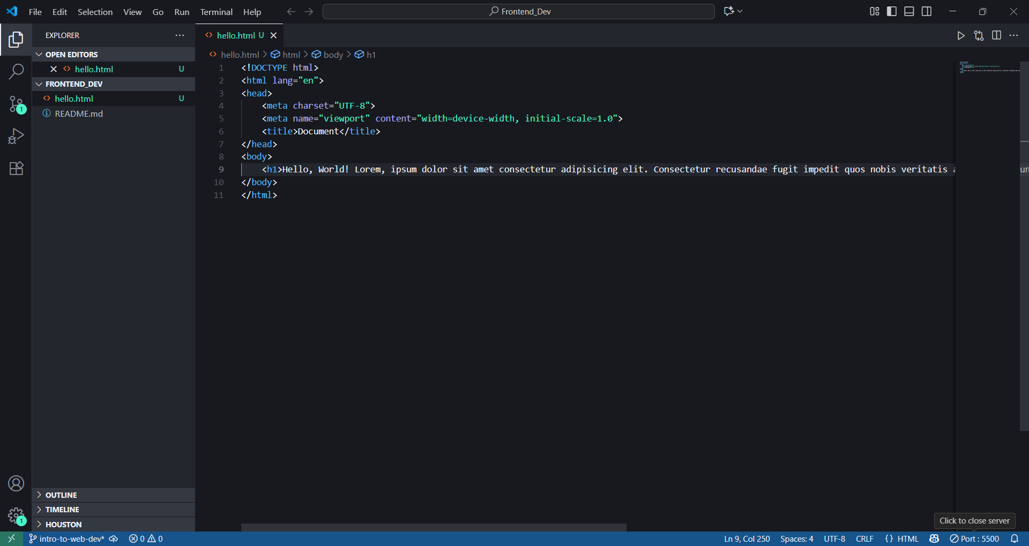
- Static - Same content for everyone such as a Portfolio website
Dynamic Changes content based on user or data such as Facebook, Intstagram
- Chrome, Brave, FireFox, Edge, Opera
Each engine interprets HTML/CSS differently, which is why websites may look slightly different across browsers.
- Client sends requests → Server processes → Fetches from Database → Sends results back to Client.
