ML & DL Project Documentation

Project Tittle :- MRI Based Early Diagnosis of Alzheimer's Disease

About Dataset
Dataset Used: OASIS MRI dataset (https://www.kaggle.com/datasets/uraninjo/augmented-alzheimer-mri-dataset)
Total Images: Around 80,000 brain MRI images
Purpose: Supports research on early detection and progression of Alzheimer’s disease
File Conversion: Original .img and .hdr files converted to Nifti (.nii) format using FSL (FMRIB Software Library)
Data Availability:MRI scans of 461 patients uploaded to GitHub, divided into multiple parts
Data Preparation for Training:
1 )Used 2D slices from 3D MRI scans
2 )Sliced along the z-axis into 256 sections
3 )Slices 100–160 selected per patient for training
For training the model, each 3D MRI brain scan was divided into many flat 2D images, similar to taking slices of a loaf of bread. The scans were cut along the z-axis into 256 thin sections.
Out of these, only the slices between numbers 100 and 160 were chosen because they show the most important parts of the brain where Alzheimer’s-related changes are usually visible. This helped reduce unnecessary data while keeping the most useful information for the model to learn from.

Classification Labels:
1 )Clinical Dementia Rating (CDR):- The Clinical Dementia Rating (CDR) measures the severity of memory and thinking problems to classify patients into stages of Alzheimer’s disease — from non-demented to severely demented.
2 )Four classes: Non-demented, Very mild demented, Mild demented, Demented
Image Format for Model: .nii files converted to .jpg images for easier model processing
Dataset Size: 1.3 GB
Project Goal: Train and evaluate neural network models for Alzheimer’s disease detection and progression analysis
Distribution of MRI images
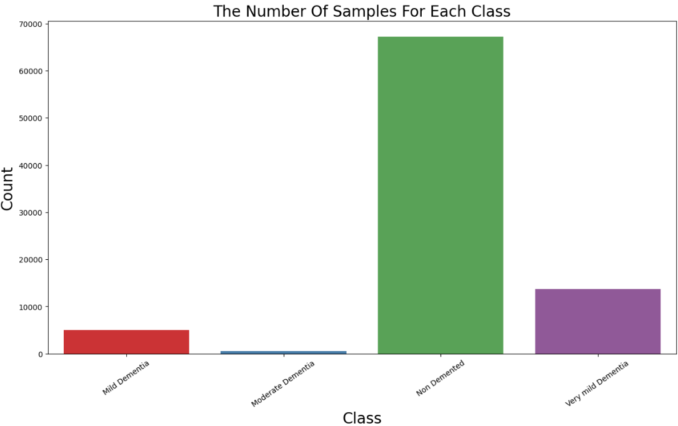

Data Augmentation
mage Augmentation (OpenCV-Based)
Applies several augmentation techniques such as:
- Rotation
- Flipping
- Brightness adjustment
- Noise addition
- Zoom and shift operations
Each augmented image is saved into a corresponding class folder.
Purpose:
- Increase dataset size(where the data was Low)
- Improve generalization
- Balance class distribution

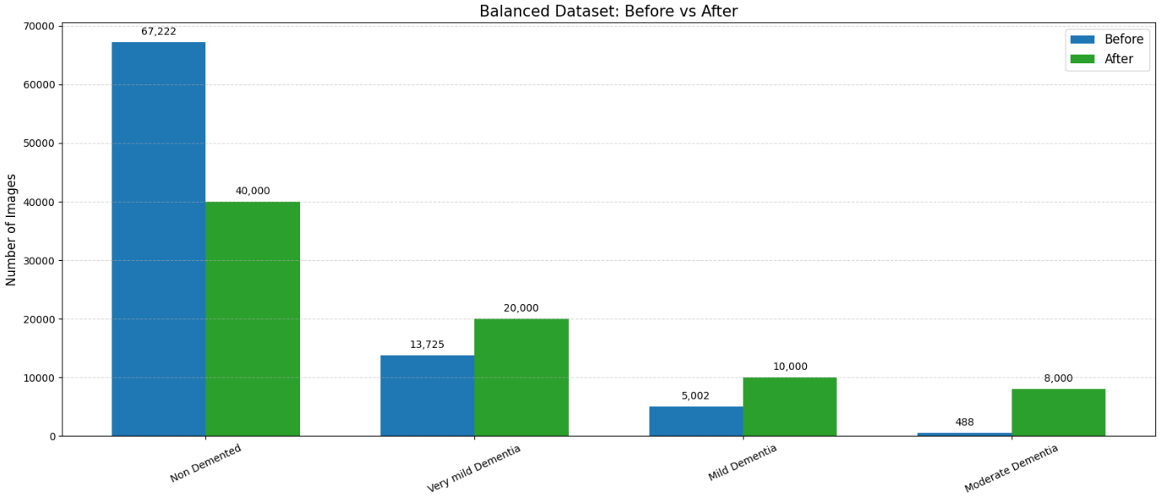

One-Hot Encoding
Purpose: To convert categorical class labels (0, 1, 2, 3) into a machine-readable format.
What is One-Hot Encoding?
- It transforms numerical class labels into binary vectors.
- Example:
  - 0 → [1, 0, 0, 0]
  - 1 → [0, 1, 0, 0]
  - 2 → [0, 0, 1, 0]
  - 3 → [0, 0, 0, 1]

CNN Model

MRI CNN Notebook: Cell-by-Cell Explanation (Simple Words, Bullet Points)
Cell 0 — Importing Libraries
- Loads Python libraries needed for image loading, data processing, and deep learning.
- Includes: NumPy, Pandas, PIL, tqdm, PyTorch, TorchVision, and scikit-learn.
- Purpose: prepares all tools required for dataset handling, model building, training, and evaluation.
Cell 1 — Creating the AlzheimerDataset Class
- Defines a custom PyTorch Dataset class.
- Responsibilities:
  - Reads image paths and their labels.
  - Opens each image using PIL.
  - Applies image transformations.
  - Returns a single image and its label when requested by DataLoader.
- This makes data loading efficient and GPU-friendly.
Cell 2 — Loading Image Paths and Labels
- Sets the root folder of the dataset.
- Scans through folders containing images.
- Extracts class names from folder names.
- Stores image file paths.
- Creates a numerical label for each image.
- Converts label list into a NumPy array.
Cell 3 — Train–Test Split
- Splits dataset into training and testing sets.
- Uses train_test_split with:
  - 80% for training
  - 20% for testing
  - Stratified sampling (keeps class balance)
- Stores training and testing image paths separately.
Cell 4 — Defining Transformations
- Creates two transform pipelines:
  - Training Transform: resize, normalize, horizontal flip, rotation, augmentations.
  - Testing Transform: resize + normalize (no augmentation).
- Purpose: improve generalization and reduce overfitting.
Cell 5 — Creating Dataset Objects
- Creates train_dataset with augmentation.
- Creates test_dataset with only normalization.
- Wraps them using the custom Dataset class from Cell 1.
Cell 6 — Handling Class Imbalance
- Counts how many images exist per class.
- Calculates weights for each class.
- Creates a WeightedRandomSampler so rare classes are sampled more often.
- Prevents overfitting on majority classes.
Cell 7 — Creating DataLoaders
- Wraps datasets into DataLoaders.
- Parameters:
  - Batch size.
  - Shuffle or weighted sampling for training.
- DataLoader output:
  - Mini-batches sent to GPU.
  - Parallel loading using workers.
Cell 8 — Defining the CNN Model
- Builds a custom convolutional neural network.
- Typical CNN blocks include:
  - Conv2D → ReLU → MaxPool.
  - Flatten layer.
  - Fully connected layers.
  - Dropout layers (reduces overfitting).
- Output layer matches number of classes.
Cell 9 — Moving Model to GPU
- Checks if CUDA GPU is available.
- Transfers model to GPU for faster training.
Cell 10 — Loss Function and Optimizer
- Defines:
  - Loss: Cross-Entropy Loss
  - Optimizer: Adam or SGD
  - Learning rate
- These control how the model learns.
Cell 11 — Training Loop
- Iterates through multiple epochs.
- For each batch:
  - Loads data.
  - Moves it to GPU.
  - Performs forward pass.
  - Computes loss.
  - Backpropagation.
  - Optimizer updates model weights.
- Stores training loss.
- Prints progress.
Cell 12 — Testing Loop
- Sets model in evaluation mode.
- No gradient calculation.
- Predicts labels for test images.
- Stores:
  - Predictions.
  - True labels.
- Calculates accuracy.
Cell 13 — Classification Report
- Uses scikit-learn to print:
  - Precision
  - Recall
  - F1 Score
  - Per-class performance
- Helps understand model behaviour.
Cell 14 — Confusion Matrix Plot
- Builds confusion matrix from predictions.
- Visualizes it using matplotlib.
- Shows where model makes mistakes.
Cell 15 — ROC Curve
- Binarizes labels.
- Computes ROC curve for each class.
- Calculates AUC score.
- Plots ROC for multi-class classification.

CNN Architecture

1. Input
- Input image size: 128 × 128 × 3
- Images are normalized and augmented before entering the network.

2. Convolutional Blocks
Block 1
- Conv2D: 32 filters, kernel size 3×3
- Activation: ReLU
- MaxPooling: 2×2
- Purpose: capture low-level features (edges, textures)

Block 2
- Conv2D: 64 filters, kernel size 3×3
- Activation: ReLU
- MaxPooling: 2×2
- Purpose: detect stronger features such as shapes

Block 3
- Conv2D: 128 filters, kernel size 3×3
- Activation: ReLU
- MaxPooling: 2×2
- Purpose: learn higher-level brain structure patterns

Block 4
- Conv2D: 256 filters, kernel size 3×3
- Activation: ReLU
- MaxPooling: 2×2
- Purpose: learn detailed MRI differences between classes

3. Flatten Layer
- Converts the multi-channel feature map into a 1D vector.
- Prepares output for fully connected layers.

4. Fully Connected Layers (Classifier)
FC Layer 1
- Units: 512
- Activation: ReLU
- Dropout: 0.30
- Purpose: reduce overfitting + learn class separation
FC Layer 2
- Units: 128
- Activation: ReLU
- Dropout: 0.20
Output Layer
- Units = number of classes (4)
Example: AD, MCI, Mild Dementia, Healthy
- Activation: Softmax
Converts outputs into class probabilities.

5. Summary Table
Stage | Description
Input | 128×128×3
Conv Block 1 | Conv(32) → ReLU → MaxPool
Conv Block 2 | Conv(64) → ReLU → MaxPool
Conv Block 3 | Conv(128) → ReLU → MaxPool
Conv Block 4 | Conv(256) → ReLU → MaxPool
Flatten | Converts to 1D
FC 1 | 512 → ReLU → Dropout
FC 2 | 128 → ReLU → Dropout
Output | Softmax (4 classes)

6. Total Learnable Layers
- 4 Convolution layers
- 2 Fully connected layers
- 1 Output layer
Total trainable: 7 layers

VGG Model
Visual Geometry Group(VGG)
16 → Number of trainable layers (13 Conv + 3 Fully Connected)

MRI VGG16 Notebook: Cell-by-Cell Explanation (Simple Words, Bullet Points)
Cell 0 — Checking GPU Availability
- Imports PyTorch.
- Prints whether CUDA GPU is available.
- Sets the device:
  - If GPU available → use GPU.
  - Else → use CPU.
- Purpose: ensures training uses hardware acceleration.
Cell 1 — Importing All Required Libraries
- Loads libraries for:
  - File handling (os)
  - Arrays (NumPy)
  - Image loading (PIL)
  - Progress bar (tqdm)
  - PyTorch & DataLoaders
  - Pre-trained models (VGG16)
  - Transformations (TorchVision)
  - Evaluation (scikit-learn)
  - Plotting (Matplotlib / Seaborn)
- Prepares the notebook to process data, build model, train, and evaluate.
Cell 2 — Creating the MRIDataset Class
- Defines a custom dataset to load MRI images.
- Responsibilities:
  - Stores image paths and labels.
  - Opens each image using PIL.
  - Converts to RGB (some images may be grayscale).
  - Applies transformations (resize, normalize, etc.).
  - Returns processed image + label.
- Used by DataLoader to efficiently send data to GPU.
Cell 3 — Loading Dataset Paths and Labels
- Sets the root folder containing MRI image folders.
- Iterates through each class folder.
- Reads all image file paths.
- Assigns numerical labels (0, 1, 2, 3...).
- Converts labels into NumPy array.
- Purpose: prepares full dataset list for splitting.
Cell 4 — Train/Test Split
- Splits data into:
  - 80% training
  - 20% testing
- Uses stratify so class distribution remains balanced.
- Ensures the model is trained and tested fairly.
Cell 5 — Transformations
- Defines training transforms:
  - Resize to 224×224 (VGG16 required size)
  - Random horizontal flip
  - Random rotation
  - Convert to Tensor
  - Normalize using ImageNet mean/std
- Defines testing transforms:
  - Resize
  - Convert to Tensor
  - Normalize
- Purpose: augment training data & prepare images for VGG16.
Cell 6 — Creating Dataset Objects
- Creates train_dataset with augmentations.
- Creates test_dataset with only normalization.
- Wraps both using MRIDataset class.
Cell 7 — Handling Class Imbalance
- Counts frequency of each class.
- Creates weights: rare classes get higher weight.
- Creates WeightedRandomSampler to avoid bias.
- Ensures each class appears equally during training.
Cell 8 — Creating DataLoaders
- Wraps datasets into DataLoader with:
  - Batch size
  - Sampler for training
  - Shuffle disabled (sampler handles sampling)
  - Multiple workers for speed
- Test DataLoader shuffles automatically.
Cell 9 — Loading Pretrained VGG16
- Loads VGG16 model from TorchVision.
- Sets pretrained=True.
- Freezes feature extractor (optional).
- Modifies classifier layer to match number of output classes.
- Moves model to GPU.
Cell 10 — Loss Function and Optimizer
- Defines:
  - Loss → CrossEntropyLoss
  - Optimizer → Adam
  - Optional: Learning rate
- Controls how the model learns.
Cell 11 — Training Loop
- Runs for several epochs.
- For each batch:
  - Loads image + label.
  - Moves data to GPU.
  - Forward pass.
  - Calculates loss.
  - Backpropagation.
  - Updates model weights.
- Prints loss for monitoring.
Cell 12 — Evaluation on Test Data
- Switches model to evaluation mode.
- Disables gradient calculation.
- For every image in test set:
  - Predicts probabilities.
  - Gets predicted class.
  - Stores predictions and true labels.
- Used to measure accuracy.
Cell 13 — Classification Report
- Prints:
  - Precision
  - Recall
  - F1-score
  - Support per class
- Helps understand performance class-wise.
Cell 14 — Confusion Matrix
- Computes confusion matrix.
- Plots it using Matplotlib + Seaborn.
- Shows which classes are confused with others.
Cell 15 — ROC Curve
- Binarizes labels.
- Computes ROC and AUC for each class.
- Plots curves.
- Helps evaluate how well model separates classes.

VGG Architecture

1. Input
- Input image size: 224 × 224 × 3

2. Convolutional Blocks
Block 1
- Conv (3×3, 64 filters)
- Conv (3×3, 64 filters)
- MaxPooling (2×2)
Block 2
- Conv (3×3, 128 filters)
- Conv (3×3, 128 filters)
- MaxPooling (2×2)
Block 3
- Conv (3×3, 256 filters)
- Conv (3×3, 256 filters)
- Conv (3×3, 256 filters)
- MaxPooling (2×2)
Block 4
- Conv (3×3, 512 filters)
- Conv (3×3, 512 filters)
- Conv (3×3, 512 filters)
- MaxPooling (2×2)
Block 5
- Conv (3×3, 512 filters)
- Conv (3×3, 512 filters)
- Conv (3×3, 512 filters)
- MaxPooling (2×2)

3. Flatten Layer
- Converts the output into a 1D vector.

4. Fully Connected Layers (Classifier)
- FC 1: 4096 neurons, ReLU
- FC 2: 4096 neurons, ReLU
- FC 3 (Output): 1000 neurons (ImageNet classes), Softmax

5. Total Learnable Layers
- 13 Convolution layers
- 3 Fully connected layers
Total: 16 layers → VGG16

Summary (Very Simple View)
Stage | Layers
Input | 224×224×3
Block 1 | 2 × Conv(64) + MaxPool
Block 2 | 2 × Conv(128) + MaxPool
Block 3 | 3 × Conv(256) + MaxPool
Block 4 | 3 × Conv(512) + MaxPool
Block 5 | 3 × Conv(512) + MaxPool
Classifier | FC 4096 → FC 4096 → FC 1000

Term | Meaning (Simple)
Cross Entropy | Measures how wrong the model’s prediction is
Adam | Optimizer that updates weights smartly and fast
Learning Rate | Controls how fast the model learns
Pretrained Weights | Already-learned knowledge loaded into the model

Formulas from the Paper
Concept | Formula | Explanation (Simple Words)
ReLU Activation | ReLU(x) = max(0, x) | Turns negative values into 0 and keeps positive values. Adds non-linearity so the model can learn complex patterns. Used in VGG, ResNet, EfficientNet, CNNs.
Average Pooling | ( O(i,j) = \frac{1}{k_h k_w} \sum I(i+m, j+n) ) | Takes the average of all pixel values inside a pooling window. Reduces image size while keeping overall information. (k_h) = kernel height, (k_w) = kernel width.
Max Pooling | ( O(i,j) = \max_\text{window} ; I(i+m, j+n) ) | Takes the largest value from each pooling window. Keeps the strongest features and reduces spatial size.
Flatten Layer | Flatten(H × W × C) = HWC vector | Converts a 3D feature map (Height, Width, Channels) into a 1D vector for input to fully connected layers.
Fully Connected Layer | ( y = Wx + b ) | Performs a linear transformation. W = weights the model learns, x = input vector, b = bias. Used in final classification.
Batch Normalization | Normalize: ( \hat{x} = \frac{x - \mu}{\sqrt{\sigma^2 + \epsilon}} ) Scale + Shift: ( y = \gamma \hat{x} + \beta ) | First normalizes values using mean (µ) and variance (σ). Then applies learned scale (γ) and shift (β). Helps stable and faster training.

Softmax turns the model’s raw numbers into probabilities, so the model can choose the most likely class.

