Comparative Deep Neural Study For Stage-Wise Alzheimer’s Disease Detection Using Brain MRI

Figures :

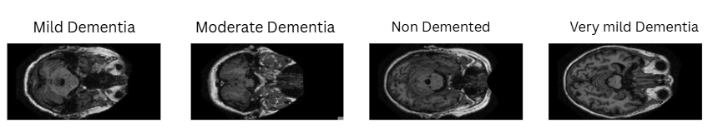
Fig 1.(a)Mild-Demented;(b)Moderate-Demented;(c)Non-Demented;(d)Very Mild Demented.

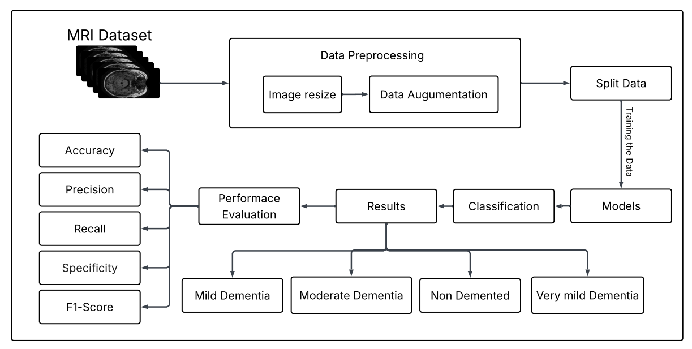
Fig 2.MRI-based demented classification workflow.

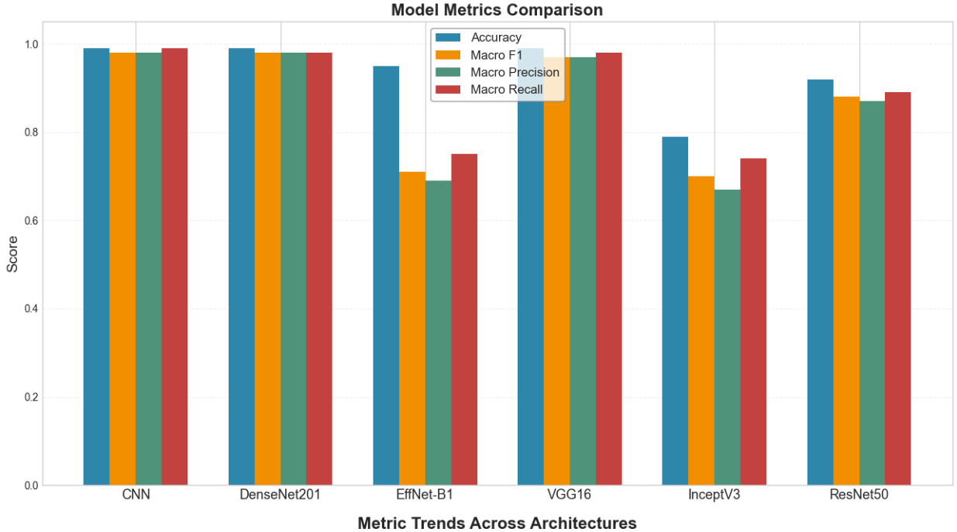

Fig 3.Model Metrics Comparision

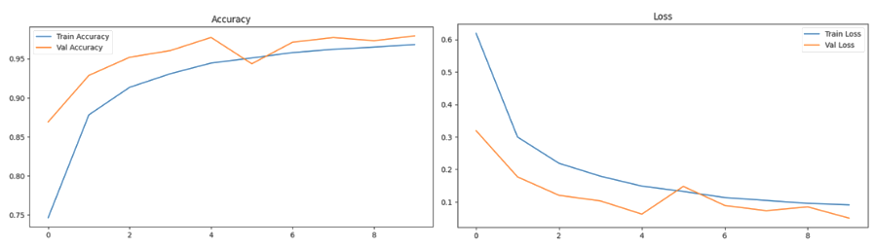
Fig 4.Performance of CNN model (a)Accuracy Curve; (b)Loss Curve.

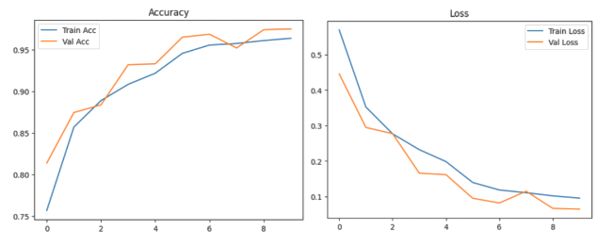
Fig 5. Performance of VGG16 Model (a)Accuracy Curve; (b)Loss Curve.

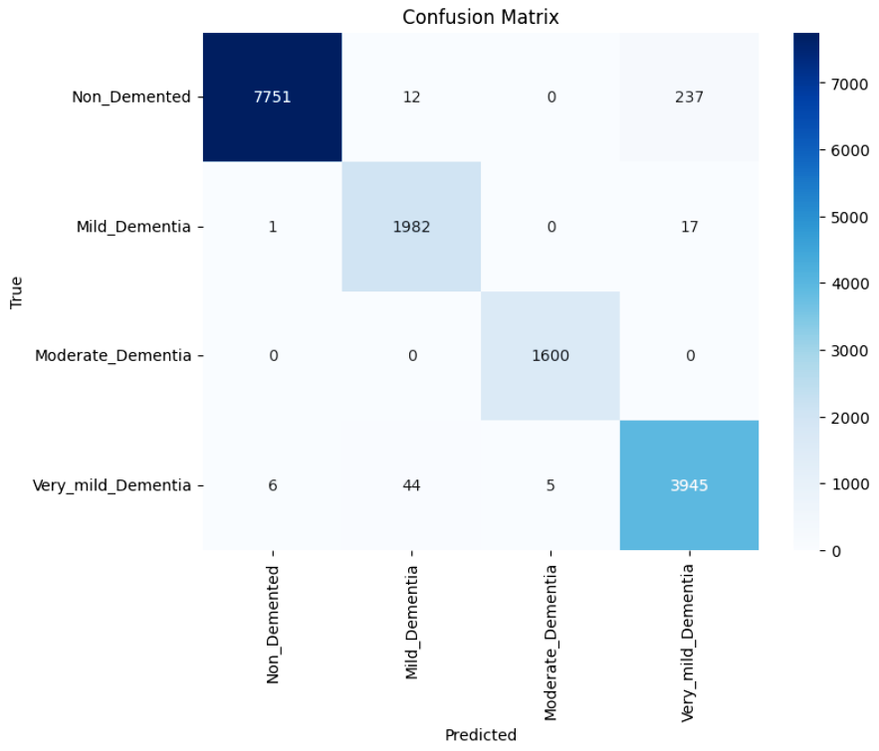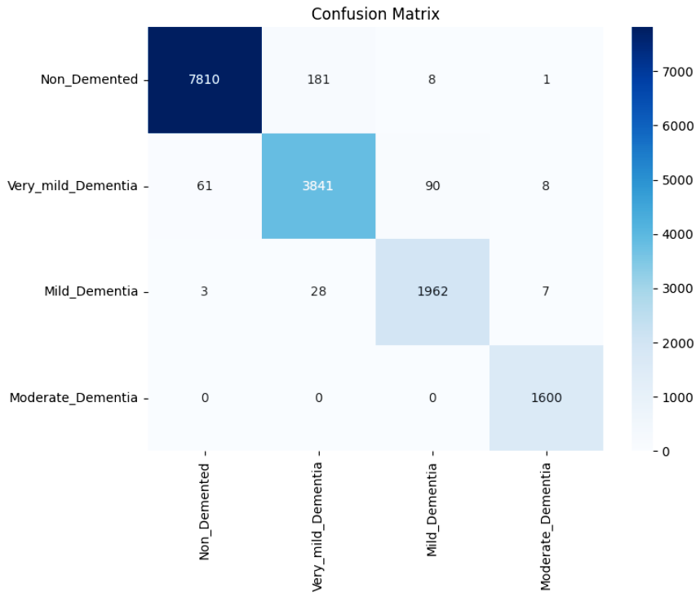
Fig 6.(a)Heatmap of Custom CNN;(b)Heatmap of VGG16.

Tables :
Table 1. Dataset Description
Class | Number of Images (Original) | Number of Images (After Balancing)
Non-Dementia | 67,222 | 40,000
Mild-Dementia | 5,002 | 10,000
Moderate-Dementia | 488 | 8000
Very Mild-Dementia | 13,725 | 20,000

Table 2.Model Description.
Model Name | Model Type | Description | Key Strengths/Focus
CNN (Custom) | Custom CNN | A straightforward neural network built from scratch for image classification, using stacked layers. | Fast to train, simple, good as baseline.
ResNet50 | Deep CNN | Uses skip (residual) connections, allowing very deep networks without losing important signals. | Handles deeper layers; less overfitting.
VGG16 | Deep CNN | Stacks many convolutional layers in a simple pattern for strong feature extraction. | Easy to use, proven for image tasks.
DenseNet201 | Deep CNN | Connects each layer to every other, so features are reused and learning is more efficient. | Very efficient learning, robust results.
InceptionV3 | Deep CNN | Combines different filter sizes at every level for multi-scale feature extraction. | Captures diverse image patterns well.
EfficientNet-B1 | Deep CNN | Scales width, depth, and resolution together so the network is both accurate and efficient. | Cutting-edge accuracy, lightweight.

Table 3. Model-Specific Image Resizing Parameters.
Models | Resizing Details
EfficientNet-B1 | Images resized to either 240 ×240 pixels, matching EfficientNet’s native input resolution for optimal performance.
ResNet50,VGG16,  DenseNet201 | Images resized to 224 ×224 pixels according to pretrained model requirements
InceptionV3 | Images resized to 240 ×240pixels as required for InceptionV3’s architecture.
Custom CNN | Images resized to either 128 ×128 as per the custom implementation to improve speed and suit model design.

Table 4.Training Configuration and Hyperparameters for Each Model.
Model | Optimizer | Learning  Rate | Loss Function | Early  Stopping | Check  point | Batch Size | Epochs
Custom  CNN | Adam | 0.001 | SparseCategorical  Crossentropy | Yes | Yes | 32 | 10
Efficient  Net-B1 | AdamW | 0.0001 | CrossEntropyLoss | Yes | Yes | 32 | 20
ResNet50 | Adam | 0.0001 | Categorical  Crossentropy | Yes | Yes | 32 | 50
VGG16 | Adam | 0.0001 | Categorical  Crossentropy | Yes | Yes | 32 | 10
DenseNet201 | Adam | 0.0001 | CategoricalCross  entropy or similar | Yes | Yes | 32 | 10–15
InceptionV3 | Adam | 0.0001 | CrossEntropyLoss | Yes | Yes | 32 | 30

Table 5 . Summary of Test Metrics for All Deep Learning Models.
Model | Acc | Pre (M) | Reca (M) | F1(M) | Pre(W) | Reca(W) | F1(W) | Number
CNN | 0.98 | 0.98 | 0.98 | 0.98 | 0.98 | 0.98 | 0.98 | 15600
DenseNet201 | 0.98 | 0.98 | 0.98 | 0.98 | 0.98 | 0.98 | 0.98 | 160
EffNet-B1 | 0.75 | 0.69 | 0.75 | 0.71 | 0.76 | 0.75 | 0.75 | 15600
VGG16 | 0.98 | 0.97 | 0.98 | 0.97 | 0.98 | 0.98 | 0.98 | 15600
InceptV3 | 0.75 | 0.43 | 0.29 | 0.29 | 0.72 | 0.79 | 0.72 | 15600
ResNet50 | 0.95 | 0.87 | 0.89 | 0.88 | 0.92 | 0.91 | 0.91 | 15600

