Comparative Deep Neural Study For Stage-Wise Alzheimer’s Disease Detection Using Brain MRI
Shashank Shetgeri^{1*} , Srushti Honnangi¹ , Anushri Kajagar¹ , Tanvi Korgaonkar¹ , Salma Shahapur² , Rajashri Khanai² , Niranjan Muchandi²
Corresponding Author(s) E-mail(s) : 02fe24bcs413@kletech.ac.in
Contributing Author(s) E-mail(s):02fe23bcs062@kletech.ac.in 02fe23bcs084@kletech.ac.in,02fe23bcs013@kletech.ac.in, salmashahapur.mss@kletech.ac.in , rajashrikhanai.mss@kletech.ac.in niranjanmuchandi.mss@kletech.ac.in
^{1,2} Department of Computer Science and Engineering, KLE Technological University
Dr. M. S. Sheshgiri Campus, Belagavi 590008, Karnataka, India.

Abstract: Alzheimer's disease(AD) is a progressive neurological condition in which reliable recognition of disease stage is important for planning treatment and follow up. This study investigates four stages(Non, Very-Mild, Mild, Moderate dementia) using structural brain MRI from an ADNI-based dataset that is balanced across classes.A unified deep-learning pipeline is built around one custom CNN and 5 transfer-learning models (VGG16, ResNet50, DenseNet201, InceptionV3, EfficientNet-B1) all trained with consistent preprocessing, augmentation and stratified data splits. The custom CNN ,VGG16 and denseNet201 reach test accuracy and macro F1-scores of 95-98%, whereas EfficientNet-B1 and InceptionV3 remain substantially lower. The results show that carefully tuned 2D CNN architectures are sufficient for accurate stage-wise AD classification from MRI and help indicate which model families are most suitable for computer-aided diagnosis in this setting.

Keywords: Alzheimer's disease(AD), Alzheimer's disease Neuroimaging Initiative(ADNI) ,CNN, DenseNet201 , Early diagnosis , EfficientNet-B1 , InceptionV3 ,Multi-Class Classification, ResNet50 , VGG16.
- Introduction
Alzheimer’s disease gradually affects brain cells and damages memory, language, reasoning, and behavior, significantly impairing daily functioning and eventually impacting the quality of life for persons affected, especially in older adults. The buildup of synaptic reserves allows those affected to better adapt as neural cells are lost during the advance of the disease[3] .As life expectancy increases, the number of people affected by AD continues to grow, creating additional pressure on healthcare systems and making early, accurate recognition of disease stage for crucial for planning treatment and support. Structural MRI has become a central imaging tool because it allows clinicians to inspect brain anatomy, monitor atrophy patterns and search for early stages of degradation without invasive procedures.[5].PET scans and other imaging methods are also used to monitor brain activity related to AD. The use of deep-learning techniques has improved the way these images are examined by making interpretation faster and more accurate [6].In routine practices, a reliable stage-wise AD classifier could help radiologists by automatically flagging MRI scans that are likely to correspond to very or very mild dementia,so that these cases receive closer review and timely follow-up. Motivated by this, the objective of this work is to build a unified pipeline for 4 stage AD classification and compare the models.
2 Related Work
Most existing model studies rarely compare multiple CNN families on a 4-stage AD task,so this work fills that gap with a single,controlled evaluation on a class-branched ADNI subset. Chen and team used deep learning on MRI scans to stage Alzheimer’s and hit up to 99% accuracy, but they still need to test it on outside data[1]. E.R. Vinukonda’s group built a hybrid network—combining DeepLabV3+ and ResNext—which got 98% accuracy, though uneven class sizes held them back[2]. A.D. Arya took a broader look at machine and deep learning methods, and found that using both MRI and PET scans works better than just MRI. They also pushed for cross-cohort validation[3]. Shaji, Helaly, and others showed that CNNs and transfer learning models can classify dementia with 69–97% accuracy, but small datasets make things tricky[4]. S.E. Sorour used deep learning for Alzheimer’s classification and pointed out that researchers need to be clearer about their methods[5]. Fundación Dialenti’s team stressed the value of mixing imaging with biomarkers, but said the field needs bigger, standardized datasets[6]. Turrisi R, Verri A and Barla A built 3D-CNN models on ADNI MRI data and studied how data augmentation and network depth affect both accuracy and reproducibility for binary AD vs CN detection with an accuracy of 82% [7]. Subhrangshu Bit, Pritam Dey, and Arnab Maji developed a VAE-based feature extractor on 3D structural MRI, followed by classical ML classifiers to distinguish CN, MCI, AD[8]. El-Assy’s custom CNN for Alzheimer’s detection landed between 85% and 95% accuracy, but they see fixing class imbalance as the next step[9]. Finally, B.S. Rao compared several deep learning models for MRI-based Alzheimer’s classification, highlighting how MRI quality and outside validation really matter[10]. Odusami combined MRI and PET with a quantum-inspired optimizer for dementia staging, but still requires external validation[11].Raza’s group used a hybrid ML-DL pipeline on multi-view MRI and showed that performance drops when the imbalance is more realistic[12]. Anuradha Vashishtha proposed a hybrid deep model for early AD from MRI, reporting accuracies in mid-to-high 80%[13]. Wang X and colleagues applied spectral graph CNNs to MRI-derived brain graphs, with some setups remaining below 90% accuracy[14]. Baili, J, Alqahtani, A, Almadhor, A addressed multi-class neurodegenerative disease classification and noted sub-accuracy of 90% for a multi-disease scenario [15].
3 Methodology
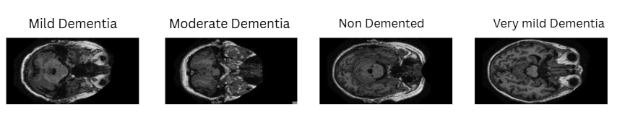
Fig. 1. (a) Mild Dementia; (b) Moderate Dementia; (c)Non-Dementia; (d)Very Mild Dementia.

The dataset consists of brain scans grouped into four classes: Mild, Moderate, Non and Very-mild Dementia with Fig.1(a)-(d)showing one example slice from each category. These labels span the progression of cognitive decline and provide a broad set of samples for training and testing. Each image is a grayscale brain slice; the dataset was cleaned to remove duplicates, corrupted files, and mislabeled cases, and all images were stored in class-specific folders to support automatic loading and labeled in Python.

3.1 DataSet Collection.

ADNI subset in this study consists of raw structural MRI volumes downloaded in NIfTI format,without pre-segmentation tissue masks or scanner-specific instrument.Table 1 presents the quantity of MRI scans in each diagnostic class before and after dataset balancing. Originally, the dataset showed strong class imbalance, with non-denmented images significantly outnumbering others.After balancing, each class was given a similar number of images by randomly resampling under-represented subjects and limiting the number of slices per subject so no exact duplicate slices were created and patient identities remained consistent within each split.
Table 1. Dataset Description.
Class | Number of Images (Original) | Number of Images (After Balancing)
Non-Dementia | 67,222 | 40,000
Mild-Dementia | 5,002 | 10,000
Moderate-Dementia | 488 | 8000
Very Mild-Dementia | 13,725 | 20,000
The data file was partitioned into train, validation, and test subsets using a stratified sampling method with 70% for training,15% for testing, and 15% for validation.
3.2 Models Description
Deep learning is implemented with standard 2D CNN backbones instead of 3D networks to keep computation manageable and enable a fair comparison on the same axial MRI slices. The research investigated multiple DL architectures to bifurcate between different stages of Alzheimer’s disease by analyzing MRI scans.6 Convolutional architectures were evaluated. A custom CNN is built from scratch as a simple, fast baseline for image classification. ResNet50 represents residual networks, using skip connections to support very deep models while limiting overfitting.VGG16 is a classic stacked-layer design that applies many small convolution filters in sequence and is widely used for image analysis. DenseNet201 is a densely connected network in which each layer receives features from all previous layers, encouraging feature reuse and stable gradients.InceptionV3 is a multi-branch architecture that processes several filter sizes in parallel to capture at different spatial scales.EfficientNet-B1 is a scaled backbone that jointly adjusts depth, width, input resolution to remain lightweight yet accurate.
3.3 Model Workflow

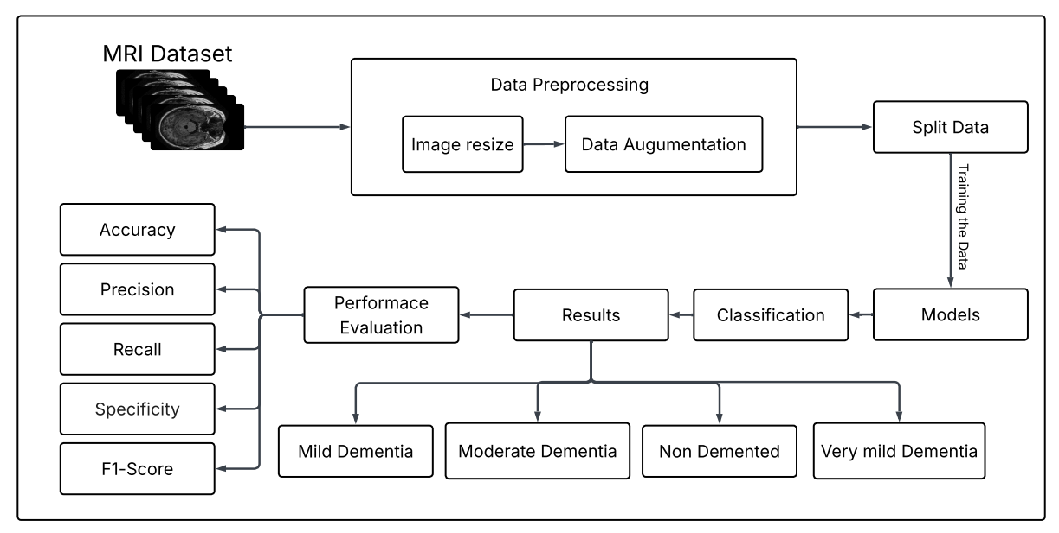
Fig. 2.MRI-based demented classification workflow.
Fig.2 presents the complete workflow used to classify Alzheimer’s disease (AD) stage with deep-learning models applied to MRI scans. Each 3D MRI volume was split into 256 axial slices,of which slices 100-160 were selected because they capture hippocampal and medical temporal regions relevant to AD. All slices from each subject were kept strictly within a single train, validation partition to avoid data leakage. The process begins with key preprocessing steps such as image resizing and data augmentation, which improve both image quality and dataset variability. The dataset is then divided into training, validation, and test sets before being used to train multiple neural network architectures. These models learn to categorize MRI images into four diagnostic classes. The final predictions are assessed with standard evaluation metrics, ensuring a clear, structured, and reliable pipeline from data preparation to model evaluation for dementia classification.
3.4 Image Loading and Image Resizing
All MRI scans were loaded via a scripted Python pipeline utilizing Numpy, and Pandas. Each scan received an automatic diagnosis label based either on the folder structure of the dataset or for more nuance, metadata. This was to ensure reliable and replicable access for downstream modeling. Each scan was then resized to the desired input size per each neural network model. This resizing standardized input formatting to prevent training errors and allowed uniform feature extraction in all models. To prevent identity leakage, a patient-wise split was used. All slices from the same patient were kept within the same partition.
3.5 Normalization and Data Augmentation

In Fig.2 all Images are first resized to 128 x 128 so the model receives a fixed-size input,then resized to specific resolution required by each backbone.EfficientNet-B1 and InceptionV3 receive images resized to 240$×$240 pixels,aligning with their expected native resolution.ResNet50,VGG16 and DenseNet2001 use inputs scaled to 244$×$244 pixels,consistent with standard pretrained configuration.The Custom CNN operates on smaller 128$×$128 images to reduce computation and fit the chosen architecture.The ToTesor() Operation automatically normalizes pixel values by converting them from the 0 - 255 range to 0-1, which prepares the data for scale gradient updates during training. In the training pipeline, an additional step, RandomHorizontalFlip(), is applied, which randomly flips images left-right to increase the variation in the dataset. This helps the model avoid overfitting by exposing it to multiple orientations of MRI scans. Augmentation was applied only to the training set, after splitting the dataset using patient-wise stratification to prevent data leakage. To prevent anatomical validity, augmentation excluded unrealistic transformation. MRI-specific augmentation, such as slight elastic deformation, Gaussian noise, and intensity normalization, were used to improve generalization. Duplicate detection was used to prevent repeated identical images during augmentation. Each image was augmented at most N times (N=3) to avoid low-variance duplicates.

3.6 Model Implementation

The implementation of a Custom Convolution Neural Network(CNN) contains two major components: convolution feature extraction and fully connected classification. The model first processes the MRI images through multiple convolution layers, each followed by ReLU activation and maxpooling. These layers progressively learn spatial patterns such as edges, texture, and structure differences found in MRI scans. The output from the final convolution block is converted into a 1-D array and subsequently processed into fully connected layers that make the high-level decision and classify MRI images into their respective category. The forward pass processes the input through all the convolution layers. Then, through the dense layer and finally return the predicted class scores.

3.7 Equations

1 ReLU Activation

$ReLU (x) = max ( 0, x )$ (1)

ReLU activation in Eq(1) is applied after each convolution layer to introduce non-linearity.

2 Average Pooling

O(i,j) = $k_{h}$$k_{w}$ I ( i+m , j+n) (2)
Average pooling layer in Eq(2) computes the average in each pooling window,where O(i,j) is the output at (i,j) and $k_{w}$ , $k_{h}$ is kernel width and height.

3 Max Pooling

$O( i , j ) = max window I( i+m , j+n )$ (3)

Max pooling in Eq(3) takes the maximum activation in the pooling window to reduce spatial dimensions and down-samples feature map.

4 Flatten Layer

$Flatten(H×W×C)=HWC vector$ (4)
Flatten operation in Eq(4) flattens a feature map of size H$×$W$×$C into a 1-D vector before fully connected layers and converts the final feature map into 1D vector.

5 Batch Normalization

$\hat{x}$ = $\frac{x - μ}{\sqrt{σ^{2}+ϵ}}$ (5)
$Then scale + shift : y= γ\hat{x }+β$
Batch Normalization in Eq(5) where x is the input,$μ$ and $σ^{2}$ are batch mean and variance ,$ϵ$ ensures numerical stability and $γ,β$ are learnable scale and shift parameters.

3.8 Training & Evaluation

Stratified training and validation sets were generated for appropriate model classification of a balanced approach.Models were trained on a workstation with an NVIDIA GPU GTX 1650 Ti and 16GB RAM and python deep learning stack(Pytorch with CUDA support) using The Adam optimizer with comparable learning rates and multiclass loss function.Early stopping is deployed relative to val_loss and val_accuracy for overfitting prevention and automatic model checkpoint saving kept the best performing.Table 2 lists the main training parameters used for each model.

Table 2.Parameters for Training.
Model | Optimizer | Learning  Rate | Loss  Function | Early  Stopping | Check  point | Batch Size | Epochs
Custom  CNN | Adam | 0.001 | CrossEntropyLoss | Yes | Yes | 32 | 10
Efficient  Net-B1 | Adam | 0.0001 | CrossEntropyLoss | Yes | Yes | 32 | 20
ResNet50 | Adam | 0.0001 | CrossEntropyLoss | Yes | Yes | 32 | 50
VGG16 | Adam | 0.0001 | CrossEntropyLoss | Yes | Yes | 32 | 10
DenseNet  201 | Adam | 0.0001 | CrossEntropyLoss | Yes | Yes | 32 | 10–15
Inception  V3 | Adam | 0.0001 | CrossEntropyLoss | Yes | Yes | 32 | 30
4 Results

This work has been implemented and evaluated for the performance of six CNN architectures: Custom CNN, VGG16, ResNet50, DenseNet201, InceptionV3 and EfficientNet-B1, across multiple Alzheimer's stages using MRI scans. Table 3 summarizes the accuracy, macro and weighted precision, recall, F1-score, and test sample counts for each deep learning model, allowing comparison of their classification performance. Key results show that the custom CNN, DenseNet201, ResNet50, and VGG16 achieve the highest overall accuracy, consistently above 95% when distinguishing between the 4 AD stages. In contrast, EfficientNet-B1 and InceptionNetV3 obtain clearly lower accuracy and recall, indicating that these deeper architectures struggle to learn stable features under the current 2D slice resolution and training setup. Because top models have similar scores, they were interpreted as descriptive only, and no formal statistical significance testing was carried out. Prior MRI-based AD studies often report 82-99% accuracy for binary or three-class diagnosis, where these best models (custom CNN, VGG16, DenseNET201) reach about 95-98% accuracy and macro F1 on a four-stage task. Rather than introducing a single new architecture, this work compliments earlier research by comparing six CNN families under a unified pipeline and highlights which ones are most reliable for stage-wise AD staging.
The following abbreviations are used in the results table:
- Acc = Final Test set accuracy
- Macro Pre = Precision averaged over all categories(macro precision)
- Macro Rec = Recall averaged over all categories(macro recall)
- Macro F1= F1 averaged over across all classes(macro F1 score)
- Wt Pre, Rec, F1=Precision, Recall, F1-score averaged over classes, weighted by class frequency, respectively.
- N = Number of test samples evaluated for each model.

Table 3.Summary of Test Metrics for All Deep Learning Models.
Model | Acc | Macro  Pre | Macro  Rec | Macro  F1 | Wt  Pre | Wt  Rec | Wt  F1 | N
CNN | 0.98 | 0.98 | 0.98 | 0.98 | 0.98 | 0.98 | 0.98 | 15600
DenseNet201 | 0.98 | 0.98 | 0.98 | 0.98 | 0.98 | 0.98 | 0.98 | 15600
EffNet-B1 | 0.75 | 0.69 | 0.75 | 0.71 | 0.76 | 0.75 | 0.75 | 15600
VGG16 | 0.98 | 0.97 | 0.98 | 0.97 | 0.98 | 0.98 | 0.98 | 15600
InceptV3 | 0.75 | 0.43 | 0.29 | 0.29 | 0.72 | 0.79 | 0.72 | 15600
ResNet50 | 0.95 | 0.87 | 0.89 | 0.88 | 0.92 | 0.91 | 0.91 | 15600

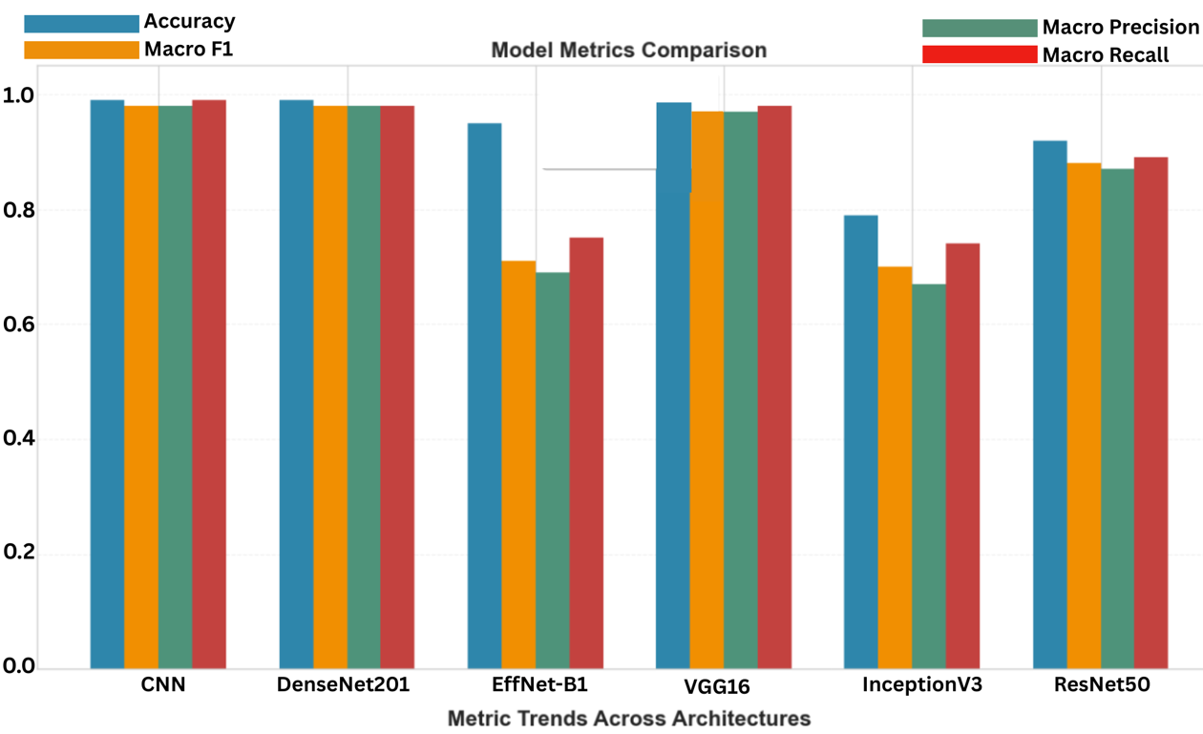
Fig. 3..Model Metrics Comparision

Fig.3 is a comparison of the performance of various deep-learning architectures in terms of their key evaluation metrics.Models such as CNN, DenseNet201, and VGG16 have exhibited high and stable scores for accuracy , Macro F1 , precision, and recall , thereby implying that these models have not only correctly classified the majority of the samples but have also treated all the classes quite fairly.Efficient-B1 and InceptionV3, on the other hand,are at a considerable distance from the rest , thus pointing to a greater struggle with balanced classification.ResNet50 is a middle-ground performer as it is more stable than the weaker models but it is still a bit behind the top performers.

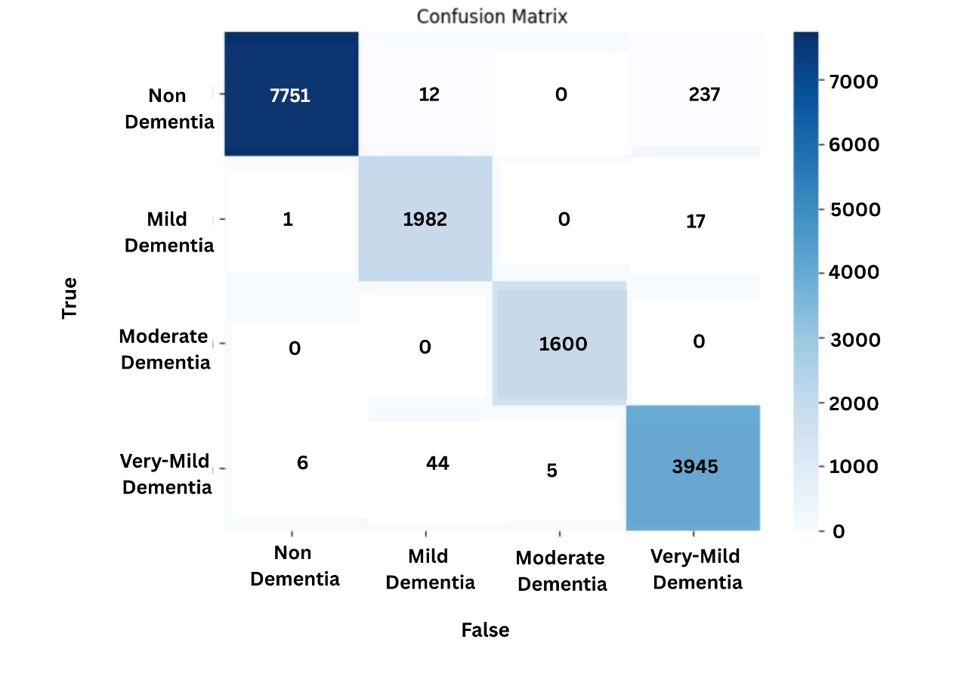
Fig. 4. CNN Heatmap
Fig.4 shows a confusion matrix for the custom CNN across 4 dementia stages, where rows are true labels, columns are predicted labels and the strong diagonal indicates many correct classifications with few errors. CNN is used because they are well-suited to MRI images, learning spatial patterns directly from the scans and allowing a fair comparison between different CNN architectures under the same pipeline.

5 Conclusion

Among the evaluated architectures, the custom CNN, VGG16, ResNet50, and DenseNet201 achieved the best performance for stage-wise AD prediction from MRI.EfficientNet-B1 and InceptionNetV3 underperformed relative to these models, showing that deeper or more complex networks do not automatically yield better results on this dataset. The present work is limited by using 2D slices from a single ,class-balanced MRI dataset, which may not match real clinical distributions. Future extensions will explore 3D or multimodal imaging and validate the models on independent cohorts to better assess generalization.

References
- Chen, Y.Automated Alzheimer’s disease classification using deep learning. ScienceDirect(2024).Availableat:https://www.sciencedirect.com/science/article/pii/S1687850723002601
- Vinukonda, E.R.: An integrated deep learning model for early and multi-class Alzheimer’s disease diagnosis. Nature (2025). Available at: https://www.nature.com/articles/s41598-025-01845-ynature​
- Arya, A.D.A systematic review on machine learning and deep learning approaches for Alzheimer’s disease diagnosis using MRI and PET. Springer (2023).Availableat:https://link.springer.com/article/10.1186/s40708-023-00195-7​
- Shaji, A., Helaly, H: Novel deep learning for multi-class classification of Alzheimer’s dementia stages. Frontiers in Bioinformatics (2025). Available at:https://www.frontiersin.org/journals/bioinformatics/articles/10.3389/fbinf.2025.1567219
- Sorour, S.E.,: Classification of Alzheimer’s disease using MRI data based on deep learning. ScienceDirect (2024). Available at: https://www.sciencedirect.com/science/article/pii/S1319157824000296
- Fundación Dialneti,.: Advancements in Alzheimer’s disease classification: Integrating machine learning, neuroimaging, and biomarkers. Dialnet (2024). Available at: https://dialnet.unirioja.es/servlet/articulo?codigo=9968874
- Turrisi, R., Verri, A., and Barla, A.: Deep learning-based Alzheimer’s disease detection: reproducibility and the effect of modeling choices. Frontiers in Computational Neuroscience (2024). Available at: https://www.frontiersin.org/journals/computational-neuroscience/articles/10.3389/fncom.2024.1360095/full
- Subhrangshu Bit, Pritam Dey, Arnab Maji: MRI-based mild cognitive disease classification (2024). Available at: https://journals.sagepub.com/doi/abs/10.1177/25424823241290694
- El-Assy, A.M..: A novel CNN architecture for accurate early detection and classification of Alzheimer’s disease. Nature (2024). Available at: https://www.nature.com/articles/s41598-024-53733-6
- Rao, B.S., Aparna, M.: Alzheimer’s disease through analysis of MRI images using deep learning techniques. IEEE (2023). Available at: https://ieeexplore.ieee.org/abstract/document/10182253​
- Odusami, M. Alzheimer’s disease recognition from MRI and PET imaging data. Heliyon (2024). Available at: https://www.cell.com/heliyon/fulltext/S2405-8440(24)10433-1
- Raza, H.A. Alzheimer’s classification: machine learning and deep learning hybrid approach using multi-view MRI. Scientific Reports (2024). Available at:https://www.nature.com/articles/s41598-024-81563-z
- Anuradha Vashishtha., Hybrid model: deep learning method for early detection of Alzheimer’s disease from MRI images. Biomedical and Pharmacology Journal (2023). Available at: https://pdfs.semanticscholar.org/7d26/3c8383eb284f54971d70064ad0ccc3cf908b.pdf
- Hadeel Alharbi:Spectral graph convolutional neural network for Alzheimer’s disease classification. Frontiers in Neuroinformatics (2024). Available at: https://www.frontiersin.org/journals/neuroinformatics/articles/10.3389/fninf.2024.1495571
- Baili, J., Alqahtani:Enhancing multi-class neurodegenerative disease classification with deep learning. Frontiers in Medicine(2025).Available: https://www.frontiersin.org/journals/medicine/articles/10.3389/fmed.2025.1562629/full

