Comparative Deep Neural Study For Stage-Wise Alzheimer’s Disease Detection Using Brain MRI
Shashank Shetgeri^{1*} , Srushti Honnangi¹ , Anushri Kajagar¹ , Tanvi Korgaonkar¹ , Salma Shahapur² , Rajashri Khanai² , Niranjan Muchandi²
Corresponding Author(s) E-mail(s) : 02fe24bcs413@kletech.ac.in
Contributing Author(s) E-mail(s):02fe23bcs062@kletech.ac.in 02fe23bcs084@kletech.ac.in,02fe23bcs013@kletech.ac.in, salmashahapur.mss@kletech.ac.in , rajashrikhanai.mss@kletech.ac.in niranjanmuchandi.mss@kletech.ac.in
^{1,2} Department of Computer Science and Engineering, KLE Technological University
Dr. M. S. Sheshgiri Campus, Belagavi 590008, Karnataka, India.

Abstract. Alzheimer’s disease is a progressive brain disorder that frequently impacts older adults and among the leading disorders associated with aging and brain functions. Since it is highly prevalent, correctly identifying Alzheimer’s Disease is crucial for initiating treatment early, which leads to the best outcomes. With the advancement of deep learning algorithms, it is useful to analyze and compare various architectures of CNNs and their ability to distinguish stages of AD. Models such as ResNet50, VGG16, and DenseNet201, as well as InceptionV3, EfficientNet-B1, and a custom CNN, were tested to classify MRIs of Alzheimer's Disease patients. The architecture was ADNI's subset and separated into four classes: Mild Dementia, Moderate Dementia, Very Mild Dementia, and Non Demented. Each model is trained on a subset of MRI images and learns to recognize features that separate one stage of Alzheimer's disease from another. After training, the models are evaluated using several CNN layer equations, like ReLU Activation, Average Polling, Max Pooling, Flatten Layer, Fully Connected Layer, and Batch Normalization were used to understand how well they perform. The results show that recent models generally give better performance than simpler or older CNN designs. This suggests that modern deep learning models can be valuable tools for supporting early and stage-wise identification of Alzheimer's disease from MRI scans.
Keywords: Alzheimer's disease(AD), Alzheimer's disease Neuroimaging Initiative(ADNI) , EfficientNet-B1 , DenseNet201 , CNN , Early diagnosis , ResNet50 , VGG16 , InceptionV3 , Multi-Class Classification.
- Introduction
Alzheimer’s disease gradually affects brain cells and leads to a steady decline in brain function. It is a disorder which leads to the deterioration of cognitive skills such as memory, language, reasoning, and behavior, significantly impairing daily functioning and eventually impacting the quality of life for persons affected. Individuals typically diagnosed with this condition are generally 65 years old or older. Extensive Education is linked to increased development of synapses within the brain.This buildup of synaptic reserves allow those affected to better adapt as neural cells are lost during the advance of the disease [3].The number of Alzheimer's disease diagnoses continues to grow as life expectancy increases , creating additional responsibility on healthcare systems. Early and accurate recognition of AD remains important because it guides timely intervention and improves patient management .In recent years,MRI has become one of the main tools used to observe changes in the brain. It allows doctors to study brain structure, follow how the disease progresses and look for early signs without any surgical procedures[5].PET scans and other imaging methods are also used to monitor brain activity related to AD. The use of deep-learning techniques has improved the way these images are examined by making interpretation faster and more accurate [6].
2 Related Work
Y. Chen and team used deep learning on MRI scans to stage Alzheimer’s and hit up to 99% accuracy, but they still need to test it on outside data[1]. E.R. Vinukonda’s group built a hybrid network—combining DeepLabV3+ and ResNext—which got 98% accuracy, though uneven class sizes held them back[2]. A.D. Arya took a broader look at machine and deep learning methods, and found that using both MRI and PET scans works better than just MRI. They also pushed for cross-cohort validation[3]. Shaji, Helaly, and others showed that CNNs and transfer learning models can classify dementia with 69–97% accuracy, but small datasets make things tricky[4]. S.E. Sorour used deep learning for Alzheimer’s classification and pointed out that researchers need to be clearer about their methods[5]. Fundación Dialenti’s team stressed the value of mixing imaging with biomarkers, but said the field needs bigger, standardized datasets[6].Turrisi R,Verri A and Barla A built 3d-CNN models on ADNI MRI data and studied how data augmentation and network depth affect both accuracy and reproducibility for binary AD vs CN detection with accuracy of 82% [7].Subhrangshu Bit ,Pritam Dey ,Arnab Maji developed a VAE-based feature extractor on 3D structural MRI ,followed by classical ML classifiers to distinguish CN,MCI,AD[8]. El-Assy’s custom CNN for Alzheimer’s detection landed between 85% and 95% accuracy, but they see fixing class imbalance as the next step[9]. Finally, B.S. Rao compared several deep learning models for MRI-based Alzheimer’s classification, highlighting how MRI quality and outside validation really matter[10].
3 Methodology
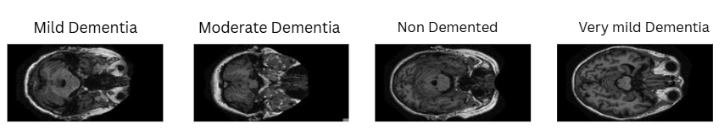
Fig 1.(a)Mild-Dementia; (b)Moderate-Dementia; (c)Non-Dementia; (d)Very Mild Dementia.

The dataset consists of brain scans organized into 4 groups : Mild, Moderate, Non and Very Mild Dementia and Fig.1 shows one example image from each group. These categories represent increasing levels of cognitive decline, offering a comprehensive range of samples for training and testing. Each image corresponds to a brain scale slice in grayscale format. The dataset was curated to remove duplicates, corrupted files, and misabled images. To ensure consistency, all images were organized into structured directories, one for each dementia stage. This made it easy for loading and labeling through automated scripts in Python.

3.1 DataSet Collection.

Table 1 presents the quantity of MRI scans in each diagnostic class before and after dataset balancing.Originally, the dataset showed strong class imbalance,with non-denmented images significantly outnumbering others.Originally, the dataset showed strong class imbalance,with non-denmented images significantly outnumbering others.After balancing,each class was adjusted to contain a more comparable image count to support fair and effective model training.

Table 1. Dataset Description.
Class | Number of Images (Original) | Number of Images (After Balancing)
Non-Dementia | 67,222 | 40,000
Mild-Dementia | 5,002 | 10,000
Moderate-Dementia | 488 | 8000
Very Mild-Dementia | 13,725 | 20,000
The datafile was partitioned into train , validation and test subsets using stratified sampling method maintaining class balance across all subsets to avoid bias in model learning, with 70% for training,15% for testing and 15% for validation.
3.2 Models Description.
Deep learning, a form of artificial intelligence, has assisted doctors in improving ways to diagnose Alzheimer's disease from brain scans.The research investigated multiple DL architectures to bifurcate between different stages of Alzheimer’s disease by analyzing MRI scans.Table 2 presents descriptions of different models used while training and testing which includes their type ,purpose and key advantages.
Table 2.Model Description.
Model Name | Model Type  (CNN) | Description | Key Strengths/Focus
CNN | Custom | A straightforward neural network built from scratch for image classification, using stacked layers. | Fast to train, simple, good as baseline.
ResNet50 | Residual | Uses skip (residual) connections, allowing very deep networks without losing important signals. | Handles deeper layers; less overfitting.
VGG16 | Stacked layer | Stacks many convolutional layers in a simple pattern for strong feature extraction. | Easy to use, proven for image tasks.
DenseNet  201 | Densely connected | Connects each layer to every other, so features are reused and learning is more efficient. | Very efficient learning, robust results.
Inception  V3 | Multi branch | Combines different filter sizes at every level for multi-scale feature extraction. | Captures diverse image patterns well.
EfficientNet-B1 | Scaled | Scales width, depth, and resolution together so the network is both accurate and efficient. | Cutting-edge accuracy, lightweight.

3.3 Model WorkFlow

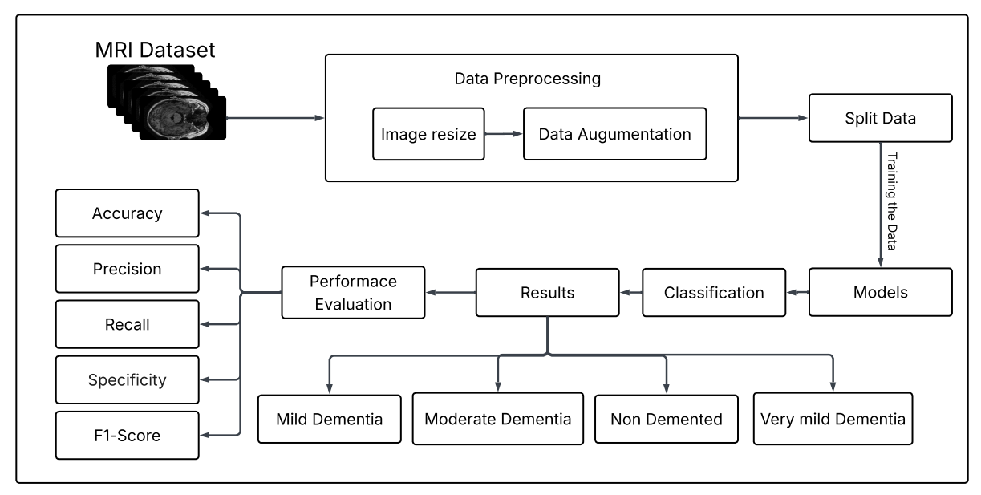
Fig 2.MRI-based demented classification workflow.
Fig.2 presents the complete workflow used to classify Alzheimer’s disease (AD) stage with deep-learning models applied to MRI scans. The process begins with key preprocessing steps such as image resizing and data augmentation, which improve both image quality and dataset variability. The dataset is then divided into training, validation, and test sets before being used to train multiple neural network architectures. These models learn to categorize MRI images into four diagnostic classes. The final predictions are assessed with standard evaluation metrics, ensuring a clear, structured, and reliable pipeline from data preparation to model evaluation for dementia classification.
3.4 Image Loading and Image Resizing
All MRI scans were loaded via a scripted python pipeline utilizing OpenCV, Numpy ,and Pandas. Each scan received an automatic diagnosis label based either on the folder structure of the dataset or, for more nuance, metadata. This was to ensure reliable and replicable access for downstream modeling. Each scan was then resized to the desired input size per each neural network model as denoted in Table 3. This resizing standardized input formatting to prevent training errors and allowed uniform feature extraction in all models.
Table 3. Model-Specific Image Resizing Parameters.
Models | Resizing Details
EfficientNet-B1 | Images resized to either 240 ×240 pixels, matching EfficientNet’s native input resolution for optimal performance.
ResNet50,VGG16,  DenseNet201 | Images were adjusted to 224 × 224 pixels to meet the input specifications of pretrained neural network models.
InceptionV3 | Images resized to 240 ×240pixels as required for InceptionV3’s architecture.
Custom CNN | Images resized to either 128 ×128 as per the custom implementation to improve speed and suit model design.

3.5 Normalization and Data Augmentation

All Images are first resized to 128 x 128 so the Model receives a fixed-size input. The ToTesor() Operation automatically normalizes pixel values by converting them from the 0 - 255 range to 0 - 1, which prepares the data for scale gradient updates during training. In the training pipeline, an additional step, RandomHorizontalFlip(), is applied, which randomly flips images left-right to increase the variation in the dataset. This helps the model avoid overfitting by exposing it to multiple orientations of MRI scans.

3.6 Model Implementation

The implementation of a Custom Convolution Neural Network(CNN) contains two major components: convolution feature extraction is fully connected classification. The model first processes the MRI images through multiple convolution layers, each followed by ReLU activation and maxpooling. These layers progressively learn spatial patterns such as edges, texture, and structure differences found in MRI scans. The output from the final convolution block is converted into a 1-D array and subsequently processed into fully connected layers that make the high-level decision and classify MRI images into its respective category .The forward pass processes the input through all the convolution layers .Then, through the dense layer, and finally return the predicted class scores.

3.7 Equations

1 ReLU Activation

ReLU (x) = max ( 0, x ) (1)

Eq(1) adds non-linearity to the model. Used throughout VGG, ResNet, EfficientNet, and CNN.

2 Average Pooling

O(i,j) = $k_{h}$$k_{w}$ I ( i+m , j+n) (2)
Eq(2) computes the average value within each window for dimensionality reduction, where $k_{w}$ is kernel width and $k_{h}$ is kernel height.

3 Max Pooling

O( i , j ) = max window I( i+m , j+n ) (3)

Eq(3) is obtained by taking the largest value within each window to reduce spatial dimensions.

4 Flatten Layer

Flatten(H$×$W$×$C)=HWC vector (4)

Eq(4) converts multi-dimensional input into a single vector for fully connected layers, where H is height, C is channel, W is width.

5 Batch Normalization

$\hat{x}$ = $\frac{x - μ}{\sqrt{σ^{2}+ϵ}}$ (5)
Then scale + shift : y= $γ\hat{x }+β$

Parameters Learned by model where $γ$is scale and $β$is shift.Eq(6) normalizes inputs for each batch and applies learned scaling and shifting.

3.8 Training & Evaluation

Stratified training and validation sets were generated for appropriate model classification of a balanced approach. Models were fitted with Adam optimizers and relatively equivalent learning rates and loss functions adjusted for multiclass classification for training. Early stopping is deployed relative to val_loss and val_accuracy for overfitting prevention and automatic model checkpoint saving kept the best performing.Table 4 lists the main training parameters used for each model.

Table 4.Parameters for Training.
Model | Optimizer | Learning  Rate | Loss Function | Early  Stopping | Check  point | Batch Size | Epochs
Custom  CNN | Adam | 0.001 | SparseCategorical  Crossentropy | Yes | Yes | 32 | 10
Efficient  Net-B1 | Adam | 0.0001 | CrossEntropyLoss | Yes | Yes | 32 | 20
ResNet50 | Adam | 0.0001 | Categorical  Crossentropy | Yes | Yes | 32 | 50
VGG16 | Adam | 0.0001 | Categorical  Crossentropy | Yes | Yes | 32 | 10
DenseNet  201 | Adam | 0.0001 | CategoricalCross  entropy or similar | Yes | Yes | 32 | 10–15
Inception  V3 | Adam | 0.0001 | CrossEntropyLoss | Yes | Yes | 32 | 30
4 Results

This work has been implemented and evaluated for the performance of six CNN architectures: Custom CNN, VGG16, ResNet50, DenseNet201, InceptionV3, and EfficientNet-B1, across multiple Alzheimer's stages using MRI scans.Table 5 summarizes the accuracy ,macro and weighted precision,recall, F1-score and test sample counts for each deep learning model, allowing comparison of their classification performance.

Key results including Custom CNN, DenseNet201, ResNet50, and VGG16 had the highest overall accuracy, consistently exceeding 95% accuracy when distinguishing between various stages of AD. These models demonstrated great ability in learning detailed and subtle features from MRI data. EfficientNet-B1 and InceptionV3 also performed well, having slightly lower accuracy rates than DenseNet201 and ResNet50, but still turning in a good overall performance.

The following abbreviations are used in the results table:
- Acc = Final Test set accuracy
- Pre = Precision averaged over all categories(macro precision)
- Rec= Recall averaged over all categories(macro recall)
- F1= Value calculated as the unweighted average across all classes(macro F1 score)
- N=Number of test samples evaluated for each model
Table 5 Summary of Test Metrics for All Deep Learning Models.
Model | Acc | Pre | Rec | F1 | Pre | Rec | F1 | N
CNN | 0.98 | 0.98 | 0.98 | 0.98 | 0.98 | 0.98 | 0.98 | 15600
DenseNet201 | 0.98 | 0.98 | 0.98 | 0.98 | 0.98 | 0.98 | 0.98 | 160
EffNet-B1 | 0.75 | 0.69 | 0.75 | 0.71 | 0.76 | 0.75 | 0.75 | 15600
VGG16 | 0.98 | 0.97 | 0.98 | 0.97 | 0.98 | 0.98 | 0.98 | 15600
InceptV3 | 0.75 | 0.43 | 0.29 | 0.29 | 0.72 | 0.79 | 0.72 | 15600
ResNet50 | 0.95 | 0.87 | 0.89 | 0.88 | 0.92 | 0.91 | 0.91 | 15600
As per the results, the Models such as Custom CNN, VGG16 and Densenet201 showed best performance, achieving substantial high accuracy, sensitivity, specificity, and F1-score whereas the models like EffNet-B1 and InceptV3 showed poor Performance.
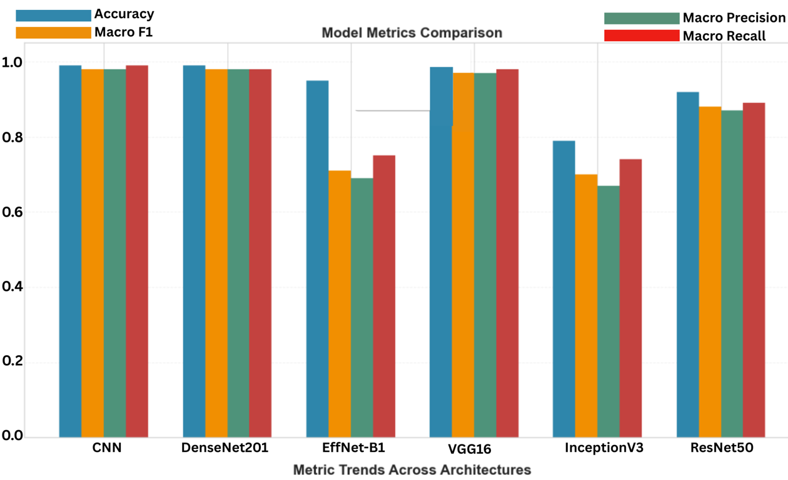
Fig 3.Model Metrics Comparision

Fig.3 is a comparison of the performance of various deep-learning architectures in terms of their key evaluation metrics.Models such as CNN, DenseNet201, and VGG16 have exhibited high and stable scores for accuracy , Macro F1 , precision, and recall , thereby implying that these models have not only correctly classified the majority of the samples but have also treated all the classes quite fairly.Efficient-B1 and InceptionV3, on the other hand,are at a considerable distance from the rest , thus pointing to a greater struggle with balanced classification.ResNet50 is a middle-ground performer as it is more stable than the weaker models but it is still a bit behind the top performers.
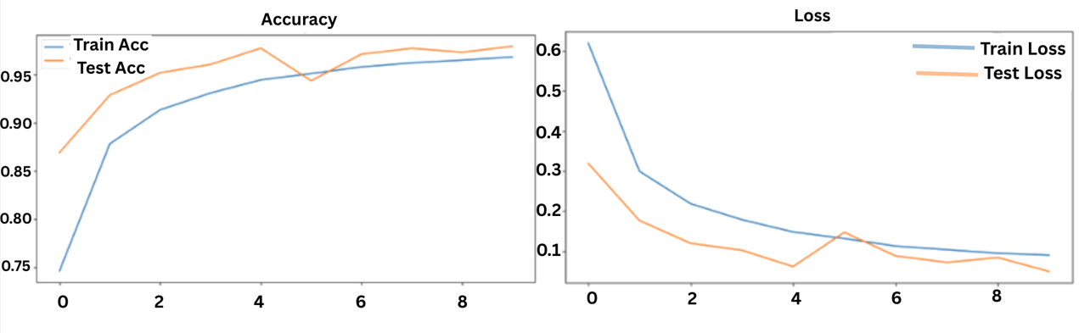
Fig 4. Performance of CNN model (a)Accuracy Curve; (b)Loss Curve.
Fig.4 illustrates the CNN model's accuracy and loss curve. Fig.4(a) shows both training and Validation accuracy rising sharply and closely together, indicating rapid learning and strong generalization. In Fig.4(b), both loss curves steadily decrease and remain tightly aligned, suggesting minimal overfitting. These parallel trends confirm that the model is capturing meaningful patterns rather than noise, demonstrating stable and reliable learning dynamics in Custom CNN.
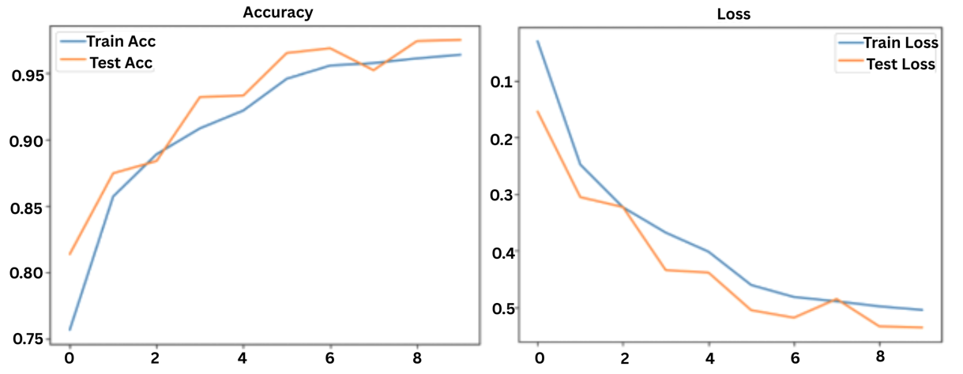Fig 5. Performance of VGG16 Model (a)Accuracy Curve; (b)Loss Curve.
Fig 5 shows the error curves and loss curves of the VGG16 model. In Fig5(a), the training and validation accuracy show a gradual increase and are quite similar to each other thus indicating strong generalization. Fig 5(b) indicates that there is a gradual decrease in training and validation loss and the two curves are closely aligned during the training epochs. The constant negative dynamics and the overall consistency of the curves are all the evidence of the successful learning and insignificant overfitting in the VGG16 architecture.
5 Conclusion

In terms of predicting the various stages of AD, MRI brain images can be classified with excellent accuracy by advanced convolutional neural networks, namely EfficientNet-B1 and DenseNet201. These models encapsulate the non-obvious and minute changes in brain structure as the disease progresses. In this study, optimized architectures such as EfficientNet-B1 and DenseNet201 outperformed simpler and baseline CNN models, and could provide more reliable and stable diagnostic performance, which makes this technique’s clinical utility. Although there are still some hurdles with understanding the decision-making process of the models and applying them more broadly, the results demonstrate that early and accurate identification of Alzheimer’s will result in better quality care and medical outcomes.

References
- Chen, Y., et al.: Automated Alzheimer’s disease classification using deep learning. ScienceDirect (2024). Available at: https://www.sciencedirect.com/science/article/pii/S1687850723002601​
- Vinukonda, E.R., et al.: An integrated deep learning model for early and multi-class Alzheimer’s disease diagnosis. Nature (2025). Available at: https://www.nature.com/articles/s41598-025-01845-y
- Arya, A.D., et al.: A systematic review on machine learning and deep learning approaches for Alzheimer’s disease diagnosis using MRI and PET. Springer (2023). Available at: https://link.springer.com/article/10.1186/s40708-023-00195-7
- Shaji, A., Helaly, H., et al.: Novel deep learning for multi-class classification of Alzheimer’s dementia stages. Frontiers in Bioinformatics (2021–2022). Available at: https://www.frontiersin.org/journals/bioinformatics/articles/10.3389/fbinf.2025.1567219
- Sorour, S.E., et al.: Classification of Alzheimer’s disease using MRI data based on deep learning. ScienceDirect (2024). Available at: https://www.sciencedirect.com/science/article/pii/S1319157824000296
- Fundación Dialneti, et al.: Advancements in Alzheimer’s disease classification: Integrating machine learning, neuroimaging, and biomarkers. Dialnet (2024). Available at: https://dialnet.unirioja.es/servlet/articulo?codigo=9968874
- Turrisi, R., Verri, A., and Barla, A.: Deep learning-based Alzheimer’s disease detection: reproducibility and the effect of modeling choices. Frontiers in Computational Neuroscience (2024). Available at:https://www.frontiersin.org/journals/computational-neuroscience/articles/10.3389/fncom.2024.1360095/full
- Subhrangshu Bit ,Pritam Dey ,Arnab Maji :MRI based mild cognitive disease classification(2024) Available at: https://journals.sagepub.com/doi/abs/10.1177/25424823241290694
- El-Assy, A.M., et al.: A novel CNN architecture for accurate early detection and classification of Alzheimer’s disease. Nature (2024). Available at: https://www.nature.com/articles/s41598-024-53733-6
- Rao, B.S., Aparna,M.: Alzheimer’s disease through analysis of MRI images using deep learning techniques. IEEE (2023). Available at: https://ieeexplore.ieee.org/abstract/document/10182253

