Chapter-1
1.INTRODUCTION:-
In today’s time most of the industries doesn’t focus on environmental pollution too so, that I have decided to increase illustration of all who take it lightly but it creating major harmful activities like make poisonous to the environment. By using AI based deciding system which will calculate percentage hazardous of air quality on which it decide this industry is capable of being open or should be close due more poisonous environment in industry. If focused industry is in medium range of hazardous air now for it the system will decide the area in different range according to it’s impact.
Figure:1.1
- OBJECTIVE
To reduce the environmental pollution in consequences of awareness about the pollution to industries because industries dominate by 8.06% ,energy sector co2 emission is 75.66% approx. and from Agriculture 13.72% including 2.56% waste This is not only about industries but also energy sectors and all .To design a new industrial model which sets some rules and regulation which fixes the amount or rate or percentage of emission of different gaseous chemical in environment.
- Project Overview
A dashboard is designed for predicting percentage of pollution level in particular place air actually it compare the entered data/percentage with a pre created database using sqlite-3 with the help of industries exist in past time but was successful means that non-hazardous nature.On comparing it decides the percentage hazardous of air according to result it throws output in terms of level of air quality such as non-hazardous,poor,medium,dangerous,hazardous,more hazardous etc.After some time it’s level can increase or decrease so I have added updation mode through which I can manually set range of area and hazadic level.
- Benefits
It will provide better air Quality.
It will create a super environment which helps in better health of people such as breathing ,asthama, other lungs disease ,eyes disease,various heart disease etc.
Same rules would be followed by all industries makes better look.
Due to decrease in pollution plants will growup and hence oxygen level also will increase
Temprature will decrease on decreasing in air pollution.
Productivity will increase because when anyone will have better health can do lots of work.
Living environment in fresh air.
It decreases smog in industrial area which can irritate lungs this can be of type such as sulfureous smog/London smog.
- Scope Of Project
Purpose of this mini project is to provide an idea which create a thought how can air quality manage meanwhile will provide a limitation in which industries will do development outside of the formatted rules all will punishable .this can implement in more industrial area like Delhi,Gujrat,Mumbai,Surat,Noida,Kolkata,Tamilnadu etc. the database will created on that basis of CPCV(Central Pollution Control board),on guidelines of WHO(World Health Organisation),UNEP(United Nation Environment Program).

Chapter - 2
2. REQUIREMENT ANALYSIS
This software-based project is an air pollution prediction system. It uses artificial intelligence and machine learning techniques to analyze available environmental and pollution-related data and estimate future pollution levels.
The system stores and manages data using JSON files and databases such as SQLite-3 or MongoDB. Its frontend is developed using HTML, CSS, JavaScript, and React.js. FastAPI provides APIs to connect the frontend with the backend and handle data exchange and prediction requests.
The website’s user interface and experience are designed with the help of Figma, with a focus on clear presentation and ease of use. Users can view pollution-related information and predicted levels through the website. The website is hosted locally, so the required software, server, and database components must be available on the local system.
Key requirements include reliable data handling, accurate and understandable predictions, responsive performance, and simple navigation.
Technical note: In your final report, clarify whether SQLite-3 and MongoDB serve different purposes or whether only one is the primary database. JSON files are best described as a data storage or exchange format.
It is software based project so it requires knowledge about AI and machine learning helps in predicting the pollution percentage. A database which has created with the help of sqlite-3, HTML,CSS,Javascript,react.js,MongoDB,json files which stores data,API for integrating frontend with backend such as Fast Api ,and also requires some basic knowledge about UI/UX designing which has done with the help of FIGMA . This website is locally hosted .

Chapter -3
3.PROJECT DESIGN
The project is designed as a web-based air pollution prediction system with three main parts: the frontend, backend, and data storage and prediction components.
The frontend is built with React.js, HTML, CSS, and JavaScript. It provides the pages and forms through which users can enter or view pollution-related information. The interface is designed in Figma to make the website clear and easy to navigate.
The backend uses FastAPI to receive requests from the frontend, process data, and return results. APIs connect the two parts and support the exchange of information. The prediction component applies an AI or machine learning model to the available data to estimate pollution levels.
The system stores data using the selected database, such as SQLite-3 or MongoDB. JSON files may be used to import, export, or exchange data. The website is hosted locally, so the frontend, backend, prediction model, and database run on the local system.
System flow:
User → React.js frontend → FastAPI backend → Database and prediction model → Prediction result shown to the user
- SRS
Software requirement
Component | Description/Purpose
Operating system | Windows 10/11,Android
Frontend Technologies | HTML,CSS,Javascript,React.js,UI/UX
Backend Technologies | Node.js,MongoDB
Database | Sqlite-3
Design Tools | Figma
Code Editor | Visual studio code
Version Control | Git& Github
Web Browser | Google Chrome/Microsoft Edge
b.ER Design
id INTEGER PRIMARY KEY AUTOINCREMENT,
co2 REAL NOT NULL,
no2 REAL NOT NULL,
so2 REAL NOT NULL,
hg REAL NOT NULL,
co REAL NOT NULL,
created_at TEXT DEFAULT (datetime('now'))
- DFD
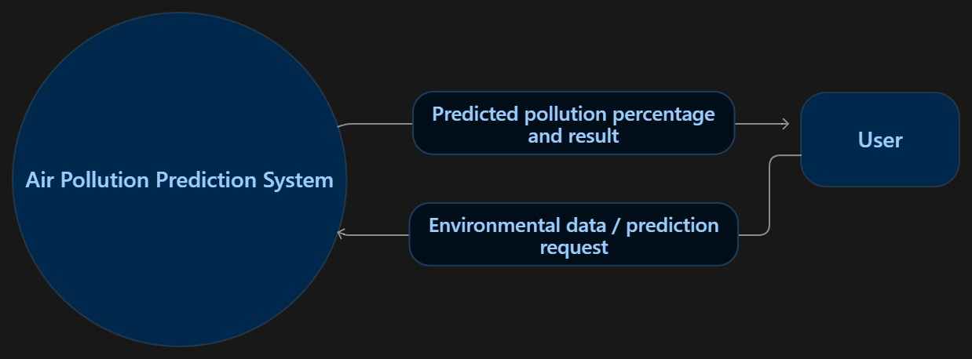
Figure: 3.1
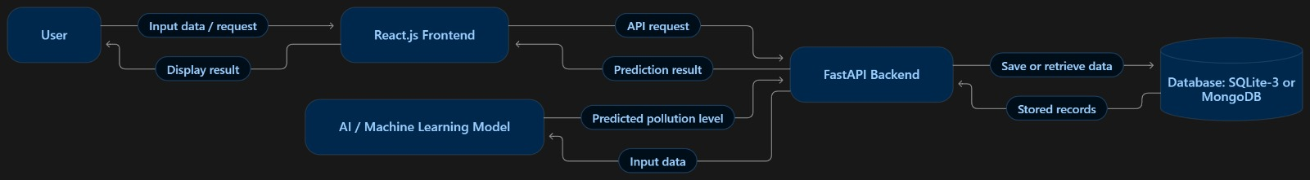
Figure: 3.2

Chapter -4
4. FLOW DIAGRAM/ILLUSTRATION
Start
↓
User opens the website
↓
User enters environmental data
↓
System validates the input data
↓
Is the data valid?
├── No → Show an error message → User enters the data again
└── Yes
↓
Frontend sends the data to the FastAPI backend
↓
Backend processes the input data
↓
Machine learning model predicts the pollution level End
↓ Display the result on
Save the prediction in the database (if implemented) the Website
Chapter-5
5.Conclusion and Future Work
Conclusion
The Air Pollution Prediction System uses a web-based platform to present pollution predictions to users. Environmental data is processed by a machine learning model through a backend API, and the predicted pollution level is displayed on the website. The project combines React.js for the frontend, FastAPI for backend communication, and a database for storing data. Its locally hosted design makes it suitable for demonstration and use in a local environment.
Future Work
- Connect the system to live reliable real-time data APIs.
- Train the model with a larger and more recent dataset to improve prediction accuracy.
- Add interactive charts showing pollution trends over time.
- Include more locations and pollutant types.
- Deploy the website online so users can access it remotely.
- Add user accounts, alerts, and downloadable reports if needed.

