# CREATE AND MANAGE EMAIL COMMUNICATION SERVICE RESOURCES

**STEP – 1:**

Create a new communications service.

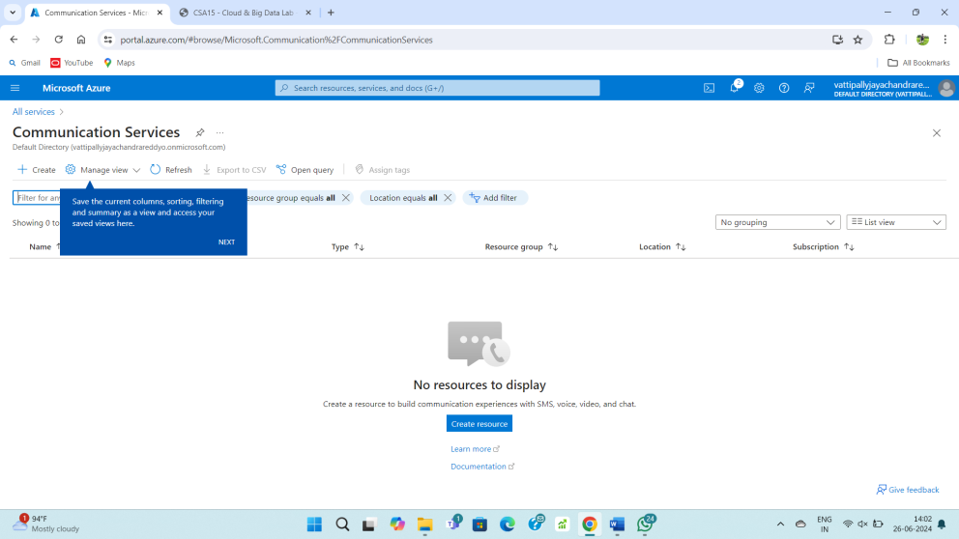

**STEP – 2:**

Fill upon the basics form.

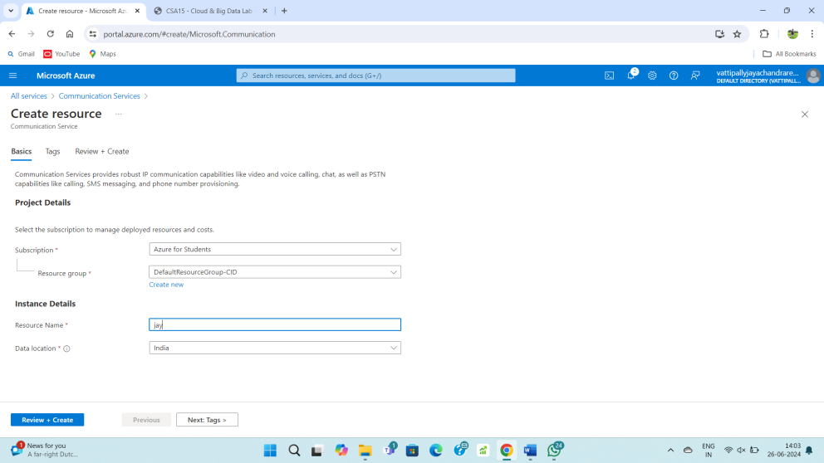

**STEP – 3:**

Fill upon the tags form.

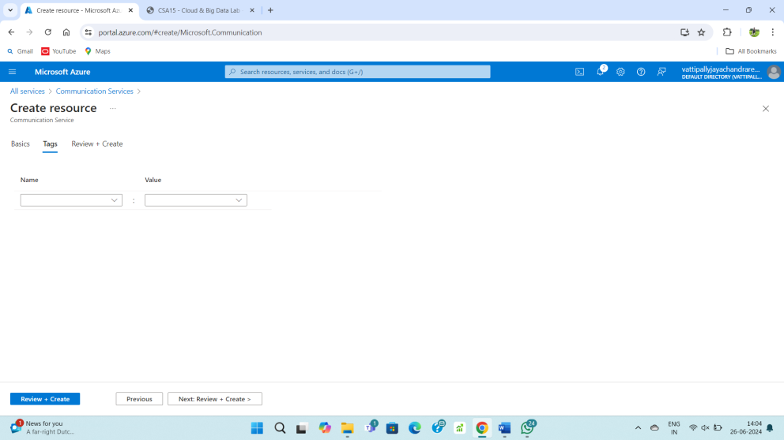

**STEP – 4:**

Review and create.

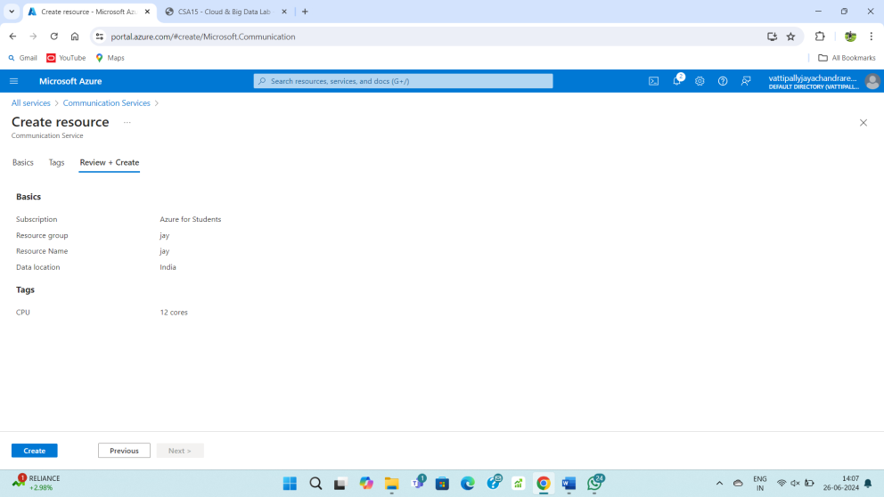

**STEP – 5:**

After completing deployment your resource is ready.

