Linux Foundation Consortium – AllSeen Alliance

* AllSeen Alliance is the broadest, cross-industry open source effort to advance the Internet of Things (IoT) and Internet of Everything beyond the connected home.
* The initiative includes more than 170 member companies including leading consumer electronics manufacturers, home appliance makers, automotive companies, Internet of Things cloud providers, enterprise technology companies, innovative startups, chipset manufacturers, service providers, retailers and software developers.
* The AllSeen Alliance manages the AllJoyn open source project with software code using open standards to enable all the ‘things’ in the Internet of Things to work together. The code and software is freely available.
* AllJoyn works across platforms ranging from Android to iOS, Linux, OpenWRT Windows, OS X and embedded systems with limited memory and processing power.
* The code used by the AllSeen Alliance has been open source from the beginning. When everyone jointly develops and uses the same freely available code, companies can develop innovative services on top of it and get to market faster.

What is AllJoyn about?

* In order to fully realize the vision of the Internet of Things and apps, we need a common way to interact and speak to each other. This can be possible with AllJoyn Framework.
* It allows the devices from different compaines to work together running on the different operating systems, written with different language bindings to all speak together and just work.

Actual Problem -> One app, one solution coming together or you can have mutiple things but you have to buy them from one company.

AllJoyn solves the problem -> Our problem can be solves if they speak the same languages.

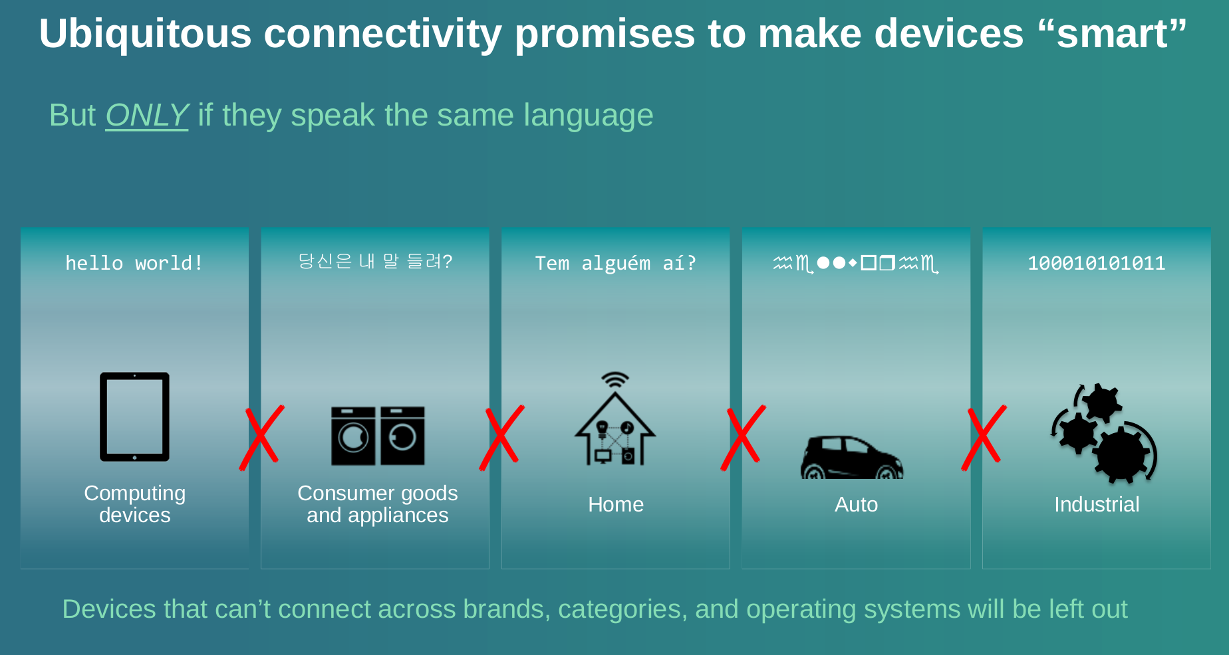

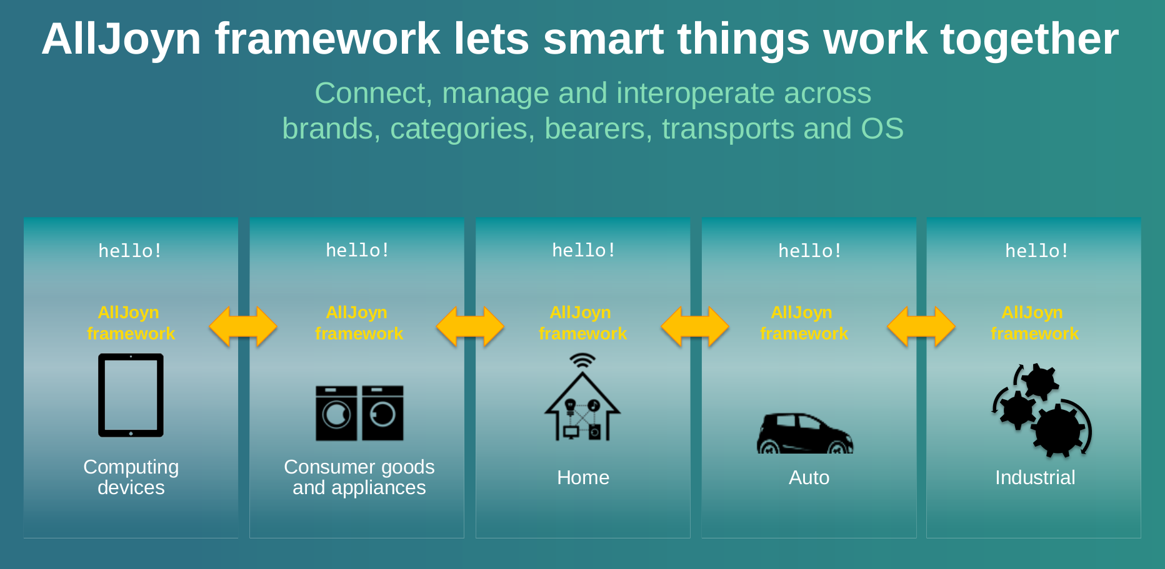

* AllJoyn framework lets the smartthings work together.

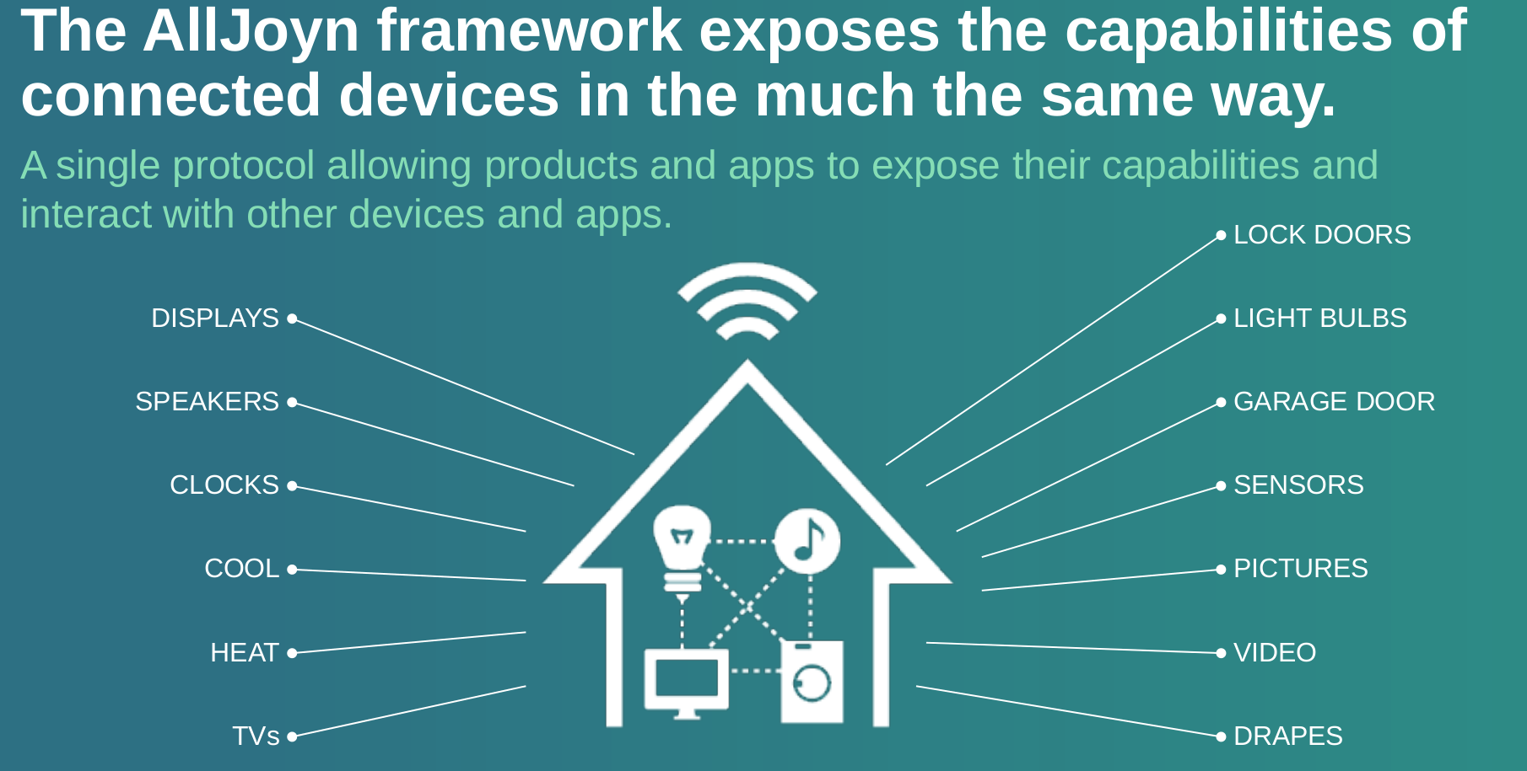

* Connect, manage and interoperate across brands, categories, transport, OS.

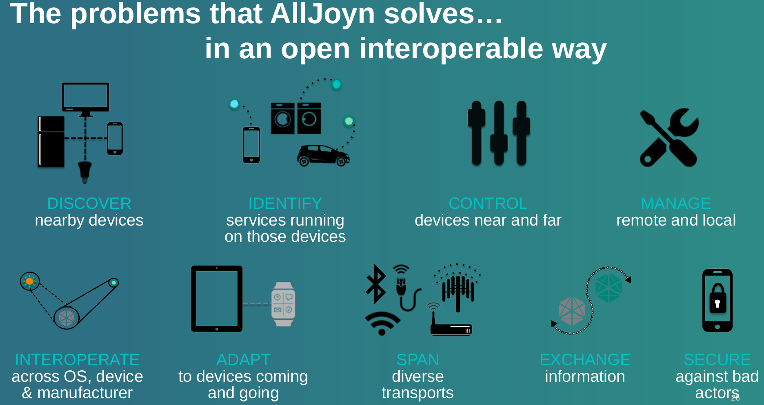

For more reference, check out the links below -

* <https://allseenalliance.org/about>
* download the datasheet - <https://allseenalliance.org/sites/default/files/resources/intro_to_alliance_9.4.15.pdf>
* To learn - <https://allseenalliance.org/developers/learn>

Now, I am searching on -

1. On which protocol mostly companies used for IOT communication – there are two famously used in whole industry. One is zigbee and second is Z-wave. I have to study that.
2. First target the what type of devices we want to communicate and which type of sensors are used.
3. What type of sensors are used currently in the market and how we can get the data from that.
4. Most Important – Data coming from sensors, How we interpret data and in which form we study the data and gives back to the customers in informative form.
5. Currently, I am also working on the Alljoyn framework. How we can that software for our purpose. All coding is done in python and I started working on that.