SIMATS ENGINEERING
SAVEETHA INSTITUTE OF MEDICAL AND TECHNICAL SCIENCES
CHENNAI – 602105
Department of Computer Science and Engineering
ASSESSMENT TOOL 2 – OPEN DATA ANALYSIS

Course Code: | DSA0502
Course Title: | Query Processing for Data Science
CO Assessed: | CO4
Assessment: | Tool 2 – Open Data Analysis
Dataset Domains Chosen: | Question 3 – Education Dataset & Question 5 – Economic/Financial Dataset
Student Name: | ____________________________
Reg. No.: | ____________________________
Section / Batch: | ____________________________
Date of Submission: | ____________________________
Faculty Incharge: | Dr. B. Shyamala Gowri
Project Mode: | Individual Submission

CO4 Statement
Explore datasets using analytical techniques such as grouping, correlation detection, joining datasets, and extracting meaningful insights.

Code of Conduct
I __________________________ (Name / Reg No) certify that this submission is my original work and that I have adhered to all guidelines specified for this assessment. I understand that any violation of academic integrity rules will result in disciplinary action.

Signature: _________________________

1. Introduction and Objective
This report satisfies Assessment Tool 2 (CO4) of the course Query Processing for Data Science. As permitted by the assessment brief, two open dataset domains have been selected and combined into a single joined analysis: the Education domain (Question 3 — state-wise literacy data) and the Economic/Financial domain (Question 5 — state-wise per-capita income data). Both datasets describe the 28 states and select union territories of India and are joined on the common key "State", which allows the relationship between educational attainment and economic prosperity to be explored directly — an approach explicitly encouraged by Question 5 ("combine multiple datasets where applicable").
The objective is to demonstrate the full open-data-analysis workflow prescribed by CO4: importing data, using table functions, filtering and sorting, grouping, correlation detection, outlier detection, joining datasets, visualization, and extraction of meaningful insights.

2. Dataset Description and Source
Two publicly available government datasets were used:
- Education dataset — State-wise Literacy Rate (2011 Census of India), sourced from the Open Government Data (OGD) Platform India / Census of India, Government of India (data.gov.in, censusdata.in).
- Economic dataset — State-wise Per-Capita Net State Domestic Product (NSDP) at current prices for FY 2023-24, sourced from the Reserve Bank of India's Handbook of Statistics on Indian States and the Ministry of Statistics and Programme Implementation (MoSPI).
The two datasets were joined on the "State" field to produce a single working table of 30 states/UTs with the fields: State, Literacy Rate 2011 (%), and Per Capita NSDP 2023-24 (₹). A limitation to note is the ~12-year gap between the literacy census year (2011, the most recent available) and the income year (2023-24); this is a well-known constraint of Indian open data (a new census has not yet been conducted) and is treated as a data limitation rather than an analytical error.

3. Data Import and Table Functions
The joined CSV file was imported into a pandas DataFrame in Python. Basic table functions — .shape, .describe(), .head(), .dtypes — were used to inspect structure and confirm no missing values were present across the 30 rows and 3 columns.
Statistic | Literacy Rate 2011 (%) | Per Capita NSDP 2023-24 (₹)
Count | 30 | 30
Mean | 76.11 | 227,065
Std. Dev. | 8.33 | 125,259
Minimum | 63.82 (Bihar) | 60,337 (Bihar)
Median | 75.70 | 196,276
Maximum | 93.91 (Kerala) | 587,743 (Sikkim)

4. Filtering and Sorting
The dataset was sorted in both directions on each metric to identify leaders and laggards.
Top 5 – Literacy | Bottom 5 – Literacy | Top 5 – Income | Bottom 5 – Income
Kerala (93.91%) | Bihar (63.82%) | Sikkim (₹5,87,743) | Bihar (₹60,337)
Mizoram (91.58%) | Arunachal Pr. (65.38%) | Goa (₹4,92,648) | Uttar Pradesh (₹93,514)
Goa (88.70%) | Jammu & Kashmir (67.16%) | Delhi (₹4,61,910) | Jharkhand (₹1,05,274)
Tripura (87.75%) | Rajasthan (66.11%) | Telangana (₹3,56,564) | Madhya Pradesh (₹1,26,249)
Delhi (86.21%) | Jharkhand (66.41%) | Karnataka (₹3,32,926) | Odisha (₹1,32,197)

A useful filter is states with literacy above the national average (76.1%) but income below the national average (₹2,27,065) — this flags states with strong educational foundations that have not yet translated into commensurate economic output, notably West Bengal, Meghalaya, Manipur, Nagaland and Mizoram.

5. Grouping Analysis
States were grouped into three literacy tiers — Low (<70%), Medium (70–79.9%) and High (≥80%) — and the average per-capita income was computed for each group using a pandas groupby operation.
Literacy Tier | No. of States | Avg. Per Capita NSDP (₹) | Median Per Capita NSDP (₹)
Low (<70%) | 9 | 1,59,606 | 1,26,249
Medium (70–79.9%) | 12 | 2,01,016 | 1,75,020
High (≥80%) | 9 | 3,29,255 | 2,81,001

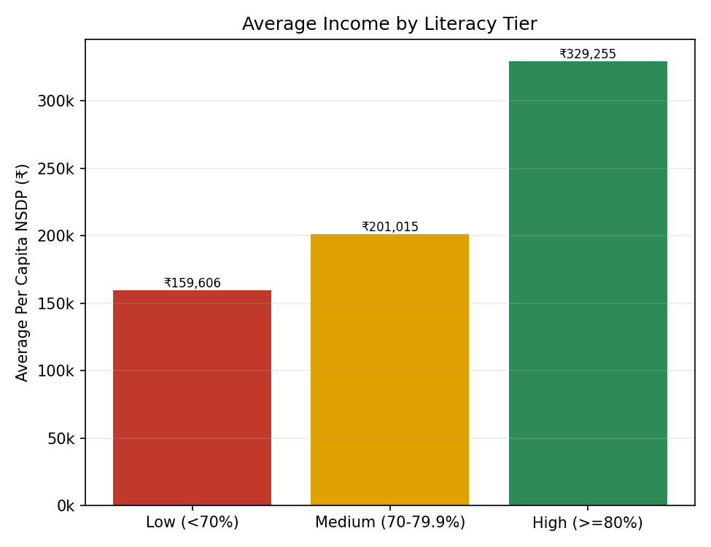
Figure 1: Average per-capita income rises consistently across literacy tiers.
The high-literacy tier's average income (₹3.29 lakh) is more than double that of the low-literacy tier (₹1.60 lakh) — a clear, if not perfectly linear, grouped pattern.

6. Correlation Analysis
Pearson and Spearman correlation coefficients were computed between literacy rate and per-capita income across all 30 states.
- Pearson r = 0.478 (moderate positive linear correlation)
- Spearman ρ = 0.533 (moderate positive rank correlation)
- Pearson r excluding Sikkim & Goa (small, tourism/hydropower-driven economies) = 0.421
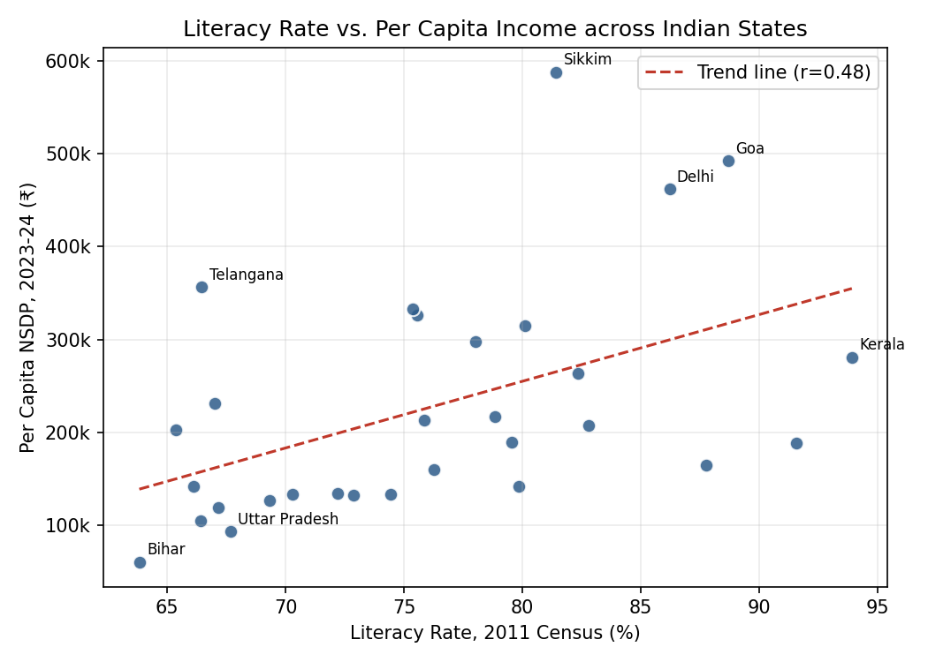
Figure 2: Scatter plot of literacy rate vs. per-capita income with a fitted trend line.
The moderate positive correlation confirms that literacy is associated with higher income, but it is far from deterministic (r ≈ 0.48 explains only about 23% of the variance, r² = 0.228). States such as Telangana, Karnataka, Haryana and Delhi combine only moderate literacy with very high income, driven by IT, services and government-sector concentration rather than mass literacy alone. Conversely, Mizoram and Tripura show high literacy without correspondingly high income, reflecting limited industrial bases in the North-East.

7. Outlier Detection
Outliers were identified using the Interquartile Range (IQR) method (1.5×IQR fences) and cross-verified with z-scores (|z| > 1.5).
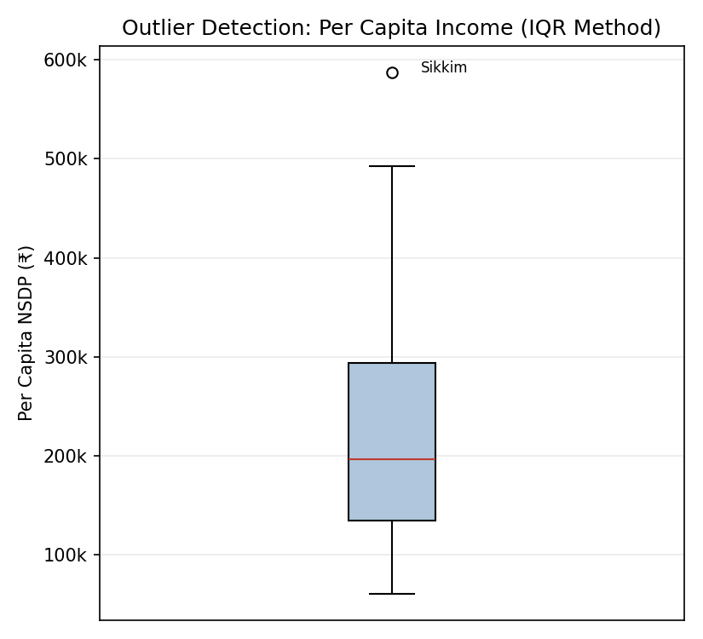
Figure 3: Boxplot of per-capita income — Sikkim sits beyond the upper IQR fence.
Method | Outlier State(s) | Value | Interpretation
IQR (income) | Sikkim | ₹5,87,743 | Beyond upper fence (₹5,32,967); small population inflates the per-capita figure
Z-score (income) | Sikkim, Goa, Delhi | z = 2.88, 2.12, 1.87 | All are small-population / service-dominated economies, not representative of typical states
IQR (literacy) | None detected | — | Literacy values are comparatively tightly clustered; no state falls outside the fences

No outliers were detected on literacy, meaning no state has an anomalously extreme literacy figure relative to the group. On income, Sikkim, Goa and Delhi are consistent outliers under both methods, reflecting a structural feature of Indian regional economics — very small or highly urbanised populations mechanically inflate per-capita figures — rather than a data error.

8. Additional Visualizations
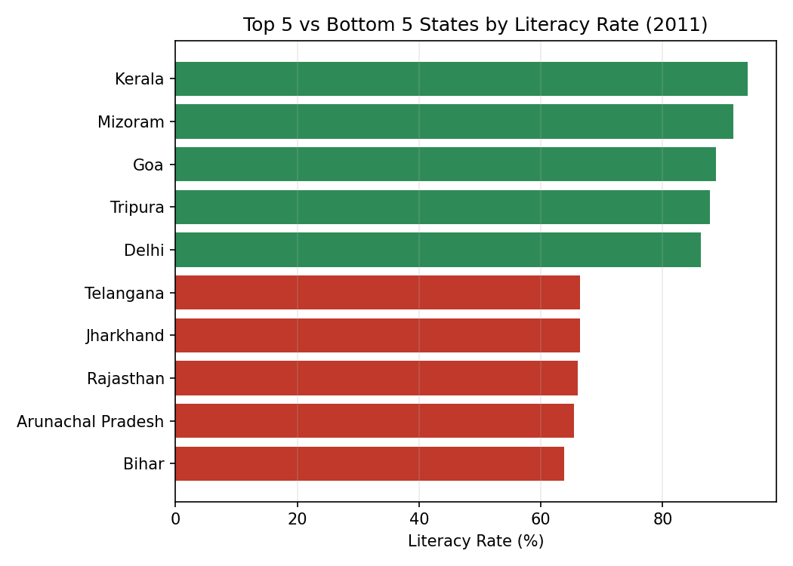
Figure 4: Top 5 and bottom 5 states ranked by literacy rate.
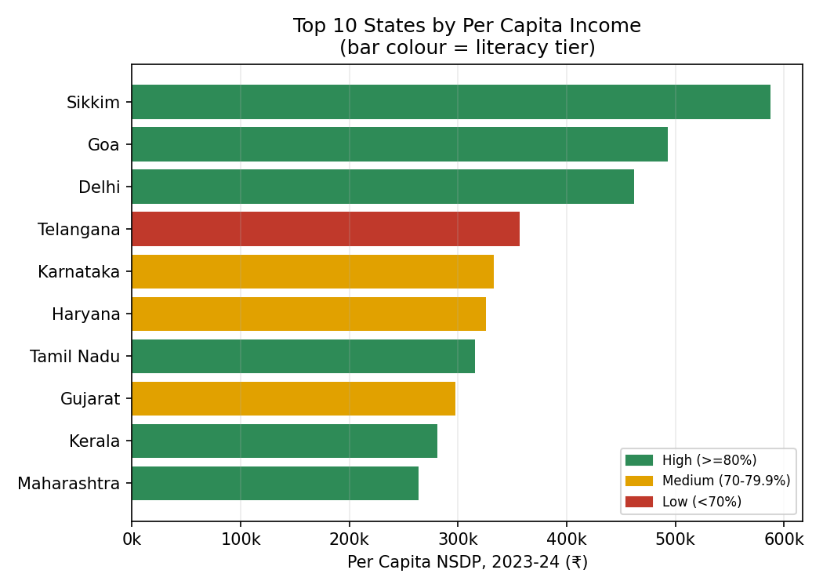
Figure 5: Top 10 states by per-capita income, bar colour indicating literacy tier — most high-income states also fall in the medium/high literacy tiers.

9. Key Insights
- Literacy and per-capita income show a moderate positive relationship (Pearson r ≈ 0.48), confirming education as one contributing factor to state prosperity, but not the only one.
- Grouping by literacy tier shows a clear step-up in average income from Low → Medium → High tiers, supporting the general development narrative.
- Small, service/tourism/hydropower-driven states (Sikkim, Goa, Delhi) are statistical outliers on income and should be interpreted separately from large agrarian states.
- Southern and western states (Tamil Nadu, Karnataka, Telangana, Kerala, Gujarat, Maharashtra) combine reasonably high literacy with strong incomes, consistent with their service- and industry-led economies.
- Bihar is the lowest-ranked state on both literacy (63.82%) and income (₹60,337), making it the clearest joint underperformer and a priority for combined educational and industrial policy intervention.
- States such as Mizoram, Tripura, Manipur and Nagaland show that high literacy does not guarantee high income when industrial infrastructure is limited — underscoring that literacy is necessary but not sufficient for economic development.

10. Conclusion
The combined education–economic dataset analysis fulfils the CO4 requirement to explore data using grouping, correlation detection, joining, and outlier extraction. Joining the two open government datasets on "State" enabled a cross-domain insight that neither dataset could offer alone: that literacy correlates moderately with income, but structural and sectoral factors (services, tourism, IT, population size) play an equally significant role in shaping a state's economic outcome. This kind of combined analysis is a realistic example of the multi-source data science work described in the CO4 statement.

11. Publishing on an Open-Source Platform
In line with the assessment brief, the processed dataset, Python analysis script and charts are intended to be published as a public notebook/repository (e.g., on GitHub or Kaggle) so the analysis is reproducible and open for peer review. The repository should include: data.csv (joined dataset), the analysis script, the five generated charts, and a README summarising the methodology and key insights presented in this report.

12. References
- Census of India / Open Government Data Platform India — State-wise Literacy Rate up to 2011 (data.gov.in, censusdata.in).
- Reserve Bank of India, Handbook of Statistics on Indian States — Per Capita Net State Domestic Product, FY 2023-24.
- Ministry of Statistics and Programme Implementation (MoSPI), Government of India — State income estimates.

