DATA WRANGLING

1. Perform Complete Data Wrangling on a Student Dataset
import pandas as pd
df = pd.read_csv("students.csv")
df.drop_duplicates(inplace=True)
df.fillna({"Name": "Unknown", "Age": df["Age"].mean()}, inplace=True)
df.rename(columns={"Name": "StudentName", "Age": "StudentAge"}, inplace=True)
df["StudentAge"] = df["StudentAge"].astype(int)
df.to_csv("cleaned_students.csv", index=False)
print(df)
print("Cleaned dataset saved successfully.")
OUTPUT:
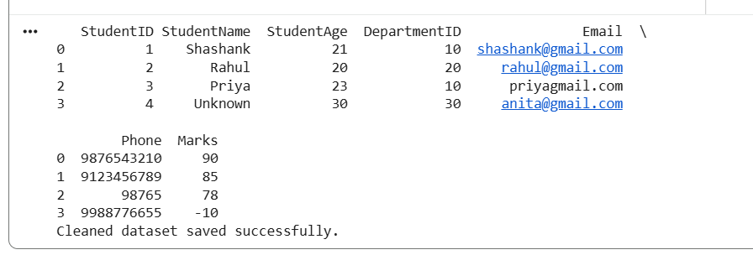

Result: Duplicate records and missing values are handled, columns are renamed, data types are changed, and the cleaned dataset is saved.

2. Merge Student, Department, and Marks Datasets
import pandas as pd
students = pd.read_csv("students.csv")
departments = pd.read_csv("departments.csv")
marks = pd.read_csv("marks.csv")
report = pd.merge(students, departments, on="DepartmentID")
report = pd.merge(report, marks, on="StudentID")
report.to_csv("student_report.csv", index=False)
print(report)
OUTPUT:
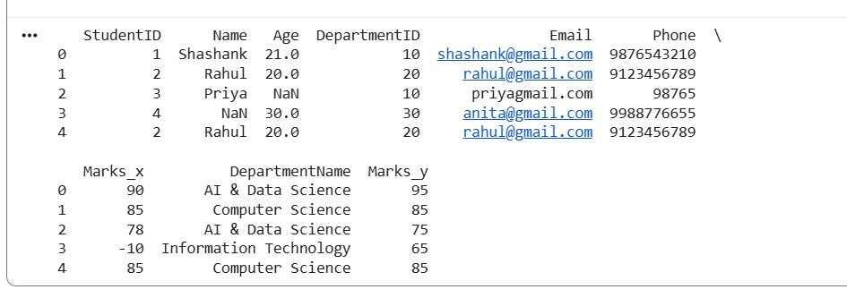
Result: Student, Department, and Marks datasets are merged to generate a consolidated student report.

3. Convert Data Between Multiple Formats
import pandas as pd
df = pd.read_csv("students.csv")
df.to_json("students.json", orient="records", indent=4)
df.to_xml("students.xml", index=False)
json_data = pd.read_json("students.json")
xml_data = pd.read_xml("students.xml")
print("JSON Data:")
print(json_data)
print("\nXML Data:")
print(xml_data)
OUTPUT:
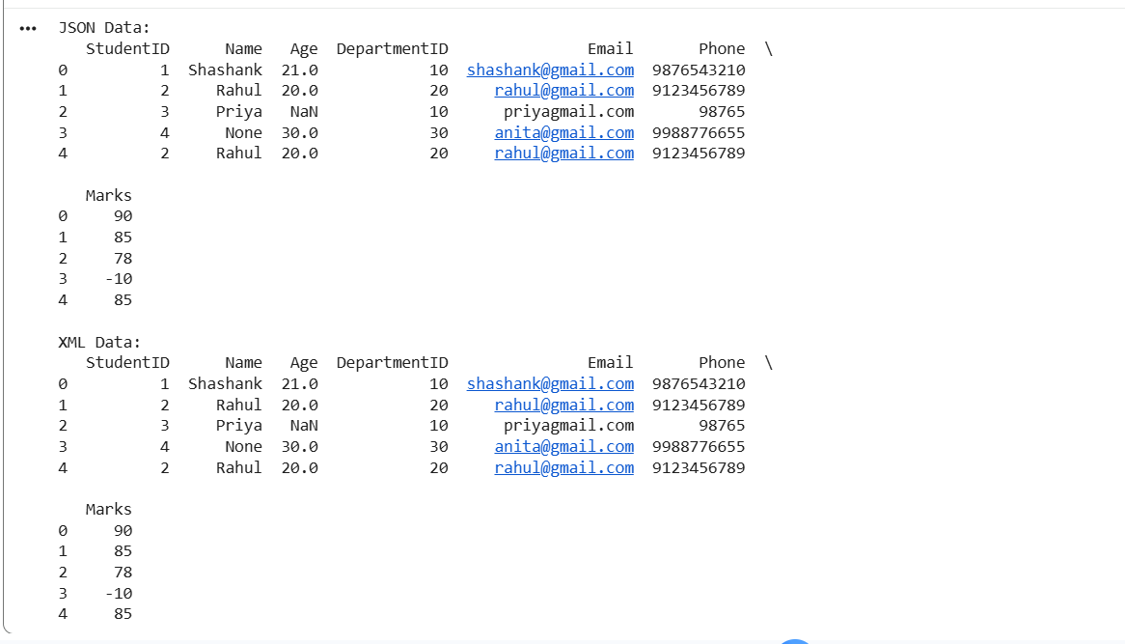
Result: CSV data is converted into JSON and XML formats and verified by reading the generated files.

4. Analyze Student Performance Using Pandas
import pandas as pd
df = pd.read_csv("marks.csv")
print("Highest Marks:", df["Marks"].max())
print("Lowest Marks:", df["Marks"].min())
print("Average Marks:", df["Marks"].mean())
print("Median Marks:", df["Marks"].median())
print("Standard Deviation:", df["Marks"].std())
def assign_grade(mark):
if mark >= 90:
return "A+"
elif mark >= 80:
return "A"
elif mark >= 70:
return "B"
elif mark >= 60:
return "C"
elif mark >= 50:
return "D"
else:
return "F"
df["Grade"] = df["Marks"].apply(assign_grade)
highest_mark = df["Marks"].max()
top_students = df[df["Marks"] == highest_mark]
print("\nStudent Performance:")
print(df)
print("\nTop Performing Students:")
print(top_students)
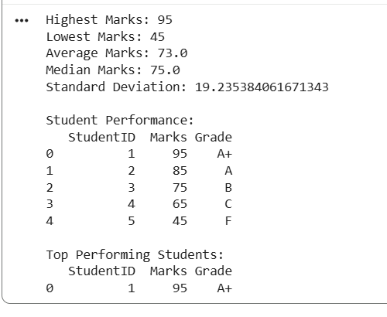
Result: Statistical measures are calculated, grades are assigned, and top-performing students are identified.

5. Read Data from an SQLite Database and Generate Reports
import sqlite3
import pandas as pd
conn = sqlite3.connect("student.db")
query = "SELECT * FROM Student"
df = pd.read_sql_query(query, conn)
print("Student Records:")
print(df)
filtered_data = df[df["Age"] >= 20]
print("\nFiltered Records:")
print(filtered_data)
filtered_data.to_csv("student_database_report.csv", index=False)
conn.close()
print("\nReport exported successfully.")
Result: Records are retrieved from SQLite, filtered based on conditions, and exported to a CSV file.

6. Create and Analyze a Database Schema
import sqlite3
conn = sqlite3.connect("college.db")
cursor = conn.cursor()
cursor.execute("""
CREATE TABLE IF NOT EXISTS Student (
StudentID INTEGER PRIMARY KEY,
StudentName TEXT NOT NULL
)
""")
cursor.execute("""
CREATE TABLE IF NOT EXISTS Course (
CourseID INTEGER PRIMARY KEY,
CourseName TEXT NOT NULL
)
""")
cursor.execute("""
CREATE TABLE IF NOT EXISTS Marks (
StudentID INTEGER,
CourseID INTEGER,
Marks INTEGER,
FOREIGN KEY(StudentID) REFERENCES Student(StudentID),
FOREIGN KEY(CourseID) REFERENCES Course(CourseID)
)
""")
cursor.execute("INSERT OR IGNORE INTO Student VALUES (1, 'Shashank')")
cursor.execute("INSERT OR IGNORE INTO Student VALUES (2, 'Rahul')")
cursor.execute("INSERT OR IGNORE INTO Course VALUES (101, 'Python')")
cursor.execute("INSERT OR IGNORE INTO Course VALUES (102, 'Data Science')")
cursor.execute("INSERT INTO Marks VALUES (1, 101, 90)")
cursor.execute("INSERT INTO Marks VALUES (2, 102, 85)")
conn.commit()
query = """
SELECT Student.StudentName, Course.CourseName, Marks.Marks
FROM Marks
JOIN Student ON Marks.StudentID = Student.StudentID
JOIN Course ON Marks.CourseID = Course.CourseID
"""
cursor.execute(query)
records = cursor.fetchall()
for row in records:
print(row)
conn.close()
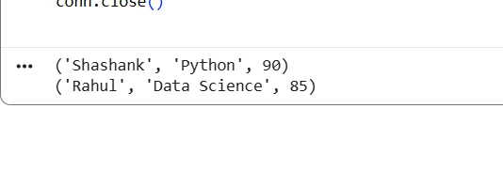
Result: Student, Course, and Marks tables are created with primary and foreign keys, and data is retrieved using SQL JOIN operations.

7. Data Validation and Error Detection
import pandas as pd
import re
df = pd.read_csv("students.csv")
print("Missing Values:")
print(df.isnull().sum())
print("\nDuplicate Records:")
print(df[df.duplicated()])
email_pattern = r'^[\w\.-]+@[\w\.-]+\.\w+$'
df["ValidEmail"] = df["Email"].apply(
lambda x: bool(re.match(email_pattern, str(x)))
)
df["ValidPhone"] = df["Phone"].astype(str).apply(
lambda x: x.isdigit() and len(x) == 10
)
negative_marks = df[df["Marks"] < 0]
print("\nInvalid Emails:")
print(df[df["ValidEmail"] == False])
print("\nInvalid Phone Numbers:")
print(df[df["ValidPhone"] == False])
print("\nNegative Marks:")
print(negative_marks)
df.drop_duplicates(inplace=True)
df.dropna(inplace=True)
df = df[
(df["ValidEmail"] == True) &
(df["ValidPhone"] == True) &
(df["Marks"] >= 0)
]
df.drop(columns=["ValidEmail", "ValidPhone"], inplace=True)
df.to_csv("validated_students.csv", index=False)
print("\nCleaned Dataset:")
print(df)
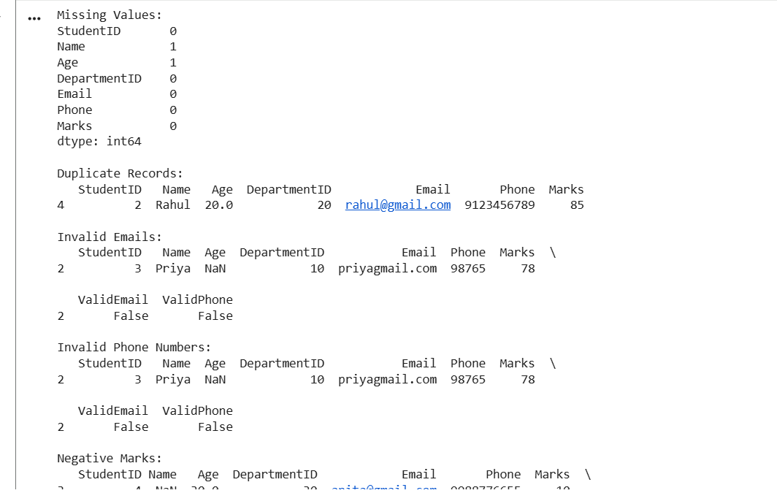
Result: Missing values, duplicates, invalid emails, incorrect phone numbers, and negative marks are detected and removed.

8. Build a Mini Data Wrangling Pipeline
import pandas as pd
csv_data = pd.read_csv("students.csv")
json_data = pd.read_json("students.json")
xml_data = pd.read_xml("students.xml")
combined_data = pd.concat(
[csv_data, json_data, xml_data],
ignore_index=True
)
combined_data.drop_duplicates(inplace=True)
combined_data.dropna(inplace=True)
combined_data.columns = combined_data.columns.str.strip().str.lower()
for column in combined_data.select_dtypes(include="object").columns:
combined_data[column] = combined_data[column].str.strip()
combined_data.to_csv("final_wrangled_data.csv", index=False)
print(combined_data)
print("\nData wrangling pipeline completed.")
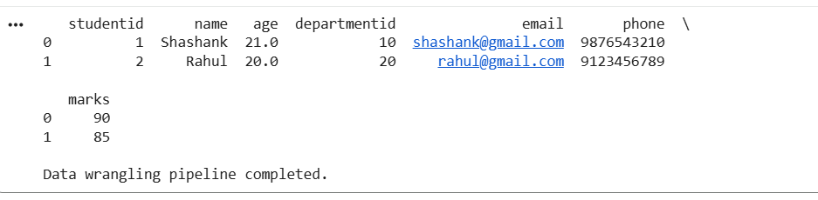
Result: CSV, JSON, and XML data are combined, cleaned, and saved as a final wrangled dataset.

9. Employee Payroll Data Analysis
import pandas as pd
df = pd.read_csv("employee_payroll.csv")
df["NetSalary"] = (
df["BasicSalary"] + df["Allowance"] - df["Deduction"]
)
highest_salary = df[df["NetSalary"] == df["NetSalary"].max()]
department_summary = df.groupby("Department")["NetSalary"].agg(
["sum", "mean", "max"]
)
print("Employee Payroll:")
print(df)
print("\nHighest Salary Employee:")
print(highest_salary)
print("\nDepartment-wise Salary Summary:")
print(department_summary)
df.to_csv("payroll_report.csv", index=False)
department_summary.to_csv("department_salary_summary.csv")
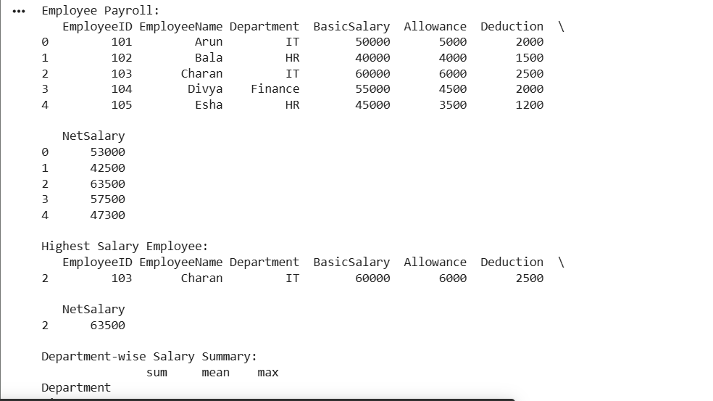
Result: Net salary is calculated, the highest-paid employee is identified, and department-wise salary summaries are generated.

10. Sales Data Analysis Dashboard
import pandas as pd
import glob
files = glob.glob("sales_*.csv")
dataframes = []
for file in files:
df = pd.read_csv(file)
dataframes.append(df)
sales_data = pd.concat(dataframes, ignore_index=True)
sales_data["TotalSales"] = (
sales_data["Quantity"] * sales_data["Price"]
)
total_sales = sales_data["TotalSales"].sum()
monthly_revenue = sales_data.groupby("Month")["TotalSales"].sum()
product_sales = sales_data.groupby("Product")["Quantity"].sum()
top_product = product_sales.idxmax()
print("Total Sales:", total_sales)
print("\nMonthly Revenue:")
print(monthly_revenue)
print("\nProduct Sales:")
print(product_sales)
print("\nTop Selling Product:", top_product)
sales_data.to_csv("combined_sales_report.csv", index=False)
monthly_revenue.to_csv("monthly_revenue_report.csv")
product_sales.to_csv("product_sales_report.csv")

Result: Monthly sales files are merged, total sales and monthly revenue are calculated, and the top-selling product is identified.

