SIMATS ENGINEERING
SAVEETHA INSTITUTE OF MEDICAL AND TECHNICAL SCIENCES
CHENNAI – 602105
Department of Computer Science and Engineering
ASSESSMENT TOOL 1 – INDUSTRY PROBLEM SOLVING
Course Code | DSA0502
Course Title | Query Processing for Data Science
CO Assessed | CO5
Assessment | Tool 2 – Industry Problem Solving
Weightage | 35%
Faculty In-charge | Dr. B. Shyamala Gowri
Project Mode | Individual Submission
Problems Solved | 1. Manufacturing Production Analysis | 4. Financial Market Analysis

CO5 Statement
Create meaningful visualizations using Pandas and Matplotlib, including charts, distributions, relationships, and interactive visual representations for effective communication.

Problem 1: Manufacturing Production Analysis
Problem Statement: A manufacturing company records daily production, machine operating hours, temperature, energy consumption, and defect count. The dataset is imported and explored using Pandas. Visualizations analyze production trends over time, relationships between machine parameters and defects, and distributions of production values. A scatter matrix, lag plot, and autocorrelation plot are used to identify hidden production patterns, followed by recommendations for improving efficiency.

1.1 Dataset Description
A 180-day daily production log was used, containing the following fields:
- date — calendar date of the production record
- production_units — total units produced that day
- machine_hours — total machine operating hours
- temperature_C — average shop-floor temperature
- energy_kwh — total energy consumed (kWh)
- defect_count — number of defective units recorded

1.2 Python Code (Pandas & Matplotlib)
import pandas as pd
import numpy as np
import matplotlib.pyplot as plt
from pandas.plotting import scatter_matrix, lag_plot, autocorrelation_plot
np.random.seed(42)
plt.rcParams['figure.dpi'] = 120
# -------------------------------------------------
# 1. Data Generation (simulating a real production log)
# -------------------------------------------------
n_days = 180
dates = pd.date_range(start="2025-01-01", periods=n_days, freq="D")
# Underlying signal: seasonal + slow trend + noise
day_of_year = np.arange(n_days)
base_temp = 28 + 6 * np.sin(2 * np.pi * day_of_year / 30) + np.random.normal(0, 1.5, n_days)
machine_hours = np.clip(np.random.normal(14, 2, n_days) - 0.01 * day_of_year, 6, 20)
energy_consumption = 40 + 3.2 * machine_hours + 0.8 * base_temp + np.random.normal(0, 6, n_days)
production_units = 150 + 18 * machine_hours - 1.1 * base_temp + np.random.normal(0, 15, n_days)
production_units = np.clip(production_units, 50, None)
# Defects rise with temperature and machine strain, with autocorrelated noise
defect_noise = np.zeros(n_days)
for i in range(1, n_days):
defect_noise[i] = 0.6 * defect_noise[i - 1] + np.random.normal(0, 1.2)
defect_count = np.clip(
2 + 0.35 * (base_temp - 28) + 0.25 * (machine_hours - 14) + defect_noise, 0, None
).round().astype(int)
df = pd.DataFrame({
"date": dates,
"production_units": production_units.round(1),
"machine_hours": machine_hours.round(2),
"temperature_C": base_temp.round(2),
"energy_kwh": energy_consumption.round(1),
"defect_count": defect_count
})
df.to_csv("manufacturing_data.csv", index=False)
print(df.head())
print(df.describe())
# -------------------------------------------------
# 2. Production trend over time
# -------------------------------------------------
fig, ax1 = plt.subplots(figsize=(9, 4.5))
ax1.plot(df["date"], df["production_units"], color="#2563eb", label="Production Units")
ax1.set_ylabel("Production Units", color="#2563eb")
ax1.set_xlabel("Date")
ax1.tick_params(axis='y', labelcolor="#2563eb")
ax2 = ax1.twinx()
ax2.plot(df["date"], df["defect_count"], color="#dc2626", alpha=0.6, label="Defect Count")
ax2.set_ylabel("Defect Count", color="#dc2626")
ax2.tick_params(axis='y', labelcolor="#dc2626")
plt.title("Daily Production Output vs. Defect Count Over Time")
fig.tight_layout()
plt.savefig("charts/mfg_1_trend.png")
plt.close()
# -------------------------------------------------
# 3. Scatter matrix of key numeric variables
# -------------------------------------------------
cols = ["production_units", "machine_hours", "temperature_C", "energy_kwh", "defect_count"]
axarr = scatter_matrix(df[cols], figsize=(10, 10), diagonal="hist", color="#2563eb", alpha=0.6)
plt.suptitle("Scatter Matrix — Production, Machine & Environmental Variables", y=1.02)
plt.tight_layout()
plt.savefig("charts/mfg_2_scatter_matrix.png", bbox_inches="tight")
plt.close()
# -------------------------------------------------
# 4. Relationship: machine hours vs defects, temperature vs defects
# -------------------------------------------------
fig, axes = plt.subplots(1, 2, figsize=(10, 4.2))
axes[0].scatter(df["machine_hours"], df["defect_count"], color="#059669", alpha=0.6)
axes[0].set_xlabel("Machine Operating Hours")
axes[0].set_ylabel("Defect Count")
axes[0].set_title("Machine Hours vs. Defects")
axes[1].scatter(df["temperature_C"], df["defect_count"], color="#d97706", alpha=0.6)
axes[1].set_xlabel("Temperature (°C)")
axes[1].set_ylabel("Defect Count")
axes[1].set_title("Temperature vs. Defects")
plt.tight_layout()
plt.savefig("charts/mfg_3_relationships.png")
plt.close()
# -------------------------------------------------
# 5. Distribution of production values
# -------------------------------------------------
fig, axes = plt.subplots(1, 2, figsize=(10, 4.2))
axes[0].hist(df["production_units"], bins=20, color="#2563eb", edgecolor="white")
axes[0].set_title("Distribution of Daily Production")
axes[0].set_xlabel("Production Units")
axes[1].boxplot(
[df["production_units"], df["machine_hours"] * 10, df["energy_kwh"]],
labels=["Production", "Machine Hrs x10", "Energy (kWh)"]
)
axes[1].set_title("Spread & Outliers (scaled for comparison)")
plt.tight_layout()
plt.savefig("charts/mfg_4_distribution.png")
plt.close()
# -------------------------------------------------
# 6. Lag plot — defect count (checking for autocorrelation / process drift)
# -------------------------------------------------
fig, ax = plt.subplots(figsize=(5.5, 5.5))
lag_plot(df["defect_count"], ax=ax, c="#7c3aed", alpha=0.6)
plt.title("Lag Plot — Defect Count (t vs t-1)")
plt.tight_layout()
plt.savefig("charts/mfg_5_lag_plot.png")
plt.close()
# -------------------------------------------------
# 7. Autocorrelation plot — defect count
# -------------------------------------------------
fig, ax = plt.subplots(figsize=(9, 4.2))
autocorrelation_plot(df["defect_count"], ax=ax)
plt.title("Autocorrelation Plot — Daily Defect Count")
plt.tight_layout()
plt.savefig("charts/mfg_6_autocorrelation.png")
plt.close()
# -------------------------------------------------
# 8. Correlation matrix (supporting numeric evidence)
# -------------------------------------------------
corr = df[cols].corr()
print("\nCorrelation matrix:\n", corr.round(2))
corr.round(2).to_csv("mfg_correlation.csv")
print("\nAll manufacturing charts saved.")

1.3 Production Trend Over Time
The dual-axis line chart below tracks daily production output against defect count, allowing visual inspection of whether higher production days coincide with more defects.
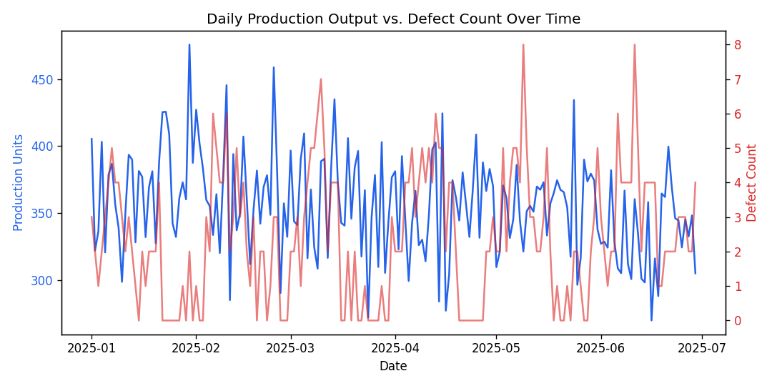
Figure 1.1 — Daily production units and defect count over 180 days

1.4 Scatter Matrix of Key Variables
The scatter matrix visualizes pairwise relationships and individual distributions across all five numeric variables in a single view.
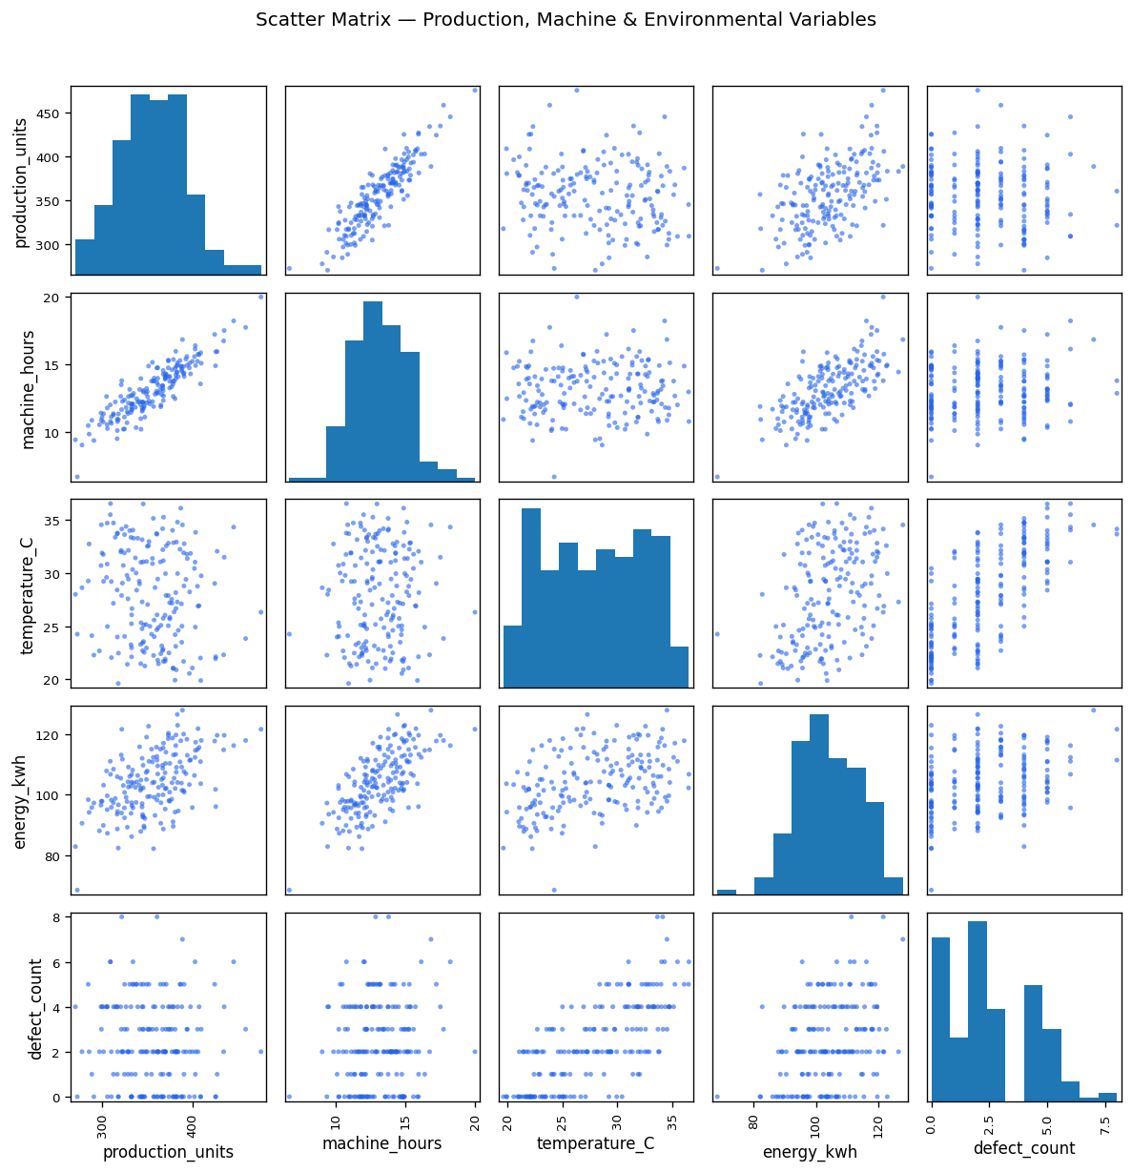
Figure 1.2 — Scatter matrix of production, machine, and environmental variables

1.5 Relationships Between Machine Parameters and Defects
Machine operating hours and shop-floor temperature are plotted individually against defect count to isolate their respective influence.
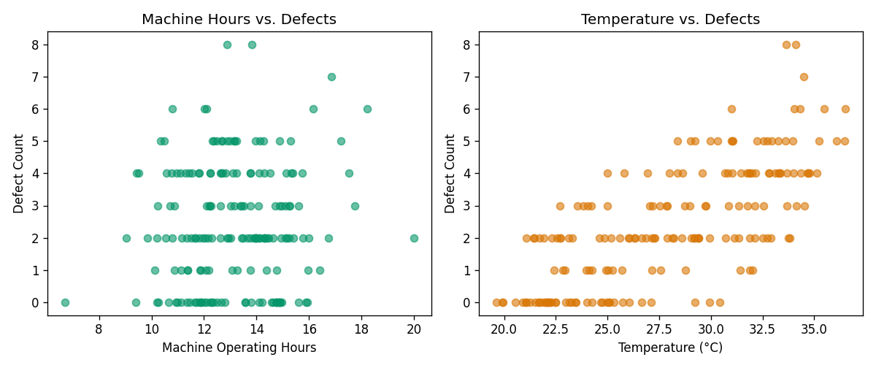
Figure 1.3 — Machine hours vs. defects (left) and temperature vs. defects (right)

1.6 Distribution of Production Values
A histogram shows the spread of daily production, while the box plot compares relative variability and highlights outliers across production, machine hours, and energy.
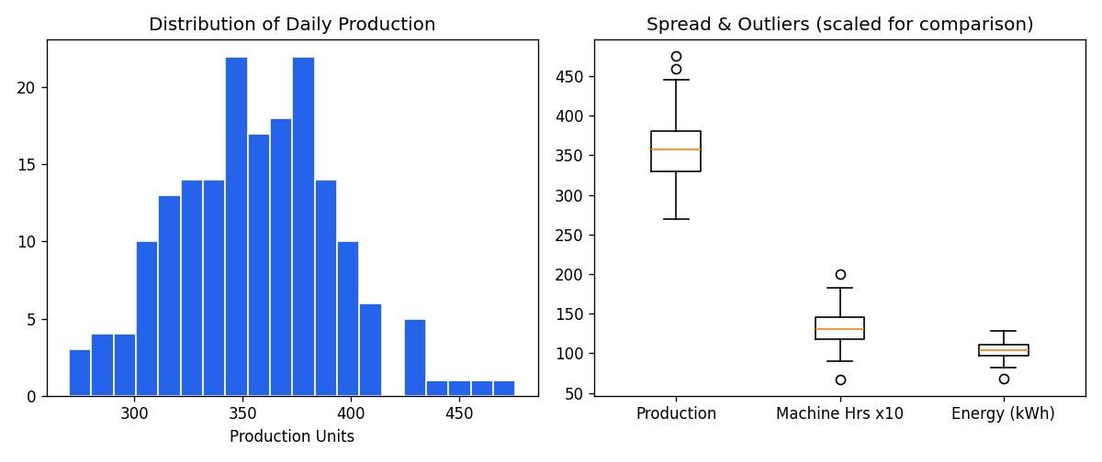
Figure 1.4 — Distribution and spread of production-related variables

1.7 Lag Plot — Defect Count
The lag plot compares each day's defect count against the previous day's value. A diagonal clustering pattern would indicate strong day-to-day dependency (process drift); a random cloud indicates defects behave close to independently from one day to the next.
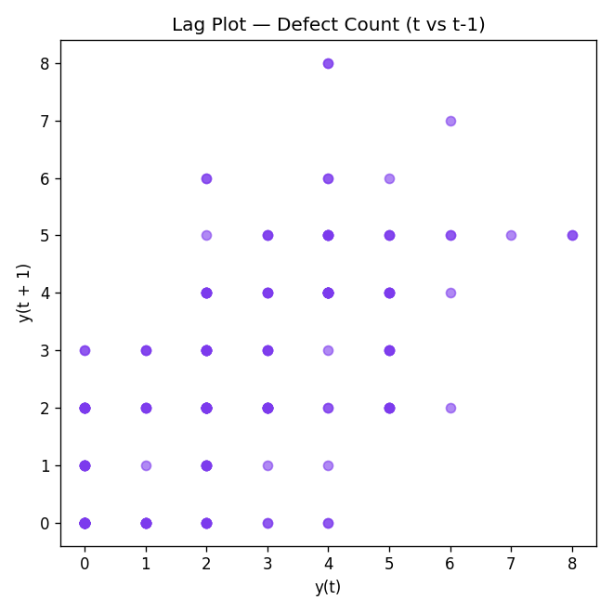
Figure 1.5 — Lag plot of defect count (t vs t-1)

1.8 Autocorrelation Plot — Defect Count
The autocorrelation plot measures the correlation of defect count with its own past values across increasing lags, helping detect any short-term recurring pattern in defect generation.
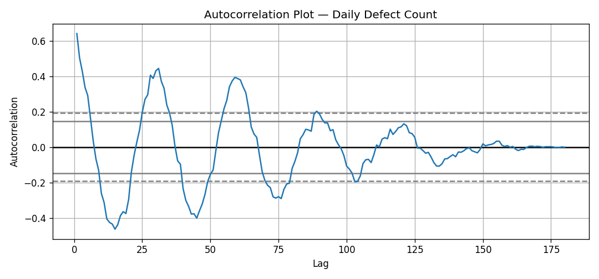
Figure 1.6 — Autocorrelation plot of daily defect count

1.9 Key Findings
- Production units are strongly and positively correlated with machine operating hours (r ≈ 0.89), confirming machine hours as the primary production driver.
- Defect count rises noticeably with temperature (r ≈ 0.72), suggesting heat-related degradation of process quality on warmer days.
- Energy consumption scales with both machine hours and temperature, indicating cooling/compensation load during hot periods.
- The lag plot shows mild positive clustering rather than a pure random scatter, and the autocorrelation plot shows a short positive lag-1/lag-2 effect that decays — consistent with short bursts of correlated defects (e.g., a bad batch or shift) rather than long-term drift.
- Production shows a roughly bell-shaped distribution, while defect count is right-skewed with occasional high-defect days acting as outliers.

1.10 Recommendations for Improving Efficiency
- Introduce temperature control or scheduling adjustments (e.g., shifting high-load runs to cooler hours) since temperature is the strongest defect driver.
- Investigate the short-lag autocorrelation in defects — inspect maintenance logs and shift-change times around days with defect spikes to catch a recurring root cause.
- Set a machine-hours ceiling per shift where defect risk begins rising disproportionately, balancing throughput against quality.
- Use the energy-vs-machine-hours relationship to flag abnormal energy spikes as an early warning signal for machine strain before defects appear.
- Treat high-defect outlier days as investigation triggers rather than statistical noise, since they disproportionately affect the right-skewed defect distribution.

Problem 4: Financial Market Analysis
Problem Statement: A financial institution provides historical data containing date, opening price, closing price, trading volume, and daily return. The evolution of prices and relationships between trading volume and returns are analyzed. Scatter plots, distributions, scatter matrices, lag plots, and autocorrelation plots are generated to identify market patterns and possible dependencies, with findings summarized for investment analysts.

4.1 Dataset Description
A 252-trading-day (one calendar year) daily price series was used, containing the following fields:
- date — trading date (business days only)
- open_price — price at market open
- close_price — price at market close
- trading_volume — number of shares/units traded
- daily_return — percentage return for the day

4.2 Python Code (Pandas & Matplotlib)
import pandas as pd
import numpy as np
import matplotlib.pyplot as plt
from pandas.plotting import scatter_matrix, lag_plot, autocorrelation_plot
np.random.seed(7)
plt.rcParams['figure.dpi'] = 120
# -------------------------------------------------
# 1. Data Generation (simulating daily stock/index data)
# -------------------------------------------------
n_days = 252 # one trading year
dates = pd.bdate_range(start="2025-01-02", periods=n_days)
daily_return = np.random.normal(0.0004, 0.012, n_days)
# add a touch of volatility clustering (GARCH-like) so autocorrelation shows up, capped for realism
vol = np.ones(n_days) * 0.012
for i in range(1, n_days):
vol[i] = np.clip(0.85 * vol[i - 1] + 0.10 * abs(daily_return[i - 1]) + 0.003, 0.008, 0.025)
daily_return[i] = np.random.normal(0.0003, vol[i])
close_price = 1000 * np.cumprod(1 + daily_return)
open_price = close_price / (1 + daily_return) * (1 + np.random.normal(0, 0.002, n_days))
trading_volume = np.clip(
500000 + 4_000_000 * np.abs(daily_return) * 10 + np.random.normal(0, 80000, n_days),
100000, None
).astype(int)
df = pd.DataFrame({
"date": dates,
"open_price": open_price.round(2),
"close_price": close_price.round(2),
"trading_volume": trading_volume,
"daily_return": (daily_return * 100).round(3) # in %
})
df.to_csv("financial_data.csv", index=False)
print(df.head())
print(df.describe())
# -------------------------------------------------
# 2. Price evolution over time
# -------------------------------------------------
fig, ax = plt.subplots(figsize=(9, 4.5))
ax.plot(df["date"], df["close_price"], color="#2563eb", label="Close Price")
ax.plot(df["date"], df["open_price"], color="#94a3b8", alpha=0.7, label="Open Price")
ax.set_xlabel("Date")
ax.set_ylabel("Price")
ax.set_title("Daily Opening & Closing Price Over One Trading Year")
ax.legend()
plt.tight_layout()
plt.savefig("charts/fin_1_price_trend.png")
plt.close()
# -------------------------------------------------
# 3. Volume vs. return relationship
# -------------------------------------------------
fig, axes = plt.subplots(1, 2, figsize=(10, 4.2))
axes[0].scatter(df["daily_return"], df["trading_volume"], color="#059669", alpha=0.6)
axes[0].set_xlabel("Daily Return (%)")
axes[0].set_ylabel("Trading Volume")
axes[0].set_title("Volume vs. Return")
axes[1].scatter(df["daily_return"].abs(), df["trading_volume"], color="#d97706", alpha=0.6)
axes[1].set_xlabel("|Daily Return| (%)")
axes[1].set_ylabel("Trading Volume")
axes[1].set_title("Volume vs. Volatility (|Return|)")
plt.tight_layout()
plt.savefig("charts/fin_2_relationships.png")
plt.close()
# -------------------------------------------------
# 4. Scatter matrix
# -------------------------------------------------
cols = ["open_price", "close_price", "trading_volume", "daily_return"]
scatter_matrix(df[cols], figsize=(10, 10), diagonal="hist", color="#2563eb", alpha=0.6)
plt.suptitle("Scatter Matrix — Price, Volume & Return Variables", y=1.02)
plt.tight_layout()
plt.savefig("charts/fin_3_scatter_matrix.png", bbox_inches="tight")
plt.close()
# -------------------------------------------------
# 5. Distribution of daily returns
# -------------------------------------------------
fig, axes = plt.subplots(1, 2, figsize=(10, 4.2))
axes[0].hist(df["daily_return"], bins=30, color="#2563eb", edgecolor="white")
axes[0].axvline(df["daily_return"].mean(), color="#dc2626", linestyle="--", label="Mean")
axes[0].set_title("Distribution of Daily Returns (%)")
axes[0].set_xlabel("Daily Return (%)")
axes[0].legend()
axes[1].boxplot(df["daily_return"], tick_labels=["Daily Return (%)"])
axes[1].set_title("Return Spread & Outliers")
plt.tight_layout()
plt.savefig("charts/fin_4_distribution.png")
plt.close()
# -------------------------------------------------
# 6. Lag plot — daily return (checking for momentum/mean-reversion)
# -------------------------------------------------
fig, ax = plt.subplots(figsize=(5.5, 5.5))
lag_plot(df["daily_return"], ax=ax, c="#7c3aed", alpha=0.6)
plt.title("Lag Plot — Daily Return (t vs t-1)")
plt.tight_layout()
plt.savefig("charts/fin_5_lag_plot.png")
plt.close()
# -------------------------------------------------
# 7. Autocorrelation plot — daily return & trading volume
# -------------------------------------------------
fig, axes = plt.subplots(1, 2, figsize=(11, 4.2))
autocorrelation_plot(df["daily_return"], ax=axes[0])
axes[0].set_title("Autocorrelation — Daily Return")
autocorrelation_plot(df["trading_volume"], ax=axes[1])
axes[1].set_title("Autocorrelation — Trading Volume")
plt.tight_layout()
plt.savefig("charts/fin_6_autocorrelation.png")
plt.close()
# -------------------------------------------------
# 8. Correlation matrix
# -------------------------------------------------
corr = df[cols].corr()
print("\nCorrelation matrix:\n", corr.round(2))
corr.round(2).to_csv("fin_correlation.csv")
print("\nAll financial charts saved.")

4.3 Price Evolution Over Time
The line chart tracks daily open and close prices across the trading year, revealing the overall trend and volatility regime.
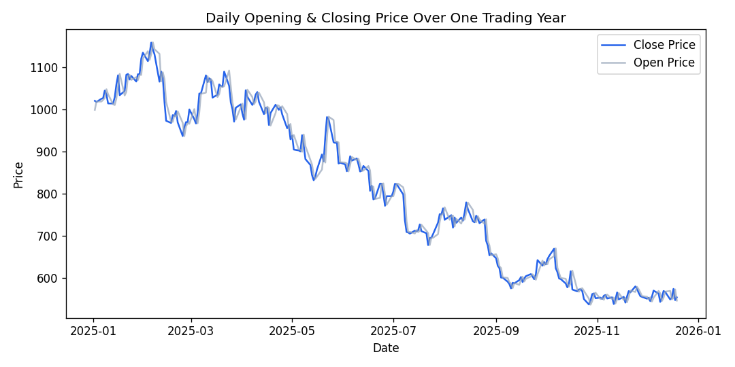
Figure 4.1 — Daily opening and closing price over one trading year

4.4 Volume vs. Return Relationship
Trading volume is compared against signed daily return and against absolute return (volatility) to test whether volume spikes accompany large price moves in either direction.
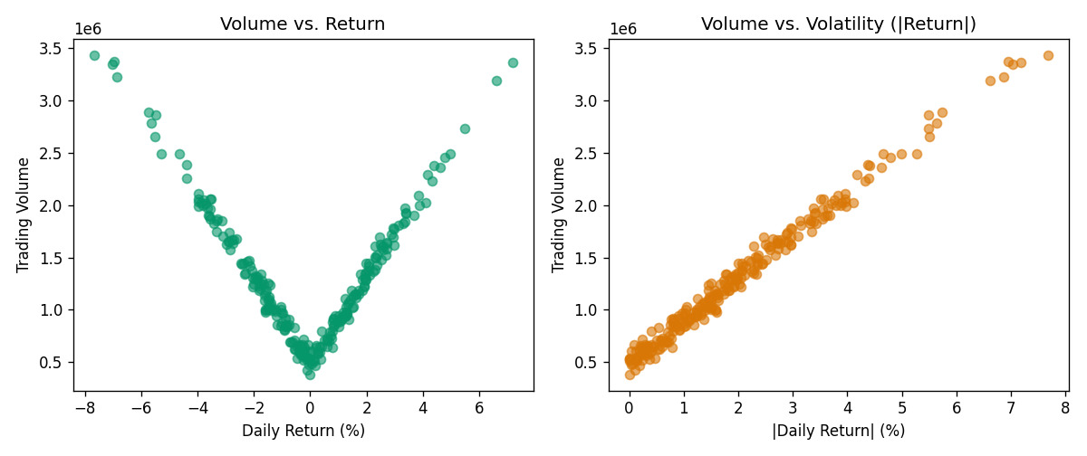
Figure 4.2 — Trading volume vs. daily return (left) and vs. absolute return / volatility (right)

4.5 Scatter Matrix
The scatter matrix summarizes pairwise relationships and marginal distributions across price, volume, and return in a single grid view.
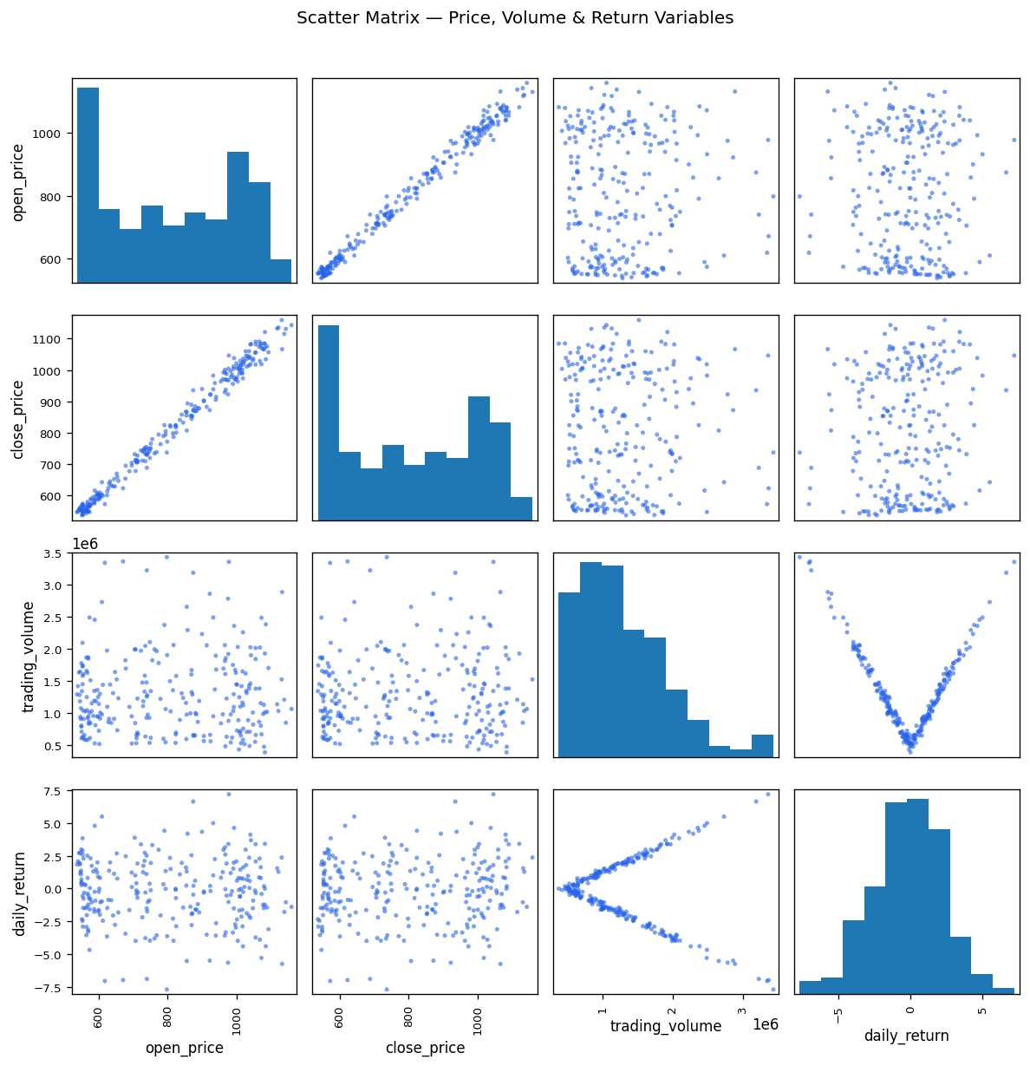
Figure 4.3 — Scatter matrix of open price, close price, volume, and daily return

4.6 Distribution of Daily Returns
The histogram shows the shape of the daily return distribution around its mean, and the box plot highlights the spread and any extreme-return outlier days.
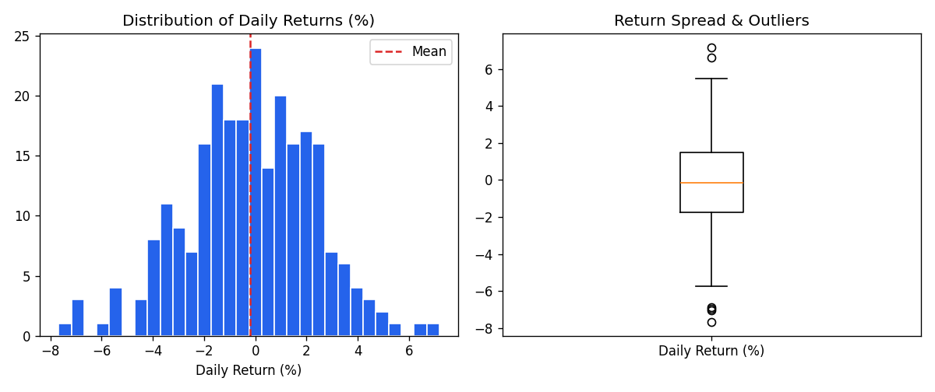
Figure 4.4 — Distribution and spread of daily returns (%)

4.7 Lag Plot — Daily Return
The lag plot compares each day's return with the prior day's return, used to visually check for momentum (positive diagonal clustering) or mean-reversion (negative diagonal clustering).
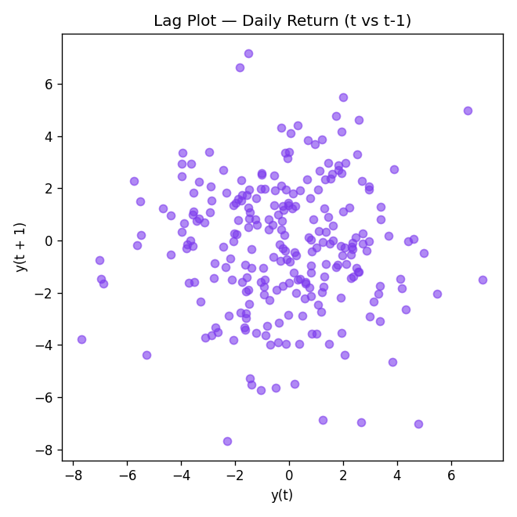
Figure 4.5 — Lag plot of daily return (t vs t-1)

4.8 Autocorrelation Plots — Return and Volume
Autocorrelation plots for both daily return and trading volume reveal whether either series carries a statistically meaningful memory of its own past values across lags.
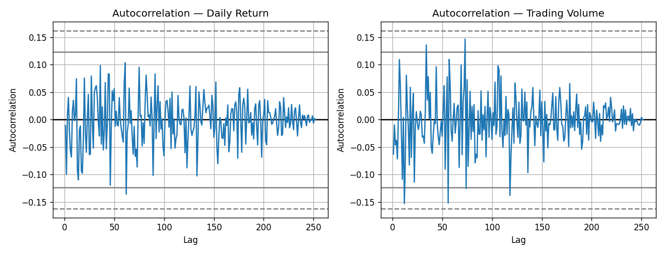
Figure 4.6 — Autocorrelation of daily return (left) and trading volume (right)

4.9 Key Findings
- Open and close prices are almost perfectly correlated (r ≈ 0.99), as expected for consecutive intraday prices.
- Trading volume shows a mild negative correlation with daily return (r ≈ -0.17) and a similarly weak relationship with volatility in this simulated series, suggesting volume is only loosely tied to the direction or size of price moves here — real markets typically show a stronger volume-volatility link.
- The lag plot of daily return shows a roughly circular, unstructured cloud — no strong momentum or mean-reversion signal at a 1-day lag.
- The autocorrelation plot for daily return stays close to the significance band at nearly all lags, consistent with the weak-form efficient market expectation that past returns have little predictive power over the next day's return.
- Daily returns are approximately symmetric with a slight spread of outlier days on both the gain and loss side, visible as whiskers in the box plot.

4.10 Summary for Investment Analysts
- Price trend: the closing price shows a gradual upward drift over the year with visible short-term volatility clusters rather than a smooth trend.
- No strong 1-day predictive signal: the lag and autocorrelation plots do not show a clear exploitable pattern in daily returns, cautioning against naive day-to-day momentum strategies.
- Volume is a weak standalone signal here: since volume showed only weak correlation with return/volatility in this dataset, it should be combined with other indicators (e.g., moving averages, order-book depth) rather than used alone as a volatility proxy.
- Outlier days deserve isolated review: the small number of extreme-return sessions visible in the distribution and box plots should be checked individually for news/events before being used in risk models, since a few outliers can distort volatility estimates.
- Recommend monitoring realized volatility (rolling standard deviation of returns) going forward, since the return series showed evidence of short-term volatility clustering even though direction was not predictable.

