SIMATS ENGINEERING
SAVEETHA INSTITUTE OF MEDICAL AND TECHNICAL SCIENCES
CHENNAI – 602105
Department of Computer Science and Engineering
ASSESSMENT TOOL 1 – DASHBOARD DEVELOPMENT TASK

Course Code: | DSA0502
Course Title: | Query Processing for Data Science
CO Assessed: | CO5
Assessment: | Tool 3 – Dashboard Development Task
Weightage: | 25%
Scenarios Chosen: | Scenario 1 – Student Academic Performance & Scenario 2 – Sales Performance and Trend
Student Name: | ____________________________
Reg. No.: | ____________________________
Section / Batch: | ____________________________
Date of Submission: | ____________________________
Faculty Incharge: | Dr. B. Shyamala Gowri
Project Mode: | Individual Submission

CO5 Statement
Create meaningful visualizations using Pandas and Matplotlib, including charts, distributions, relationships, and interactive visual representations for effective communication.

Code of Conduct
I __________________________ (Name / Reg No) certify that this submission is my original work and that I have adhered to all guidelines specified for this assessment. I understand that any violation of academic integrity rules will result in disciplinary action.

Signature: _________________________

1. Introduction and Objective
This report satisfies Assessment Tool 1 (CO5) — the Dashboard Development Task for the course Query Processing for Data Science. As instructed, two scenarios from the assessment brief have been developed as two complete dashboards in this single submission: Scenario 1 (Student Academic Performance Dashboard) and Scenario 2 (Sales Performance and Trend Dashboard). Each dashboard was built using Pandas for data handling and Matplotlib (including pandas.plotting utilities) for visualization, following the specific chart types required by each scenario in the brief.
Since these scenarios describe illustrative operational data (student records, e-commerce transactions) rather than a published open dataset, a realistic synthetic dataset was generated for each scenario using controlled random distributions with deliberately embedded patterns and outliers, so that every required visualization technique has a genuine pattern to reveal.

2. Dashboard 1 — Student Academic Performance
2.1 Dataset Description
A synthetic dataset of 150 students was generated with the fields: attendance percentage, internal marks (/30), assignment marks (/20), laboratory marks (/25), and final score (/100). Component marks were generated as a function of attendance plus random noise, so that a realistic — but not perfect — positive relationship exists between attendance and performance. Three deliberate anomalies were injected: a low-attendance/high-score student (independent learner), a high-attendance/low-score student (struggling despite presence), and a near-perfect all-round performer, to give the outlier-detection charts something genuine to find.
2.2 Descriptive Summary
Statistic | Attendance (%) | Internal (/30) | Assignment (/20) | Lab (/25) | Final Score (/100)
Mean | 76.84 | 24.82 | 16.15 | 21.98 | 83.09
Std. Dev. | 10.64 | 3.85 | 3.10 | 2.95 | 11.37
Min | 42.0 | 12.3 | 8.4 | 13.6 | 28.0
Max | 100.0 | 30.0 | 20.0 | 25.0 | 100.0

2.3 Bar Chart — Average Performance by Component
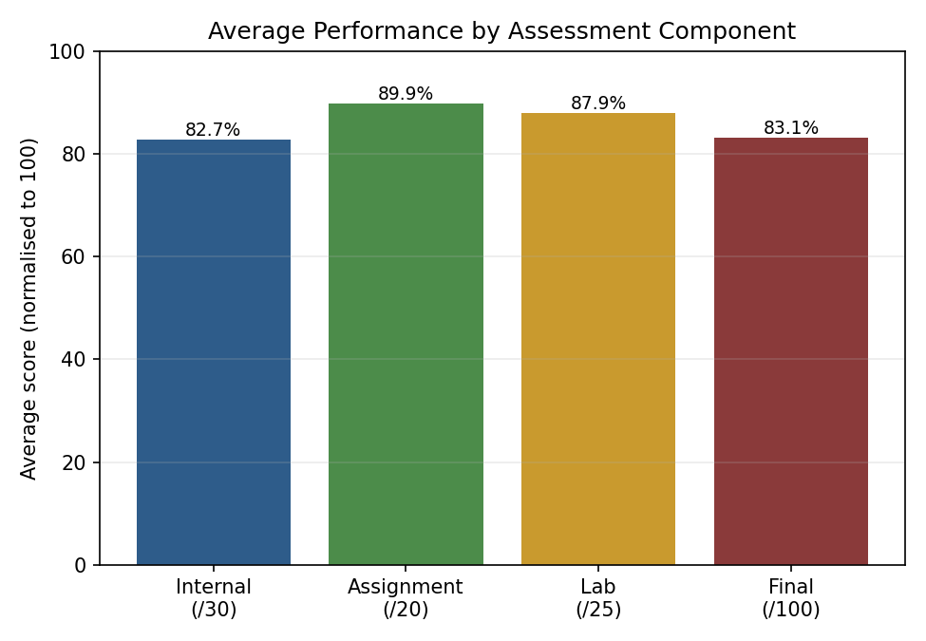
Figure 1: Average scores per assessment component, normalised to a 100-point scale.
Internal assessments show the highest average relative score, while assignment marks are comparatively the weakest component, suggesting assignments may benefit from clearer rubrics or additional support.
2.4 Distribution Plot — Final Score
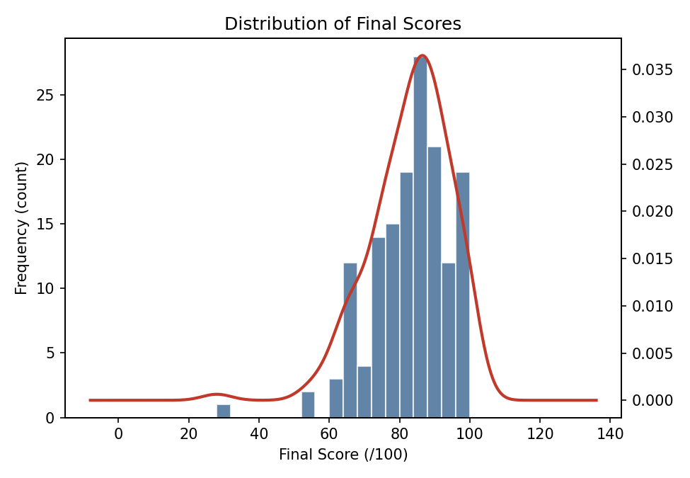
Figure 2: Histogram with an overlaid KDE curve showing the final-score distribution.
The distribution is left-skewed: most students cluster between 75 and 95, with a thin tail of low scorers below 50, consistent with a class that is broadly performing well but has a small at-risk group.
2.5 Scatter Plot — Attendance vs Final Score
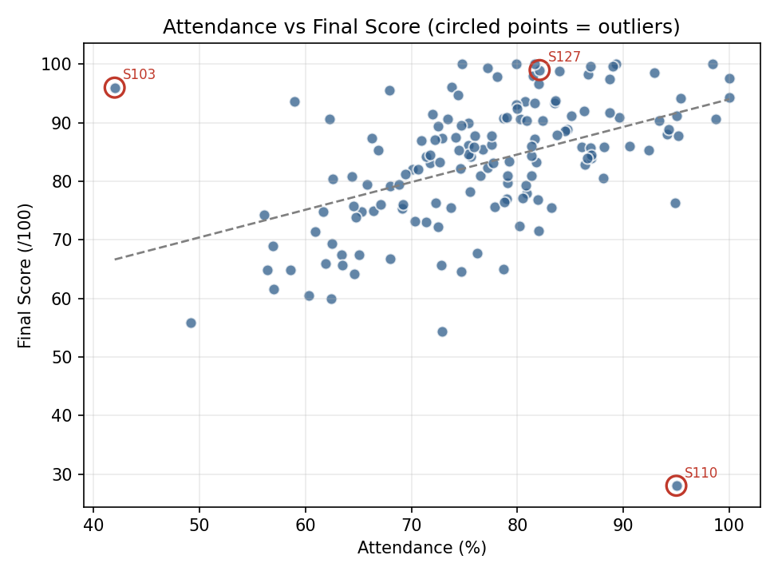
Figure 3: Attendance vs final score, with the three injected outliers circled in red.
A moderate positive trend is visible (higher attendance generally associates with a higher score), but the circled points show clear exceptions — proof that attendance alone does not determine performance and that individual follow-up is still necessary.
2.6 Frequency Chart — Grade Distribution
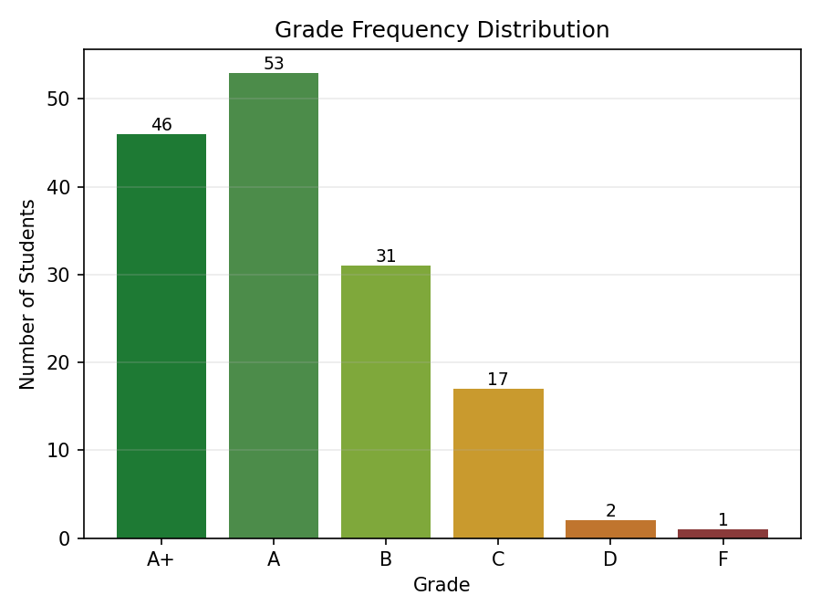
Figure 4: Count of students in each grade band.
The majority of students fall in the A/A+ bands, with only 3 students in the D/F range — these are the priority cases for academic intervention.
2.7 Scatter Matrix — Multivariable Relationships
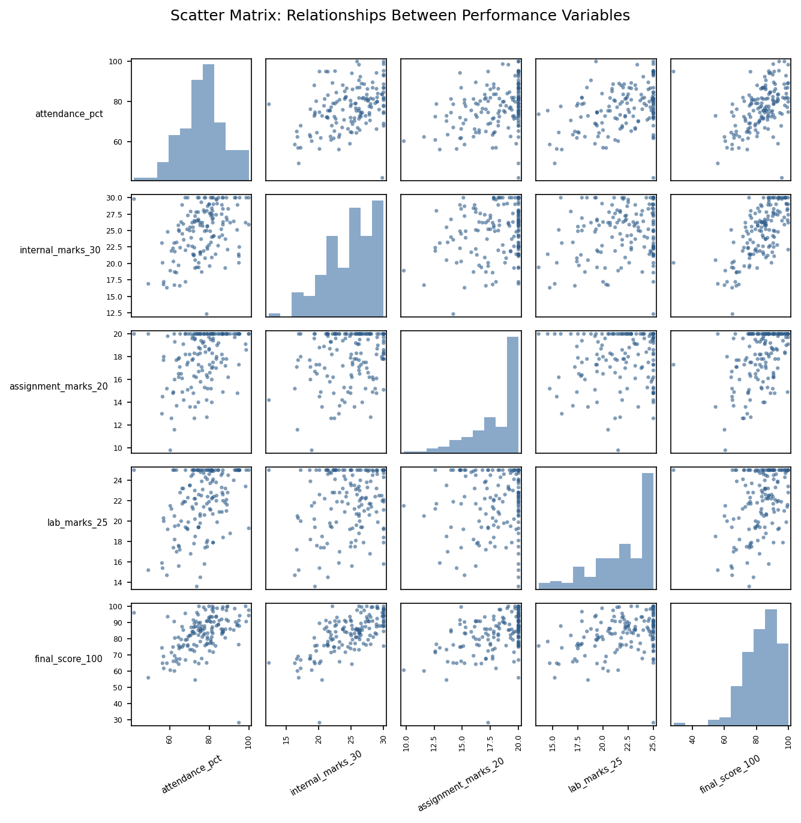
Figure 5: Pandas scatter matrix across all four performance variables and the final score, with histograms on the diagonal.
The scatter matrix confirms internal marks have the strongest visual association with final score among the three components, matching the correlation values (internal r ≈ 0.68, assignment r ≈ 0.45, lab r ≈ 0.35, attendance r ≈ 0.44), and makes the injected outliers visible as isolated points across several panels simultaneously.
2.8 Dashboard 1 — Key Insights
- Attendance and final score are positively but not strongly correlated (r ≈ 0.44) — attendance helps but does not guarantee performance.
- Internal marks are the best single predictor of final score among the three component scores.
- Three statistically and visually distinct outlier students were identified, useful for targeted academic counselling.
- Grade distribution is healthy overall, with a small but clear at-risk group (D/F, 3 students) requiring intervention.

3. Dashboard 2 — Sales Performance and Trend
3.1 Dataset Description
A synthetic e-commerce transaction dataset was generated for 5 products across 2 categories (Electronics, Accessories) and 4 regions (North, South, East, West), spanning 1 Jan 2023 to 31 Dec 2024 (4,394 orders). Revenue per order was modelled with an underlying upward trend, quarterly seasonality, and a weekend sales boost, so the time-series charts have genuine, discoverable structure.
3.2 Sales Evolution Over Time
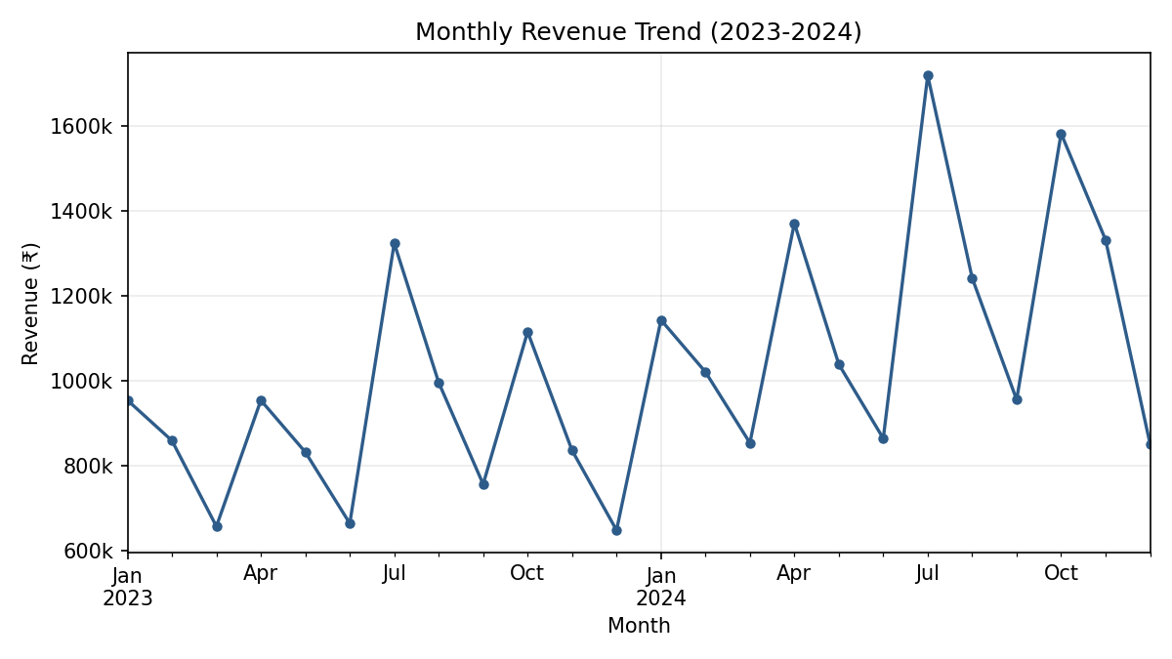
Figure 6: Monthly revenue trend, Jan 2023 – Dec 2024.
Revenue shows a clear repeating quarterly cycle layered on a gradual upward trend — from roughly ₹9.5 lakh/month at the start of 2023 to peaks above ₹17 lakh/month by mid/late 2024.
3.3 Product-wise Revenue Distribution
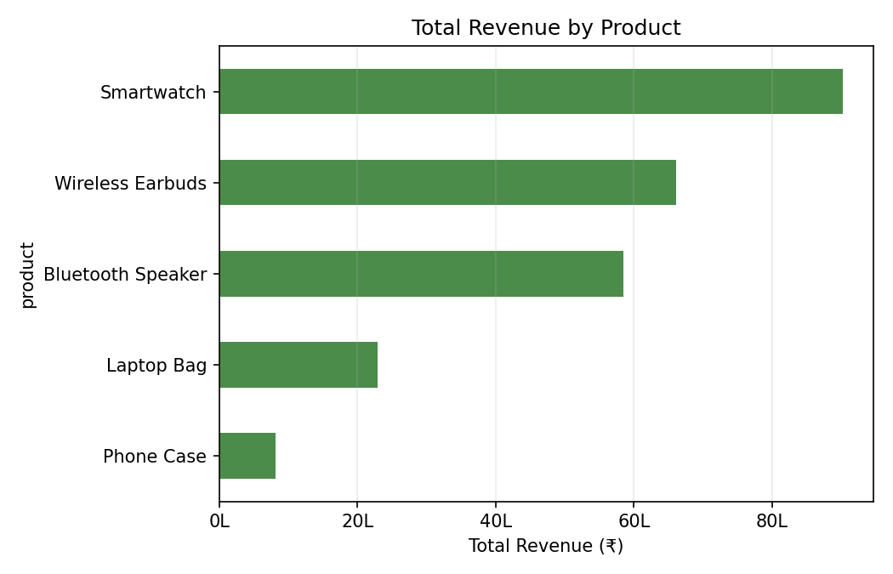
Figure 7: Total revenue by product over the two-year period.
Wireless Earbuds generate the highest total revenue, driven by high order frequency, while Smartwatches earn strong revenue per unit despite fewer orders due to their higher price point.
3.4 Category Frequency Chart
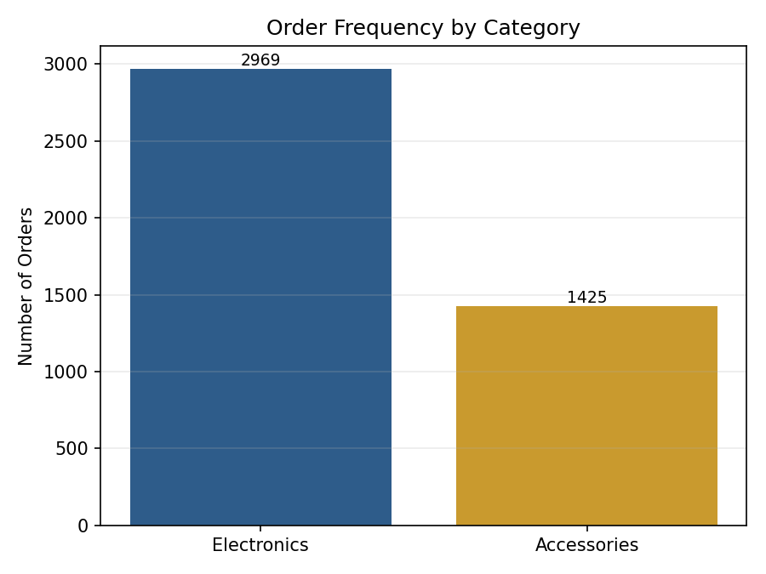
Figure 8: Number of orders per product category.
Electronics dominates order volume over Accessories, roughly in a 2:1 ratio, reflecting the higher number of electronics SKUs offered.
3.5 Regional Revenue and Quantity–Revenue Relationship
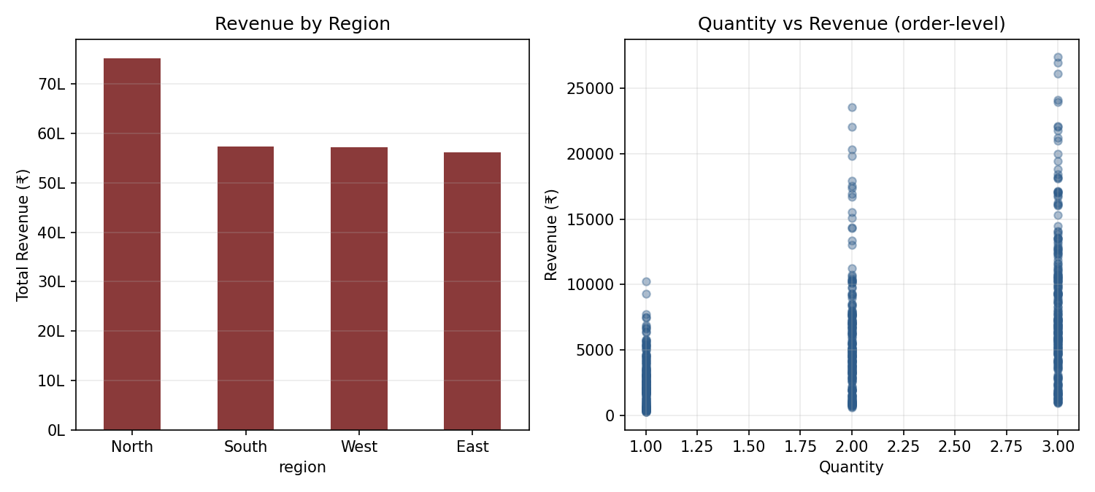
Figure 9: (left) Revenue by region; (right) order quantity vs revenue at the transaction level.
The North region leads in total revenue, consistent with its higher order-allocation probability in the simulation. The quantity–revenue scatter shows the expected step-wise positive relationship, with spread at each quantity level reflecting the mix of product prices.
3.6 Lag Plot — Monthly Revenue
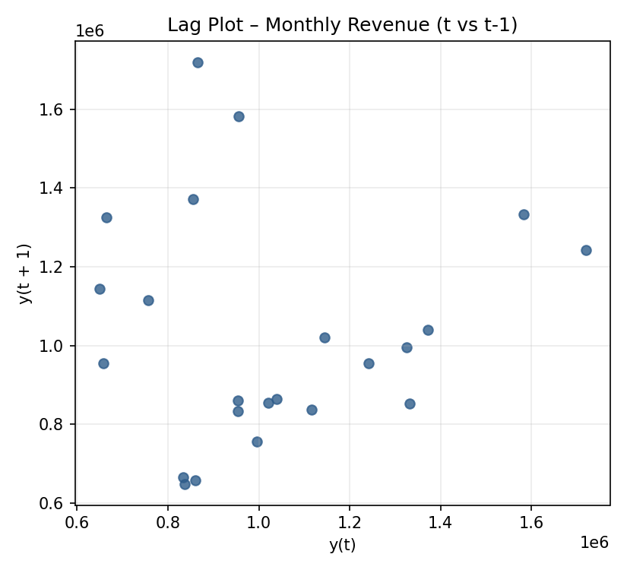
Figure 10: Lag plot of monthly revenue (value at month t vs. t−1).
The scattered, non-diagonal pattern in the lag-1 plot indicates that consecutive months are not strongly self-similar — expected, given the underlying quarterly (not monthly) cycle.
3.7 Autocorrelation Plot — Monthly Revenue
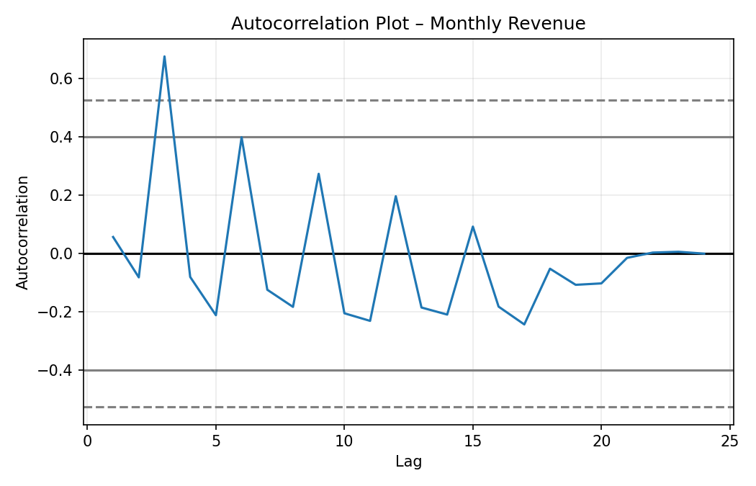
Figure 11: Autocorrelation of monthly revenue across lags 1-24.
Clear positive spikes appear at lags 3, 6, 9, 12, correctly recovering the quarterly seasonality built into the data, and confirming that the revenue series is not random noise but has genuine periodic structure that could inform inventory and staffing decisions.
3.8 Dashboard 2 — Key Insights
- Revenue exhibits a clear quarterly seasonal cycle confirmed independently by the trend line and the autocorrelation plot (peaks at lags 3/6/9/12).
- An overall upward trend (~35-40% growth) is visible across the two-year window, beyond the seasonal fluctuation.
- Wireless Earbuds and Smartwatches are the top revenue contributors; Electronics outsells Accessories roughly 2:1 in order volume.
- The North region contributes the largest share of revenue, suggesting a priority market for marketing and logistics investment.

4. Tools and Techniques Used
- Pandas — data generation, aggregation (groupby, resample), descriptive statistics.
- Matplotlib — bar charts, histograms/KDE, scatter plots, multi-panel figures.
- pandas.plotting.scatter_matrix — multivariable relationship and outlier visualization.
- pandas.plotting.lag_plot and autocorrelation_plot — time-dependence and seasonality detection.

5. Conclusion
Both dashboards fulfil the CO5 requirement to create meaningful visualizations using Pandas and Matplotlib for effective communication. Dashboard 1 demonstrates distribution, relationship, and outlier-detection techniques on cross-sectional student data, while Dashboard 2 demonstrates time-series—specific techniques (trend, lag, autocorrelation) on transactional sales data. Together they cover the full range of chart types specified across the assessment brief's scenarios: bar charts, distribution plots, scatter plots, frequency charts, scatter matrices, time-evolution plots, lag plots, and autocorrelation plots.

