EEG-Based ADHD Classification on TDBRAIN under Subject-Independent Evaluation: Temporal, Graph and Gated-Fusion Models

Abstract
Attention-deficit/hyperactivity disorder (ADHD) is diagnosed mainly from interviews, rating scales and behavioural observation, which makes objective supporting measures attractive. This paper reports a controlled, leakage-free evaluation of deep learning on resting-state EEG from the TDBRAIN database, separating ADHD from healthy-control subjects. Every split is made by subject, so no person contributes data to more than one of training, validation and test. Two experiments are reported. Experiment A is a pilot comparison of eight classifiers and a majority-class reference (logistic regression on band power, CNN, CNN-LSTM, CNN-LSTM-Attention, a graph convolutional network, and three CNN-LSTM-Attention/graph fusion variants) on eyes-closed EEG from 40 subjects, with 8 held-out test subjects. The best models reached 75% subject-level accuracy, but with 95% intervals of 50%-100% they cannot be distinguished from each other or, reliably, from chance. Experiment B trains a graph-encoder model with an XGBoost classifier on both eyes-open and eyes-closed recordings from 91 subjects, with 14 held-out test subjects. It reached 57.1% accuracy, 0% ADHD recall and ROC AUC 0.56, which is the same accuracy as always predicting the control class. We therefore find no evidence that these models generalise to unseen subjects, and we report this negative result in full together with the protocol needed to test the question properly.
Keywords: ADHD, EEG, TDBRAIN, resting state, deep learning, graph neural network, subject-independent evaluation, negative result.

1. Introduction
Attention-deficit hyperactivity disorder (ADHD) is a neurodevelopmental condition that interferes with development and everyday functioning [1]. Its symptoms fall into two groups, inattention and hyperactivity/impulsivity, and they have been linked to lower academic achievement [2]. Childhood prevalence is commonly estimated at about 6%-8% [3], [4], and symptoms often persist into adolescence and adulthood [5]. Early and reliable identification matters because it allows behavioural and developmental support to begin sooner [6], [7]. It is nevertheless difficult. Diagnosis rests on a clinician's judgement formed from interviews, behavioural observation, questionnaires and descriptions of behaviour at home and at school [1]. Each of these sources depends on an observer's perception and on how a person behaves in one setting, and misdiagnosis has been attributed to inconsistent practice, developmental immaturity and subjective judgement [9], [10]. Objective information that can be read alongside the clinical picture is therefore valuable. No single measurement, EEG included, can establish an ADHD diagnosis on its own; the aim of this work is to study supportive evidence for screening and research.
Electroencephalography (EEG) records the brain's electrical activity non-invasively and with high temporal resolution [13]. Resting EEG has been associated with cognitive performance in children with ADHD [14], and EEG is usually examined in the delta, theta, alpha and beta bands, with gamma often added. The theta/beta ratio has been the most discussed candidate marker, but its diagnostic value has been questioned [15], so no single band or ratio is treated here as a dependable indicator. Computerised continuous performance tests (CPTs) offer a complementary behavioural view [12]; the present paper, however, uses resting-state EEG only and does not analyse behavioural data.
Chang et al. [8] recorded eight-channel wireless EEG from 30 children with ADHD and 30 typically developing children during a resting baseline and a CPT, converted each second into band-power features, and classified the sequences with a Long Short-Term Memory (LSTM) network [16]. Under leave-one-subject-out cross-validation they reported 90.50% ± 0.81% accuracy for the LSTM on transition data, against 87.00% for a deep neural network, 65.83% for a CNN and 80.00% for an SVM, and found that occipital beta power (O1, O2) contributed most. These figures belong to that study and cohort and are not results of the present work. The authors noted that their cohort was a single one, recorded with one device and one commercial CPT, and suggested CNN-LSTM models as future work.
Such findings motivate further work without settling the question. EEG is easily contaminated by noise, markers differ from person to person, and a deep network can overfit a small dataset, performing well on subjects it has seen and poorly on new ones. Here we ask whether temporal (CNN-LSTM-Attention), graph (electrode-graph) and fusion models can separate ADHD from healthy controls when evaluated strictly on unseen subjects, using the public TDBRAIN database [20]. This is a research investigation with no claim of clinical use; it is meant to assist, not replace, clinical assessment.
The contributions of this paper are:
- a leakage-free, subject-independent evaluation protocol on TDBRAIN, with all splits, configurations and predictions retained for reproducibility;
- a pilot comparison of temporal, graph, concatenation-fusion and gated-fusion models against a majority-class reference, including electrode-masking robustness (Experiment A);
- a full-cohort graph-encoder run on 91 subjects, reported transparently, including that it did not learn a usable decision rule (Experiment B); and
- an explicit account of what the current evidence does and does not show.

2. Literature Survey
This survey covers four lines of work: the diagnostic context, EEG spectral markers, conventional machine learning, and deep learning on EEG. Only findings reported by the cited studies are summarised; all figures belong to those studies and their cohorts.

2.1 Diagnostic context and objective measures
Clinical assessment relies on interviews, rating scales and observation, and recent reviews have raised concerns about overdiagnosis in children and adolescents [9] and about diagnoses that track a child's age relative to classmates [10]. Computerised continuous performance tests offer an objective complement, and a recent meta-analysis has examined their clinical utility for identifying ADHD [12]. In children with ADHD, the EEG theta/beta ratio has been reported to correlate with attentional capacity measured by the Conners CPT-3 [11].

2.2 EEG spectral markers
Resting-state EEG has been related to executive function in children with ADHD [14]. The theta/beta ratio is the most studied marker, yet an EEG subtyping meta-analysis challenges its diagnostic value [15]. This motivates models that learn from several bands and from their spatial arrangement, instead of relying on one ratio.

2.3 Conventional machine learning
Classical classifiers operate on hand-crafted features. Altinkaynak et al. [17] combined time- and frequency-domain features for ADHD diagnosis. Such pipelines are easy to interpret but depend on the chosen features, which motivates the band-power logistic-regression baseline used here.

2.4 Deep learning on EEG
Deep networks learn features directly from the signal. Moghaddari et al. [18] applied a convolutional network to EEG recorded during a continuous mental task, Loh et al. [19] proposed an explainable deep network for ADHD and conduct disorder, and Chang et al. [8] used an LSTM, whose gating retains or discards information over time [16]. Reported accuracies in this literature depend strongly on the validation scheme; when windows from the same person appear in both training and test sets, results can be optimistic. This is why the present study splits strictly by subject.

2.5 Gap addressed
Prior studies show that neural networks can be applied to ADHD EEG, but evidence under strictly subject-independent evaluation on a public multi-subject archive remains limited. Graph-based EEG models and recent spatio-temporal architectures are also not covered by the references above. [Add 3-5 references on graph neural networks / spatio-temporal EEG models for ADHD before submission, and compare against them.]

3. Materials and Methods

3.1 Data
We used the TDBRAIN database [20], which contains resting-state EEG recorded with eyes open (EO) and eyes closed (EC) for healthy controls and for patients, including patients with ADHD. Two groups were used throughout: healthy control (label 0) and ADHD (label 1). [Add age and sex distribution of the selected subjects; the age range of the cohort should be confirmed, since the introduction's child-focused framing may not match it.]

3.2 Evaluation protocol (both experiments)
- All windows of a subject stay in one split; no subject appears in more than one of training, validation and test.
- Feature standardisation is fitted on training data only and applied unchanged to validation and test.
- The checkpoint is selected on validation performance; the test set is not used for early stopping or tuning.
- A subject's prediction is the mean window-level ADHD probability, with a fixed threshold of 0.5 that is not tuned on test data.
- Reported metrics: accuracy, balanced accuracy, ADHD precision, ADHD recall (sensitivity), specificity, macro F1, ROC AUC, PR AUC and Brier score, with a majority-class reference.
- Uncertainty is shown with participant-level bootstrap 95% intervals. The independent unit is the subject, not the window.

3.3 Experiment A: pilot model comparison (eyes closed)
Forty subjects (20 healthy, 20 ADHD) were selected, and each contributed up to 60 distinct, non-overlapping 2.0-second windows sampled uniformly from the eyes-closed recording at 128 Hz. Band power was computed in five bands: delta (0.5-4 Hz), theta (4-8), alpha (8-13), beta (13-30) and gamma (30-45). Subjects were split 24 / 8 / 8 into training, validation and test, stratified by label. One fold and one seed (42) were run, so this is a pilot. Models were trained for at most 20 epochs with early stopping (patience 6), learning rate 0.001 and batch size 128.
Eight classifiers and one reference were compared:
- Majority: always predicts the more frequent class (reference).
- LogReg-PSD: logistic regression on band-power features.
- CNN: temporal convolutional network on the windows.
- CNN-LSTM and CNN-LSTM-Attention: convolutional features followed by an LSTM, without and with attention over time.
- GCN: graph convolutional network over electrodes, using band-power (PSD) node features and phase-locking-value (PLV) connectivity.
- Hybrid-Concat: temporal (CNN-LSTM-Attention) and graph features joined by concatenation.
- Hybrid-Gated: the same two feature sets joined by a learned gate.
- Hybrid-Gated-Aug: Hybrid-Gated trained with 10% electrode dropout, as a trained robustness ablation.
Two sensitivity analyses were run on the test subjects only: random electrode masking at 0%, 10%, 20% and 30% (three repeats), and post-hoc band occlusion. Both are perturbations outside the training distribution and are not causal explanations.

3.4 Experiment B: full-cohort graph-encoder run
All 91 subjects with usable recordings were included (183 recordings, eyes open and eyes closed both required). Signals were resampled to 250 Hz, band-pass filtered at 0.5-45 Hz with a power-line notch, and restricted to the 26 scalp electrodes common to all recordings (Fp1, Fp2, F7, F3, Fz, F4, F8, FC3, FCz, FC4, T7, C3, Cz, C4, T8, CP3, CPz, CP4, P7, P3, Pz, P4, P8, O1, Oz, O2). Recordings were cut into 8-second windows with a 4-second stride (at most 32 per recording), and windows with peak amplitude above 400 µV were rejected, leaving 5,059 windows. Subjects were split 63 / 14 / 14 into training, validation and test (training: 34 healthy, 29 ADHD; validation: 7 and 7; test: 8 and 6).
A graph encoder (hidden size 48) produced a 64-dimensional embedding per subject using the 8 strongest connections per electrode, a gating step (κ = 0.7, τ = 0.08) and three regularisers on the learned graph (prior, sparsity, smoothness; weights 0.01, 0.0005, 0.001). An XGBoost classifier was trained on the embeddings. The encoder was trained with learning rate 0.001, weight decay 0.0001, batches of 4 subjects, at most 100 epochs and early stopping with patience 15. [Confirm these architecture details against the training code, and define the abbreviation RGAGTL used for this run.]

4. Results

4.1 Experiment A: pilot comparison
Table 1 gives the subject-level results on the 8 held-out test subjects (4 healthy, 4 ADHD). Hybrid-Gated, Hybrid-Gated-Aug and CNN-LSTM-Attention reached 75% accuracy; the majority reference reached 50%. LogReg-PSD and the plain CNN scored below the reference (25%), and Hybrid-Concat and CNN-LSTM matched it by predicting only the healthy class (ADHD recall 0).
Table 1. Experiment A, subject-level test results (8 subjects, 1 fold, seed 42).
Model | Acc. | Macro F1 | ROC AUC | ADHD recall | Specificity | Parameters
Majority (reference) | 0.50 | 0.33 | 0.50 | 0.00 | 1.00 | 0
LogReg-PSD | 0.25 | 0.20 | 0.19 | 0.00 | 0.50 | 161
CNN | 0.25 | 0.20 | 0.25 | 0.00 | 0.50 | 32,130
CNN-LSTM | 0.50 | 0.33 | 0.69 | 0.00 | 1.00 | 100,738
CNN-LSTM-Attention | 0.75 | 0.73 | 0.88 | 0.50 | 1.00 | 109,059
GCN | 0.63 | 0.62 | 0.75 | 0.75 | 0.50 | 6,562
Hybrid-Concat | 0.50 | 0.33 | 0.88 | 0.00 | 1.00 | 132,099
Hybrid-Gated | 0.75 | 0.75 | 0.75 | 0.75 | 0.75 | 132,099
Hybrid-Gated-Aug | 0.75 | 0.75 | 0.69 | 0.75 | 0.75 | 132,099
With only 8 test subjects, each subject changes accuracy by 12.5 percentage points. The participant-level bootstrap 95% intervals for accuracy are 50%-100% for Hybrid-Gated and CNN-LSTM-Attention and 25%-87.5% for the GCN, and all of them include the 50% reference. The paired difference in macro F1 between Hybrid-Gated and CNN-LSTM-Attention was +0.02 (95% interval -0.47 to +0.54), so neither is superior. Hybrid-Gated exceeded Hybrid-Concat (+0.42, interval 0.08 to 0.67) and the CNN (+0.55, interval 0.24 to 0.80), but these intervals come from a bootstrap over 8 subjects and should not be read as reliable evidence.
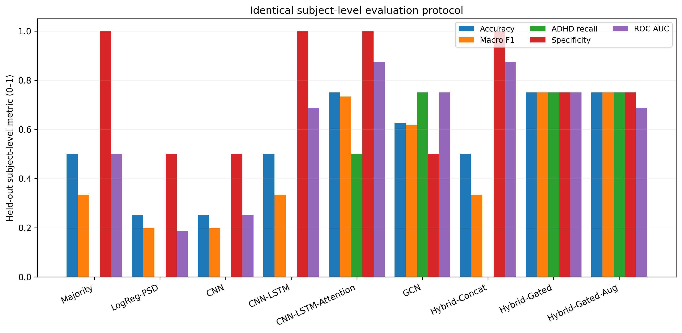
Figure 1. Experiment A: subject-level metrics for each model on the 8 held-out subjects.
In the electrode-masking test, the mean macro F1 of Hybrid-Gated stayed at 0.75 with 10% of electrodes masked and fell to 0.71 at 20% and 0.29 at 30%. The trained-dropout variant Hybrid-Gated-Aug was less robust in this single run (0.62, 0.46 and 0.37), so training with electrode dropout did not help here. CNN-LSTM-Attention was unchanged at about 0.73, and the GCN was constant at 0.62 at every masking level. In band occlusion, removing theta caused the largest drop for Hybrid-Gated (macro F1 -0.55); given the sample size and the out-of-distribution nature of occlusion, this is a hypothesis to retest, not a finding.

4.2 Experiment B: full-cohort graph-encoder run
On the 14 held-out test subjects (8 healthy, 6 ADHD) the model classified every subject as healthy (Table 2). Accuracy equals the 57.1% obtained by always predicting the majority class (8 of 14), ADHD recall and precision are both 0, and the Matthews correlation coefficient is 0. The ROC AUC of 0.56 is close to chance.
Table 2. Experiment B, held-out test results (14 subjects).
Metric | Value | Note
Accuracy | 0.571 | Equals the majority-class accuracy (8/14)
Balanced accuracy | 0.500
ADHD precision / recall | 0.000 / 0.000 | No subject predicted as ADHD
Specificity | 1.000 | All 8 healthy subjects predicted healthy
F1 (ADHD) / MCC | 0.000 / 0.000
ROC AUC | 0.563 | Close to chance
Brier score | 0.245 | About the value for a constant 0.5 prediction (0.25)
Confusion matrix (TN, FP, FN, TP) | 8, 0, 6, 0
The predicted ADHD probabilities of all 14 subjects lie between 0.44 and 0.48, below the 0.5 threshold, so the classifier output is nearly constant. Training history explains why. The selected checkpoint was epoch 1, with validation balanced accuracy 0.571. After that the training loss fell from 0.77 to 0.45, while the validation loss rose from 0.76 to 1.53 and the validation balanced accuracy stayed between 0.21 and 0.43, a pattern of overfitting rather than learning. Early stopping ended training at epoch 16, and the XGBoost classifier's best iteration was 2. The SHAP importance and electrode-occlusion analyses were also computed, but because the model's output barely varies (the largest electrode effect on the predicted probability was 0.0026), they carry no interpretable information and are not interpreted here.
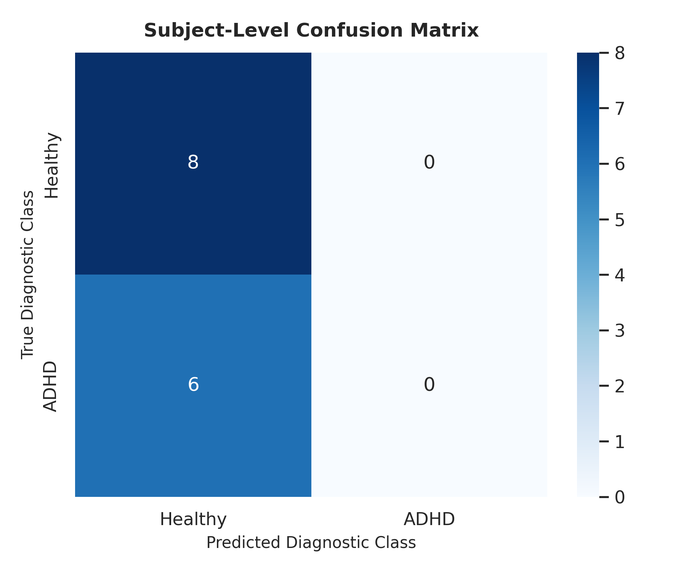
Figure 2. Experiment B: confusion matrix on the 14 held-out test subjects (all predicted healthy).
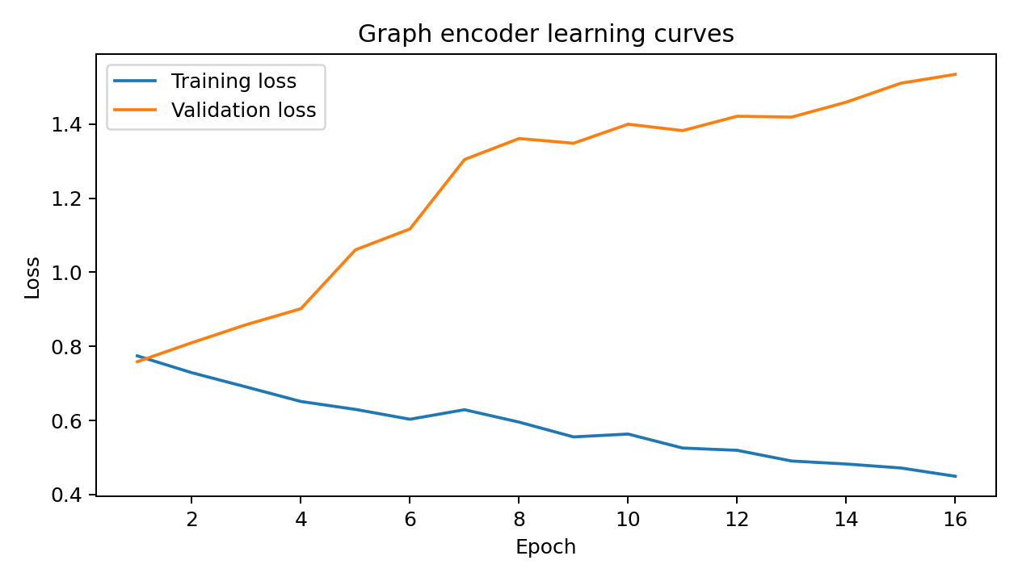
Figure 3. Experiment B: training and validation loss; validation loss rises while training loss falls.

5. Discussion
The two experiments give a consistent message: with these data and protocol, no model showed reliable ADHD detection in unseen subjects. In the pilot, three models reached 75%, but on 8 subjects that is 6 correct, and the intervals include chance and each other. The gated fusion model did not beat the attention model, so the planned comparison of gating versus concatenation and versus simpler models is inconclusive, and the trained channel-dropout ablation did not improve robustness. In the larger run, the model collapsed to the majority class, and its accuracy is no better than a constant answer.
We do not claim to know why. Plausible, untested explanations are the small number of independent subjects (91, with 14 for testing) relative to the model and feature size; heterogeneity within ADHD and the healthy group; possible confounding by age, sex, medication or recording conditions, which the label-stratified splits do not control; and a training schedule that peaked at the first epoch. These results should also not be compared with the 90.50% reported by Chang et al. [8]: that study used a different cohort, device, task, features and validation scheme, and our experiments were not designed to replicate it.
A clear implication is that window counts, such as the 5,059 windows in Experiment B, do not increase the number of independent participants. Reports based on window-level splits can therefore look strong without generalising, which supports the subject-independent protocol used here.

6. Limitations
- Small samples: 8 test subjects in Experiment A and 14 in Experiment B. Confidence intervals are wide, and AUC and calibration are unstable.
- Experiment A is a single-fold, single-seed pilot. Repeated seeds on the same subjects would not be independent biological replications.
- The two experiments use different subjects, tasks (eyes closed only versus both), window lengths (2 s versus 8 s) and models, so they are not directly comparable.
- No external cohort, age/sex/site matching, formal artefact or ICA rejection, or medication information is used. Subject splits are stratified by label only.
- Dense broad-band connectivity can reflect volume conduction. No neurological or causal biomarker claim is made; occlusion and SHAP analyses are not explanations.
- The reported run times include extra diagnostics and are not a clean training benchmark.
- This is exploratory research, not a clinical diagnostic tool.

7. Conclusion
Under strict subject-independent evaluation on TDBRAIN, neither the pilot comparison of temporal, graph and gated-fusion models nor the full-cohort graph-encoder run provided evidence of generalisable ADHD detection. The pilot's best results (75% on 8 subjects) are statistically indistinguishable from each other and from chance, and the 91-subject run classified every test subject as healthy. We report these as negative or inconclusive results. The next step is a properly powered study: repeated subject-level cross-validation across folds and seeds, age- and sex-matched cohorts, comparison with simple baselines, and external validation, before any claim of EEG-based ADHD screening is made.

References
[1] American Psychiatric Association (2022). Diagnostic and Statistical Manual of Mental Disorders (5th ed., text rev.). Washington, DC: American Psychiatric Association Publishing. https://doi.org/10.1176/appi.books.9780890425787
[2] Visser, L., Linkersdörfer, J., & Hasselhorn, M. (2020). The role of ADHD symptoms in the relationship between academic achievement and psychopathological symptoms. Research in Developmental Disabilities, 97, 103552.
[3] Salari, N., Ghasemi, H., Abdoli, N., Rahmani, A., Shiri, M. H., Hashemian, A. H., Akbari, H., & Mohammadi, M. (2023). The global prevalence of ADHD in children and adolescents: a systematic review and meta-analysis. Italian Journal of Pediatrics, 49, 48. https://doi.org/10.1186/s13052-023-01456-1
[4] Ayano, G., Demelash, S., Gizachew, Y., Tsegay, L., & Alati, R. (2023). The global prevalence of attention deficit hyperactivity disorder in children and adolescents: an umbrella review of meta-analyses. Journal of Affective Disorders, 339, 860–866. https://doi.org/10.1016/j.jad.2023.07.071
[5] Sibley, M. H., Arnold, L. E., Swanson, J. M., Hechtman, L. T., Kennedy, T. M., Owens, E. B., Molina, B. S. G., Jensen, P. S., Hinshaw, S. P., Roy, A., Chronis-Tuscano, A., Newcorn, J. H., & Rohde, L. A. (2022). Variable patterns of remission from ADHD in the Multimodal Treatment Study of ADHD. American Journal of Psychiatry, 179, 142–151. https://doi.org/10.1176/appi.ajp.2021.21010032
[6] Shephard, E., Zuccolo, P. F., Idrees, I., Godoy, P. B. G., Salomone, E., Ferrante, C., Sorgato, P., Catão, L. F. C. C., Goodwin, A., Bolton, P. F., Tye, C., Groom, M. J., & Polanczyk, G. V. (2022). Systematic review and meta-analysis: the science of early-life precursors and interventions for attention-deficit/hyperactivity disorder. Journal of the American Academy of Child & Adolescent Psychiatry, 61, 187–226. https://doi.org/10.1016/j.jaac.2021.03.016
[7] Türk, S., Korfmacher, A.-K., Gerger, H., van der Oord, S., & Christiansen, H. (2023). Interventions for ADHD in childhood and adolescence: a systematic umbrella review and meta-meta-analysis. Clinical Psychology Review, 102, 102271. https://doi.org/10.1016/j.cpr.2023.102271
[8] Chang, Y., Stevenson, C., Chen, I.-C., Lin, D.-S., & Ko, L.-W. (2022). Neurological state changes indicative of ADHD in children learned via EEG-based LSTM networks. Journal of Neural Engineering, 19(1), 016021. https://doi.org/10.1088/1741-2552/ac4f07
[9] Kazda, L., Bell, K., Thomas, R., McGeechan, K., Sims, R., & Barratt, A. (2021). Overdiagnosis of attention-deficit/hyperactivity disorder in children and adolescents: a systematic scoping review. JAMA Network Open, 4(4), e215335. https://doi.org/10.1001/jamanetworkopen.2021.5335
[10] Frisira, E., Holland, J., & Sayal, K. (2025). Systematic review and meta-analysis: relative age in attention-deficit/hyperactivity disorder and autism spectrum disorder. European Child & Adolescent Psychiatry, 34, 381–401. https://doi.org/10.1007/s00787-024-02459-x
[11] Wang, T.-S., Wang, S.-S., Wang, C.-L., & Wong, S.-B. (2024). Theta/beta ratio in EEG correlated with attentional capacity assessed by Conners Continuous Performance Test in children with ADHD. Frontiers in Psychiatry, 14, 1305397. https://doi.org/10.3389/fpsyt.2023.1305397
[12] Arrondo, G., Mulraney, M., Iturmendi-Sabater, I., Musullulu, H., Gambra, L., Niculcea, T., Banaschewski, T., Simonoff, E., Döpfner, M., Hinshaw, S. P., Coghill, D., & Cortese, S. (2024). Systematic review and meta-analysis: clinical utility of continuous performance tests for the identification of attention-deficit/hyperactivity disorder. Journal of the American Academy of Child & Adolescent Psychiatry, 63, 154–171. https://doi.org/10.1016/j.jaac.2023.03.011
[13] Beniczky, S., & Schomer, D. L. (2020). Electroencephalography: basic biophysical and technological aspects important for clinical applications. Epileptic Disorders, 22, 697–715.
[14] Tabiee, M., Azhdarloo, A., & Azhdarloo, M. (2023). Comparing executive functions in children with attention deficit hyperactivity disorder with or without reading disability: a resting-state EEG study. Brain and Behavior, 13(4), e2951. https://doi.org/10.1002/brb3.2951
[15] Boxum, M., Voetterl, H., van Dijk, H., Gordon, E., DeBeus, R., Arnold, L. E., & Arns, M. (2025). Challenging the diagnostic value of theta/beta ratio: insights from an EEG subtyping meta-analytical approach in ADHD. Applied Psychophysiology and Biofeedback, 50(4), 655–666. https://doi.org/10.1007/s10484-024-09649-y
[16] Van Houdt, G., Mosquera, C., & Nápoles, G. (2020). A review on the long short-term memory model. Artificial Intelligence Review, 53(8), 5929–5955. https://doi.org/10.1007/s10462-020-09838-1
[17] Altınkaynak, M., Dolu, N., Güven, A., Pektaş, F., Özmen, S., Demirci, E., & İzzetoğlu, M. (2020). Diagnosis of attention deficit hyperactivity disorder with combined time and frequency features. Biocybernetics and Biomedical Engineering, 40(3), 927–937. https://doi.org/10.1016/j.bbe.2020.04.006
[18] Moghaddari, M., Lighvan, M. Z., & Danishvar, S. (2020). Diagnose ADHD disorder in children using convolutional neural network based on continuous mental task EEG. Computer Methods and Programs in Biomedicine, 197, 105738. https://doi.org/10.1016/j.cmpb.2020.105738
[19] Loh, H. W., Ooi, C. P., Oh, S. L., Barua, P. D., Tan, Y. R., Acharya, U. R., … Fung, D. S. S. (2024). ADHD/CD-NET: automated EEG-based characterization of ADHD and CD using explainable deep neural network technique. Cognitive Neurodynamics, 18(4), 1609–1625. https://doi.org/10.1007/s11571-023-10028-2
[20] van Dijk, H., van Wingen, G., Denys, D., Olbrich, S., van Ruitenbeek, R., & Arns, M. (2022). The two decades brainclinics research archive for insights in neurophysiology (TDBRAIN) database. Scientific Data, 9, 333. [verify this reference and add the DOI]

