MOTILAL NEHRU NATIONAL INSTITUTE OF TECHNOLOGY ALLAHABAD
PRAYAGRAJ, INDIA – 211004

A PROJECT REPORT ON
Insurance & Claims Management System
with ML-based Fraud Risk Scoring
PROJECT Number
E6
Submitted By
Satyam Kumar (Reg. No: 20243587)
Shashank Lakkarsu (Reg. No: 20243547)
Rajiv Thodla (Reg. No: 20243539)
Shabbeer Mohammed (Reg. No: 20243544)

Submitted as DBMS Project Work
Bachelor of Technology (B. Tech.)
Department of Computer Science and Engineering
MOTILAL NEHRU NATIONAL INSTITUTE OF TECHNOLOGY ALLAHABAD
PRAYAGRAJ, UTTAR PRADESH – 211004
2026–2027

Table of Contents
1. Abstract 3
2. Introduction and Problem Statement 3
2.1 Background 3
2.2 Problem statement 3
3. Project Objectives and Scope 4
3.1 Objectives 4
3.2 Scope 4
4. System Analysis and Requirements 4
4.1 Existing system and its limitations 4
4.2 Proposed system 4
4.3 Functional requirements 5
4.4 Business rules 5
4.5 Non-functional requirements 6
4.6 Hardware and software requirements 6
5. ER/EER Diagram and Database Schema 6
5.1 Entities and relationships 6
5.2 Relational schema 7
6. Keys, Functional Dependencies and Normalization 8
6.1 Keys 8
6.2 Normalization process 8
6.3 Functional dependencies and normal form of each table 9
7. SQL Implementation 9
7.1 DDL and DML 10
7.2 Joins 10
7.3 Subqueries 10
7.4 Aggregation and ROLLUP 11
7.5 Window functions, CTEs and set operations 11
8. Views, Indexes, Triggers and Transactions 12
8.1 Views 12
8.2 Indexes 12
8.3 Triggers 13
8.4 Stored procedures and functions 13
8.5 Transactions and concurrency control 14
9. Front-End Design and Database Connectivity 14
9.1 Front-end design 14
9.2 Database connectivity 15
9.3 Security 16
10. CRUD Operations and Report Generation 17
10.1 Generic CRUD 17
10.2 Workflow operations 18
10.3 Reports 18
11. AI/ML Implementation and Model Evaluation 19
11.1 Problem definition 19
11.2 Data and features 20
11.3 Training method 20
11.4 Evaluation on the held-out test set 21
11.5 Deployment in the application 21
11.6 Limitations 22
12. Testing, Results and Screenshots 22
12.1 Testing approach 22
12.2 Automated test results 22
12.3 Business-rule demonstrations 23
12.4 Results summary 24
13. Conclusion and Future Scope 24
13.1 Conclusion 24
13.2 Future scope 25
14. References 25

1. Abstract
Insurance companies handle a large volume of policies, premium instalments and claims, and a small share of those claims are fraudulent. This project builds an Insurance & Claims Management System on MySQL 8.0 that keeps this data consistent and helps staff decide which claims need a closer look.
The database has 15 tables in Boyce-Codd Normal Form, connected by primary, foreign, unique and CHECK constraints. Ten business rules (BR1–BR10), such as "a claim cannot exceed the sum assured" or "a payout must not exceed the approved amount", are enforced inside the database by 12 triggers. The claim workflow (submit → review → approve/reject → pay) runs through 16 stored procedures that use explicit transactions, row-level locks (SELECT … FOR UPDATE) and rollback on error. 10 views feed the user interface and the reports, and 7 secondary indexes support the main filters and searches; the effect of four of them was measured with EXPLAIN ANALYZE.
A FastAPI (Python) back end exposes the database through a REST API, and a plain HTML/JavaScript front end gives staff a dashboard, generic CRUD screens for every master table, a claims work queue and eight downloadable reports. A Random Forest classifier trained with scikit-learn on 2,353 resolved claims scores every open claim for fraud risk. On a held-out test set it reached a ROC-AUC of 0.948, precision 0.82 and recall 0.74. The model's decision threshold is stored in the database, so the LOW / MEDIUM / HIGH risk bands in the views always follow the active model.
The system was loaded with a synthetic but realistic dataset (1,600 customers, 3,500 policies, 10,484 premium instalments and 2,455 claims) and verified by an automated test suite of 30 tests (all passing), 21 deliberate rule-violation demonstrations and a concurrency demonstration that shows row locking and deadlock detection.

2. Introduction and Problem Statement

2.1 Background
An insurance policy is a contract: the customer (policy holder) pays a premium, usually in instalments, and in return the insurer promises to pay up to the sum assured if an insured event happens during the policy period. When something does happen, the customer files a claim. A claims adjuster reviews the claim and its documents, approves an amount (or rejects it), and the insurer then pays the claim, often directly to a hospital or garage (the provider).
These steps involve many related records: customers, agents who sold the policy, products, policies, nominees, instalments, claims, documents, assessments and payouts. They have to stay consistent with each other. For example, a payout must never be larger than what the adjuster approved, and a claim must never be filed on a policy that has lapsed for non-payment.

2.2 Problem statement
Small and mid-sized insurers and third-party administrators often track this work in spreadsheets or in loosely connected applications. That leads to three recurring problems:
- Inconsistent data: duplicated customer addresses, claims attached to cancelled policies, payouts larger than the approved amount, and no reliable history of who changed a claim's status.
- Rules enforced only by people: checks such as "the adjuster may only approve up to their limit" depend on staff remembering them, and two staff members can act on the same claim at the same time.
- Fraud found too late: suspicious claims (filed long after the incident, with few documents, at a non-network provider) are only noticed after the money has been paid.
The goal of this project is to design and implement a normalized relational database that enforces these business rules itself, keeps the claim workflow correct even under concurrent use, gives staff a simple web interface with CRUD screens and reports, and adds a machine-learning model that ranks open claims by fraud risk so that adjusters look at the riskiest ones first.

3. Project Objectives and Scope

3.1 Objectives
- Design an ER model for the insurance domain and convert it into a relational schema in BCNF.
- Enforce data integrity with PK, FK, UNIQUE and CHECK constraints and enforce the ten business rules (BR1–BR10) with triggers, so that no client can bypass them.
- Implement the policy and claim life-cycles as stored procedures with transactions, including an atomic "approve and pay" operation and safe behaviour under concurrent access.
- Demonstrate the full range of SQL: DDL, DML, all join types, subqueries, aggregation with ROLLUP, window functions, recursive CTEs and set operations.
- Create views for the application and reports, and indexes justified by measured query plans.
- Build a web front end connected to the database through a REST API, with CRUD for every master table, a claims work queue and downloadable reports.
- Train, evaluate and deploy a fraud-risk model that scores open claims and stores its score in the database.
- Verify everything with automated tests and saved demonstration outputs.

3.2 Scope
The system is an internal tool for insurer staff and covers:
- Master data: customers, agents, products, providers, adjusters and pincodes.
- Policies: selling, nominees, premium instalments, payment, lapse, re-activation and expiry.
- Claims: filing, documents, review, approval or rejection, payout and an audit trail.
- A dashboard and eight reports with CSV export.
- Fraud-risk scoring of open claims.

4. System Analysis and Requirements

4.1 Existing system and its limitations
In the manual or spreadsheet-based process, each department keeps its own copy of customer and policy data, status changes are not recorded, validation is done by hand and reports are built manually each month. There is no locking, so two people can settle the same claim twice, and there is no systematic way to flag risky claims.

4.2 Proposed system
The proposed system keeps one normalized database as the single source of truth. All rules live in the database (constraints, triggers, procedures), so they apply whether data arrives from the web UI, the API, a script or the MySQL command line. A thin API layer translates HTTP requests into parameterised SQL and procedure calls, and the front end only displays data and sends user actions.
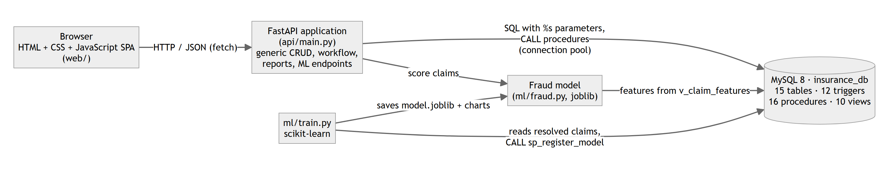
System architecture

4.3 Functional requirements
Functional requirements
ID | Requirement | Implemented by
F1 | Create, read, update, delete and search master data (customers, agents, products, providers, adjusters, pincodes, nominees, documents) | Generic CRUD API + CRUD screens
F2 | Sell a policy: validate cover against the product, compute the premium, assign a policy number, raise the first instalment | sp_sell_policy, trg_policy_bi, fn_annual_premium
F3 | Premium life-cycle: generate instalments, record payments, lapse overdue policies, re-activate on payment, expire policies | sp_generate_instalments, sp_pay_premium, sp_lapse_overdue_policies, sp_expire_policies, trg_payment_au
F4 | File a claim with documents | sp_file_claim, trg_claim_bi
F5 | Claim workflow: start review, request info, approve, reject, pay | sp_start_review, sp_request_info, sp_approve_claim, sp_reject_claim, sp_pay_claim
F6 | Approve and pay as one atomic operation | sp_approve_and_pay_claim
F7 | Score open claims for fraud risk and show a risk band | ml/train.py, ml/fraud.py, fraud_model, v_claim_summary
F8 | Dashboard and eight reports, downloadable as CSV | api/reports.py over the views

4.4 Business rules
Business rules enforced by the database
Rule | Description | Enforced in
BR1 | A claim cannot be filed on a LAPSED or CANCELLED policy | trg_claim_bi
BR2 | The incident date must lie inside the policy period | trg_claim_bi
BR3 | The claimed amount cannot exceed the sum assured | trg_claim_bi
BR4 | Claim status may only move SUBMITTED → UNDER_REVIEW → APPROVED/REJECTED, APPROVED → PAID; review needs an adjuster, a decision needs an assessment, PAID needs a payout; claim details freeze after submission | trg_claim_bu
BR5 | An approved amount cannot exceed the adjuster's approval limit or the claimed amount | trg_assessment_bi
BR6 | Only an APPROVED claim can be paid; payout ≤ approved amount; total payouts on a policy ≤ sum assured | trg_payout_bi
BR7 | Recording a payout automatically marks the claim PAID | trg_payout_ai
BR8 | Nominee shares on a policy cannot exceed 100% | trg_nominee_ai, trg_nominee_au
BR9 | Paying the last overdue instalment re-activates a LAPSED policy | trg_payment_ai, trg_payment_au
BR10 | Every claim status change is written to an audit log | trg_claim_ai, trg_claim_au

4.5 Non-functional requirements
- Integrity: rules are enforced in the database, not only in the UI.
- Atomicity and concurrency: multi-step operations either complete fully or leave no trace; two users acting on the same claim cannot both succeed.
- Security: all user input reaches SQL only as bound parameters; table and column names come from a fixed whitelist; the application connects with its own MySQL user, not root.
- Performance: list screens and reports respond in well under a second on the full dataset; indexes are justified with EXPLAIN ANALYZE.
- Usability: a plain, table-oriented interface similar to typical database administration tools.

4.6 Hardware and software requirements
Software and hardware used
Component | Used in this project
Operating system | Windows 11
Database | MySQL Community Server 8.0.46 (InnoDB engine, utf8mb4, REPEATABLE READ isolation)
Back end | Python 3.12, FastAPI, Uvicorn, mysql-connector-python (connection pool)
Front end | HTML5, CSS, plain JavaScript (single-page application, no framework)
Machine learning | scikit-learn, pandas, NumPy, matplotlib, joblib
Testing | pytest with FastAPI TestClient against a separate insurance_test database
Tools | MySQL Workbench / mysql CLI, Visual Studio Code, Google Chrome
Hardware (minimum) | Any PC with 4 GB RAM and about 500 MB free disk space

5. ER/EER Diagram and Database Schema

5.1 Entities and relationships
The main entities are Customer, Agent, Policy Type (product), Policy, Nominee, Premium Payment, Claim, Provider, Adjuster, Claim Document, Claim Assessment, Claim Payout and Claim Status Log. Pincode was separated out during normalization, and Fraud Model stores the trained ML models.
In the diagram, rectangles are entities with their attributes (the primary key is underlined), diamonds are relationships, and the 1 and N on each line give the cardinality. Every relationship is one-to-many, except that a claim is settled by at most one payout (1 : 1) and an agent manages other agents (a recursive 1 : N).
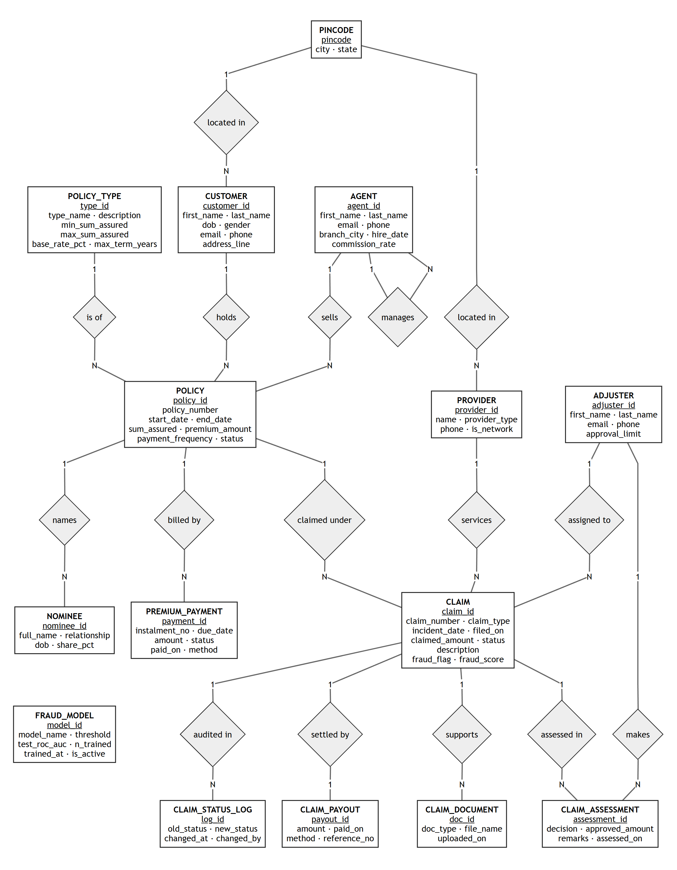
ER diagram

5.2 Relational schema
Each entity becomes one table, and each 1 : N relationship becomes a foreign key on the N side.
Tables and keys
Table | Primary key | Foreign keys | Purpose | Rows
pincode | pincode | — | Lookup of pincode → city, state | 450
agent | agent_id | manager_id → agent | Agents who sell policies; self-reference gives the hierarchy | 40
customer | customer_id | pincode → pincode | Policy holders | 1,600
policy_type | type_id | — | Product catalogue (Health, Motor, Life, Home, Travel) with cover limits and base rate | 5
provider | provider_id | pincode → pincode | Hospitals, clinics and garages; network / non-network | 120
adjuster | adjuster_id | — | Claim assessors with an approval limit | 15
policy | policy_id | customer_id, type_id, agent_id | One contract for one product | 3,500
nominee | nominee_id | policy_id | Beneficiaries and their share | 2,185
premium_payment | payment_id | policy_id | One row per instalment (due, paid, failed) | 10,484
claim | claim_id | policy_id, provider_id, adjuster_id | A claim with status, fraud flag (label) and fraud score | 2,455
claim_document | doc_id | claim_id | Supporting document metadata | 7,252
claim_assessment | assessment_id | claim_id, adjuster_id | Adjuster decisions: APPROVED, REJECTED, NEEDS_INFO | 2,484
claim_payout | payout_id | claim_id (unique) | At most one settlement per claim | 1,882
claim_status_log | log_id | claim_id | Audit trail written only by triggers | 9,101
fraud_model | model_id | — | Registry of trained models; exactly one is active | 1

6. Keys, Functional Dependencies and Normalization

6.1 Keys
- Primary keys: one per table (surrogate integers, plus the natural pincode).
- Candidate (alternate) keys, declared UNIQUE: customer.email, agent.email, adjuster.email, policy_type.type_name, policy.policy_number, claim.claim_number, claim_payout.reference_no, claim_payout.claim_id, and the composite key (policy_id, instalment_no) in premium_payment.
- Foreign keys: 16 in total, each with an explicit ON DELETE / ON UPDATE action.
- CHECK constraints: 32 domain checks, for example pincode REGEXP '^[0-9]{6}$', end_date > start_date, share_pct BETWEEN 0 AND 100, and the cross-column rule (status = 'PAID') = (paid_on IS NOT NULL) on instalments.

6.2 Normalization process
We started from the single "policy register" that an insurer would keep in a spreadsheet, with one row per policy instalment:
POLICY_REGISTER(policy_number, customer_name, customer_email, address, pincode, city, state,
product, base_rate, max_term, agent_name, agent_branch, start_date, end_date,
sum_assured, nominees{name, relation, share}, instalment_no, due_date, amount, paid_on)

- 1NF: the repeating group nominees{…} violates atomicity. It was moved to its own relation NOMINEE(policy, full_name, relationship, share_pct). Every attribute is now atomic.
- 2NF: the key of the register is (policy_number, instalment_no), but customer, product and policy attributes depend on policy_number alone (partial dependencies). Splitting gives POLICY (one row per policy) and PREMIUM_PAYMENT(policy, instalment_no, due_date, amount, status, paid_on).
- 3NF: inside POLICY there are transitive dependencies: policy → customer_email → name, address; policy → product → base_rate, max_term; policy → agent → branch. These became CUSTOMER, POLICY_TYPE and AGENT, referenced by foreign keys.
- BCNF: in CUSTOMER (and PROVIDER), pincode → city, state still holds and pincode is not a key of CUSTOMER. Moving it to PINCODE(pincode, city, state) removes the last dependency whose left side is not a superkey. The same analysis was applied to the claim side (claim, document, assessment, payout, status log).

6.3 Functional dependencies and normal form of each table
For every table, the only non-trivial functional dependencies have a candidate key on the left-hand side, so every table is in BCNF (and therefore also in 3NF, 2NF and 1NF).
Functional dependencies and normal form
Table | Non-trivial functional dependencies | NF
pincode | pincode → city, state | BCNF
agent | agent_id → all attributes; email → all attributes | BCNF
customer | customer_id → all; email → all (pincode → city, state moved out) | BCNF
policy_type | type_id → all; type_name → all | BCNF
provider | provider_id → name, provider_type, pincode, phone, is_network | BCNF
adjuster | adjuster_id → all; email → all | BCNF
policy | policy_id → all; policy_number → all | BCNF
nominee | nominee_id → policy_id, full_name, relationship, dob, share_pct | BCNF
premium_payment | payment_id → all; (policy_id, instalment_no) → all | BCNF
claim | claim_id → all; claim_number → all | BCNF
claim_document | doc_id → claim_id, doc_type, file_name, uploaded_on | BCNF
claim_assessment | assessment_id → claim_id, adjuster_id, decision, approved_amount, remarks, assessed_on | BCNF
claim_payout | payout_id → all; claim_id → all; reference_no → all | BCNF
claim_status_log | log_id → claim_id, old_status, new_status, changed_at, changed_by | BCNF
fraud_model | model_id → model_name, threshold, test_roc_auc, n_trained, trained_at, is_active | BCNF

7. SQL Implementation
All SQL lives in numbered script files under db/, so the whole database can be rebuilt from scratch with one command (python scripts/build_db.py, or db/run_all.sql from the mysql client).
SQL script files
File | Contents
01_schema.sql | DDL: 15 tables with all constraints
02_triggers.sql | 12 triggers (BR1–BR10, product cover check)
03_procedures.sql | 3 functions and 16 stored procedures
04_views.sql | 10 views
05_seed_data.sql | Generated dataset (1,600 customers, 3,500 policies, 2,455 claims, …)
06_indexes.sql | 7 secondary indexes
07_queries.sql | DML, joins, subqueries, aggregation, window functions, CTEs, set operations, reports
08_rule_demos.sql | Every business rule and transaction demonstrated, including the expected errors

7.1 DDL and DML
Tables are created with CREATE TABLE … ENGINE=InnoDB, which gives foreign keys, transactions and row-level locking. The seed data is loaded with multi-row INSERT statements. Claims in the seed are not inserted with their final status: they are replayed through the same procedures the application uses (file → review → approve/reject → pay), so every seeded claim has passed every trigger. The query script also runs an INSERT, an UPDATE with a join and a DELETE inside a transaction that is then rolled back.

7.2 Joins

Inner join across five tables
SELECT cl.claim_number, CONCAT(c.first_name, ' ', c.last_name) AS customer, pt.type_name,
pr.name AS provider, cl.claimed_amount, po.amount AS paid, DATE(po.paid_on) AS paid_on
FROM claim cl
JOIN policy p ON p.policy_id = cl.policy_id
JOIN customer c ON c.customer_id = p.customer_id
JOIN policy_type pt ON pt.type_id = p.type_id
JOIN claim_payout po ON po.claim_id = cl.claim_id
LEFT JOIN provider pr ON pr.provider_id = cl.provider_id
ORDER BY po.paid_on DESC
LIMIT 10

Output:
+-----------------+--------------+-----------+--------------------------+----------------+-----------+------------+
| claim_number | customer | type_name | provider | claimed_amount | paid | paid_on |
+-----------------+--------------+-----------+--------------------------+----------------+-----------+------------+
| CLM-2026-002406 | Neha Tiwari | Travel | Care Hospital, Ahmedabad | 49500.00 | 49500.00 | 2026-11-04 |
| CLM-2026-002381 | Ritika Reddy | Motor | Speed Motors, Ahmedabad | 3300.00 | 3300.00 | 2026-11-03 |
| CLM-2026-002353 | Meera Shah | Motor | Prime Motors, Prayagraj | 25100.00 | 25100.00 | 2026-11-02 |
| CLM-2026-002352 | Kavya Kapoor | Health | Apex Hospital, Jaipur | 2600.00 | 1600.00 | 2026-11-02 |
| ...
+-----------------+--------------+-----------+--------------------------+----------------+-----------+------------+
10 rows in set (0.03 sec)

The script also has a left anti-join (181 customers hold no policy), a self join that lists each agent with their manager, and a full outer join, emulated as a left join UNION a right join because MySQL has no FULL OUTER JOIN.

7.3 Subqueries

Correlated subquery: claims more than 3× their type's average
SELECT cl.claim_number, cl.claim_type, cl.claimed_amount
FROM claim cl
WHERE cl.claimed_amount > 3 * (SELECT AVG(c2.claimed_amount) FROM claim c2
WHERE c2.claim_type = cl.claim_type)
ORDER BY cl.claimed_amount DESC LIMIT 10

Output:
+-----------------+------------------+----------------+
| claim_number | claim_type | claimed_amount |
+-----------------+------------------+----------------+
| CLM-2025-001226 | CRITICAL_ILLNESS | 2693800.00 |
| CLM-2024-000324 | CRITICAL_ILLNESS | 2434000.00 |
| CLM-2026-001817 | CRITICAL_ILLNESS | 1538800.00 |
| CLM-2023-000064 | CRITICAL_ILLNESS | 1067900.00 |
| ...
+-----------------+------------------+----------------+
10 rows in set (3.78 sec)

Other subqueries: a scalar subquery (385 claims are above the average of ₹66,607), IN (customers with a rejected claim), NOT EXISTS (1,163 active policies never had a claim) and > ALL (providers paid more than every non-network provider).

7.4 Aggregation and ROLLUP

GROUP BY … WITH ROLLUP
SELECT IF(GROUPING(pt.type_name), 'ALL PRODUCTS', pt.type_name) AS product,
IF(GROUPING(p.status), 'all statuses', p.status) AS status,
COUNT(*) AS policies, SUM(p.sum_assured) AS total_cover
FROM policy p JOIN policy_type pt ON pt.type_id = p.type_id
GROUP BY pt.type_name, p.status WITH ROLLUP

Output:
+--------------+--------------+----------+---------------+
| product | status | policies | total_cover |
+--------------+--------------+----------+---------------+
| Health | ACTIVE | 460 | 445900000.00 |
| Health | CANCELLED | 12 | 11300000.00 |
| Health | EXPIRED | 673 | 632800000.00 |
| Health | LAPSED | 27 | 22600000.00 |
| Health | all statuses | 1172 | 1112600000.00 |
| ...
+--------------+--------------+----------+---------------+
24 rows in set (0.03 sec)

7.5 Window functions, CTEs and set operations

Running total, LAG and moving average
SELECT month_start, claims_filed,
SUM(claims_filed) OVER (ORDER BY month_start) AS running_total,
claims_filed - LAG(claims_filed) OVER (ORDER BY month_start) AS change_vs_prev,
ROUND(AVG(claims_filed) OVER (ORDER BY month_start
ROWS BETWEEN 2 PRECEDING AND CURRENT ROW), 1) AS moving_avg_3m
FROM v_monthly_claims
ORDER BY month_start DESC LIMIT 12

Output:
+-------------+--------------+---------------+----------------+---------------+
| month_start | claims_filed | running_total | change_vs_prev | moving_avg_3m |
+-------------+--------------+---------------+----------------+---------------+
| 2026-11-01 | 46 | 2455 | -55 | 80.3 |
| 2026-10-01 | 101 | 2409 | 7 | 89.7 |
| 2026-09-01 | 94 | 2308 | 20 | 82.3 |
| 2026-08-01 | 74 | 2214 | -5 | 81.3 |
| ...
+-------------+--------------+---------------+----------------+---------------+
12 rows in set (0.03 sec)

Other queries use RANK(), NTILE(4), ROW_NUMBER() and DENSE_RANK(); a recursive CTE that walks the agent hierarchy; INTERSECT (370 customers hold both Health and Motor cover); and EXCEPT (608 Health customers have no Life cover).

8. Views, Indexes, Triggers and Transactions

8.1 Views
Views
View | Purpose
v_policy_overview | Policy with customer, product, agent, city, days to expiry, overdue instalments and claim count (Policies screen)
v_claim_summary | Claim with policy, customer, provider, adjuster, latest approved amount, payout, days to settle and risk band derived from the active model's threshold (Claims screen)
v_agent_performance | Policies sold, premium collected and commission earned per agent, with manager name
v_monthly_claims | Claims filed, approved, rejected and paid per month
v_overdue_premiums | Unpaid instalments past their due date with days overdue
v_loss_ratio_by_type | Premium collected vs claims paid per product
v_payment_ledger | Money in (premiums) and money out (payouts) as one ledger, via UNION ALL
v_customer_directory | Customer joined with pincode to show city and state
v_provider_directory | Provider joined with pincode to show city and state
v_claim_features | The 12 model features computed for each claim, using only information known at filing time

The risk band in v_claim_summary reads the threshold from the active row of fraud_model, so it changes automatically when a new model is registered.

8.2 Indexes
InnoDB automatically indexes every primary key, unique key and foreign key. The secondary indexes below were added for the filters and sorts used by the screens and reports. Because MySQL has no partial indexes, the status filters use composite indexes that start with the status column.
Secondary indexes
Index | Columns | Used by
idx_claim_status_filed | claim(status, filed_on) | Open-claims queue
idx_claim_filed | claim(filed_on) | Monthly trend, date ranges
idx_policy_status_end | policy(status, end_date) | Expiring-policies report, sp_expire_policies
idx_payment_status_due | premium_payment(status, due_date) | Overdue premiums, sp_lapse_overdue_policies
idx_pincode_city | pincode(city) | City filters on customers and providers
idx_customer_name | customer(last_name, first_name) | Customer search
idx_document_claim | claim_document(claim_id, doc_type) | Documents per claim

The effect was measured with EXPLAIN ANALYZE on the full dataset, first without and then with the indexes:
EXPLAIN ANALYZE before and after indexing
Query | Without index | With index
Q1 Open-claims queue | Table scan on claim: 2,455 rows read, cost 248 | Index range scan on idx_claim_status_filed: 102 rows, cost 46.4
Q2 Overdue premiums | Table scan on premium_payment: 10,484 rows, cost 915 | Index range scan on idx_payment_status_due: 672 rows, cost 303
Q3 Policies expiring in 30 days | Table scan on policy: 3,500 rows, cost 336 | Covering index range scan on idx_policy_status_end: 79 rows, cost 17.1
Q4 Customers in a city | Table scan on pincode: 450 rows, cost 105 | Covering index lookup on idx_pincode_city: 30 rows, cost 43

8.3 Triggers
MySQL triggers have no WHEN clause and cannot modify the table that fired them, so each rule is written with IF blocks and raises an error with SIGNAL SQLSTATE '45000', which the client receives as error 1644 with a readable message. A CHECK constraint cannot read other tables, which is why cross-table rules such as BR3 must be triggers.
Triggers
Trigger | Timing / table | Rule
trg_policy_bi | BEFORE INSERT policy | Sum assured and term within the product limits
trg_claim_bi | BEFORE INSERT claim | BR1, BR2, BR3; new claims start as SUBMITTED
trg_claim_ai | AFTER INSERT claim | BR10: log the initial status
trg_claim_bu | BEFORE UPDATE claim | BR4: legal transitions, adjuster/assessment/payout guards, frozen details
trg_claim_au | AFTER UPDATE claim | BR10: log every status change
trg_assessment_bi | BEFORE INSERT claim_assessment | BR5: adjuster limit and claimed amount
trg_payout_bi | BEFORE INSERT claim_payout | BR6: claim approved, amount ≤ approved, policy cap
trg_payout_ai | AFTER INSERT claim_payout | BR7: set claim status to PAID
trg_nominee_ai / _au | AFTER INSERT / UPDATE nominee | BR8: shares ≤ 100%
trg_payment_ai / _au | AFTER INSERT / UPDATE premium_payment | BR9: re-activate a lapsed policy once nothing is overdue

8.4 Stored procedures and functions
Three functions (fn_freq_months, fn_instalments_per_year, fn_annual_premium) and 16 procedures implement the workflows. Every public procedure follows the same pattern: an exit handler that rolls back and re-raises the error, an explicit transaction, and a row lock on the claim or policy being changed. Shared steps live in core_* procedures that contain no transaction control, so they can be combined into larger atomic units. The claim life-cycle and the procedure behind each step:
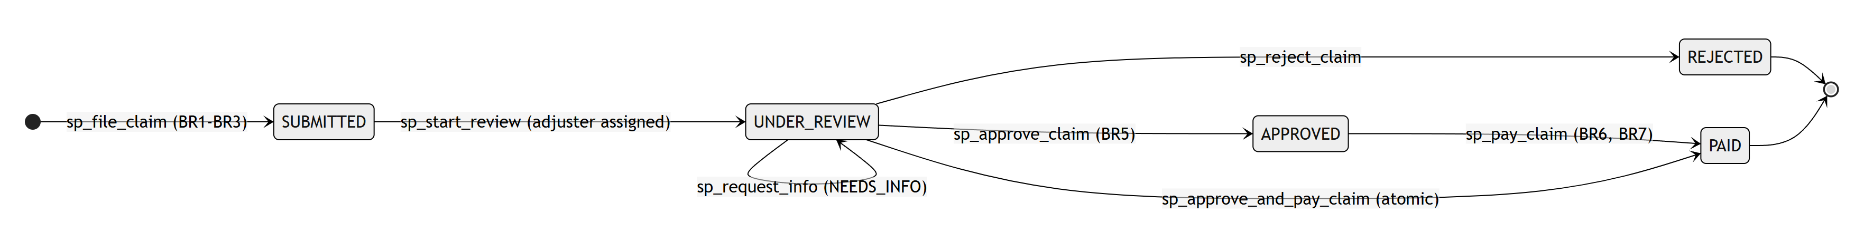
Claim life-cycle

8.5 Transactions and concurrency control
Atomicity. sp_approve_and_pay_claim inserts an assessment, changes the claim to APPROVED and inserts a payout. If the payout violates BR6 (for example, total payouts would exceed the sum assured), the exit handler rolls back the whole transaction, so the assessment and the status change disappear as well:
CALL sp_approve_and_pay_claim(@claim2, 15, 300000, 'full amount', 'NEFT', @payout2, @ref2);
ERROR 1644 (45000): BR6: total payouts 550000.00 would exceed the sum assured 500000.00

SELECT claim_id, status FROM claim WHERE claim_id = @claim2; -- 2457 | UNDER_REVIEW
SELECT COUNT(*) AS assessments_left_behind FROM claim_assessment
WHERE claim_id = @claim2; -- 0

Savepoints. The demo script also uses SAVEPOINT after_spouse and ROLLBACK TO SAVEPOINT to undo one wrong nominee row without losing the earlier one in the same transaction.
Isolation and locking. InnoDB runs at REPEATABLE READ. core_lock_claim reads the claim with SELECT … FOR UPDATE, which places an exclusive row lock. A second session trying to act on the same claim waits until the first commits, then sees the new status and fails cleanly. scripts/concurrency_demo.py runs two real database sessions in parallel threads:
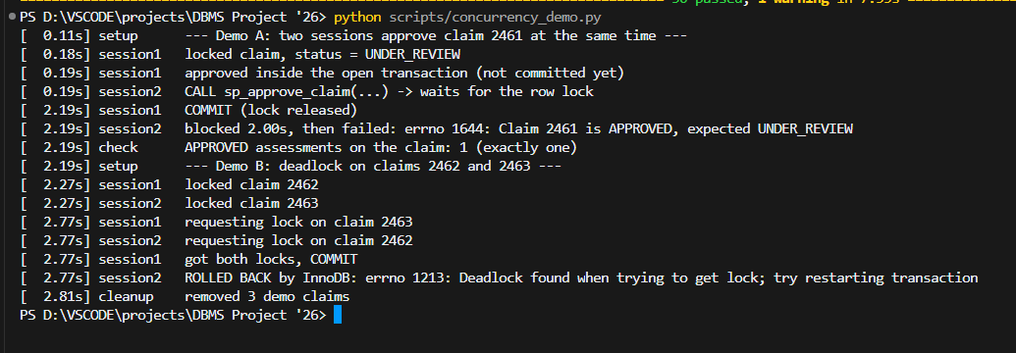
Concurrency demo: row lock and deadlock
Demo A shows that only one of two simultaneous approvals succeeds. Demo B makes two sessions lock two claims in opposite order; InnoDB detects the deadlock, rolls back one session (error 1213) and lets the other finish. The API maps error 1213 to HTTP 409 so the user can simply retry.

9. Front-End Design and Database Connectivity

9.1 Front-end design
The front end is a single-page application written in plain HTML, CSS and JavaScript, served by the API at http://127.0.0.1:8000. It was deliberately kept plain, in the style of database administration tools such as phpMyAdmin: a top menu bar, grey tables with sortable column headers, search boxes, filter drop-downs and pagination.
Screens
Menu | What it shows / does
Dashboard | Key figures (active policies, open claims, high-risk claims, 12-month premium and payouts, loss ratio, overdue instalments) and four bar charts
Claims | Work queue of open claims sorted by fraud risk; filters by status, product and risk band; "File claim"; clicking a claim opens its detail panel with the workflow buttons, documents, assessments and audit trail
Policies | All policies with filters; "Sell policy"; policy detail with nominees, instalments and claims
Customers | Generic CRUD screen (list, search, add, edit, delete)
Premiums | Overdue instalments with a Pay button, plus batch actions (generate instalments, lapse overdue, expire policies)
Reports | Eight reports as tables with CSV download
Fraud model | Active model, threshold, test metrics, model comparison, confusion matrix and charts
Master data | CRUD screens for agents, products, providers, adjusters and pincodes

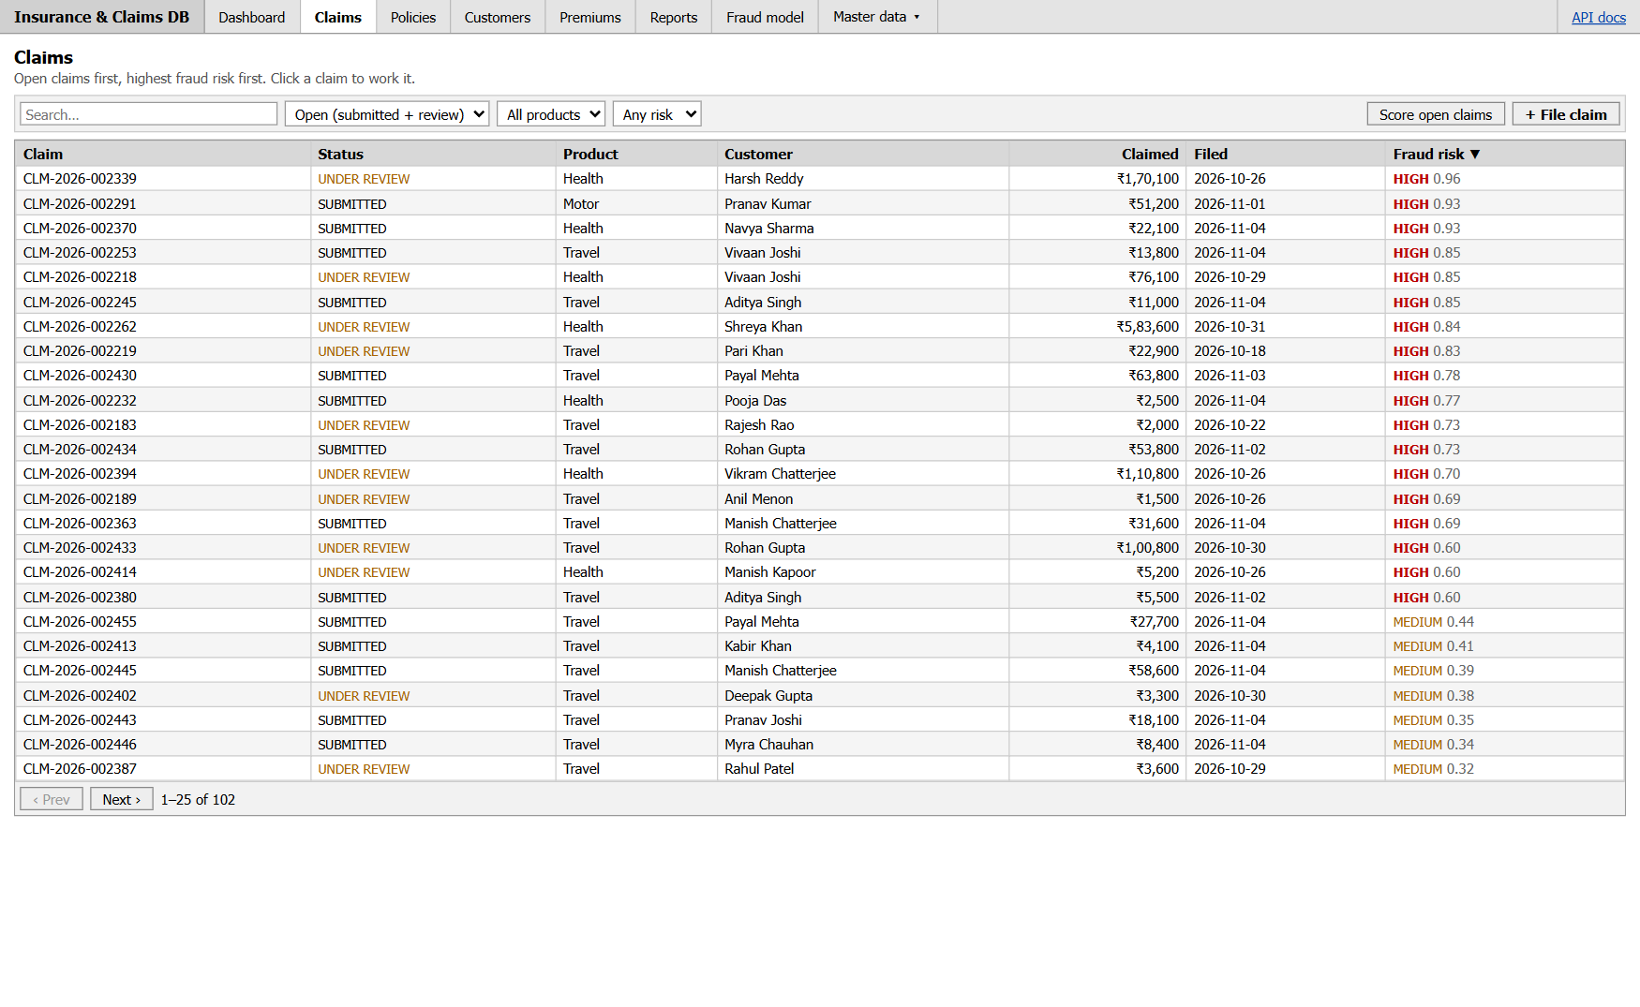
Claims work queue, riskiest first

9.2 Database connectivity
The browser never talks to MySQL directly. It calls the REST API with fetch(), and the FastAPI application talks to MySQL through mysql-connector-python with a connection pool, so each request borrows an open connection instead of opening a new one. Connection settings are read from a .env file, and the application uses its own MySQL account (insurance_app) with rights only on the project databases.
# api/db.py (excerpt)
def get_pool():
"""One pool per process. autocommit=True: the stored procedures own their transactions."""
global _pool
if _pool is None:
_pool = pooling.MySQLConnectionPool(
pool_name="insurance_pool", pool_size=int(ENV.get("DB_POOL_SIZE", 10)), pool_reset_session=True,
host=ENV.get("DB_HOST", "127.0.0.1"), port=int(ENV.get("DB_PORT", 3306)),
user=ENV["DB_USER"], password=ENV["DB_PASSWORD"],
database=os.environ.get("DB_NAME", ENV.get("DB_NAME")),
autocommit=True, charset="utf8mb4", collation="utf8mb4_0900_ai_ci")
return _pool

The workflow endpoints only call stored procedures (for example POST /api/claims/{id}/approve-and-pay calls sp_approve_and_pay_claim), so the transaction logic stays in the database. When MySQL rejects an operation, the API returns its message with a suitable HTTP status, and the front end shows it in a red message bar:
Mapping of MySQL errors to HTTP responses
MySQL error | Meaning | HTTP status
1644 | Business rule raised by a trigger or procedure (SIGNAL) | 409 Conflict
1062 | Duplicate value for a UNIQUE key | 409 Conflict
1451 / 1452 | Foreign key: parent in use / parent missing | 409 Conflict
1213 | Deadlock, transaction rolled back | 409 Conflict
3819 | CHECK constraint violated | 422 Unprocessable
1048, 1366, 1292, 1406, 1364, 1265 | NULL / wrong type / bad date / too long / missing value | 422 Unprocessable

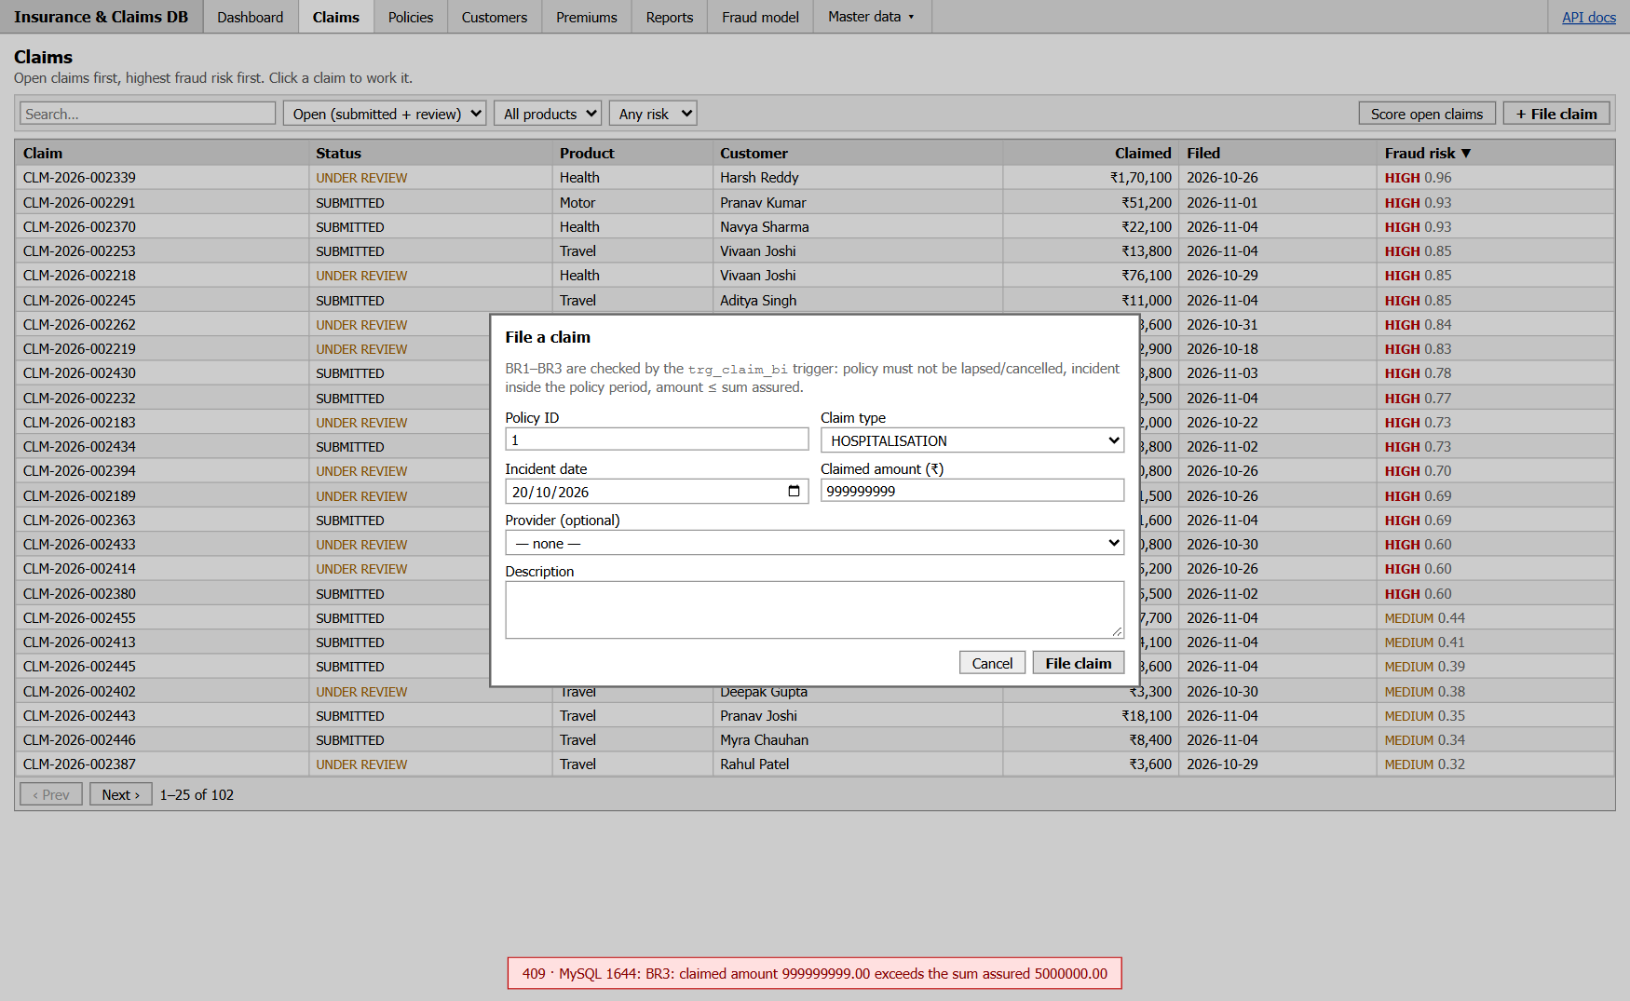
A claim above the sum assured, rejected by the BR3 trigger

9.3 Security
- SQL injection: every value is sent as a bound parameter (%s). Table names, column names and sort columns can only come from a fixed whitelist in api/crud.py; anything else is rejected with HTTP 400 or 422. Automated tests send inputs such as ' OR '1'='1 and email; DROP TABLE customer to confirm this.
- Least privilege: the app connects as insurance_app, not as root.
- Read-only paths: premium instalments cannot be edited through generic CRUD (HTTP 405); they change only through sp_pay_premium and the batch procedures.

10. CRUD Operations and Report Generation

10.1 Generic CRUD
Instead of writing separate code for every master table, one generic CRUD module serves all of them. Each resource is described once in a whitelist: its table, primary key, writable columns, searchable columns, filters and (optionally) a view to read from. For customers and providers the view adds the city and state from the pincode table, while writes still go to the base table.
Generic CRUD endpoints
HTTP request | SQL executed | Notes
GET /api/{resource}?search=&sort=&order=&limit=&offset=&<filter>= | SELECT … WHERE … LIKE %s … ORDER BY … LIMIT %s OFFSET %s, plus a COUNT(*) | Search, filter, sort, paginate
GET /api/{resource}/{id} | SELECT * … WHERE pk = %s | 404 if missing
POST /api/{resource} | INSERT INTO … VALUES (%s, …) | 201 + the new row
PUT /api/{resource}/{id} | UPDATE … SET col = %s … WHERE pk = %s | Partial update
DELETE /api/{resource}/{id} | DELETE FROM … WHERE pk = %s | 409 if the row is still referenced

Resources covered: pincodes, customers, agents, policy types, providers, adjusters, nominees, documents (full CRUD) and payments (read-only). Policies and claims are created through their procedures and listed through their views.
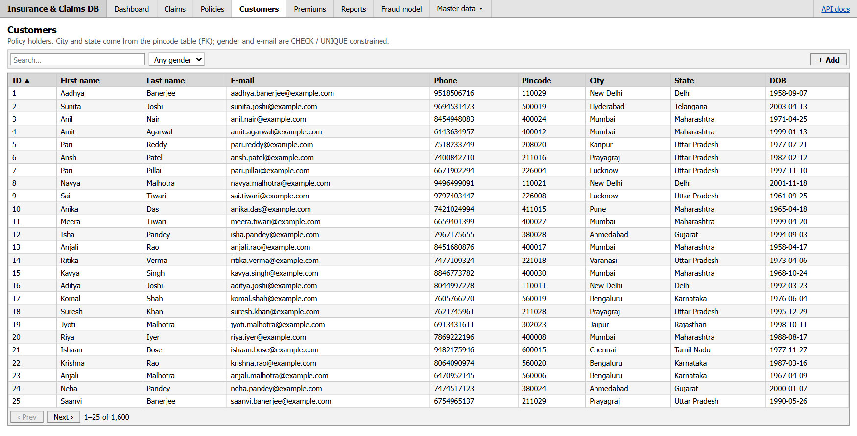
Customers screen

10.2 Workflow operations
Operations that touch several tables are not generic CRUD; each one is a dedicated endpoint that calls one stored procedure:
- POST /api/policies → sp_sell_policy (computes premium, number, first instalment).
- POST /api/claims → sp_file_claim; then start-review, request-info, approve, reject, pay, approve-and-pay → the matching sp_* procedure.
- POST /api/payments/{id}/pay → sp_pay_premium.
- POST /api/admin/generate-instalments, /lapse-overdue, /expire-policies → the batch procedures.
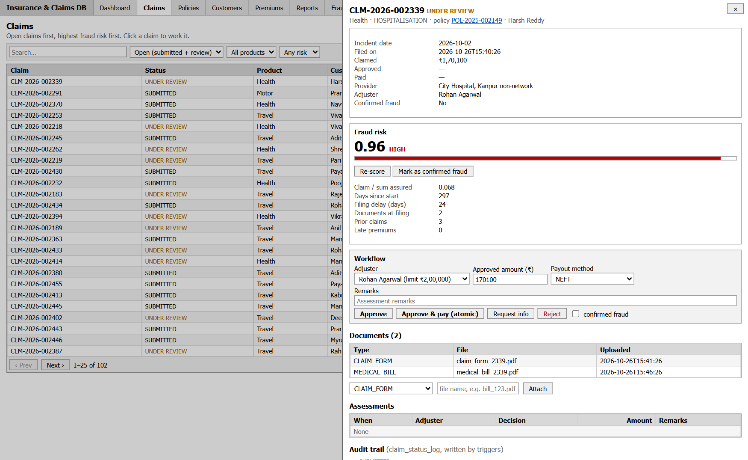
Claim detail with fraud risk and workflow actions

10.3 Reports
Each report is a single SQL query over the views and can be viewed on screen or downloaded as CSV (?format=csv).
Reports
Report | Source | Business question
Monthly claims | v_monthly_claims | How many claims are filed, approved, rejected and paid each month?
Agent commission | v_agent_performance | How much premium did each agent bring in, and what commission is due?
Overdue premiums | v_overdue_premiums | Which instalments are late, and by how many days?
Loss ratio by product | v_loss_ratio_by_type | For each product, what share of premium is paid out as claims?
Policies expiring in 60 days | v_policy_overview | Which policies should be offered for renewal?
Open claims by risk | v_claim_summary | Which open claims should adjusters review first?
Claims by product | v_claim_summary | Claim count, amounts and average days to settle per product
Top providers by amount paid | v_claim_summary | Which hospitals and garages receive the most money?

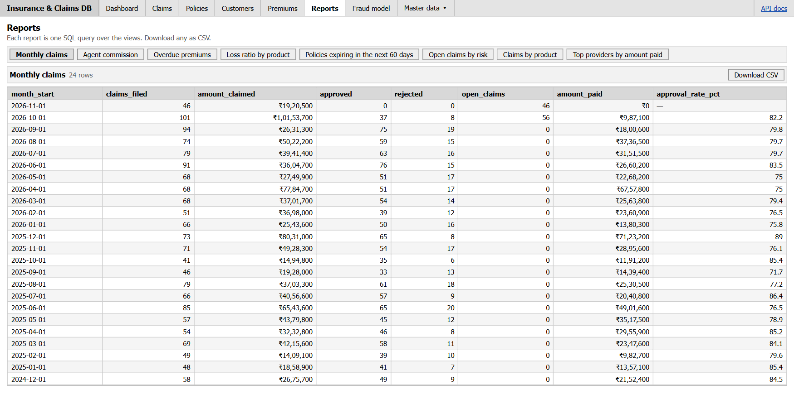
Reports screen
Example result, loss ratio by product (claims paid ÷ premium collected): Health 99.53%, Life 108.35%, Motor 133.60%, Home 91.69%, Travel 89.02%. A loss ratio above 100% means the product paid out more than it collected; in this dataset that is the case for Motor and Life.
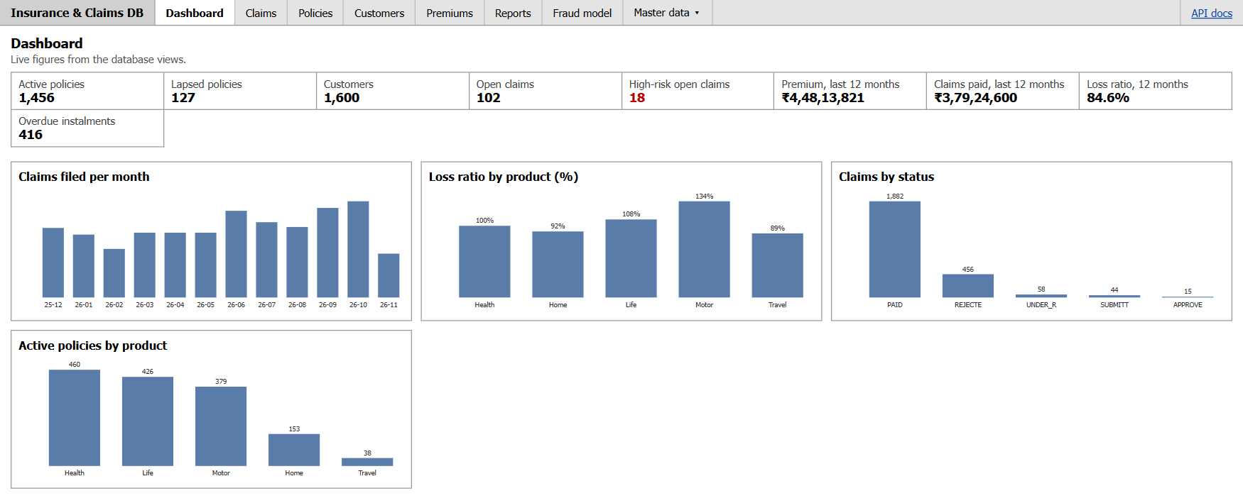
Dashboard

11. AI/ML Implementation and Model Evaluation

11.1 Problem definition
The task is binary classification: given a claim at the moment it is filed, estimate the probability that it is fraudulent. The label is claim.fraud_flag, which an adjuster sets when fraud is confirmed (typically on rejection, or later after payment). Only resolved claims (REJECTED or PAID) are used for training, because open claims have no final label yet.
The output is used to rank the work queue and to show a LOW / MEDIUM / HIGH band. It never approves or rejects a claim automatically; the decision stays with the adjuster.

11.2 Data and features
Training data comes straight from the database through the view v_claim_features. 2,353 resolved claims were available, of which 210 (8.9%) are confirmed fraud, so the classes are imbalanced. Features use only information known when the claim is filed; for example, the document count includes only documents uploaded within one day of filing. This prevents data leakage: using later information such as the payout would make the model look good in testing but useless on new claims.
Model features (computed in v_claim_features)
Feature | Meaning
claimed_amount | Amount claimed
claim_ratio | Claimed amount ÷ sum assured
days_since_start | Days between policy start and the incident
days_to_end | Days between the incident and policy end
filing_delay | Days between the incident and filing
customer_age | Age of the policy holder at the incident
prior_claims | Number of earlier claims by the same customer
late_payments | Number of premium instalments that were paid late or missed
documents_attached | Documents uploaded within one day of filing
non_network_provider | 1 if the provider is outside the insurer's network
claim_type | Category (one-hot encoded)
policy_type | Product (one-hot encoded)

11.3 Training method
- Stratified split: 80% training (1,882 claims) and 20% held-out test (471 claims). The test set is used only once, at the very end.
- Three candidate models in scikit-learn pipelines (scaling and one-hot encoding inside the pipeline): Logistic Regression, Random Forest and Histogram Gradient Boosting, each with class weighting for the imbalance.
- Model selection by 5-fold stratified cross-validation ROC-AUC on the training set.
- The decision threshold is chosen to maximise F1 on out-of-fold predictions of the training set, not on the test set.
- The selected model is refitted on the full training set, evaluated once on the test set, saved with joblib, and registered in the database with CALL sp_register_model(…), which deactivates the old model and activates the new one in a single transaction.
Cross-validation results (training set)
Model | Mean ROC-AUC | Std. dev.
Logistic regression | 0.9089 | 0.0196
Random forest (selected) | 0.9329 | 0.0095
Hist. gradient boosting | 0.9135 | 0.0151

11.4 Evaluation on the held-out test set
Test-set metrics of the selected model
Metric | Value | What it means
ROC-AUC | 0.948 | Probability that a random fraud claim is scored higher than a random genuine one
PR-AUC (average precision) | 0.776 | Area under the precision-recall curve (a random model would score about 0.09)
Precision | 0.816 | Of the claims flagged HIGH, the share that really were fraud
Recall | 0.738 | Of all fraud claims, the share that were flagged
F1 score | 0.775 | Harmonic mean of precision and recall
Threshold | 0.505 | Score at or above which a claim is HIGH risk

Confusion matrix on the 471 test claims: 31 frauds correctly flagged (true positives), 11 frauds missed (false negatives), 7 genuine claims wrongly flagged (false positives) and 422 genuine claims correctly passed (true negatives).
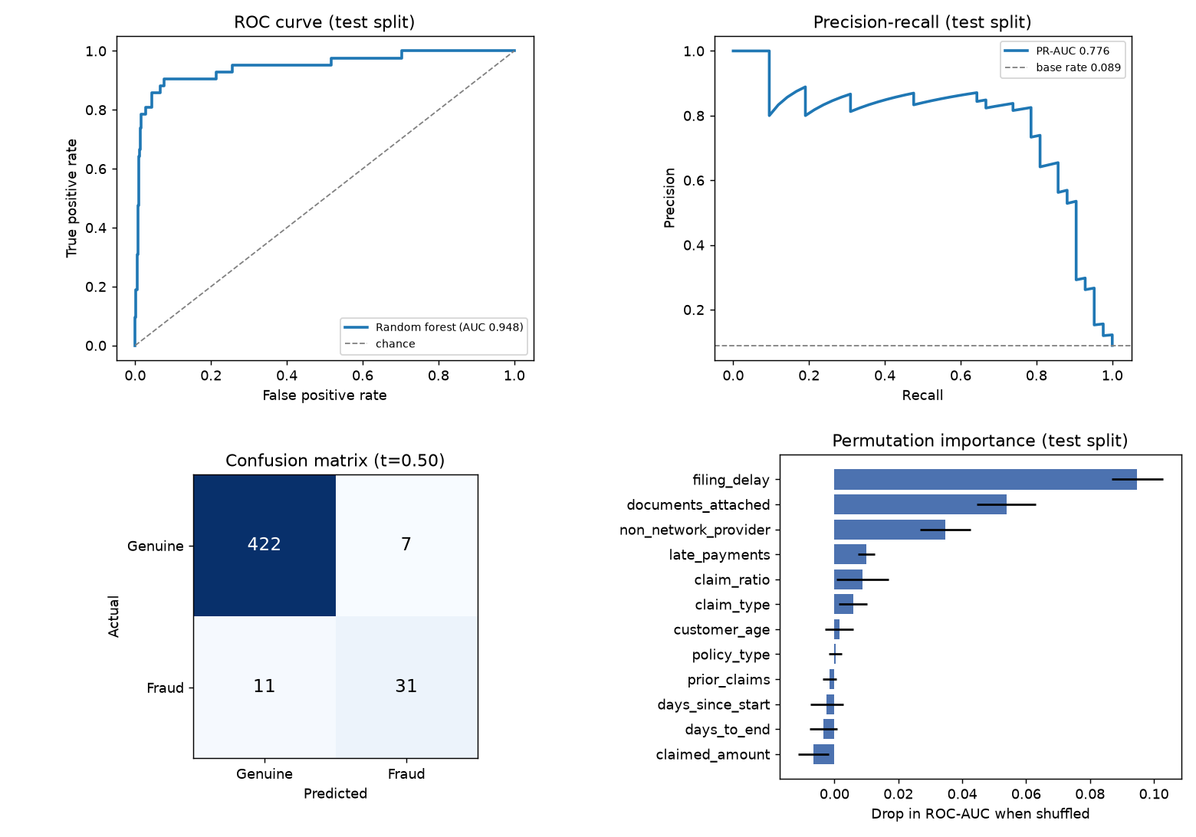
Model evaluation on the test set
Permutation importance shows that the model relies mainly on filing delay, number of documents and non-network provider, followed by late premium payments and the claim-to-cover ratio. These match the warning signs that claim investigators look for in practice.

11.5 Deployment in the application
- When a claim is filed, and again whenever a document is attached to an open claim, the API reads the claim's features from v_claim_features, scores it and writes claim.fraud_score.
- A "Score open claims" button re-scores all open claims in one batch.
- v_claim_summary turns the score into a risk band using the threshold of the active model in fraud_model; the Claims screen sorts by this score.
- The Fraud model screen shows the registered model, its metrics and these charts.

11.6 Limitations
The dataset is synthetic. It was generated with a deliberate, realistic fraud signal so that the pipeline could be built and tested end to end. The metrics therefore show that the pipeline works correctly, not how accurate the model would be on a real insurer's claims. With real data, the same code would simply be retrained, and the threshold would be re-tuned to the investigation team's capacity.

12. Testing, Results and Screenshots

12.1 Testing approach
- Automated tests (pytest): 30 tests call the real API, which talks to a separate insurance_test database built from the same SQL scripts. They cover CRUD, every business rule, atomicity, concurrency, reports and ML scoring.
- Rule demonstrations: db/08_rule_demos.sql performs each forbidden action on purpose and records the database's error. It cleans up after itself.
- Performance: EXPLAIN ANALYZE before and after indexing.
- Concurrency: two real sessions in parallel threads.
- Manual UI testing of every screen in Chrome.
All evidence is regenerated with one command, python scripts/run_everything.py, and saved under docs/outputs/.

12.2 Automated test results
Automated test suite
Test file | Tests | What is checked | Result
test_crud.py | 12 | CRUD round trips for every resource; search, filter, sort, pagination; ON UPDATE CASCADE of pincode; CHECK → 422; FK and duplicate key → 409; payments read-only (405); column whitelist and parameterised search (SQL injection attempts fail) | 12 / 12 pass
test_rules.py | 12 | Policy cover validation; each of BR1–BR10; request-info keeps the claim under review; fraud can be confirmed after payment | 12 / 12 pass
test_transactions.py | 6 | Failed approve-and-pay leaves no partial state; four concurrent approvals → exactly one succeeds; all reports and CSV export; fraud scoring, re-scoring on document upload, risk bands follow the registered threshold | 6 / 6 pass

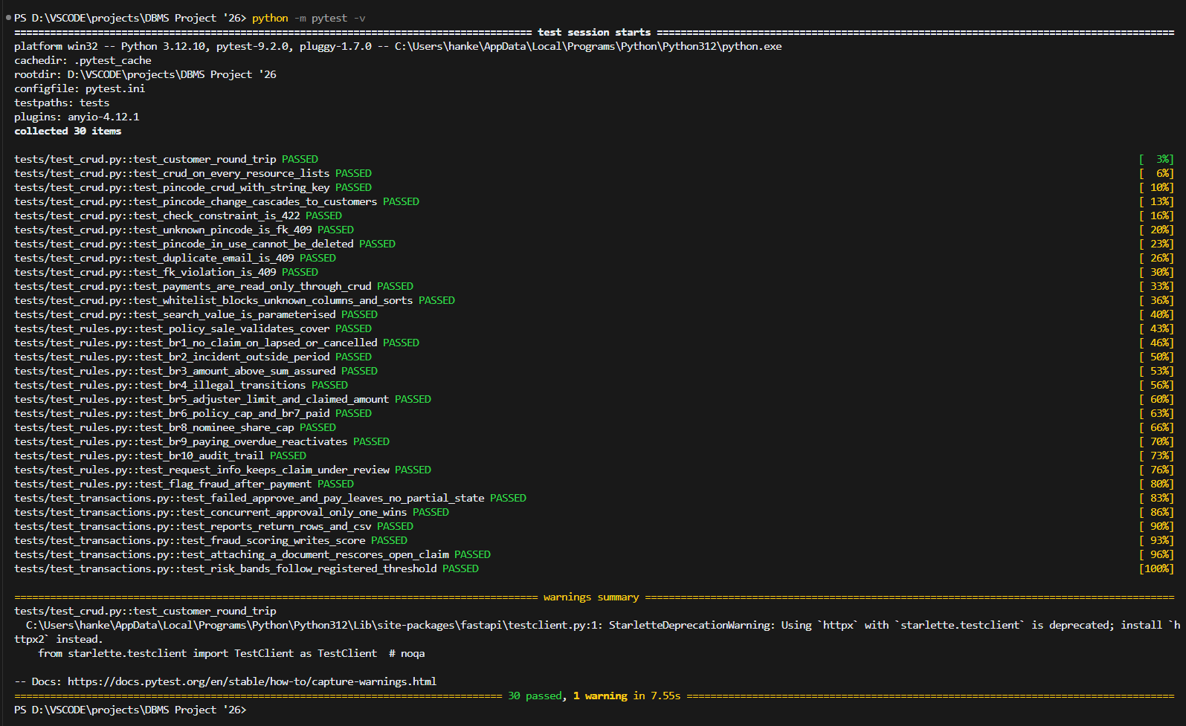
Test run: all 30 tests pass

12.3 Business-rule demonstrations
Each of the following operations was attempted on the real database and was correctly rejected. The error numbers are MySQL's: 1644 = rule raised by a trigger, 3819 = CHECK, 1451/1452 = foreign key, 1062 = duplicate key.
Expected errors from 08_rule_demos.sql
# | Attempted operation | Stopped by | Error
1 | Sum assured outside product range | trg_policy_bi | 1644
2 | Pincode not 6 digits | CHECK ck_pincode_format | 3819
3 | Instalment PAID without paid_on | CHECK ck_payment_paid_on | 3819
4 | Customer with unknown pincode | FK fk_customer_pincode | 1452
5 | Incident before policy start | BR2 (trg_claim_bi) | 1644
6 | Claim larger than sum assured | BR3 (trg_claim_bi) | 1644
7 | SUBMITTED → APPROVED directly | BR4 (trg_claim_bu) | 1644
8 | Review without an adjuster | BR4 (trg_claim_bu) | 1644
9 | Changing amount after review started | trg_claim_bu | 1644
10 | Approval above adjuster limit | BR5 (trg_assessment_bi) | 1644
11 | Approval above claimed amount | BR5 (trg_assessment_bi) | 1644
12 | Paying a claim that is not approved | BR6 (trg_payout_bi) | 1644
13 | Payout above approved amount | BR6 (trg_payout_bi) | 1644
14 | Approve-and-pay above remaining cover (rolled back) | BR6 + transaction | 1644
15 | Nominee shares 110% (insert) | BR8 (trg_nominee_ai) | 1644
16 | Nominee shares 120% (update) | BR8 (trg_nominee_au) | 1644
17 | Claim on a LAPSED policy | BR1 (trg_claim_bi) | 1644
18 | Claim on a CANCELLED policy | BR1 (trg_claim_bi) | 1644
19 | Document for a missing claim | FK fk_doc_claim | 1452
20 | Deleting a product in use | FK fk_policy_type (RESTRICT) | 1451
21 | Duplicate customer e-mail | UNIQUE uq_customer_email | 1062

The same script also shows the successful paths: BR7 (payout sets the claim to PAID), BR9 (a lapsed policy becomes ACTIVE again when the overdue instalment is paid), BR10 (audit rows for each change), a savepoint rollback, and the instalment-generation, lapse and expiry batch procedures.

12.4 Results summary
Final state of the loaded database
Item | Value
Customers / agents / providers / adjusters | 1,600 / 40 / 120 / 15
Policies (active / expired / lapsed / cancelled) | 3,500 (active 1,456, cancelled 40, expired 1,877, lapsed 127)
Premium instalments | 10,484
Claims (by status) | 2,455 (APPROVED 15, PAID 1,882, REJECTED 456, SUBMITTED 44, UNDER_REVIEW 58)
Documents / assessments / payouts / audit rows | 7,252 / 2,484 / 1,882 / 9,101
Automated tests | 30 / 30 passed
Rule demonstrations | 21 / 21 rejected as expected
Fraud model (test set) | Random forest: ROC-AUC 0.948, precision 0.82, recall 0.74

13. Conclusion and Future Scope

13.1 Conclusion
We designed and built a complete Insurance & Claims Management System on MySQL 8. Starting from an unnormalized policy register, we arrived at 15 tables in BCNF, linked by 16 foreign keys with chosen referential actions. All ten business rules are enforced inside the database by constraints and triggers, so the data stays consistent no matter which client writes to it. The policy and claim life-cycles are implemented as transactional stored procedures, and we showed that they stay correct under failure (full rollback of a partly completed approve-and-pay) and under concurrent use (row locking and deadlock detection).
The project uses the full range of SQL covered in the course, including joins of every kind, correlated subqueries, ROLLUP, window functions, recursive CTEs and set operations. Four of the seven secondary indexes were measured with EXPLAIN ANALYZE, and each turned a full table scan into an index scan; the other three support customer search, the monthly claims trend and document lookups. A FastAPI back end and a plain web interface make the database usable by non-technical staff through CRUD screens, a claims work queue and eight reports. A Random Forest model, trained only on information available at filing time, ranks open claims by fraud risk with a test ROC-AUC of 0.948, and its threshold is managed through the database itself. Thirty automated tests and twenty-one rule demonstrations confirm that the system behaves as specified.

13.2 Future scope
- Authentication and roles: separate logins for servicing staff, adjusters and managers, with MySQL roles and API permissions (for example, only managers can register a model or cancel a policy).
- Document storage: upload the actual files (to object storage) and extract data from them with OCR.
- Customer portal: let customers view policies, pay premiums and file claims online, with SMS/e-mail notifications on status changes.
- Real data and model monitoring: retrain on real claims, monitor drift, and explain each score to the adjuster (e.g. SHAP values).
- Scale: partition the claim and payment tables by year, add read replicas for reporting, and archive old audit rows.
- More products and rules: co-payments, deductibles, waiting periods, policy renewals and endorsements.

14. References
- A. Silberschatz, H. F. Korth and S. Sudarshan, Database System Concepts, 7th ed., McGraw-Hill, 2019.
- R. Elmasri and S. B. Navathe, Fundamentals of Database Systems, 7th ed., Pearson, 2016.
- Oracle Corporation, MySQL 8.0 Reference Manual, https://dev.mysql.com/doc/refman/8.0/en/ (triggers, stored programs, InnoDB locking, EXPLAIN ANALYZE, window functions, CTEs).
- Oracle Corporation, MySQL Connector/Python Developer Guide, https://dev.mysql.com/doc/connector-python/en/.
- S. Ramírez, FastAPI documentation, https://fastapi.tiangolo.com/.
- F. Pedregosa et al., "Scikit-learn: Machine Learning in Python", Journal of Machine Learning Research, vol. 12, pp. 2825–2830, 2011.
- L. Breiman, "Random Forests", Machine Learning, vol. 45, no. 1, pp. 5–32, 2001.
- T. Saito and M. Rehmsmeier, "The precision-recall plot is more informative than the ROC plot when evaluating binary classifiers on imbalanced datasets", PLOS ONE, 10(3), 2015.
- pytest documentation, https://docs.pytest.org/.

