Digit Recognizer

# Accuracy:

* Convoluted Neural Network(train_test_split):

Accuracy: 99.26%

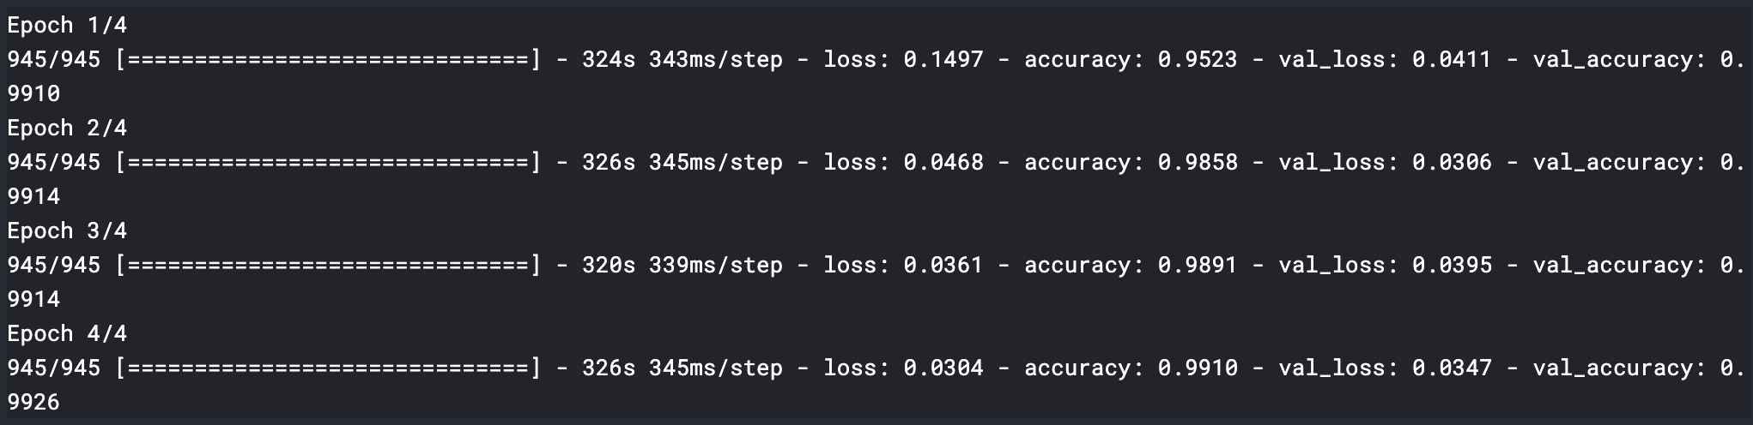

* Training Loss vs Validation Loss

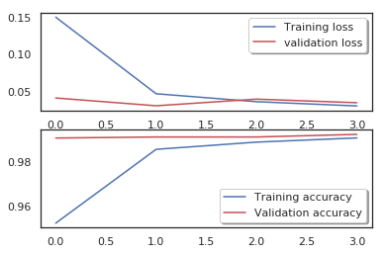

# The scatterplot in the first two principal components of the data:

Scatter graph representation of data that includes 10 different handwritten digits.

