1. Add slide for other usage in new tab
2. Add slide for Rice and floor mill in new tab
3. Put the content of On grid/Off Grid and Hybrid as following;
   1. On Grid Warranty Component
   2. Off Grid Warranty Component
   3. Hybrid Warranty Component
4. Add Hindi content also
5. Arrange slides as per following:
   1. Slide no 9 to 13: Content will be added after main heading content

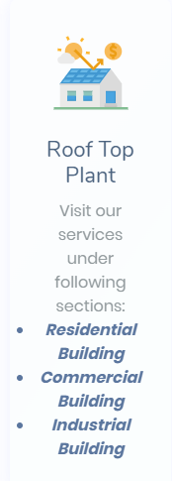

Refer loom solar website for the followings;

6. Keep Search tab at the first page like

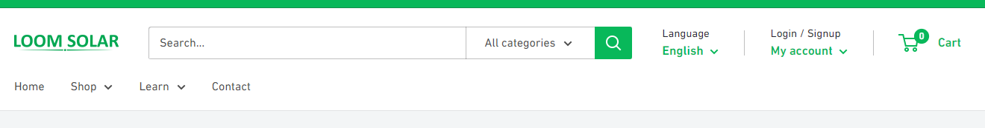

7. keep Comment box at every blog/ learn pages

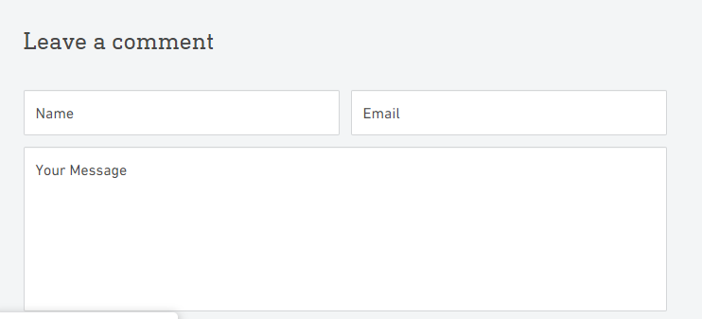

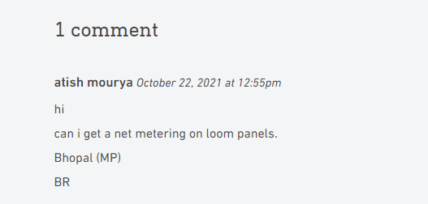

8. Add Chat box like following

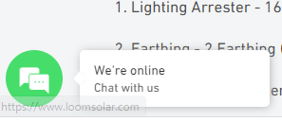

9. Content arrangement to be change to make it lucrative:

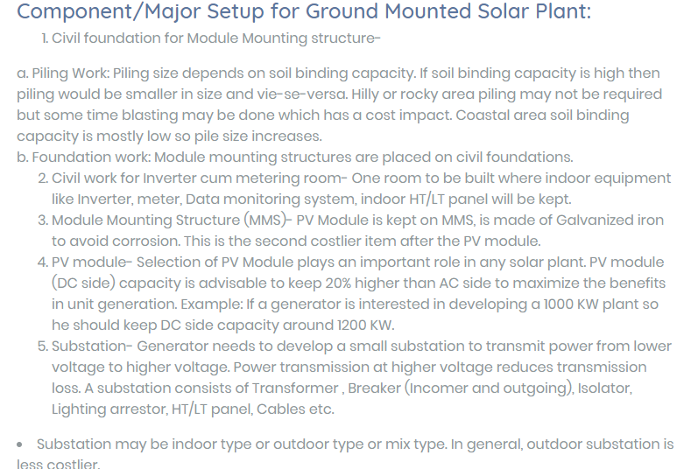

10. Add more comments ( Do not repeat same comment everywhere)

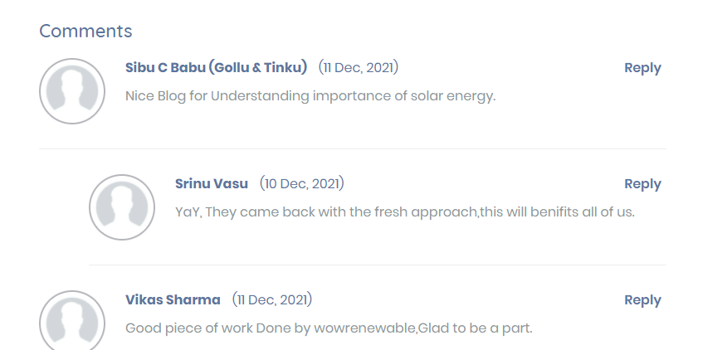

11. Each Blog need related photo like following.

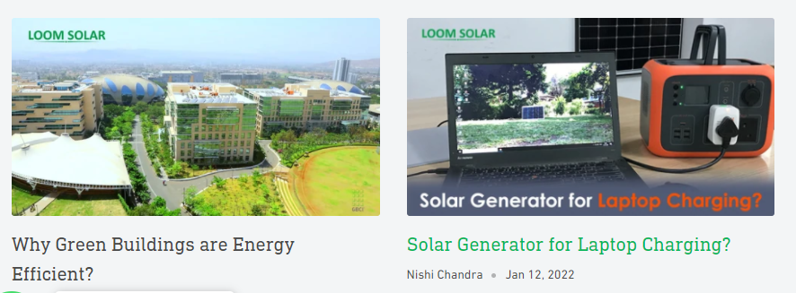

12. Add request for call back as per loom solar website:

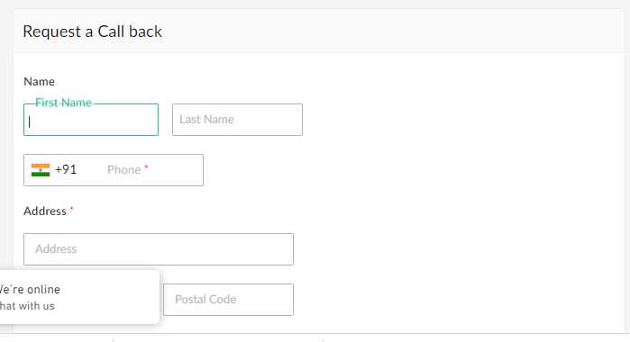

13. Following services need to reflect every page



14. We will discuss on the use of calculator

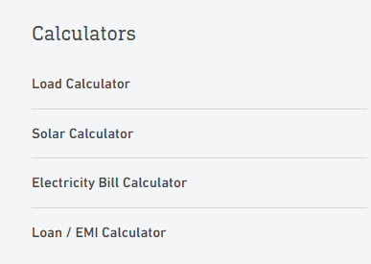

15. Front page content key words to be linked with Blogs content – Refer loom solar

Example- In Ongrid solar system content has a keyword “Net meter” and the same is available in Blog so both need to interlinked