Pdf_assessment:

Attached folder contains following files:

1. app.py 🡪 responsible for rendering and execution of streamlit
2. helper.py 🡪 All core processing logic for 3 problem statements
3. setup_execute.py 🡪 file for installing requirements and launching streamlit app
4. requirements.txt 🡪 Contains list of requirements to setup

How to setup and execute?

1. create a python env or anaconda env
2. Copy and extract “**pdf_assessment**” from attached compressed file
3. Go to folder pdf_assessment
   1. 🡪 cd pdf_assessment
4. Run setup_execute.py
   1. 🡪 python -m setup_execute

This should install all necessary requirements and launch streamlit

1. Browse pdf file. It is also present in the same folder, one can use that as well .

1. Now search the section you want to search

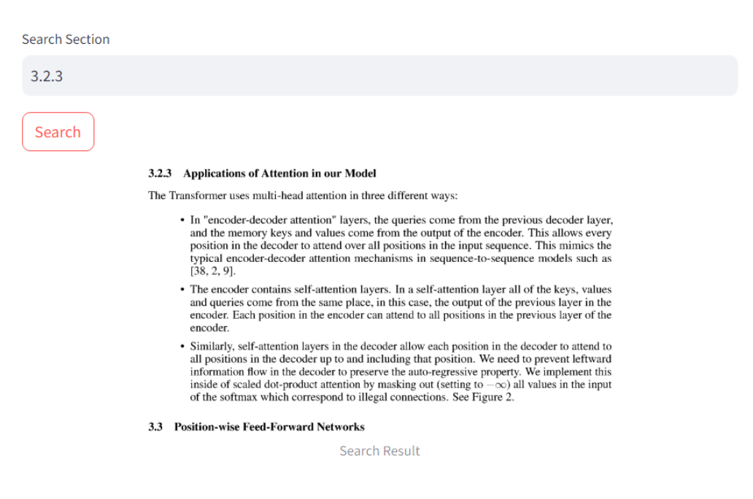

1. Search section no “5 Training”

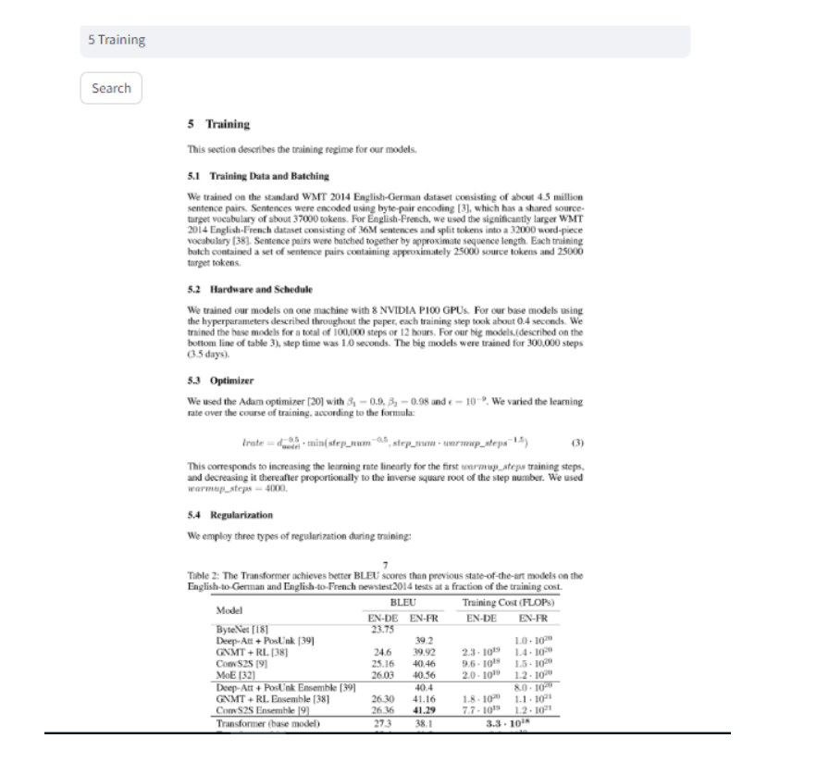

1. Now to save table we need open_api key

User needs to enter section 5.4 to extract table from 5.4 along with open api key as shown in the image :

This will store table into csv format into the same folder with name output.csv

