iOS eCommerce checkout with API plug

1. Introduction

A view which will show product details with address field and when user enter correct data and purchase method only then it will allow to purchase item is called checkout page. This plug will explore product to be purchase, allow to enter and edit address with local validation and error messages, also allow to select purchase method and enable disable BUY button.

2. Pre-requisites:

Language: Swift 4.0 and above

IDE: Xcode 9 and above

3. Features list

1. Product details
2. Add Address feature
3. Edit address feature
4. All local validation with error messages
5. To select Purchase method
6. To all BUY product with success view.

4. Screenshots

**Description**: Default checkout UI.

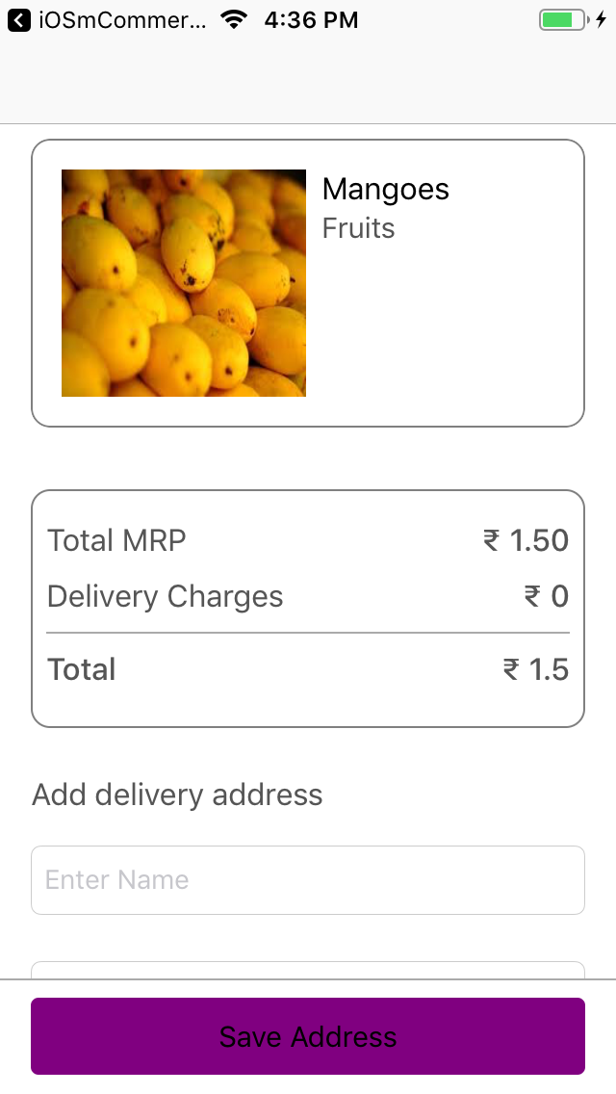

**Description**: Address error messages.

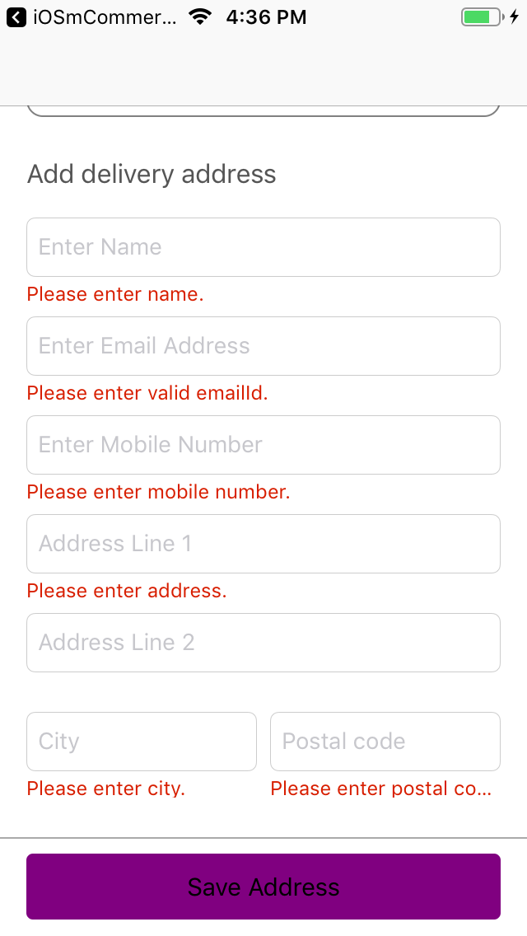

**Description**: Product with address UI.

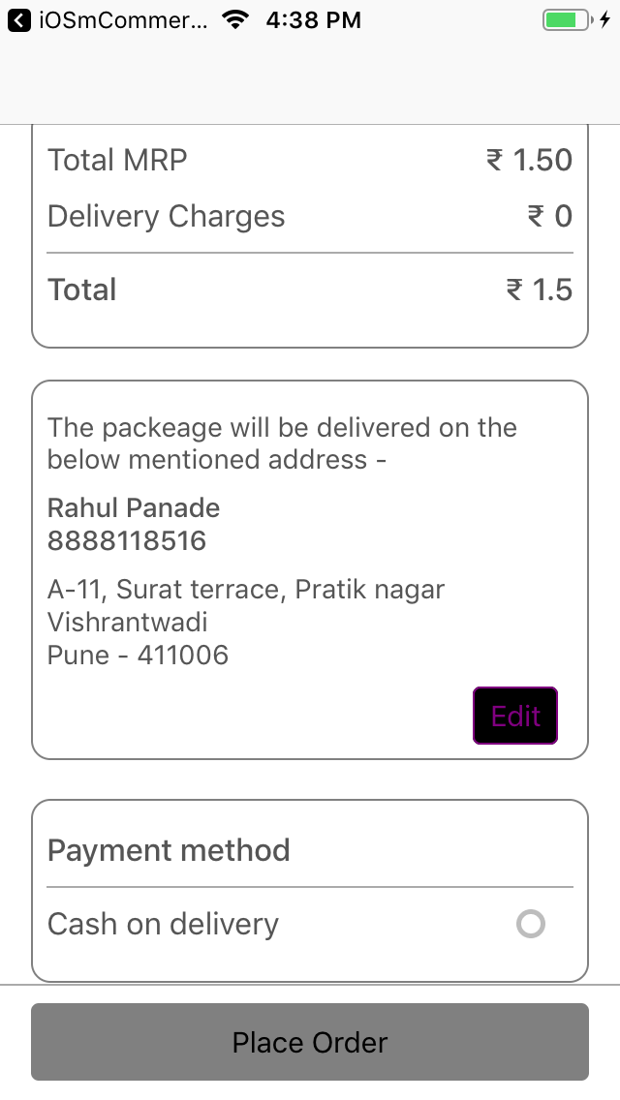

**Description**: Edit address UI.

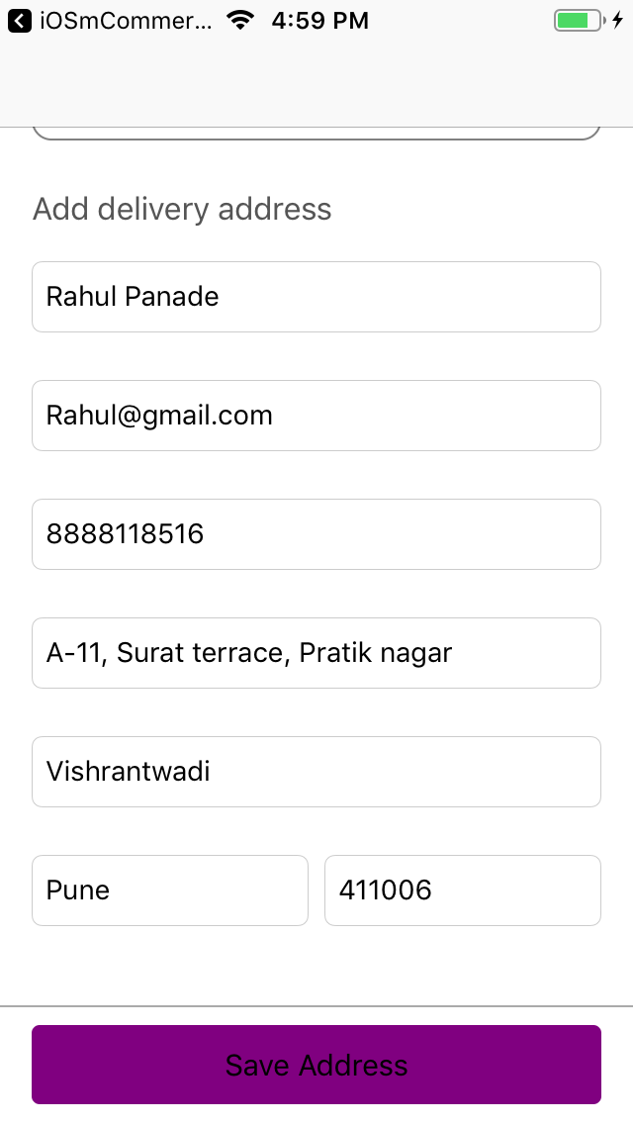

**Description**: To select purchase method.

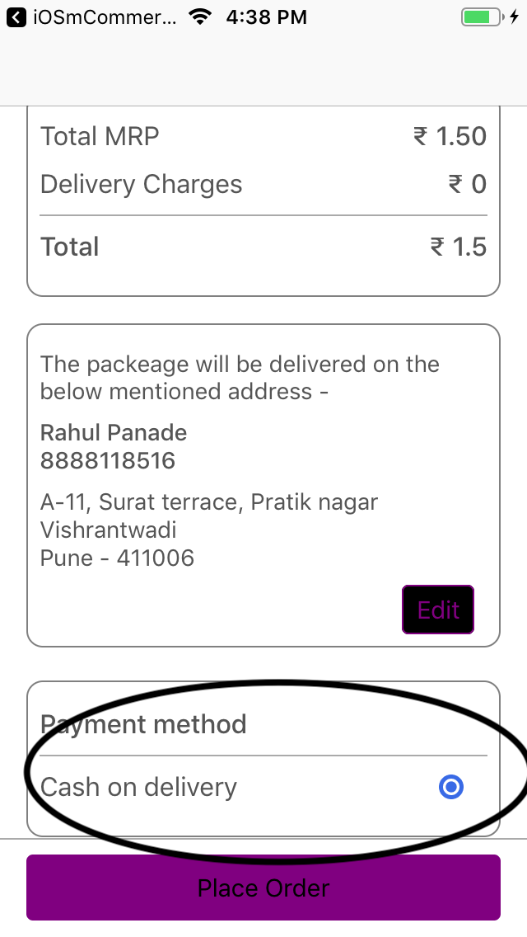

**Description**: Successfully checkout UI.

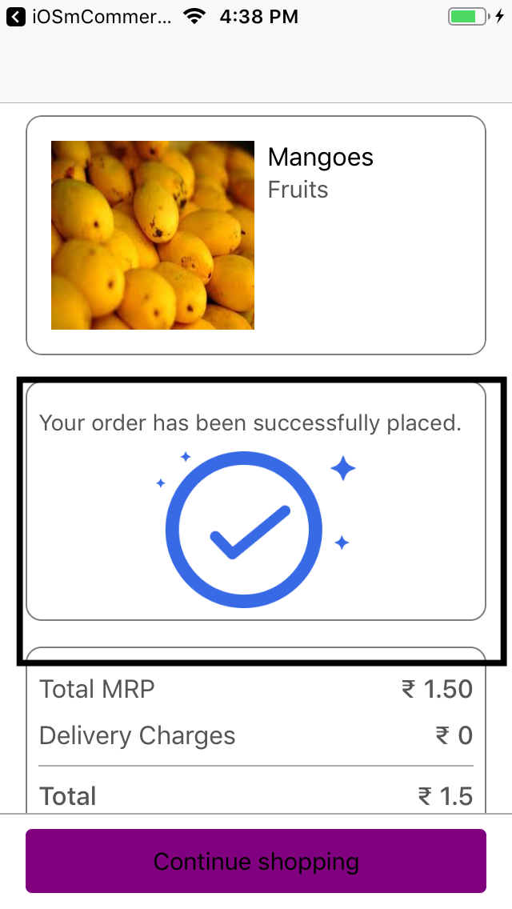

5. Steps to integrate / use / installation

1. Create Xcode project.

2. Use CocoaPods and install IQKeyboardManager

3. This method used for local validation

**func** checkLocalValidation() -> Bool

4. This method used for edit address

**@IBAction** **func** editAddressClicked(**_** sender: **Any**)

5. This method used for COD pressed

**@IBAction** **func** CODBtnClicked(**_** sender: **Any**)

6. This method used for place order

**@IBAction** **func** actionButtonClicked(**_** sender: **Any**)

7. Please go through code and check UI as well as Logic

8. Enjoy the coding

6. Contact us / Support

[Support@plug-able.com](mailto:Support@plug-able.com)

Reference link:

https://github.com/Alamofire/AlamofireImage

https://developer.apple.com/documentation/uikit/uiscrollview