iOS API based Graph Plug

1. Introduction

This is an API based graph plug, which will explore Line graph, Pie chart and Group bar graphs. Graph data filters based on date and platform. Data will show as in graph form as well as tabular form.

2. Pre-requisites:

Language: Swift 4.0 and above

IDE: Xcode 9 and above

3. Features list

1. Line graph
2. Pie chart
3. Group bar
4. Table view
5. Dynamic configure URL

4. Screenshots

**Description**: Default view showing App usage graph with one-week default time.

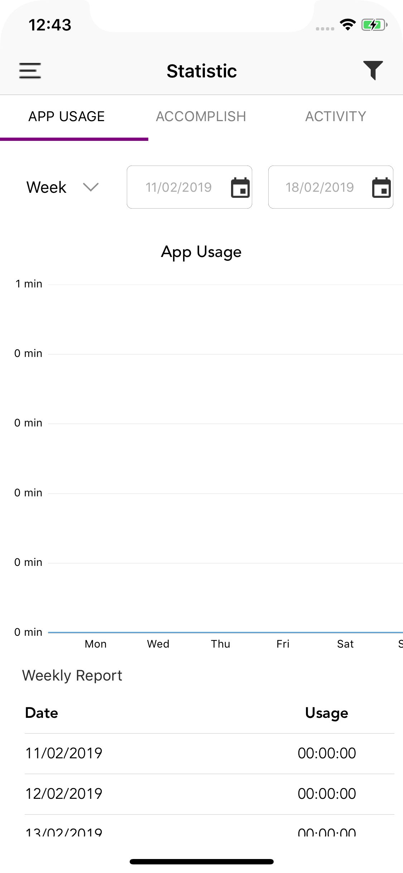

**Description**: Showing date filter dropdown option.

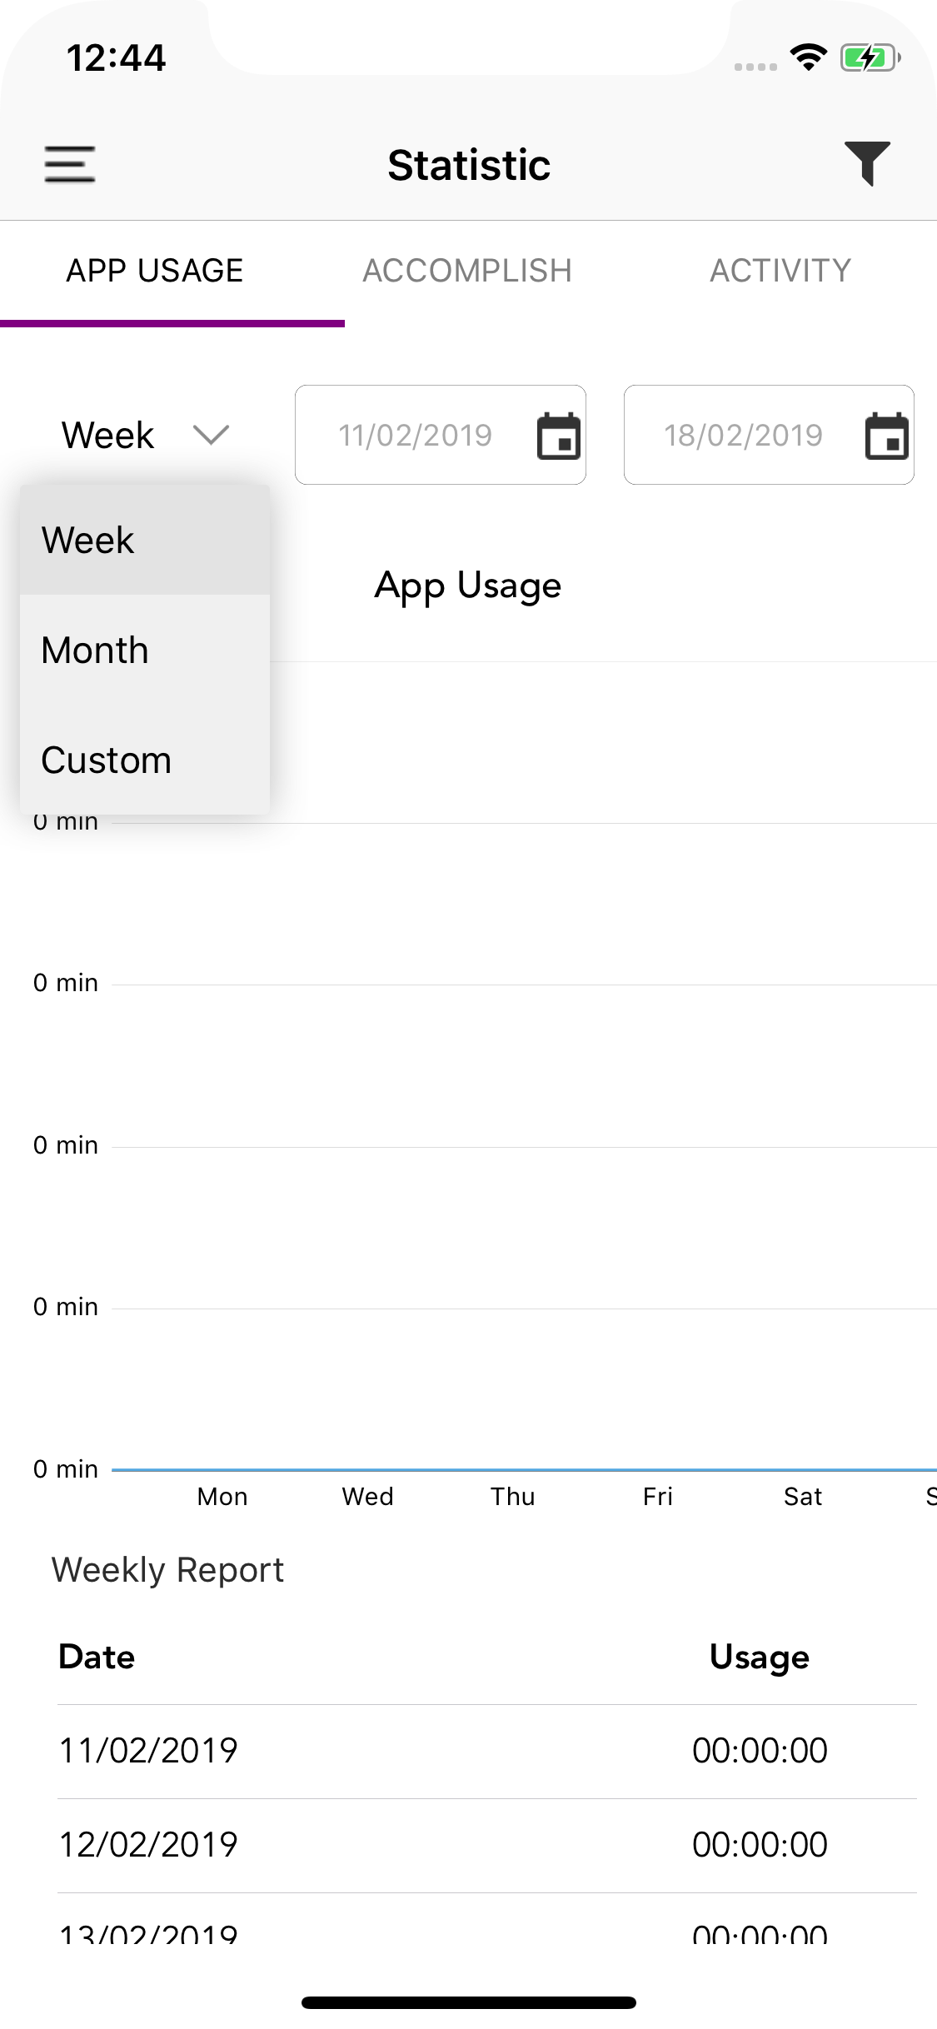

**Description**: Showing platform filter dropdown option.

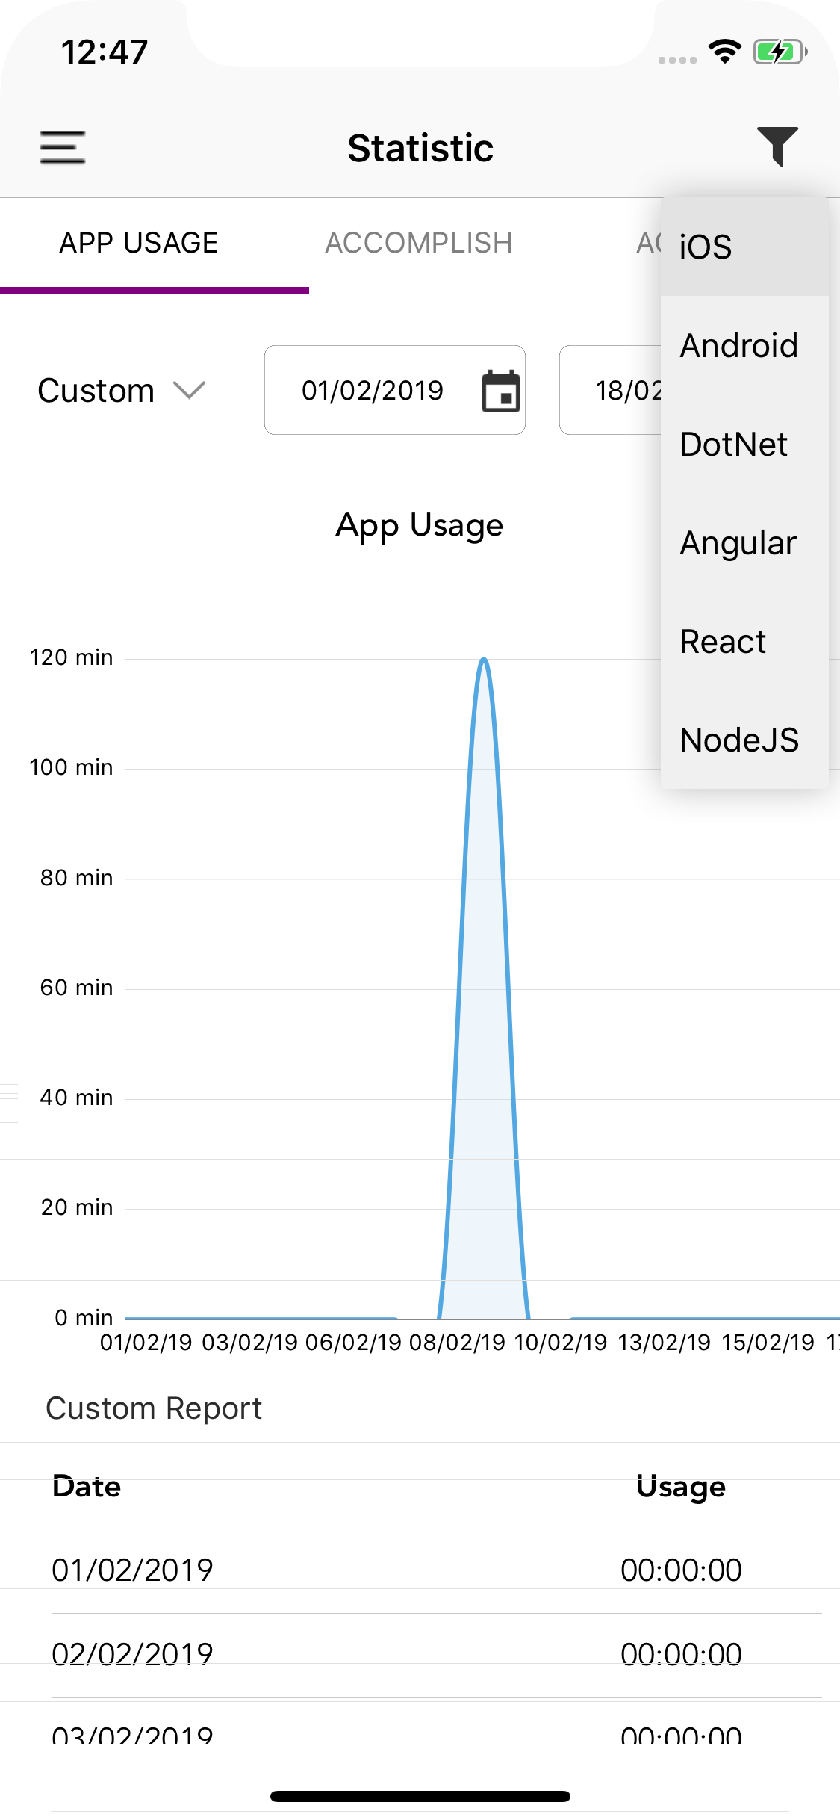

**Description**: When select month as date filter, it will set filter as FROM date as 1st date of current month and TO date as today date of current month.

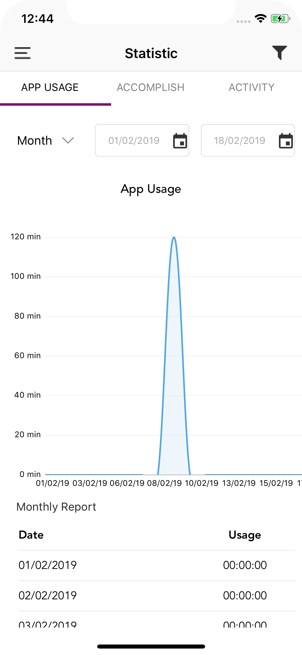

**Description**: When you select Custom as date filter option at that time you can customize both date.

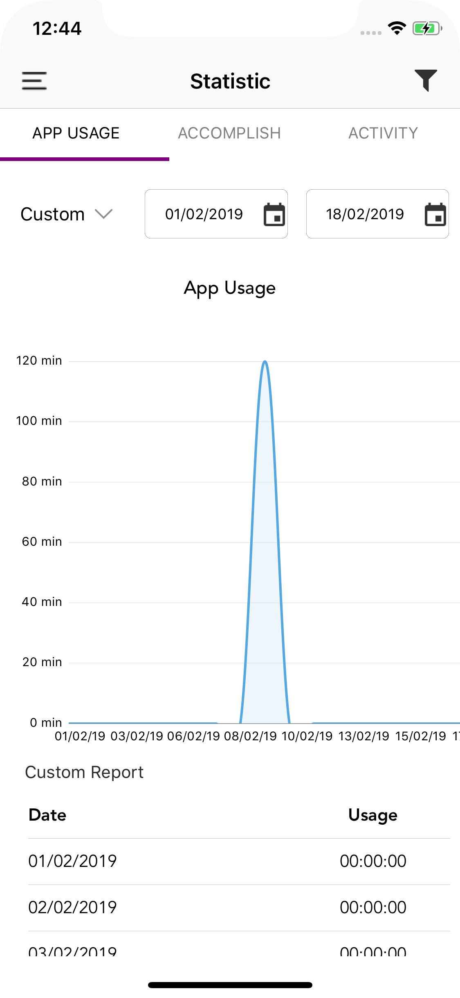

**Description**: When you click on any custom date option, calendar open as with default date of respected button.

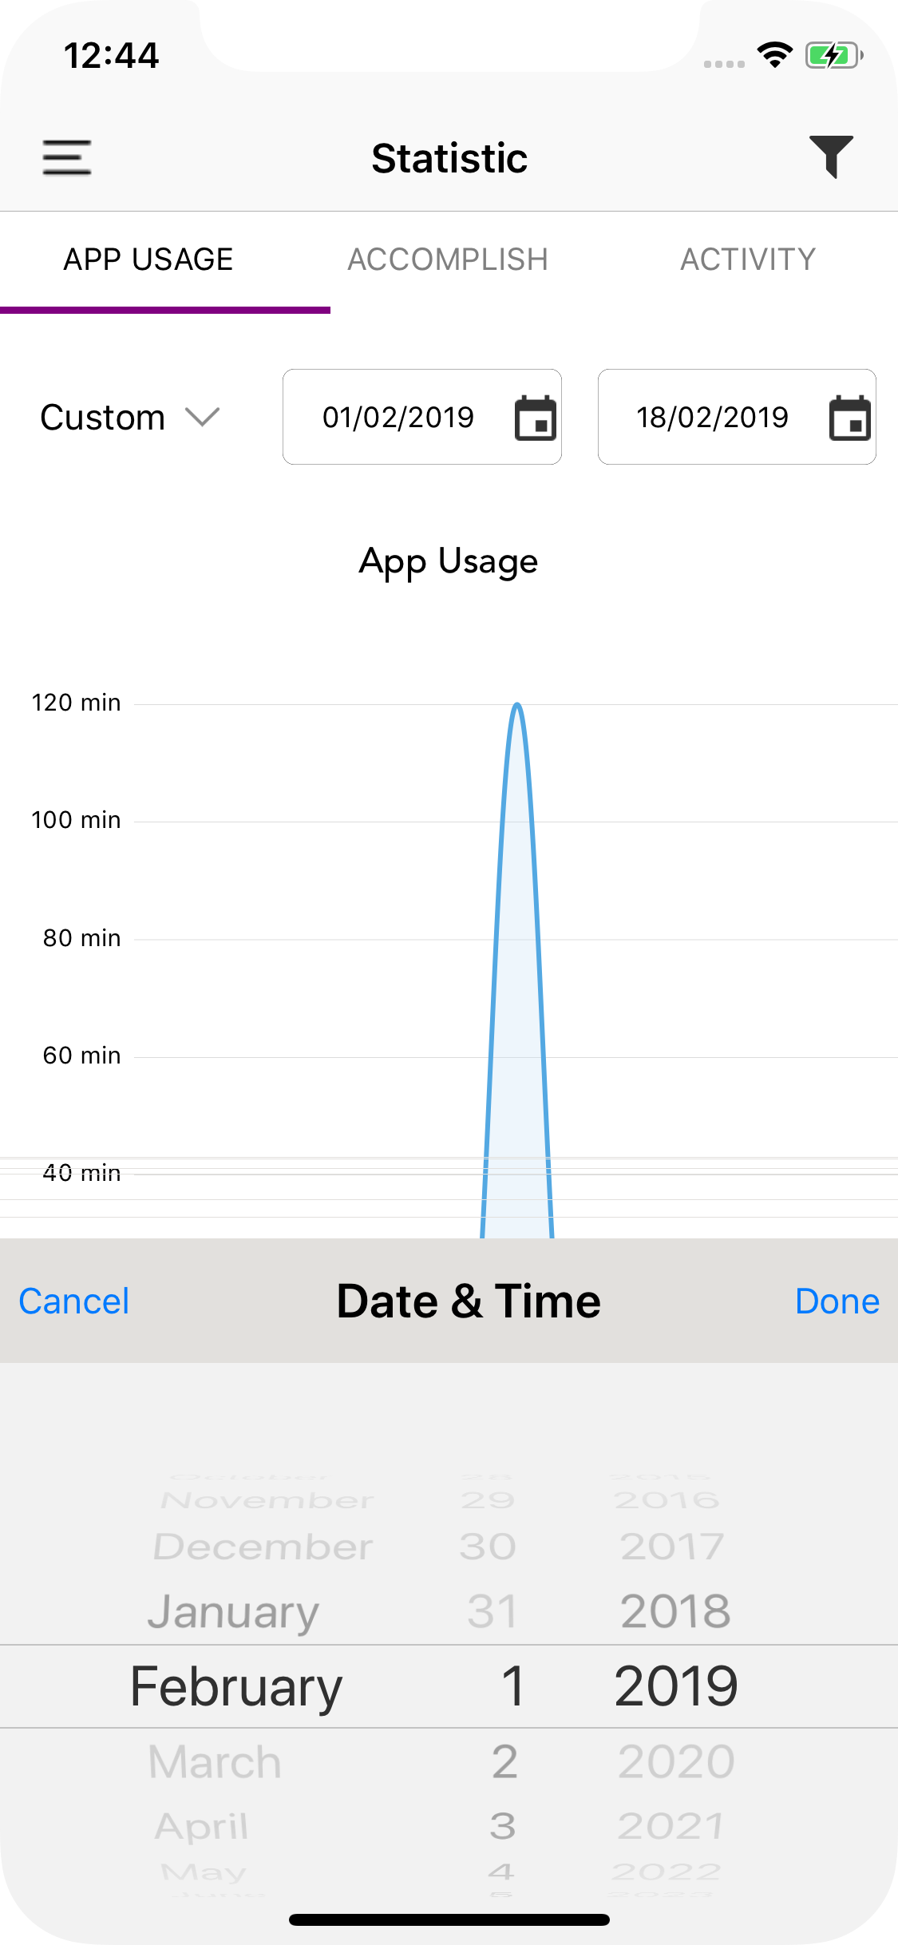

**Description**: When you tap on Accomplish segment option then Pie chart graph with show with one-week time frame as.

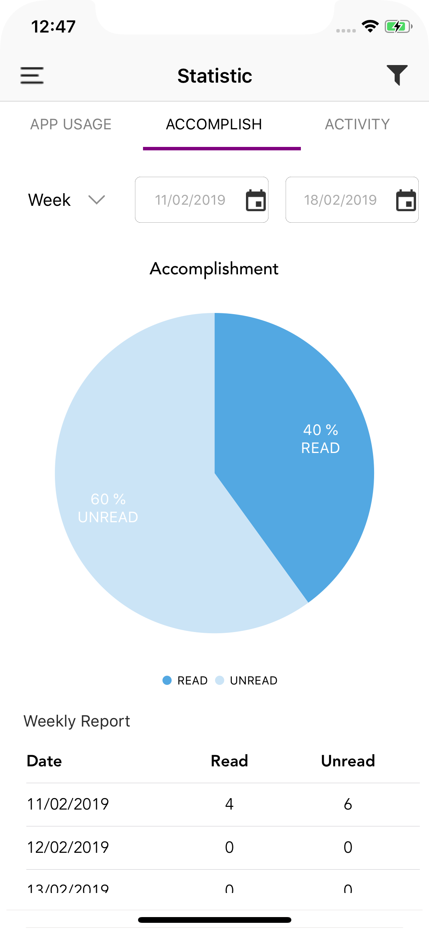

**Description**: When you tap on Activity segment option then Group bar chart graph with show with one-week time frame as.

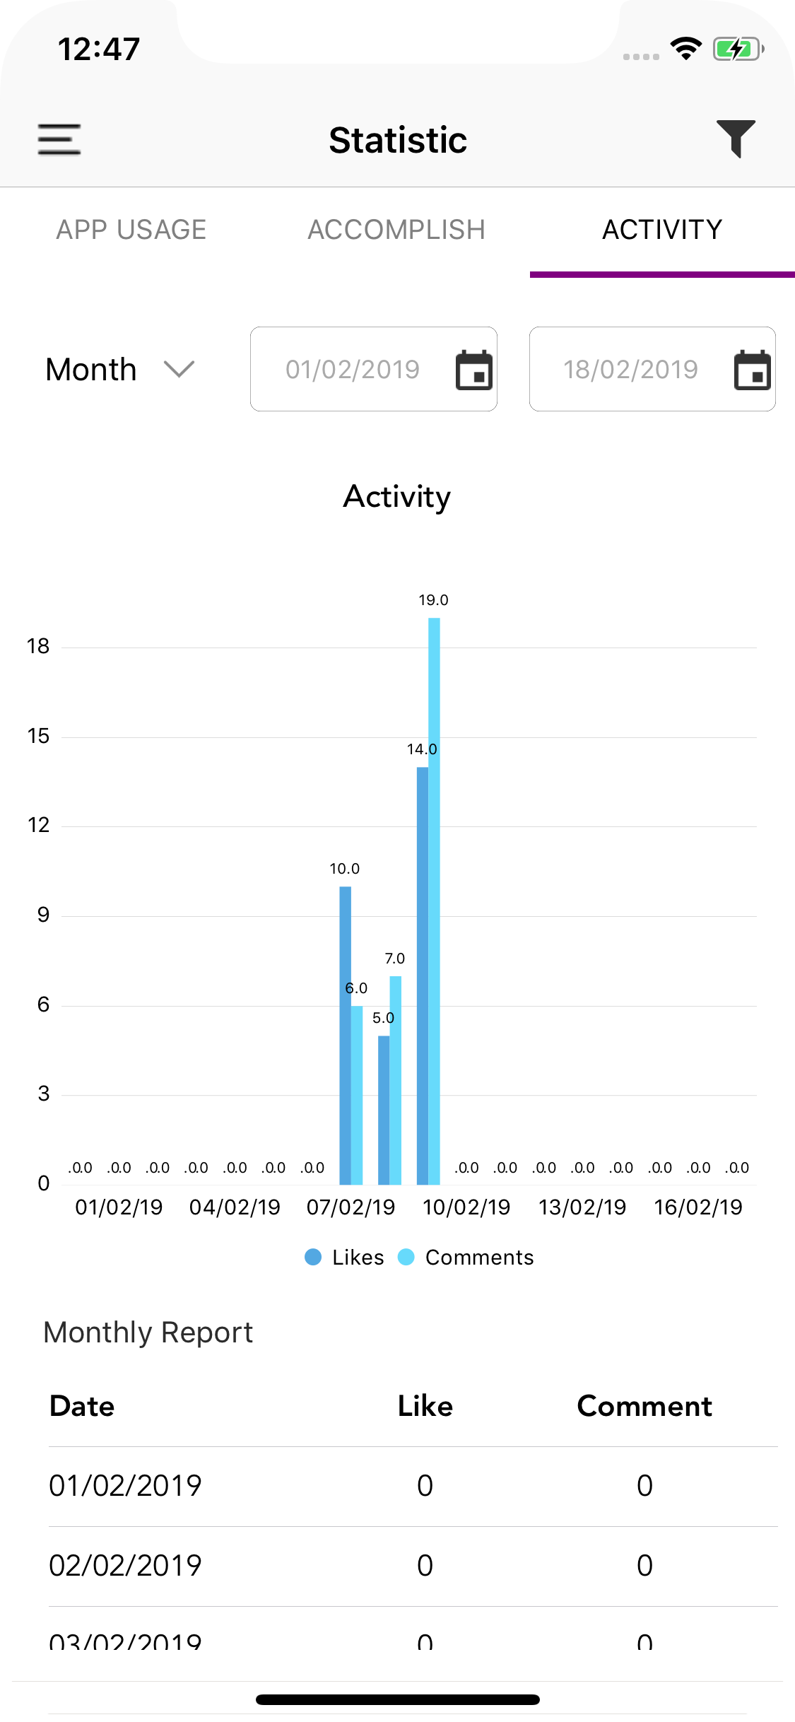

**Description**: Also showing respected data in tabular form.

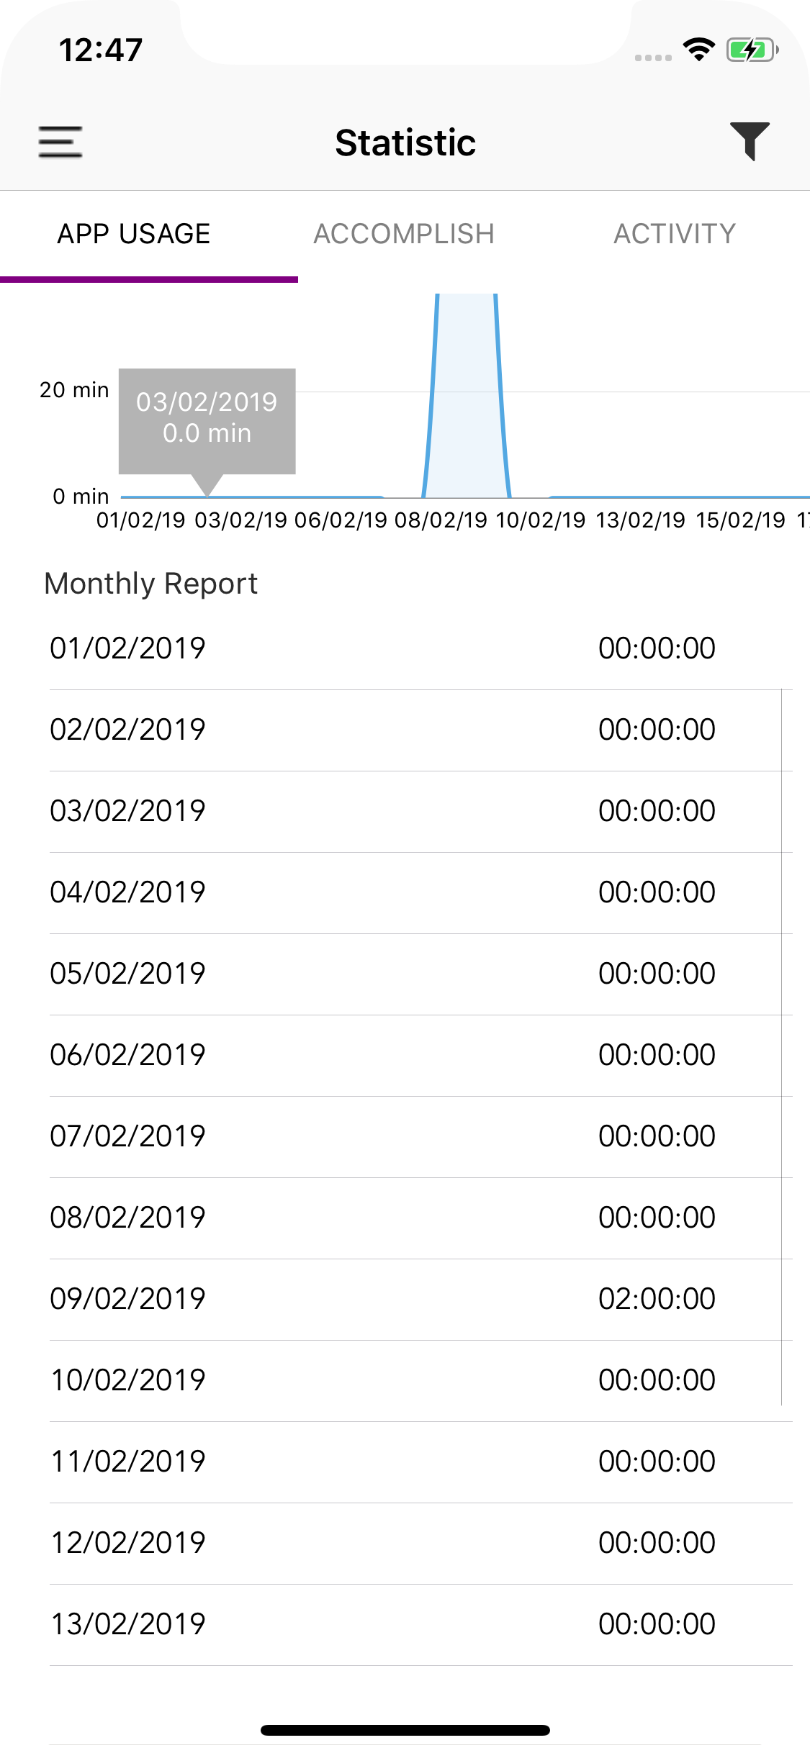

5. Steps to integrate / use / installation

1. Create Xcode project.

2. Use CocoaPods and install **Charts**

3. You can create respected graph by programmatically or in IB.

4. Customize graph property as per requirement.

5. Set data(DataEntry) to respected graph.

6. Contact us / Support

[Support@plug-able.com](mailto:Support@plug-able.com)

Reference link:

<https://github.com/danielgindi/Charts/tree/4.0.0>

<https://github.com/PhilJay/MPAndroidChart/wiki/Getting-Started>