I have attached the project in src directory.

In the src directory, a folder named Twitter_HasgTags will be present.

Open the folder in Eclipse.

Follow the below steps to open the project in Eclipse.

File->Import ->General->ArchiveFile->

Next browse the downloaded project and import into existing folder.

I am assuming that you have twitter keys like ConsumerKey, ConsumerSecret, AccessToken and AccessTokenSecret. So Before executing the program, please put your keys in the Tweets_Save_HashMap.java in the lines 34,35,36 and 37.

In the Project Twitter_HasgTags, the main file is tweetCount.java.

So run the tweetCount.java file to execute the project.

Once it is run, you will see the console as below:

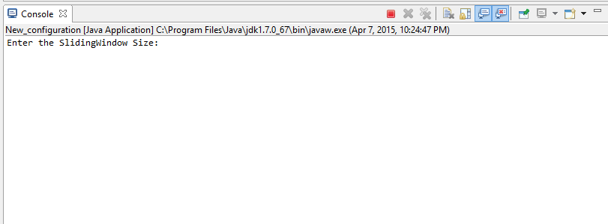

Enter the sliding window size, which is the number of tweets in my scenario.

Lets suppose you have entered 300, then it will ask for the number of top tags to be displayed as below :

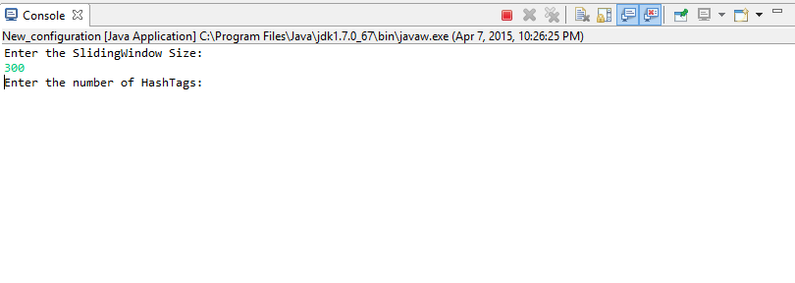

Once the number of HashTags you want to see is entered, click the enter button and then the hashtags as a set of 10 will be displayed continuously.

Whenever you would like to stop the program just click the red button in the console as highlighted in the below snapshot.

