Bar graph for the below results are found out :

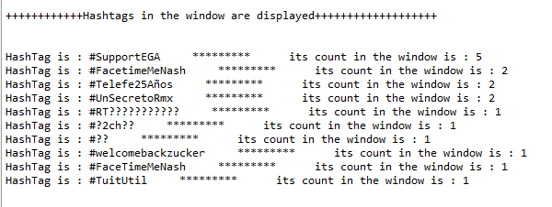

Its bar graph is

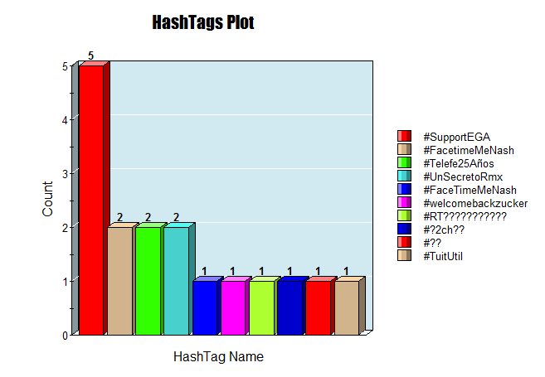

Interpretation of results:

Let’s try to understand the results from the below screenshots of results,

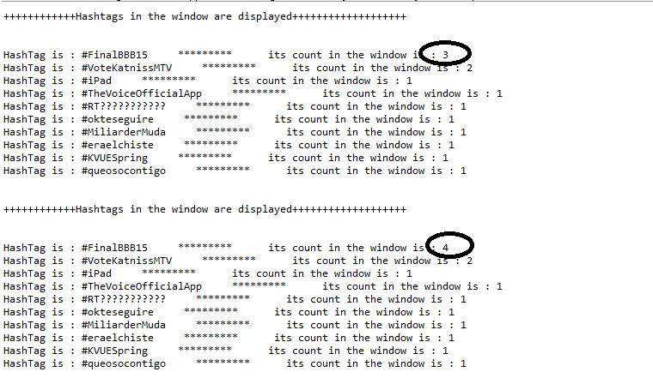

In the above screenshot, we can see that count of the hashtag #FinalBBB15 is 3 in first window and 4 in the second window, which indicates that the new tweet had #FinalBBB15 tag. In the same way ,if the new incoming tweets has a hashtag which is already present in the previous window, then its count will be increased.