|  |  |
| --- | --- |
| Name Of The Student | Yogesh |
| Internship Project Topic | RIO-210: Create Online Examination Portal - with DB Integration Batch 01 |
| Name of the Organization | TCS-iON |
| Name of the Industry Mentor | Divya S /Srijita Mondal /Indranil Pal. |
| Name of the Institute | Amity University, Noida |

|  |  |  |  |  |
| --- | --- | --- | --- | --- |
| Start Date | End Date | Total Effort (hrs.) | Project Environment | Tools used |
| May 25, 2021 | July 08, 2021 | 210 | Java based project for conducting exams online | HTML/CSS/JS, JSP, Servlet, Apache Tomcat, Google Chrome/Mozilla Firefox |

**TABLE OF CONTENT**

* Acknowledgements

It is high privilege for me to express my deep sense of gratitude to those entire faculty Members who helped me in the completion of the project, specially my industry guide guide Divya S / Srikita Mondal / Indranil Pal who was always there at hour of need.

My special thanks to all other faculty members, Batch mate & Seniors of TCS-iON for helping me in the completion of project work and its report submission

* Objective

The main objective of designing and developing this web portal to save time and cost for both student as well as for the administrative community. Online Examination is a fully automated system thar generates fast results as compared to the traditional approach.

Through the online examination portal, time will be used effectively and efficiently. Less human power and cost will be required.

* Introduction / Description of Internship

RIO-210:Create Online Examination Portal-with DB integration, is a internship program managed remotely by TCS-iON Digital Learning Hub, in order to provide working knowledge in the field of IT industry to the fresher candidates for their career growth. As this internship program includes many project, RIO-210:Create Online Examination Portal works for Exam Management System to make it easier for the students as well as for the administration to manage the exams online.

**Part 1**

1) Create a login page with two fields. (User-id and password)

2) Create a webpage for administrative where upon sign-in admin can handle the portal by performing activities like-creating/updating/deleting user accounts, setting of question papers for multiple topics-each topic has its associated question set of ‘n’ no of questions.

3) User can login to the portal by entering login id and password. After successful login, it will be redirected to exam page.

4) On the exam page, if the user is logged in his/her name is also shown, along with exam instruction and user should be able to choose the topic of exam.

5) Once topic is chosen, a ‘Start’ button should be displayed following whhich the user is presented with he first question of topic’s corresponding question set. ‘Next’ button should be provided to navigate to the next question.

6) At the end of the exam the user should click ‘finish’ button.

**Part 2**

1) Identify best practices to be followed in developing the portal

2) Perform validation for each user input field.

1) If user enters invalid login credentials, error message should be displayed.

2) Each question can have four options.

3) Next button is not shown when the user is in last question.

3) On the user login screen, provide ‘Forgot Password’ link for the user to reset password if required.

4) Make the webpage user friendly.

**Part 3**

1) Create database using MySQL

2) Establish database connection

3) Retrieve the data from database for each page.

* Internship Activities

Project Start

**Milestone #1:** Day 5, Analysis and database design of the project

**Milestone #2:** Day 15, Students should be able to create HTML pages and perform the validation of each HTML page

**Milestone #3:** Day 30, Students should be able to establish database connection and retrieve the data from database for each page.

Project End

* Charts, Table, Diagrams

**Database Tables**

admin table

|  |  |  |
| --- | --- | --- |
| **Field Name** | **Data Type** | **Constraint** |
| adminID | int | auto_increment, primary key |
| adminName | varchar(50) | Not null |
| adminMail | varchar(255) | Not null, unique |
| password | varchar(255) | Not null |

user table

|  |  |  |
| --- | --- | --- |
| **Field Name** | **Data Type** | **Constraint** |
| userID | int | auto_increment, primary key |
| userName | varchar(50) | Not null |
| userMail | varchar(255) | Not null, unique |
| password | varchar(255) | Not null |

exam table

|  |  |  |
| --- | --- | --- |
| **Field Name** | **Data Type** | **Constraint** |
| examCode | varchar(255) | primary key, not null |
| examTitle | varchar(255) | Not null |
| examCreationDate | date | Not null |
| numberOfQuestions | int | Not null |
| createdBy | int | Not null, references admin(adminID) |
| status | varchar(255) | Not null |

examQuestion Table

|  |  |  |
| --- | --- | --- |
| **Field Name** | **Data Type** | **Constraint** |
| questionNo | int | auto_increment, primary key |
| statement | varchar(255) | Not null |
| correct | varchar(255) | Not null |
| option1 | varchar(255) | Not null |
| option2 | varchar(255) | Not null |
| option3 | varchar(255) | Not null |
| option4 | varchar(255) | Not null |
| examCode | varchar(255) | Not null, references exam(examCode) |

schedule table

|  |  |  |
| --- | --- | --- |
| **Field Name** | **Data Type** | **Constraint** |
| id | int | auto_increment, primary key |
| examDate | date | Not null |
| startTime | time | Not null |
| endTime | time | Not null |
| examCode | varchar(255) | Not null, references exam(examCode) |

enrollment table

|  |  |  |
| --- | --- | --- |
| **Field Name** | **Data Type** | **Constraint** |
| id | int | auto_increment, primary key |
| examCode | varchar(255) | Not null, references exam(examCode) |
| userID | int | Not null, references user(userID) |

score table

|  |  |  |
| --- | --- | --- |
| **Field Name** | **Data Type** | **Constraint** |
| id | int | auto_increment, primary key |
| examCode | varchar(255) | Not null, references exam(examCode) |
| userID | int | Not null, references user(userID) |
| score | Int | Not null |

**ER-diagram**

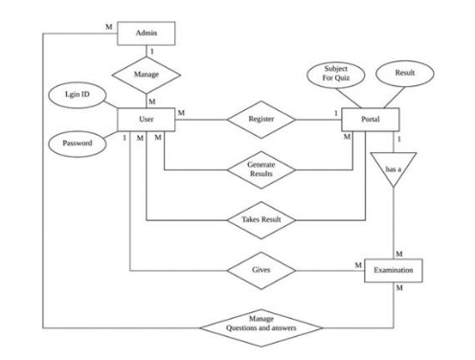

**Screenshot**

Home page

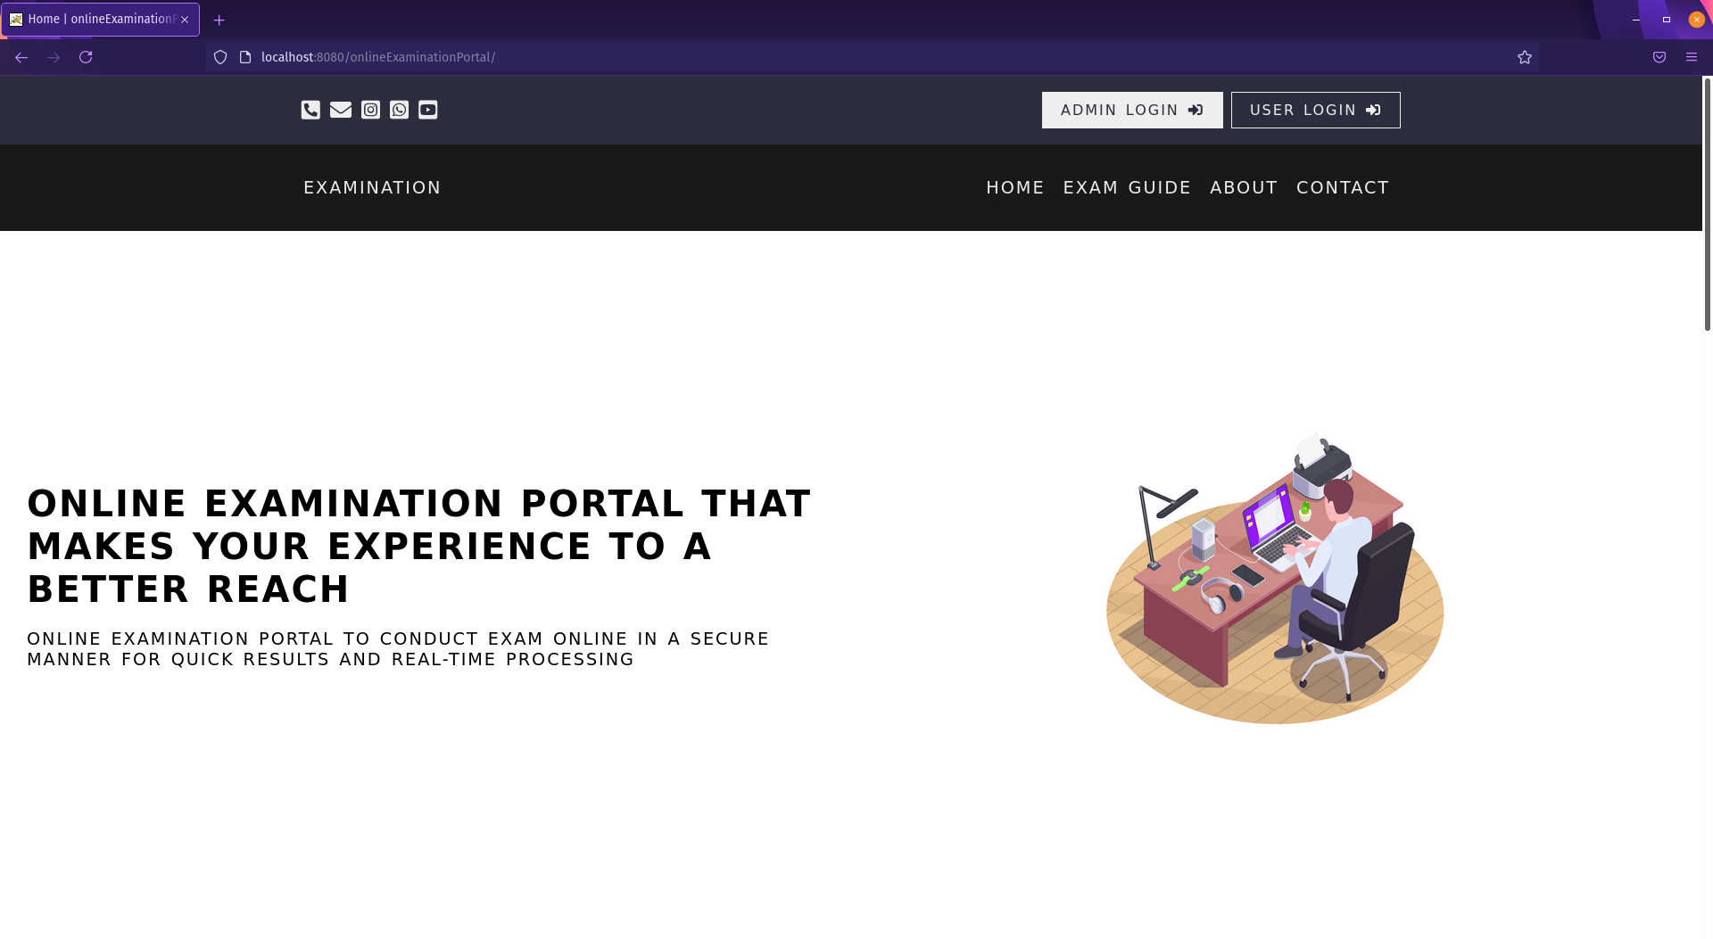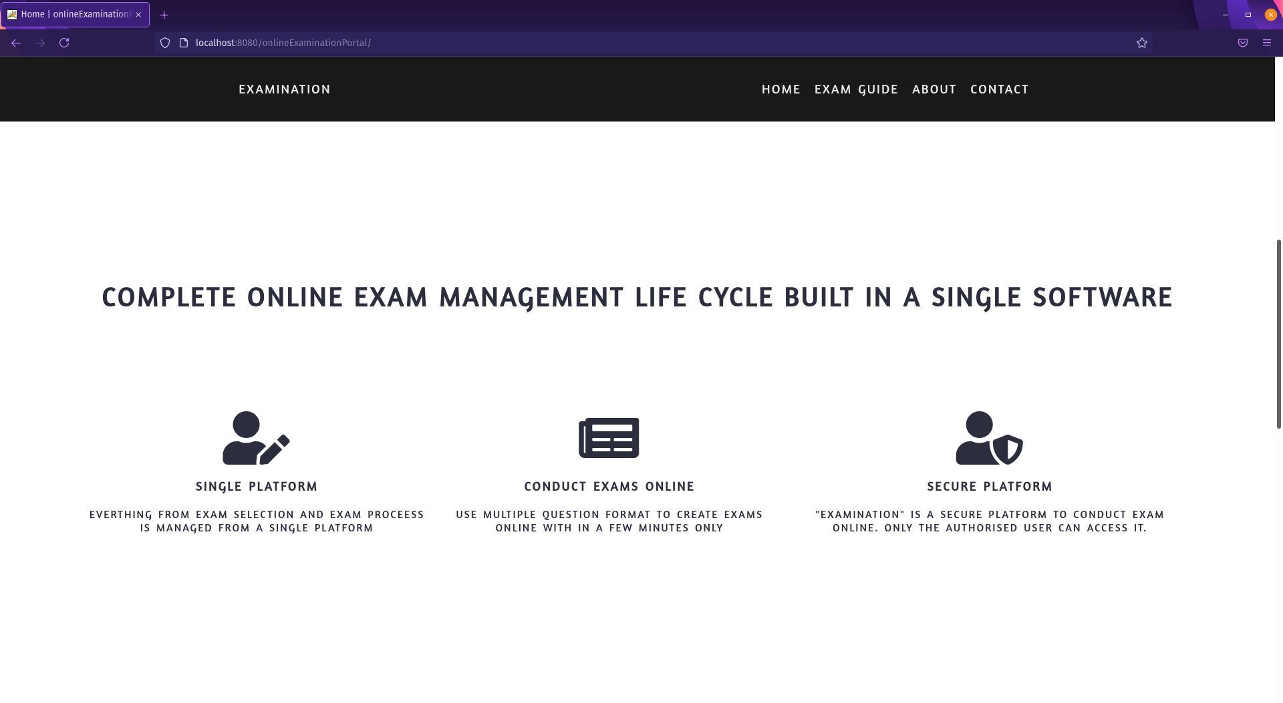

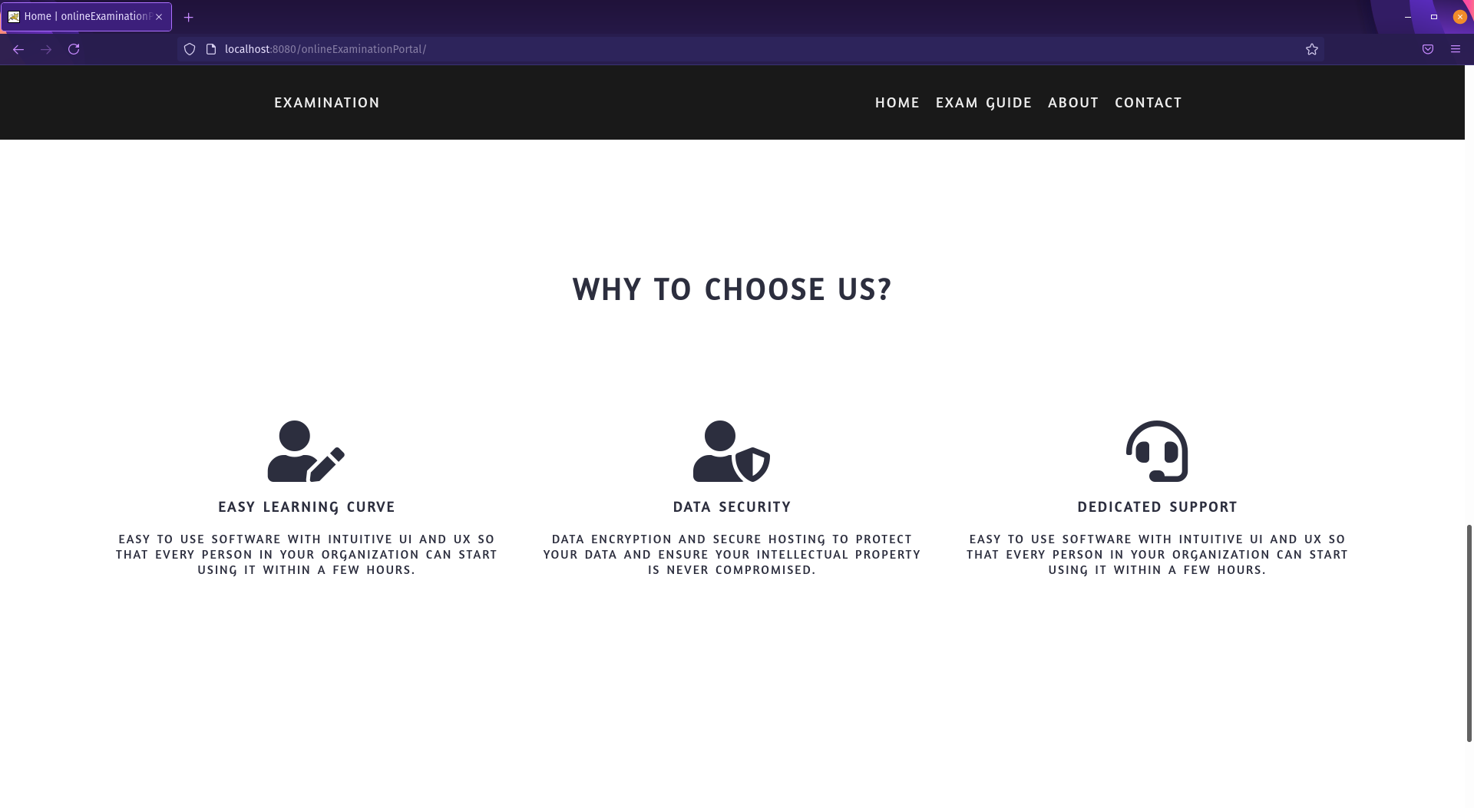



admin login

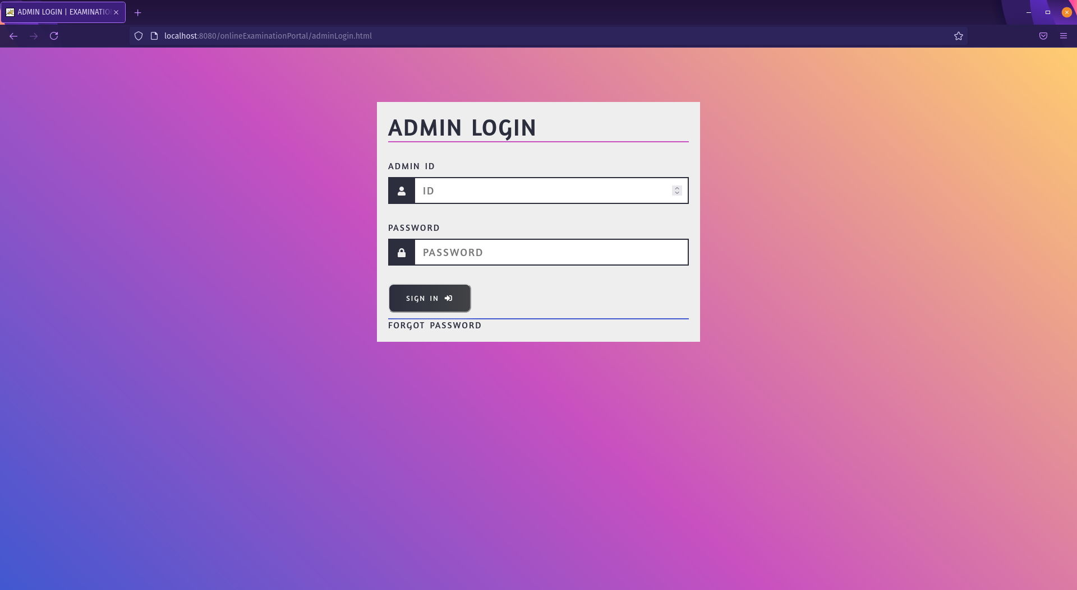

add new user

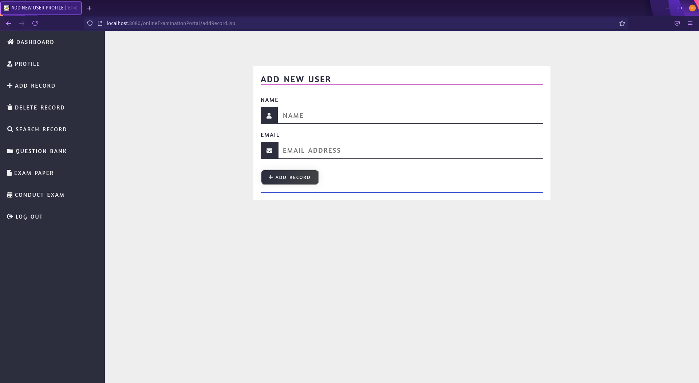

delete existing user

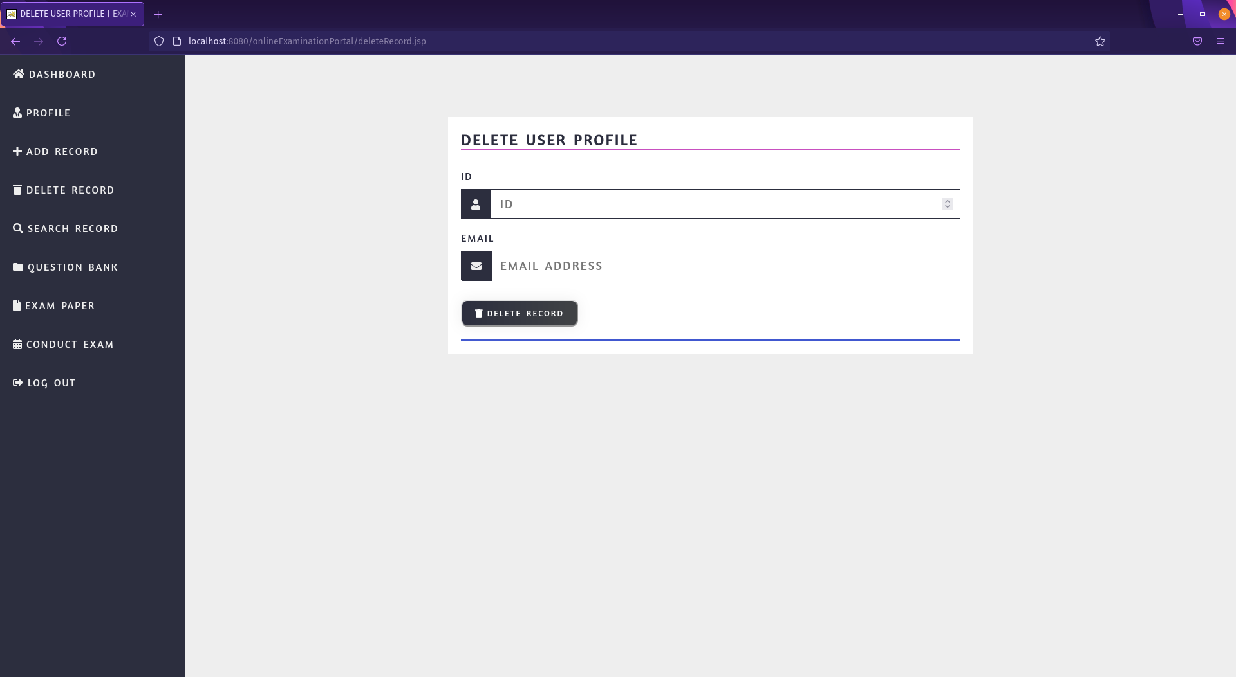

search and update user

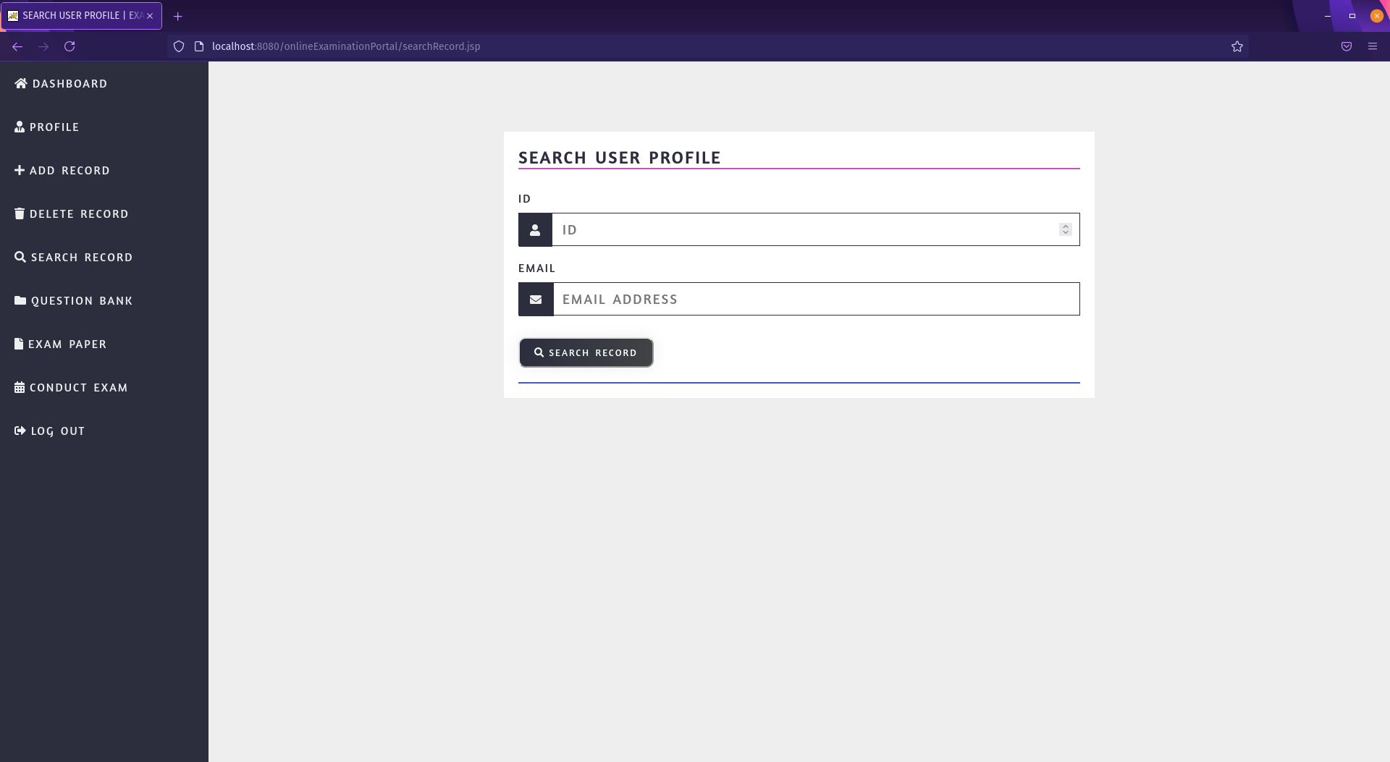

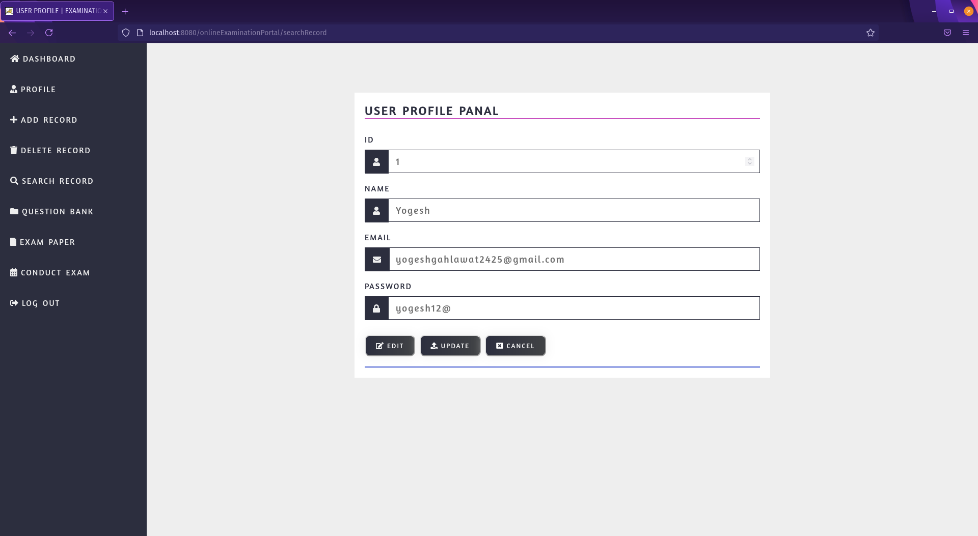

add exam paper

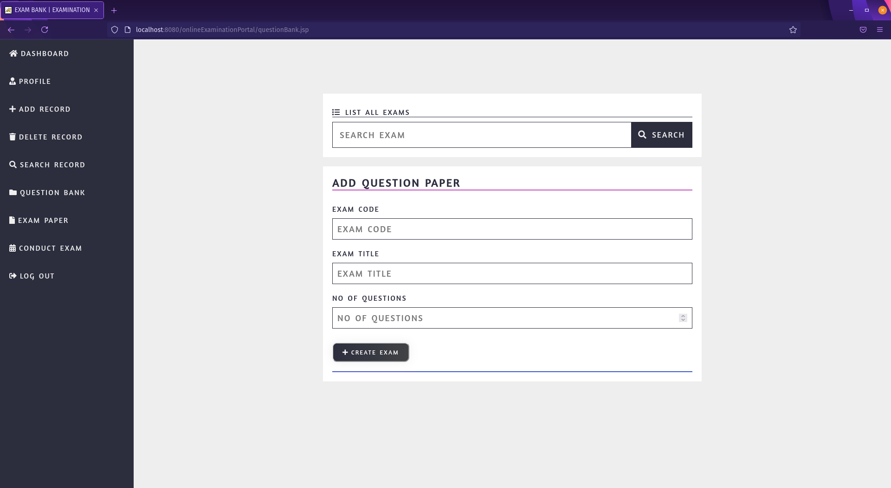

search for exam

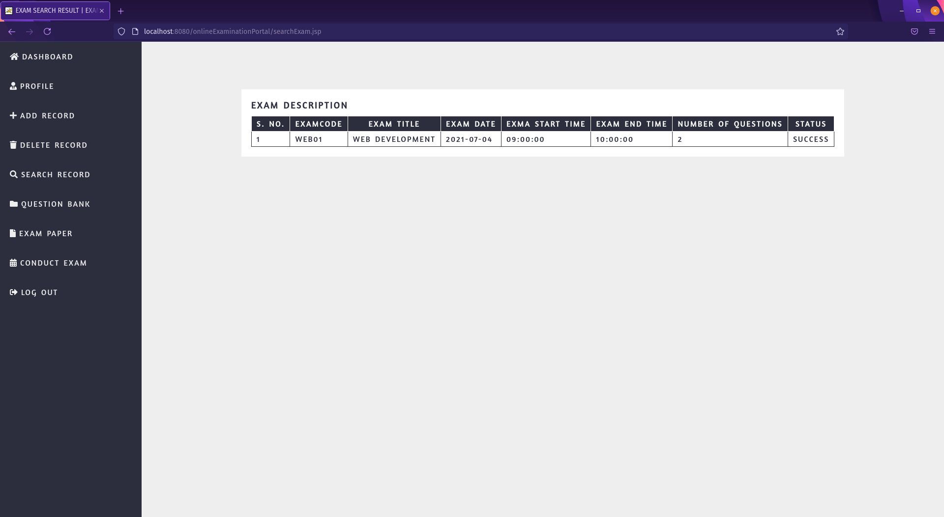

add question to a particular exam paper

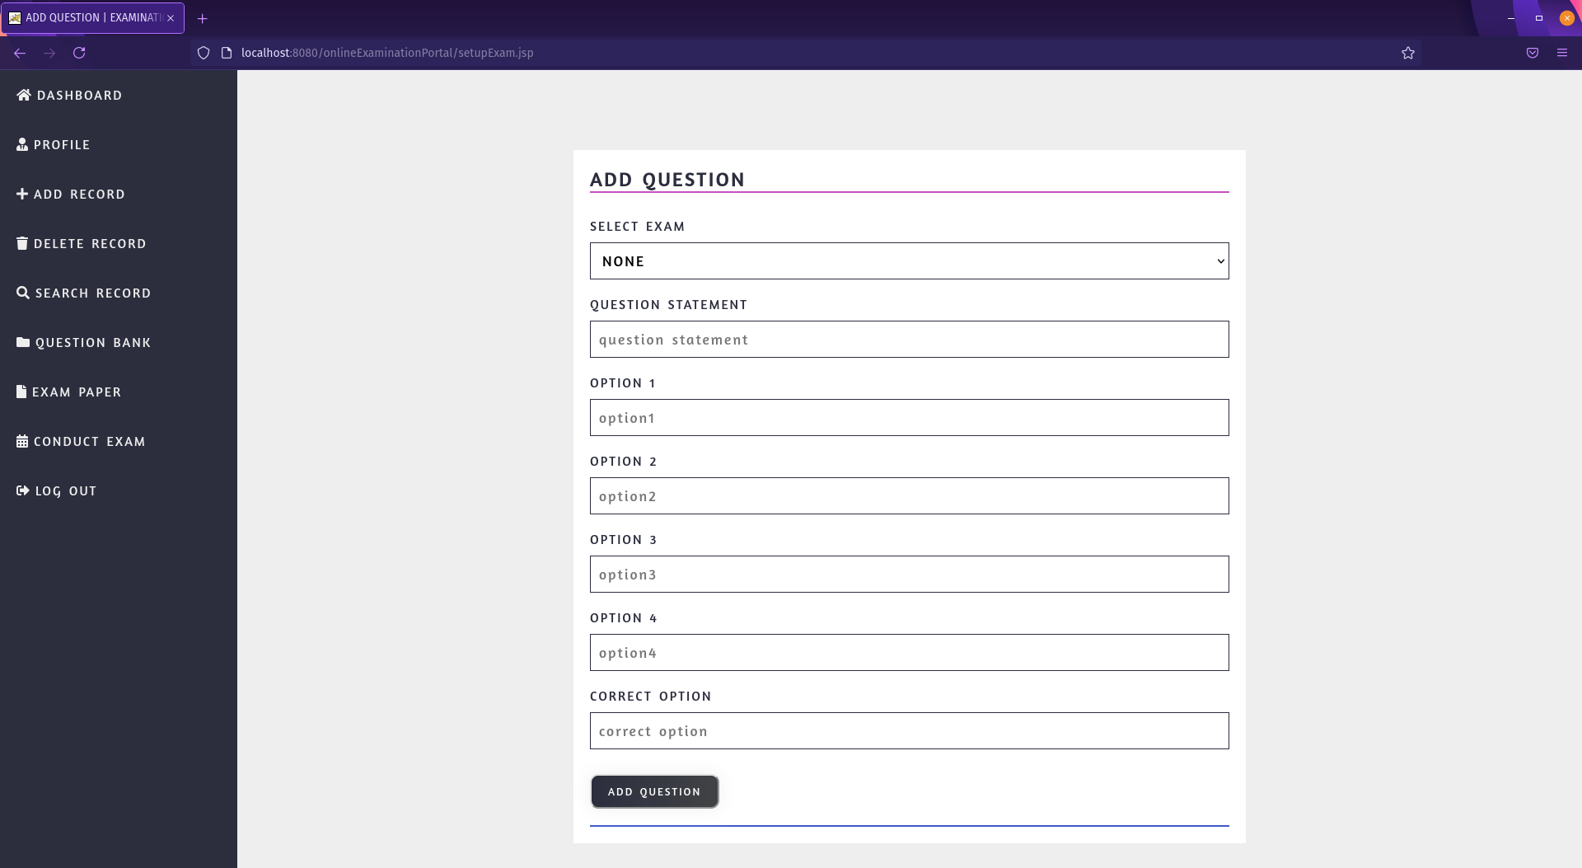

schedule exam

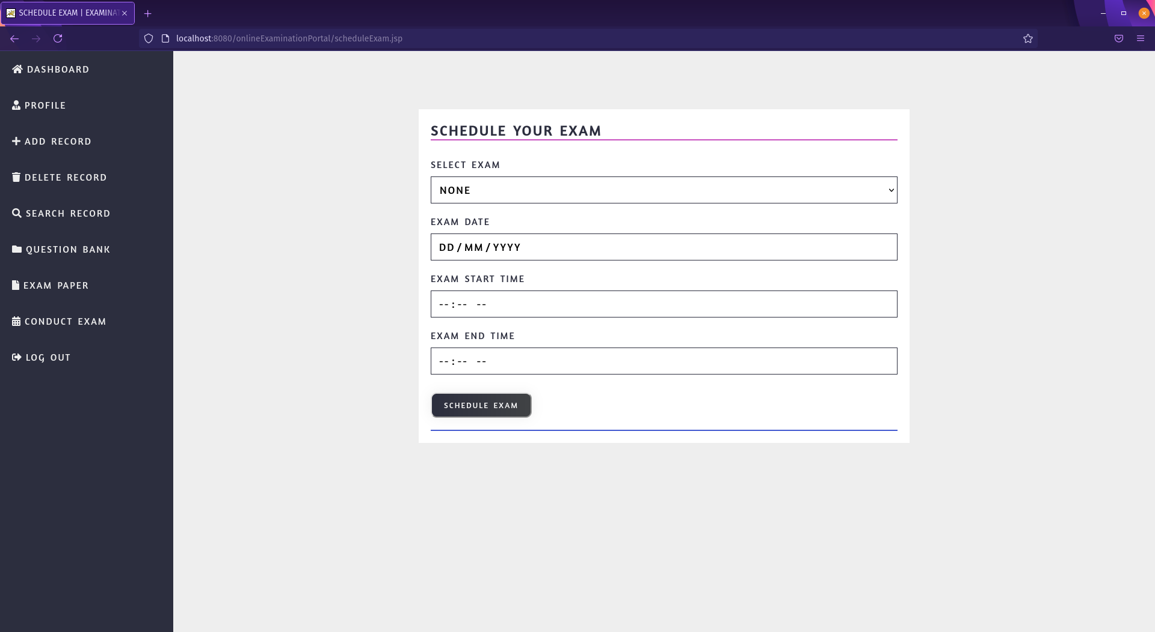

admin forgot password

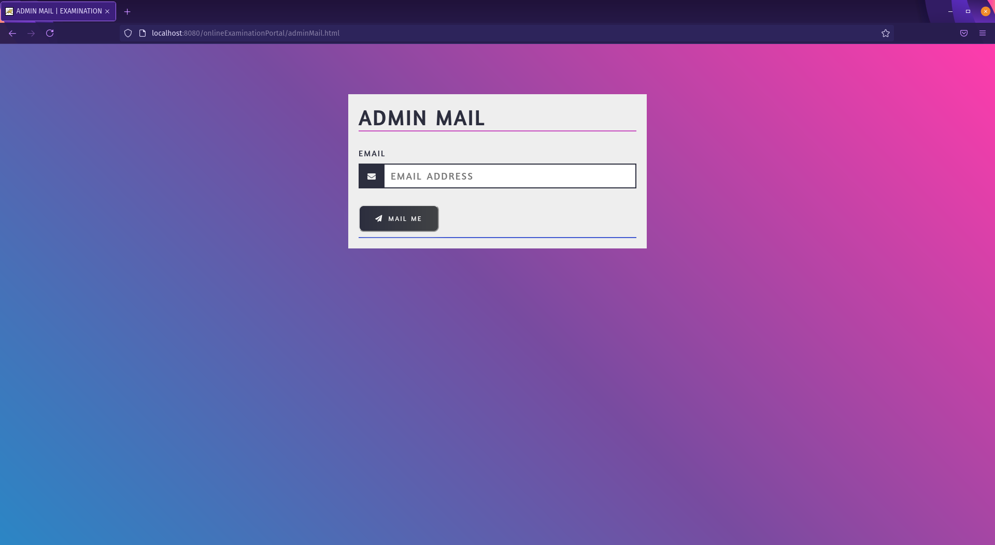

user login

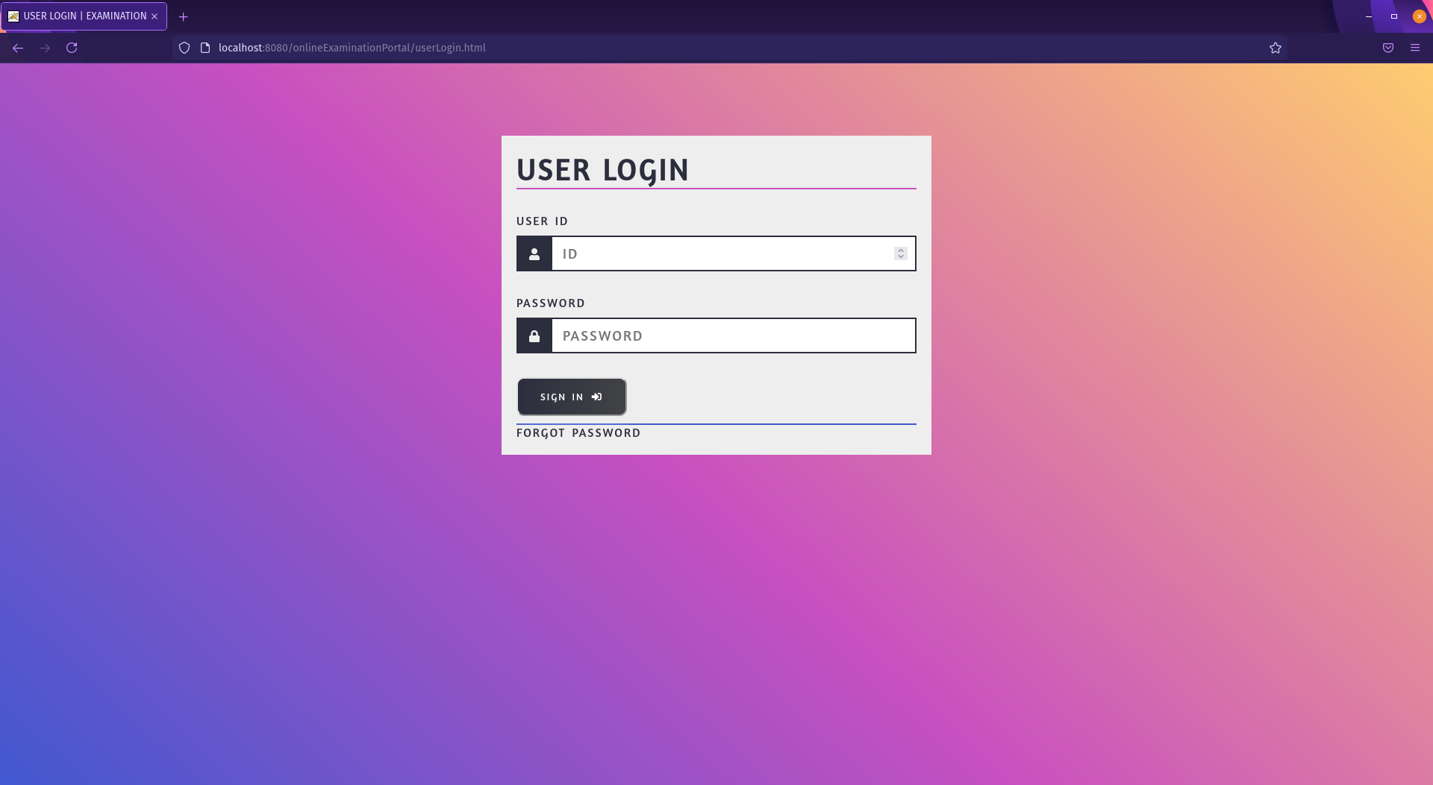

user dashboard

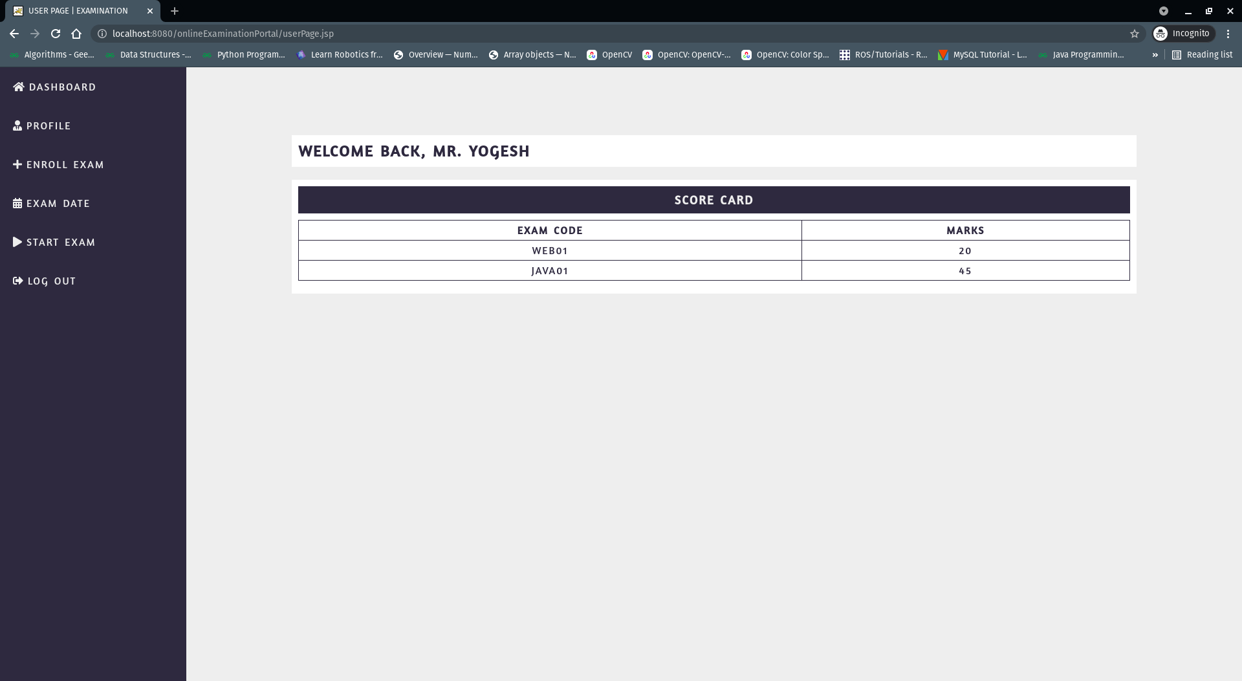

exam enrollment for user

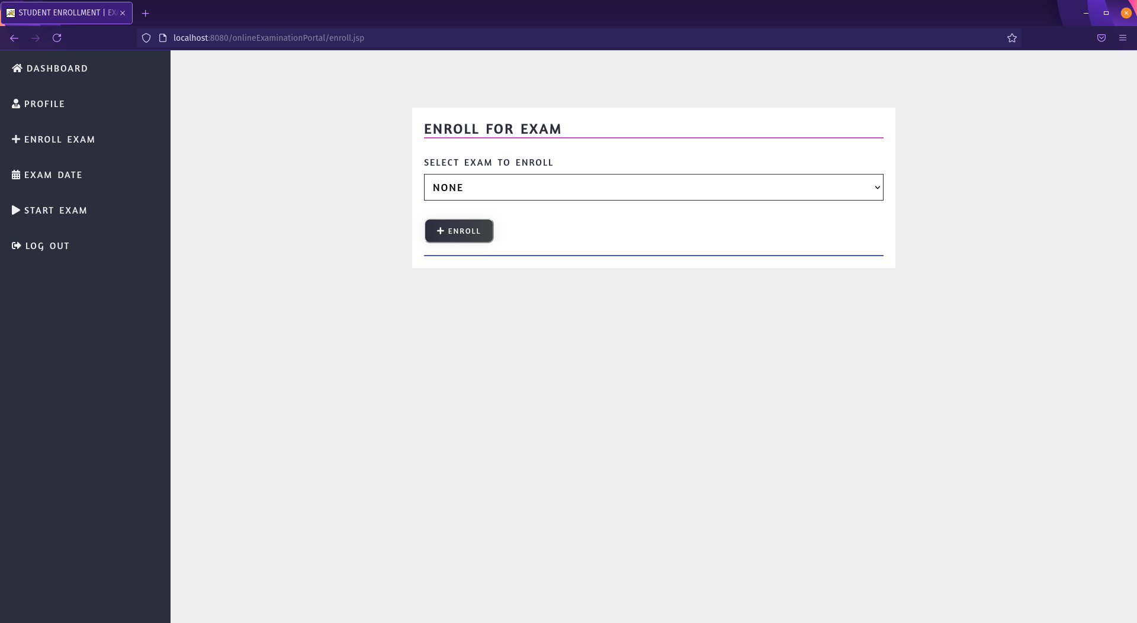

exam schedule

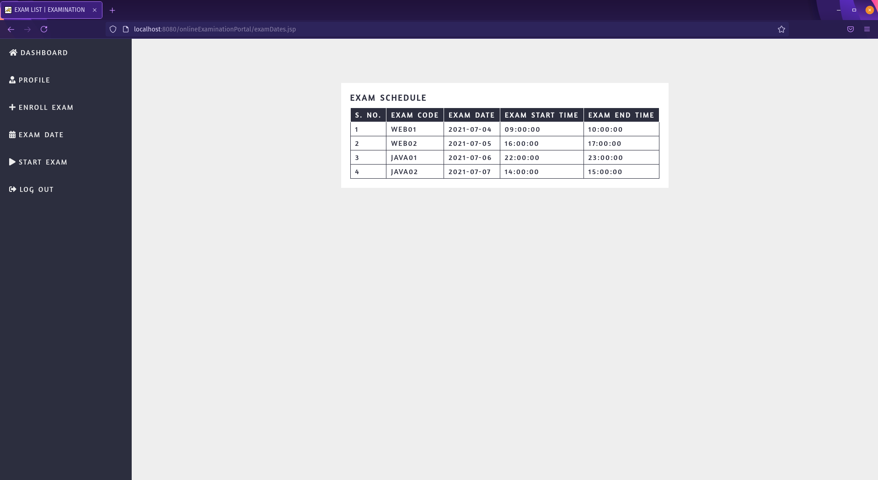

exam instructions and start exam

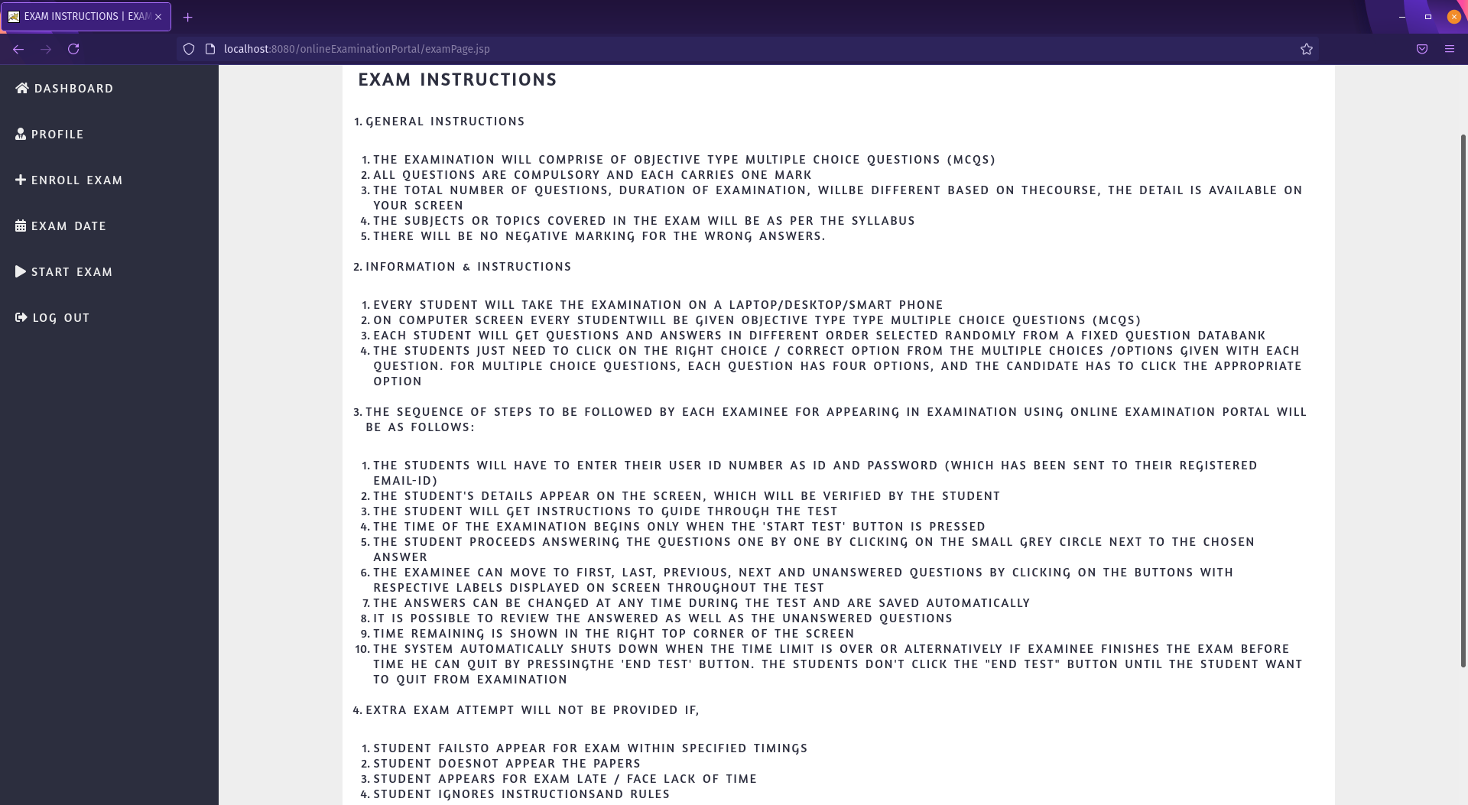

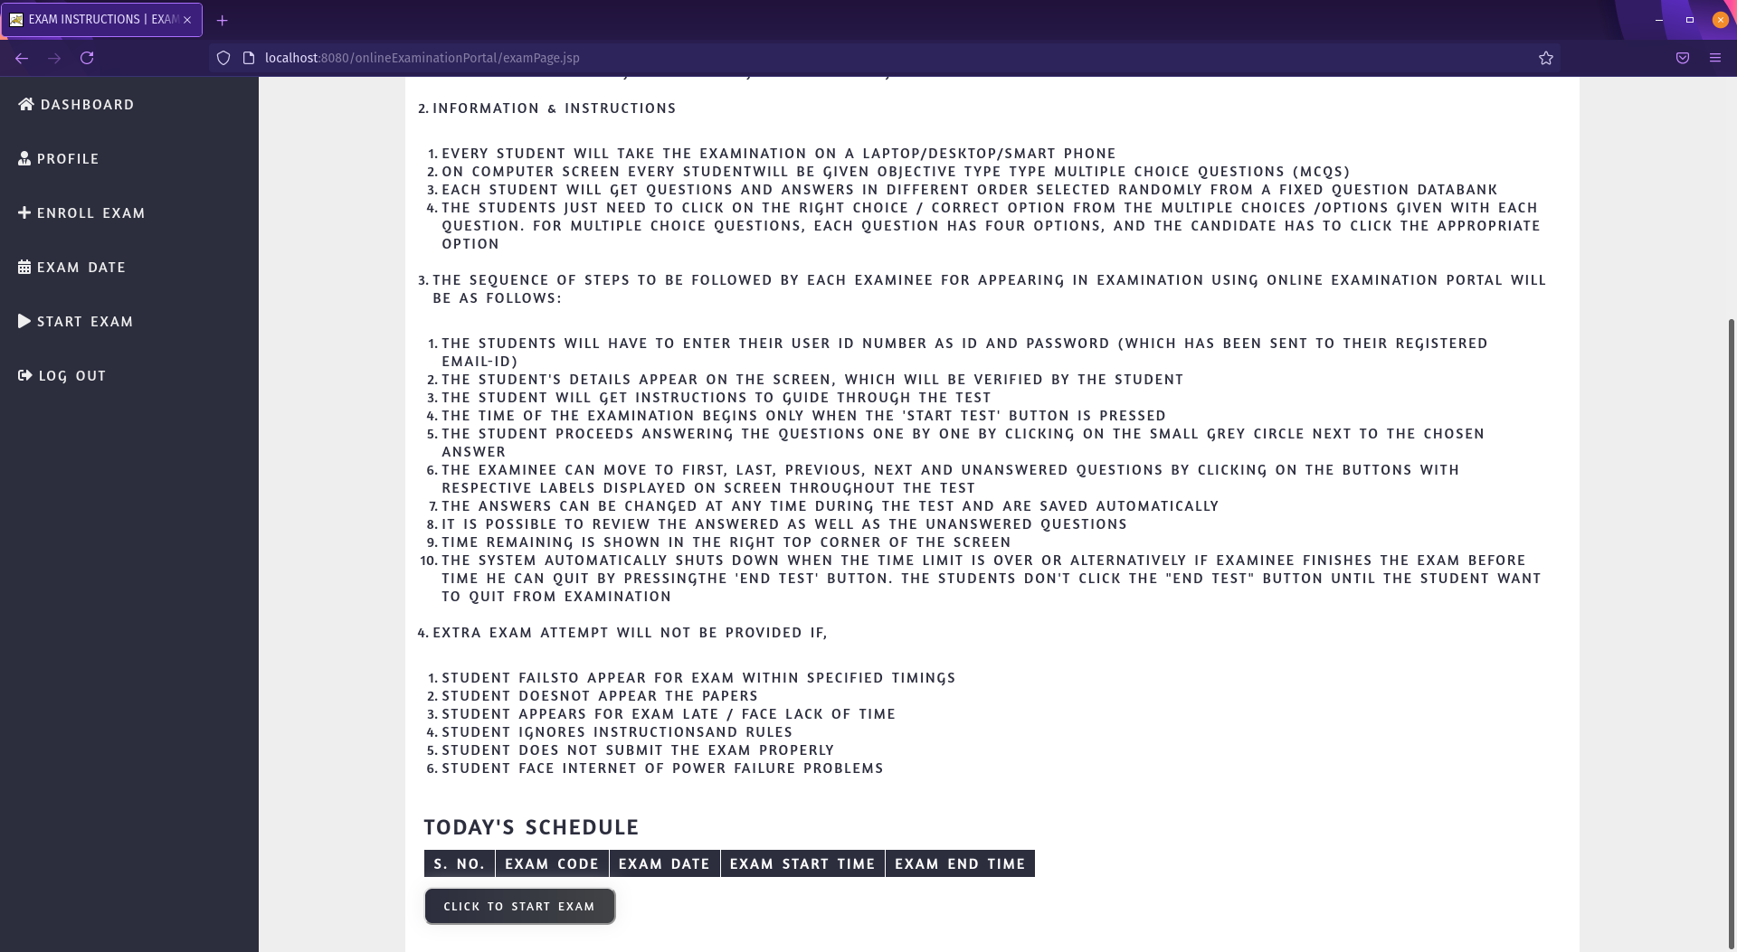

exam page

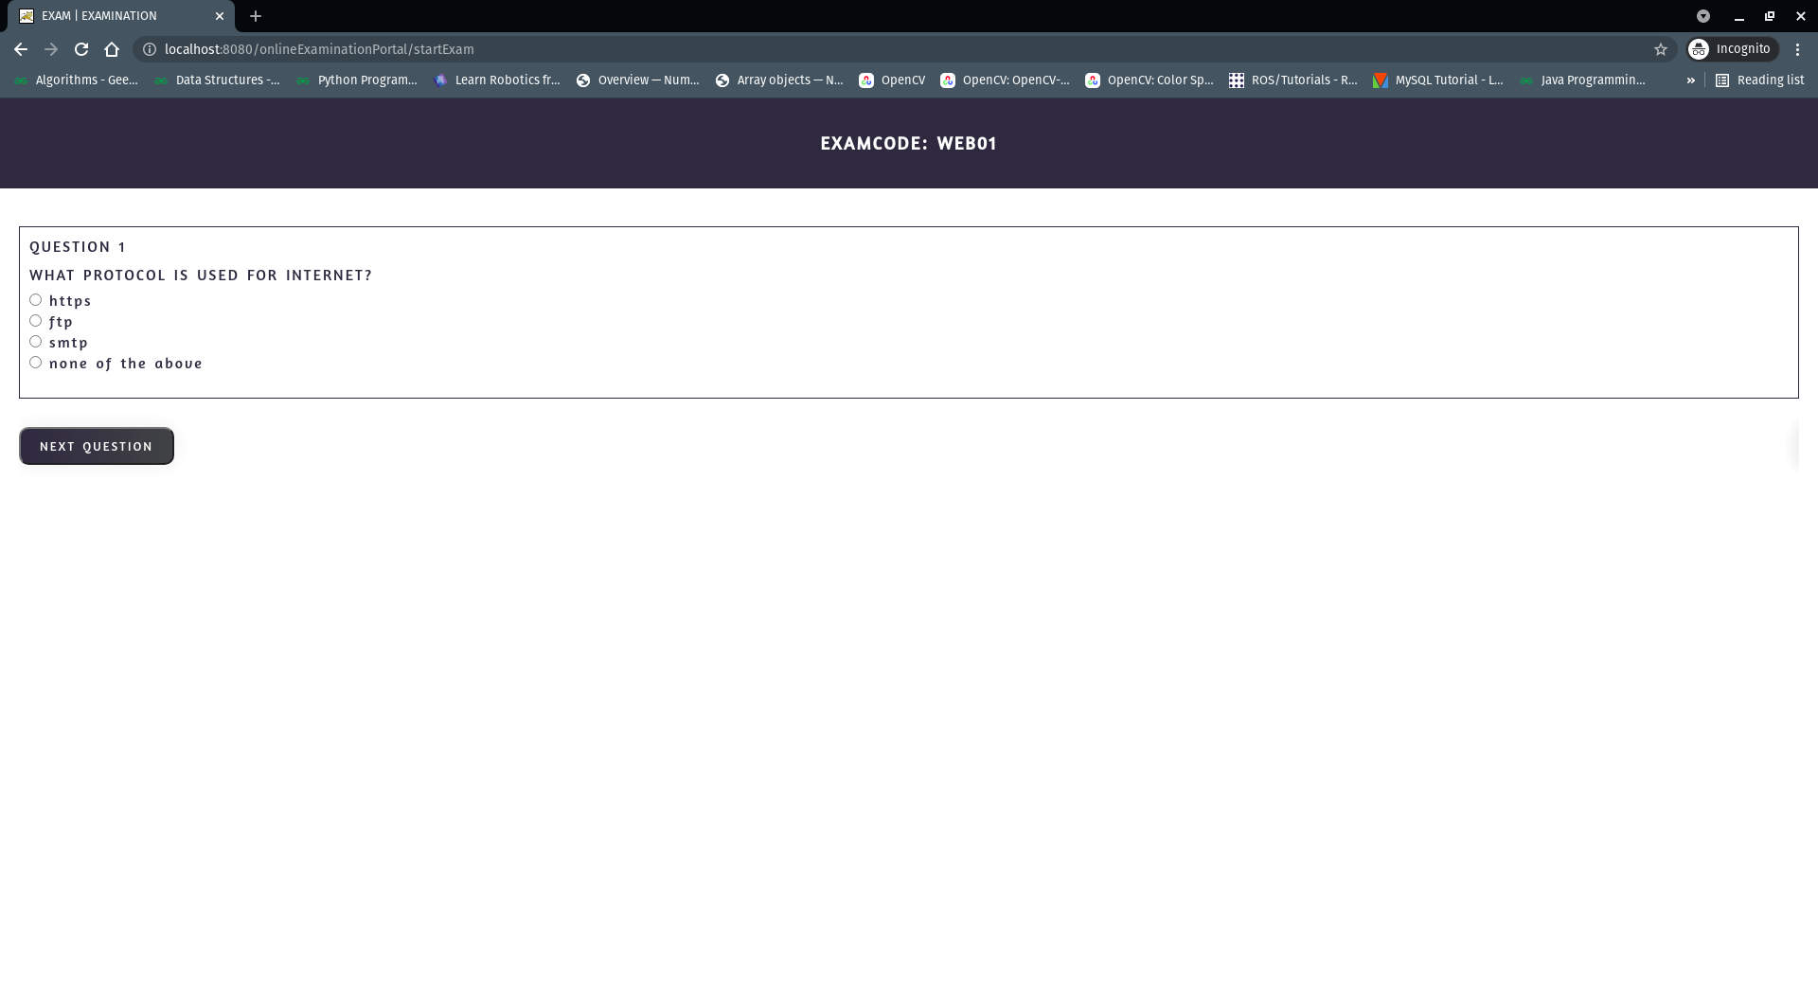

* Outcome / Conclusion

The online Examination Portal web project can fulfill the requirements of present times but we will need some future work efforts to make it much better for the students as well as for the exam conducting authorities. Also required some changes on regular bases to be done for the proper management of this online examination portal to manage and conduct the exam online. Its existence in the future is non-questionable. But it has to be kept in mind that the requirements of the client can change with time and thus, the system can’t be claimed as perfect at any part. But still, the proposed project will bring a lot more ease to the people seeking a platform where they can conduct exams online. The need for such type of platform will never be going to decrease in the future. Thus, future amendments and work on the same project will keep it into an updated existence.

* Enhancement Scope

need to implement hash algorithm for more security

* Link to code and executable file

link to code: https://github.com/YogeshGahlawat/onlineExaminationPortal

link to sample executable file(only static page will run):

https://yogeshgahlawat.github.io/onlineExaminationPortal/

* Research questions and responses

HTML references

https://www.w3schools.com/html/

https://developer.mozilla.org/en-US/docs/Web/HTML

CSS references

https://www.w3schools.com/css/

https://developer.mozilla.org/en-US/docs/Web/CSS

JS references

<https://www.w3schools.com/js/>

https://developer.mozilla.org/en-US/docs/Web/JavaScript

JSP references

<https://www.javatpoint.com/jsp-tutorial>

https://www.tutorialspoint.com/jsp/index.htm

Servlet references

https://www.javatpoint.com/servlet-tutorial

https://www.tutorialspoint.com/servlets/index.htm

MySQL references

[MySQL Tutorial - Learn MySQL Fast, Easy and Fun.](https://www.mysqltutorial.org/)