How to install expeyes on an Ubuntu based Linux Distribution?

1. Open the terminal by pressing Win+T
2. Copy paste the following commands

cd ~/Downloads
wget https://raw.githubusercontent.com/shashankholla/expeyesRVCE/master/install-expyes.sh
bash install-expeyes.sh

Please be patient as this will take some time. Once all commands are executed, you can now find ExpEYES-RVCE logo in the launcher.

How to use Expeyes-RVCE?

Step1: Click on the expeyesRVCE logo in the launcher.

If you can’t find the expeyesRVCE logo in your launcher, press Win+T to open the terminal and type the following commands

python3 ~/Documents/expeyes/expeyesRVCE-master/main.py

Step2: Now you should see the expeyes window open. And you should, by default, be in the NPN Characteristics window.

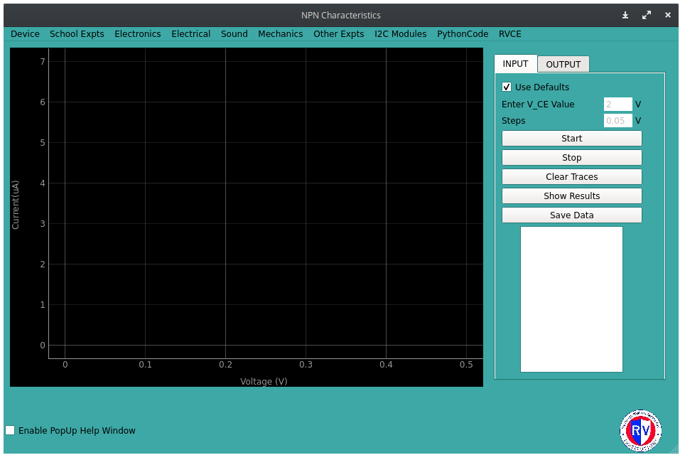
Step3: Read the guide for the experiement by checking the ‘Enable Pop up help window’.
Remember that not all experiements have instructions guides.

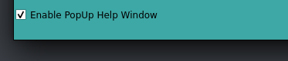
Step4: Make the circuit connections as told. Then connect the expeyes device to your computer’s USB port using the data cable and follow the instructions to perform the experiment.

Information: If you happen to receive a ‘Error. Try Device->Reconnect’ message, it means either your device isn’t properly connected to your computer or the drivers for Expeyes are missing.
Try clicking the Device option on the top left corner and click the Reconnect submenu.
Now, try performing the experiement again.


