MCP101 Project

TITLE OF THE PROJECT
Staircase Climbing Trolley with Tri-Wheel Mechanism

Group 37 and 38
Name | Entry no.
GAURAV KUMAR | 2021CS10116
SHASHANK JANGIR | 2024EE11048
ANKIT KUMAR GUPTA | 2024CE10738
ALOK KUMAR SHAH | 2024TT10160
KESHAV SHARMA | 2024EE30059
RAVALIYA NIRBHAY | 2024EE10317


Department of Mechanical Engineering

1. Title
Staircase Climbing Trolley with Tri-Wheel Mechanism

2. Background
Transporting heavy loads over staircases is a significant challenge in urban and industrial environments. Traditional trolleys are inadequate for such tasks due to their inability to navigate uneven surfaces and stairs. The Staircase Climbing Trolley with Tri-Wheel Mechanism is designed to address these limitations. The tri-wheel configuration facilitates smooth stair climbing by maintaining constant surface contact, thereby reducing user effort and improving stability. This innovation is practical for logistics, construction, and domestic use, minimizing physical strain and ensuring safety.

3. Novelty
- Tri-Wheel Mechanism: Continuous contact with the surface ensures smooth stair climbing.
- Ergonomic Design: Reduces user effort with optimized weight distribution and padded handles.
- Adaptable Usage: Functions effectively on various stair angles and surface types.
- Load Stability: Capable of carrying heavy loads without tipping.
- Modular Construction: Designed for easy assembly, maintenance, and upgrades.

4. Methodology
The project followed these steps:
- a) Design Phase:
- Modeling of the trolley, focusing on the tri-wheel assembly and frame.
- Simulation-based stress and strain analysis to ensure structural integrity.
- b) Material Selection:
- Lightweight materials like aluminum or mild steel for the frame.
- Rubberized wheels for superior grip and shock absorption.
- c) Fabrication:
- Cutting and welding the frame components.
- Assembling the tri-wheel mechanism using precision bearings and shafts.
- d) Testing and Evaluation:
- Performance tests on stairs with varying inclines and surfaces.
- Load testing to determine the maximum carrying capacity (30–50 kg).
- e) Optimization:
- Adjustments to wheel spacing and handle design for enhanced functionality.

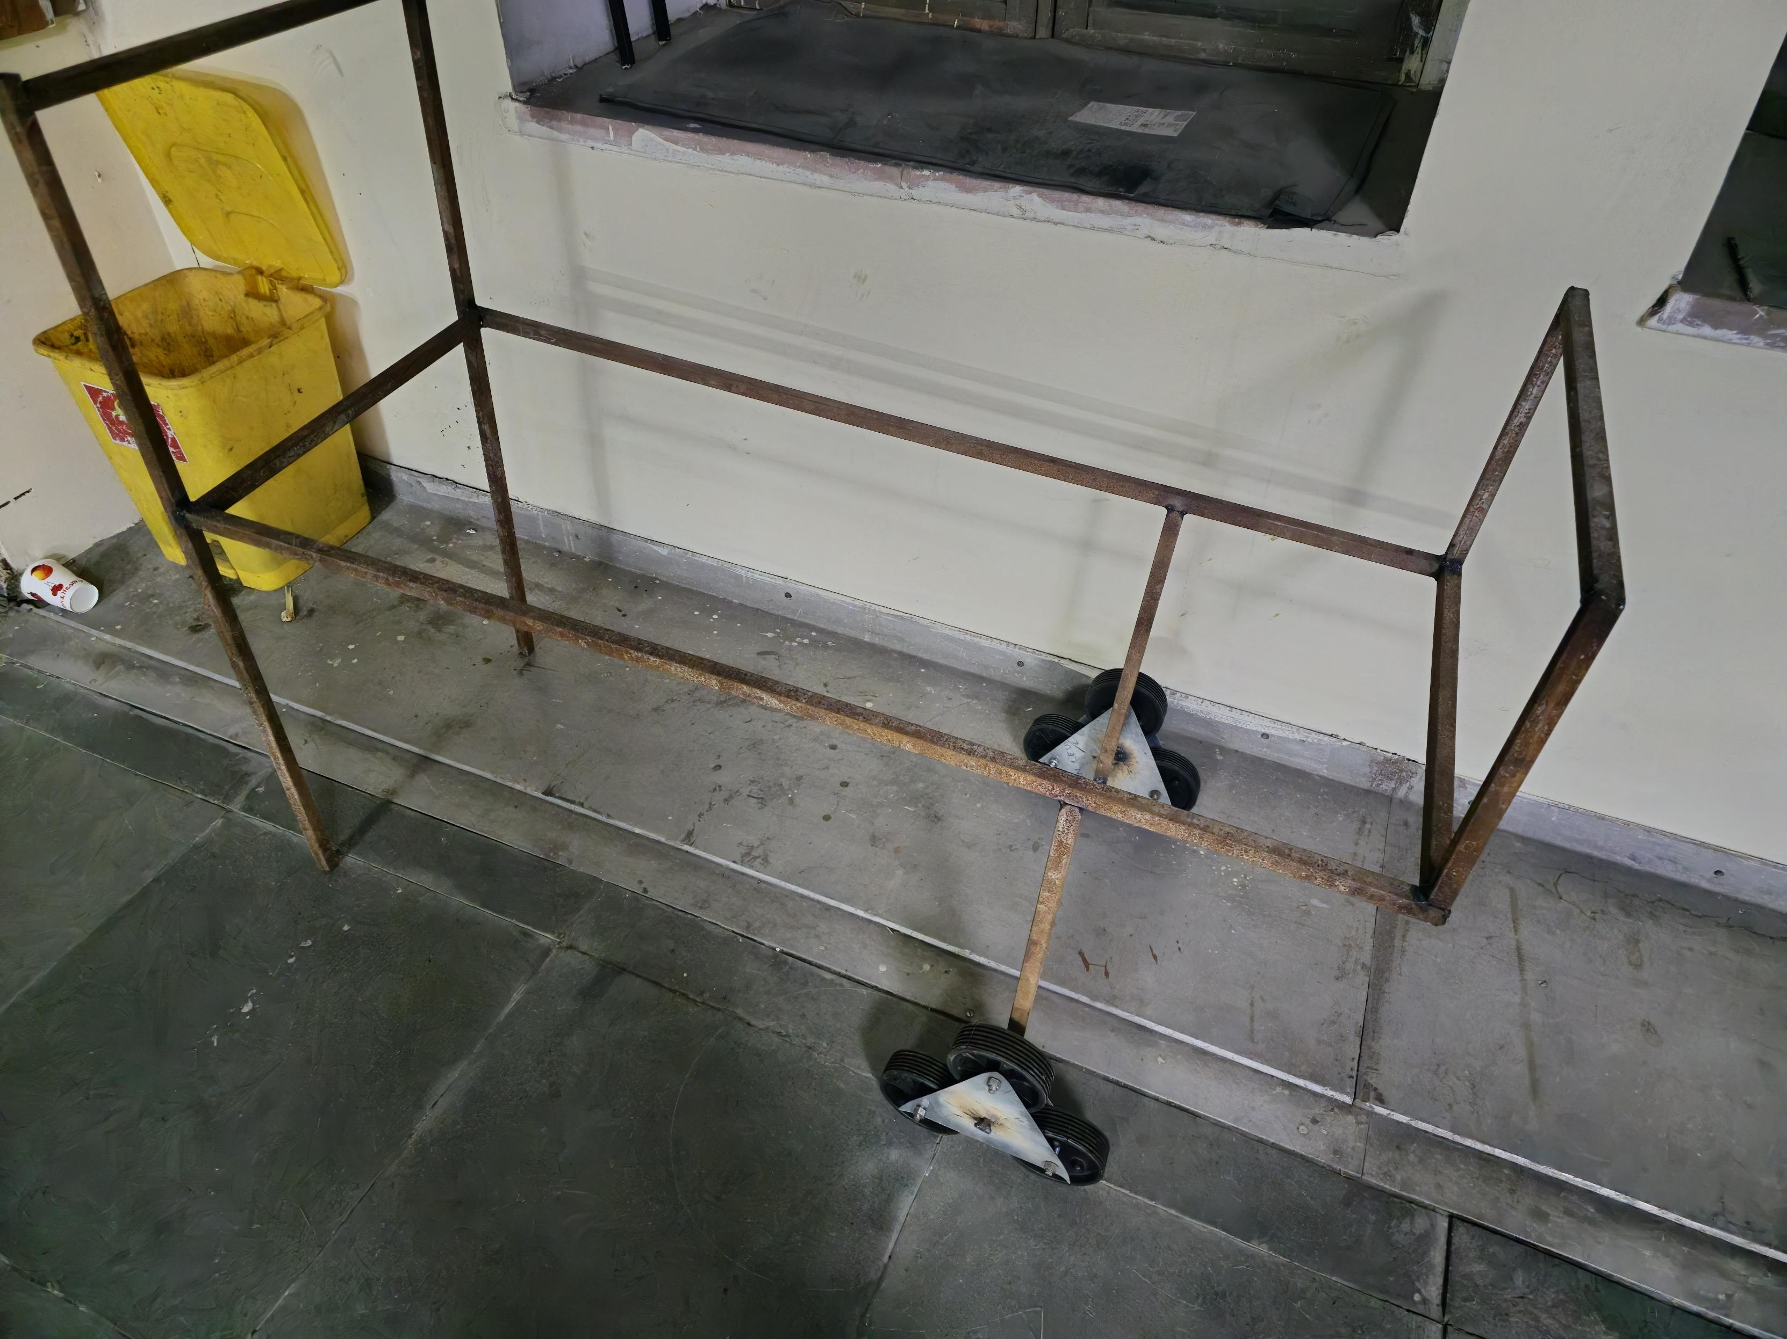
5. Result / Work Done
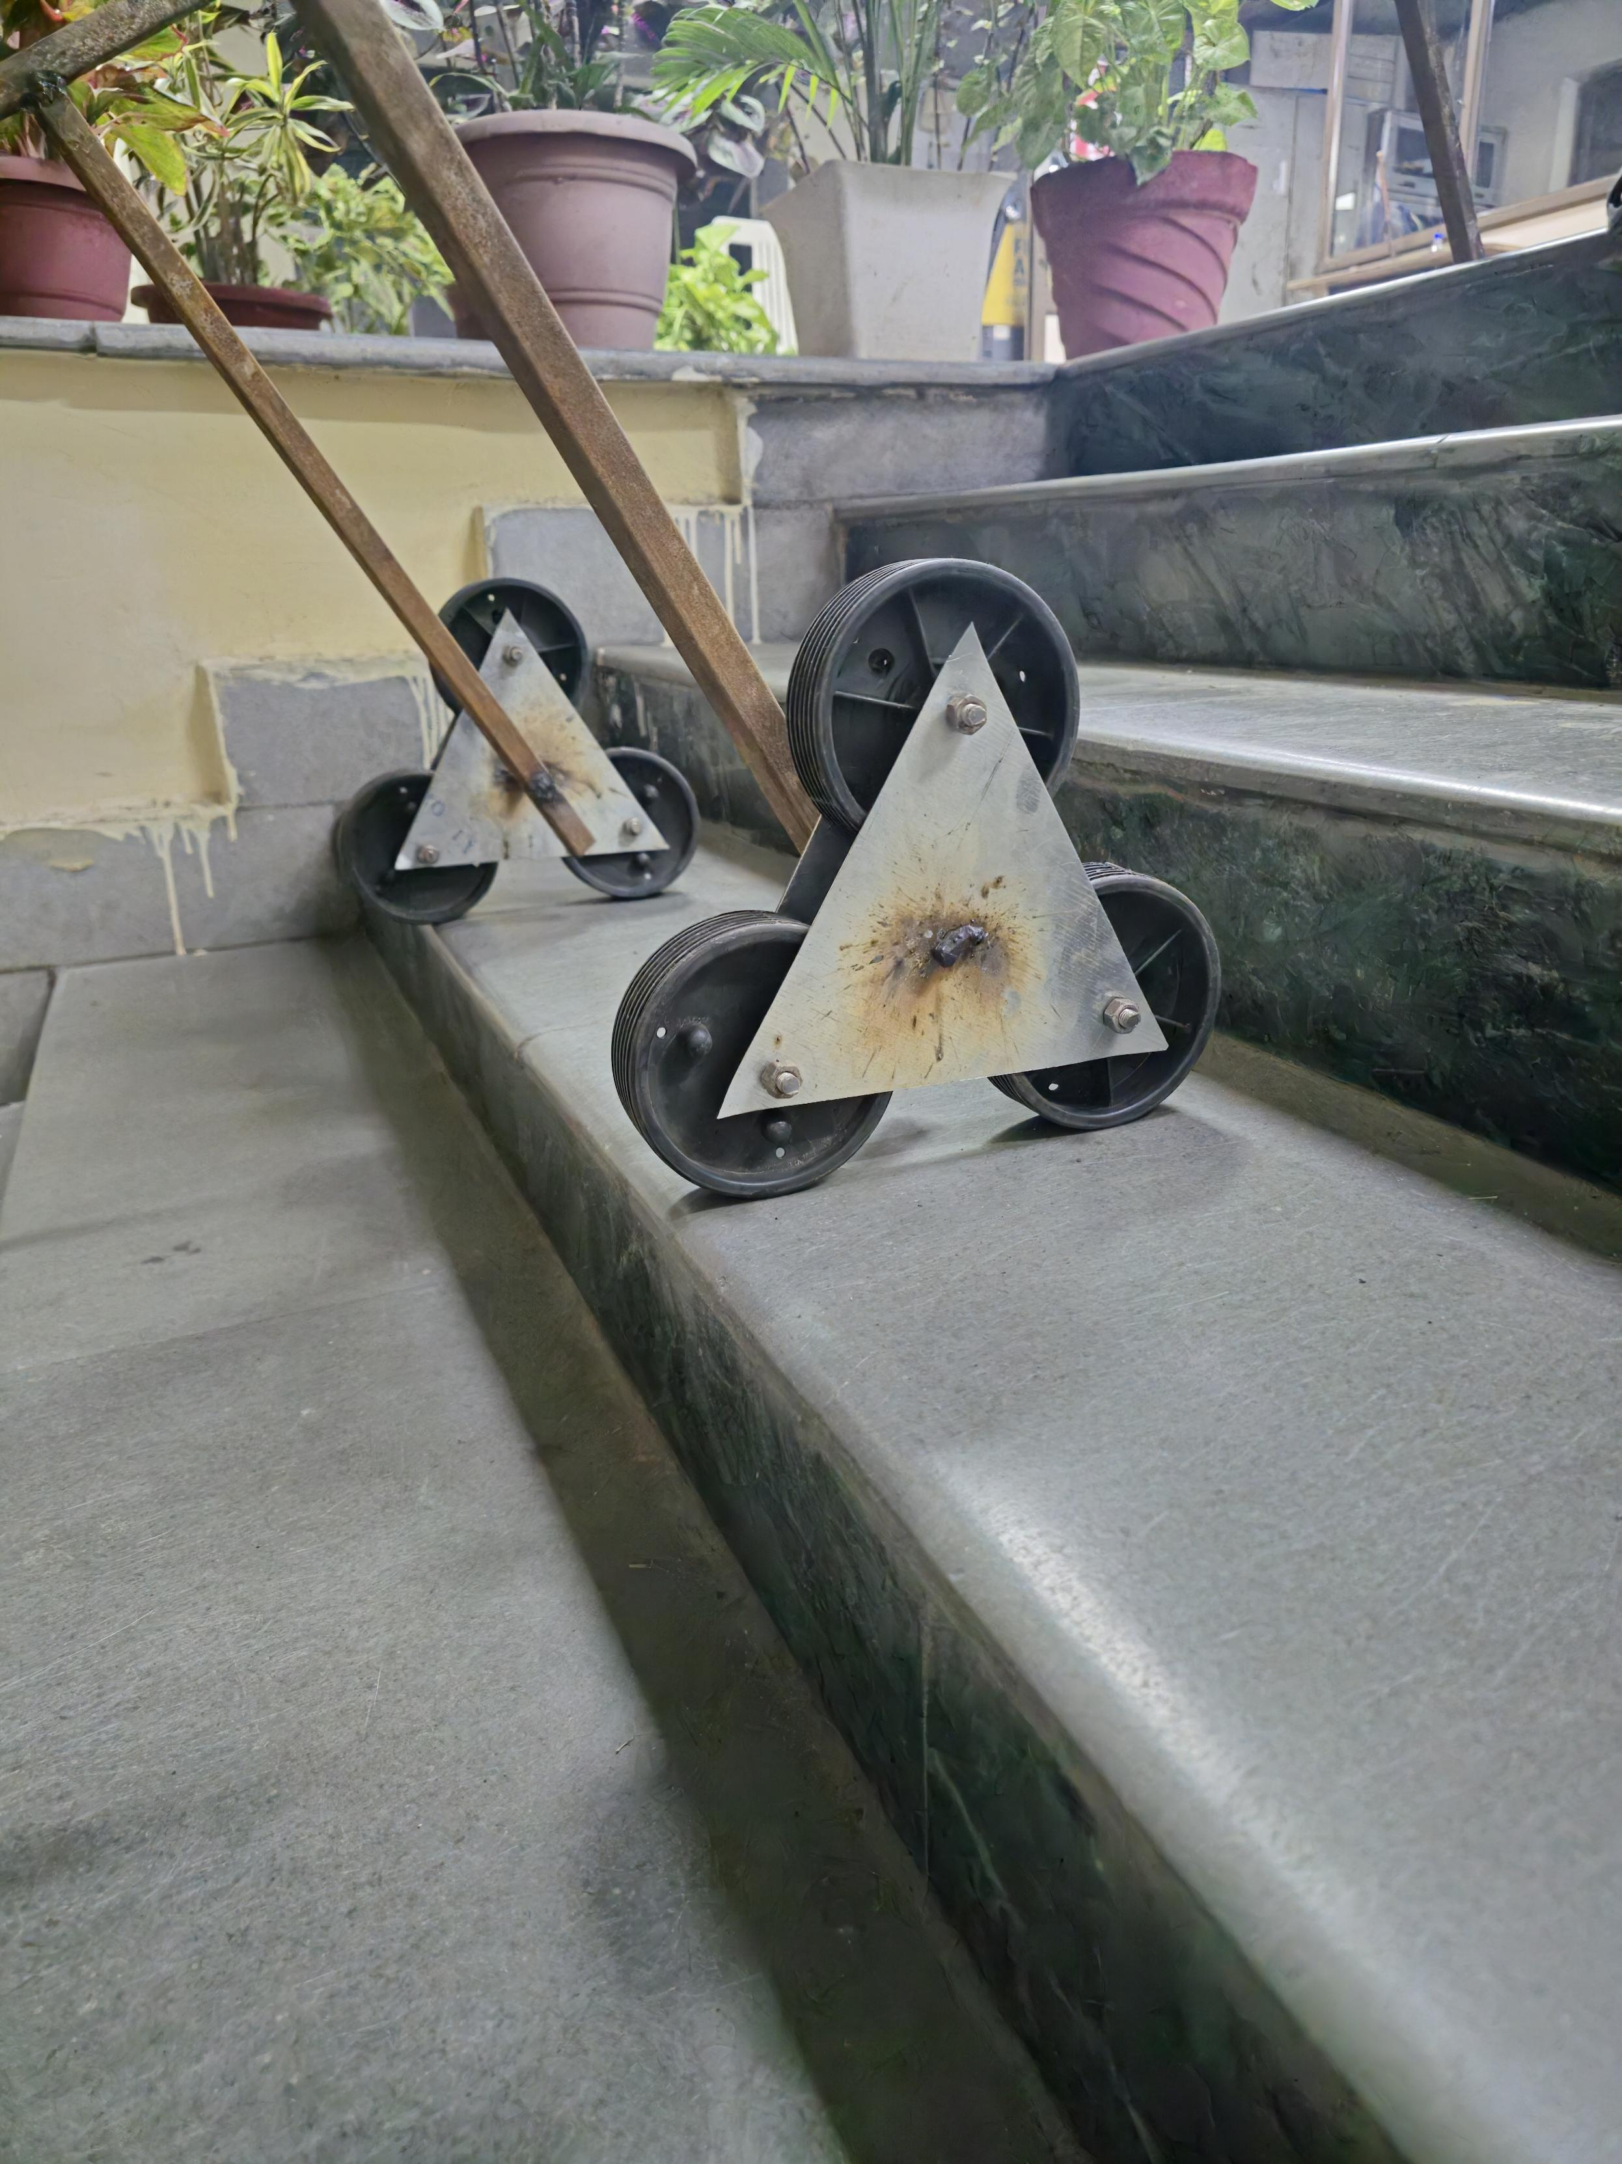
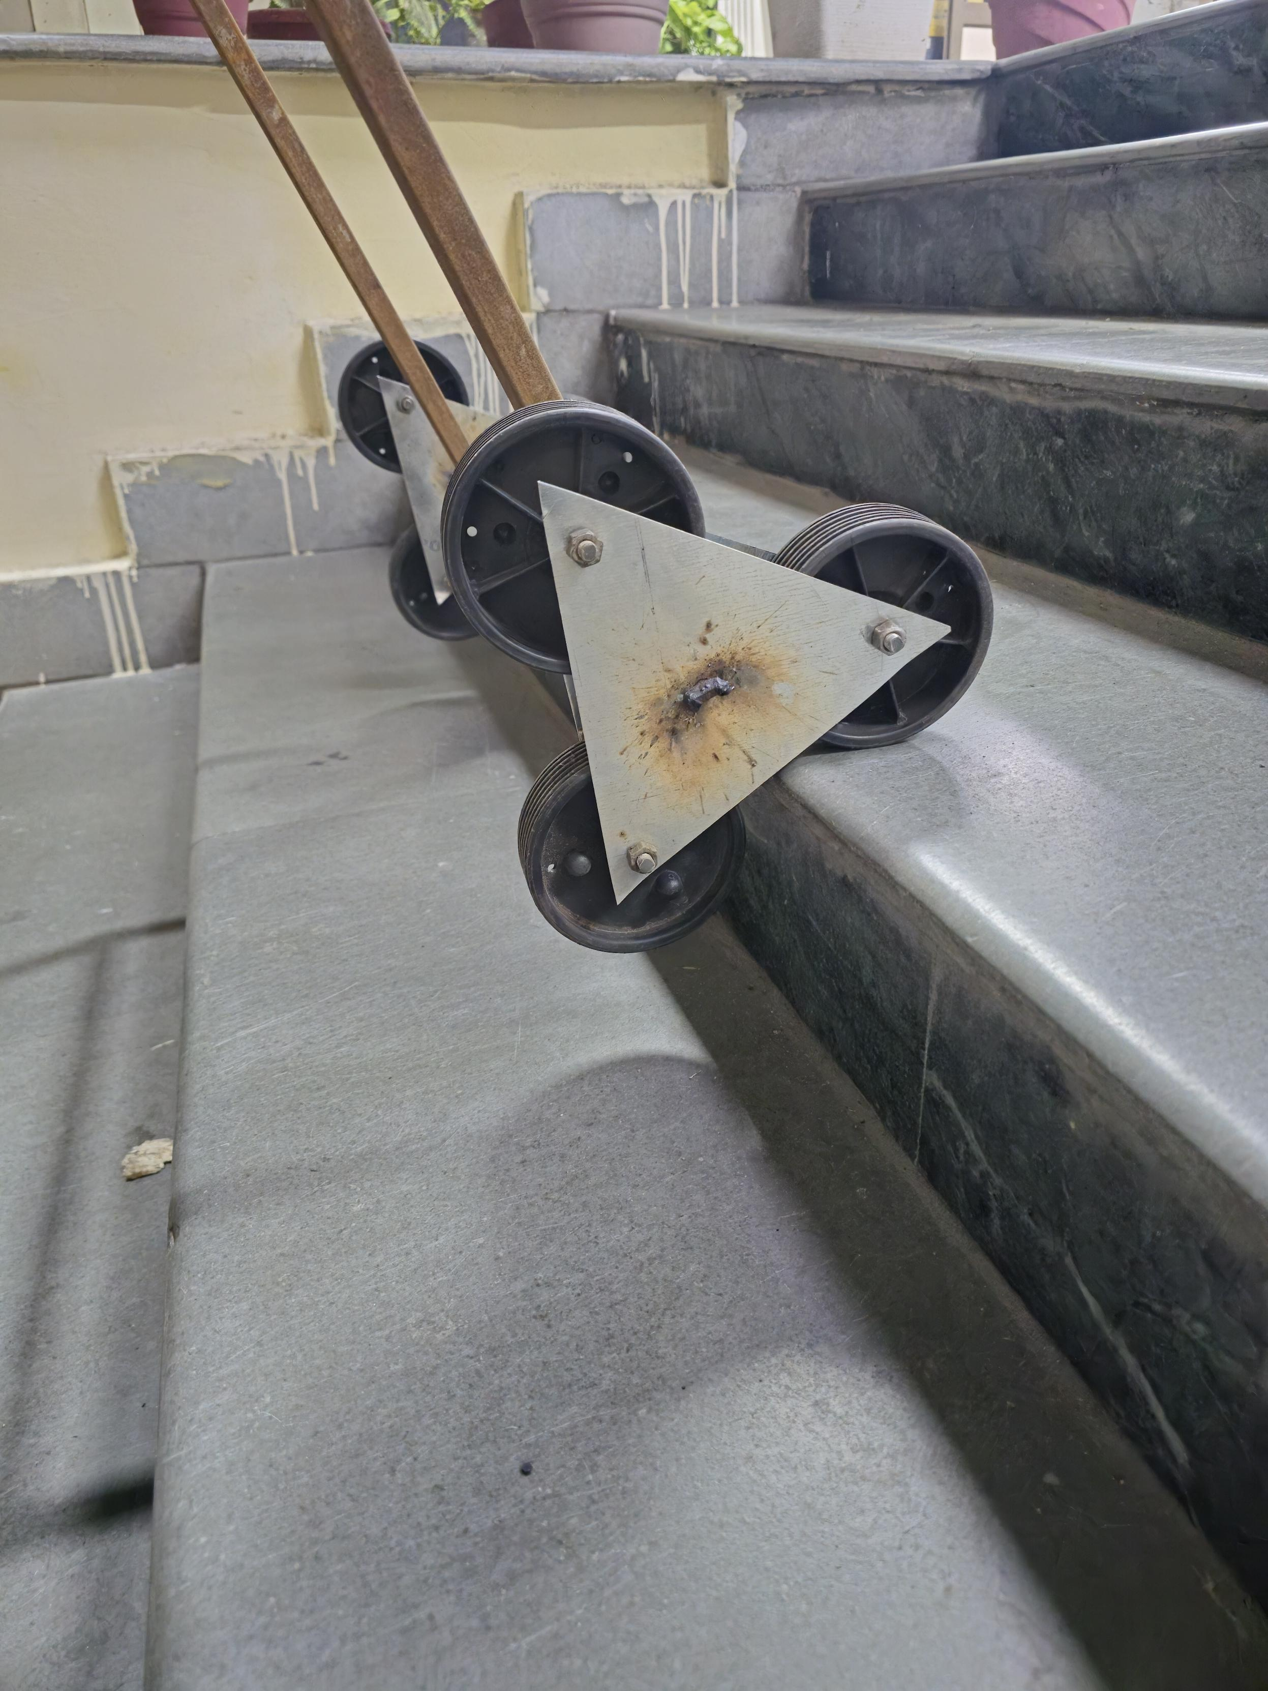
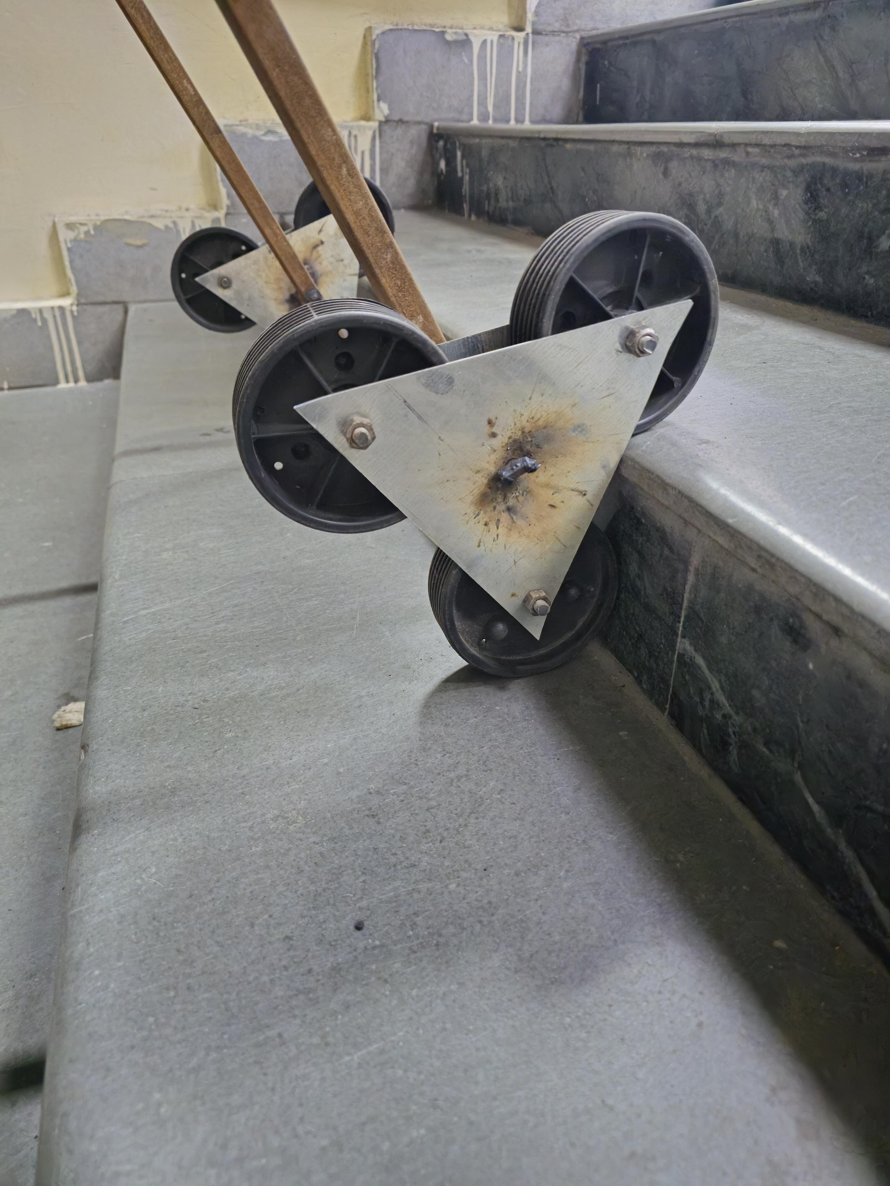
The prototype features:
- A durable rectangular frame with tri-wheel assemblies on both sides.
- Ergonomic handles for easier maneuverability.
- A platform designed to carry loads up to 50 kg.
During testing, the trolley successfully navigated various staircase configurations while reducing user effort. Its tri-wheel system enabled smooth transitions between steps, ensuring load stability.

6. Discussion
The project successfully demonstrated the utility and efficiency of the tri-wheel mechanism for stair climbing. However, the following challenges were observed during testing:
- Load Balancing: Slight tilting occurred with heavier loads.
- Traction: Performance on wet or slippery surfaces needs improvement.
- Fabrication Cost: High-quality materials increased the overall cost.
These limitations provide areas for further development and refinement.

7. Applications
- Logistics: Moving goods in multi-story buildings without elevators.
- Construction: Transporting materials on sites with incomplete infrastructure.
- Emergency Services: Carrying equipment during rescue operations.
- Household Use: Transporting groceries, furniture, and heavy items.

8. Future Direction/Further Improvements
- Motorized Assistance: Incorporating electric motors for automated stair climbing.
- Compact Design: Developing a foldable model for easy storage.
- Enhanced Traction: Using advanced materials for better performance on wet or slippery stairs.
- Safety Features: Adding a braking system and load-securing mechanisms.

