GeoDiff-GAN: Research Progress Report
Prompt-Guided Diffusion-GAN Super-Resolution for Sentinel-2 Satellite Imagery
Prepared for: Research Supervisor
Prepared by: Shashank
Reporting date: 23 June 2026
Research status: Architecture implemented; controlled training and comparative evaluation in progress

1. Executive Summary
This work investigates 4x single-image super-resolution for Sentinel-2 L2A RGB imagery, using synthetic 40 m observations and native 10 m targets. The proposed GeoDiff-GAN separates conservative reconstruction from uncertain detail synthesis. A deterministic SwinIR branch establishes radiometry and geometry, latent diffusion models plausible residual detail, a dual-policy GeoMapper controls evidence confidence and edit permission, and a residual GAN decoder reconstructs high-frequency content. Sensor back-projection finally enforces consistency with the observed LR image.
- Implemented an end-to-end multi-stage research codebase with data preparation, training, evaluation, uncertainty, diagnostics, and resumable notebooks.
- Developed small, medium, and large variants, plus an improved small model using resize-convolution to reduce periodic artifacts.
- Completed six-tile diagnostic training and expanded the controlled experiment to twelve products with validation-based checkpointing and early stopping.
- Built a common benchmark harness for recent open-source SR models and a saved-checkpoint evaluation notebook covering PSNR, SSIM, LPIPS, DISTS, edge F1, and LR consistency.

2. Research Problem and Scope
The primary experiment maps a 128 x 128 RGB LR patch to a 512 x 512 RGB HR patch. Because 4x degradation is non-invertible, the system cannot guarantee unique recovery of missing sub-pixel structure. The defensible objective is evidence-constrained reconstruction with explicit uncertainty, not unrestricted hallucination.
Item | Current scope
Sensor/product | Sentinel-2 L2A surface reflectance
Bands | B4/B3/B2 RGB
Task | Synthetic 40 m to native 10 m, 4x SR
HR patch | 3 x 512 x 512
LR patch | 3 x 128 x 128
Modes | SR reconstruction and explicitly synthetic prompt edit
Split principle | Product/tile-aware separation; spatial-block split used for controlled DGX comparison

3. Proposed Architecture
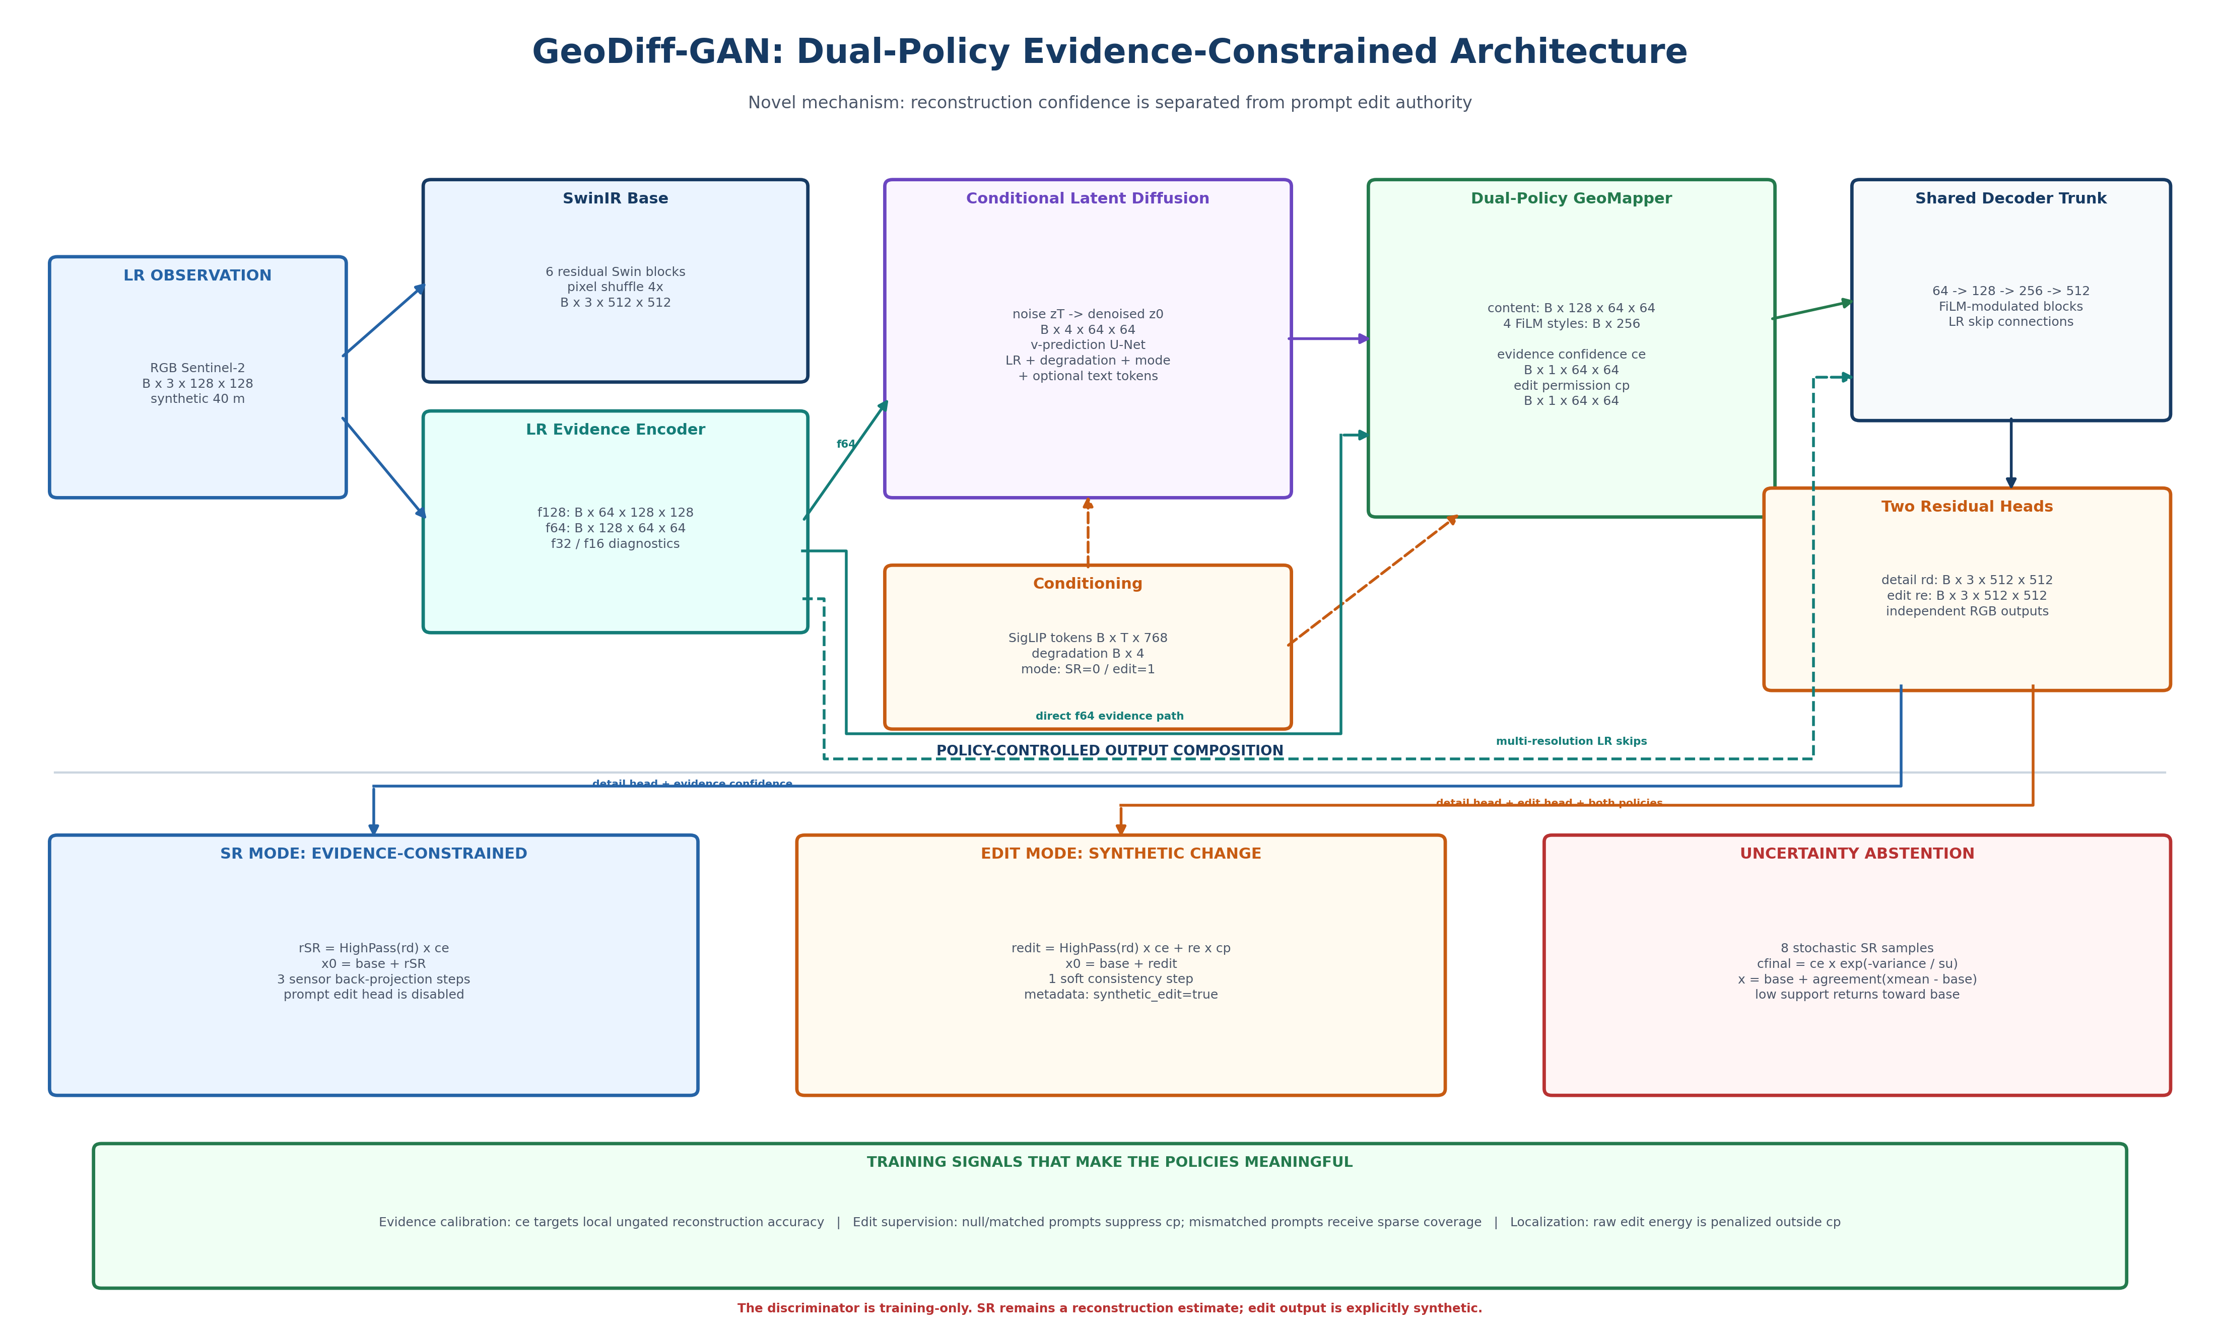
Figure 1. GeoDiff-GAN dual-policy architecture and evidence-controlled residual path.
Module | Input -> output | Research role
Deterministic base | 3x128x128 -> 3x512x512 | Conservative geometry, reflectance, and low-frequency reconstruction.
Residual VAE | 3x512x512 residual -> 4x64x64 latent | Compresses the target residual distribution for latent diffusion.
LR encoder | 3x128x128 -> multi-scale features | Anchors latent and decoder features to observed spatial evidence.
Conditional diffusion | 4x64x64 noisy latent -> denoised latent | Models ambiguous, stochastic residual detail conditioned on LR and degradation.
Dual-policy GeoMapper | latent + LR + context -> content, styles, confidence, permission | Separates evidence-supported reconstruction from prompt-controlled synthetic editing.
Residual decoder | 64-grid content -> 3x512x512 residual | Generates detail residuals with LR skip connections and layer-wise modulation.
Back-projection | HR estimate + LR -> corrected HR | Reduces sensor re-degradation error while preserving the residual formulation.
Discriminators | HR/LR pairs during training only | Patch realism and Haar high-frequency supervision; absent at inference.

4. Novel Research Contributions Under Evaluation
- Evidence-controlled residual generation: stochastic detail is added to a deterministic base rather than generating an unrestricted HR image.
- Dual spatial policies: evidence confidence controls SR detail, while edit permission independently controls prompt-driven synthetic changes.
- Uncertainty-aware abstention: multi-sample variance reduces trust in unstable generated detail and blends toward the deterministic base.
- Sensor-consistency closure: iterative back-projection uses the degradation model to constrain the final output to the LR observation.
- Dual-frequency adversarial training: conditional multi-scale PatchGAN is combined with a Haar-wavelet discriminator.
- Explicit SR/edit semantics: reconstruction outputs and synthetic prompt edits use different residual policies and metadata claims.
These are proposed contributions, not established novelty claims. Each requires controlled ablation against deterministic, diffusion-only, GAN-only, no-gate, no-projection, and alternative-decoder baselines.

5. Model Variants and Capacity
Variant | Core parameters | Purpose
XS smoke | 0.765 M | Pipeline and shape testing only
Small | 12.140 M | Primary constrained experiments and debugging
Small improved | 12.054 M | Resize-convolution decoder and stronger calibration/detail supervision
Medium | 21.127 M | Preferred capacity-scaling experiment
Large | 81.856 M | Full-capacity final experiment after data and decoder validation

6. Data and Training Pipeline
- Complete Sentinel-2 SAFE products are read window-by-window; accepted patches are stored as compressed NPZ files.
- SCL filtering removes cloud, shadow, invalid, saturated, and edge/corner background patches; rejected data are quarantined for audit.
- Training LR is generated online with randomized MTF/PSF blur, area downsampling, mild Poisson-Gaussian noise, quantization, and degradation parameters.
- Training follows base, residual VAE/decoder, latent diffusion, joint diffusion-GAN, and optional prompt-edit stages.
- Mixed precision, gradient accumulation, resumable checkpoints, compact progress reporting, validation-selected best checkpoints, and early stopping are implemented.
- Offline caption generation supports brief, descriptive, and analytical captions; a grounded multispectral workflow using B08/B11/SCL evidence was designed to reduce RGB-only caption hallucination.

7. Experimental Progress and Findings

Six-product diagnostic
Diagnostic | Observed value | Interpretation
Base-to-target L1 | 0.04736 | Deterministic base remained inaccurate on the selected validation patch.
Output-to-target L1 | 0.02650 | Final system improved patch-level reconstruction by 44%.
LR error before/after projection | 0.02032 / 0.00329 | Back-projection reduced inconsistency by 83.8%.
Evidence confidence / abstention | 0.166 / 0.834 | The model suppressed most proposed stochastic detail.
Output/target edge magnitude | 33.3% | High-frequency reconstruction was substantially too weak.
Wavelet amplitude retained | 30.7-37.8% | Directional and diagonal detail remained under-reconstructed.
Numerical stability | No NaN/Inf | Pipeline and diffusion sampling were stable.

Conclusion: the model was not numerically failing. It improved the deterministic base and preserved LR evidence, but remained overly conservative and failed to reconstruct enough target high-frequency structure.
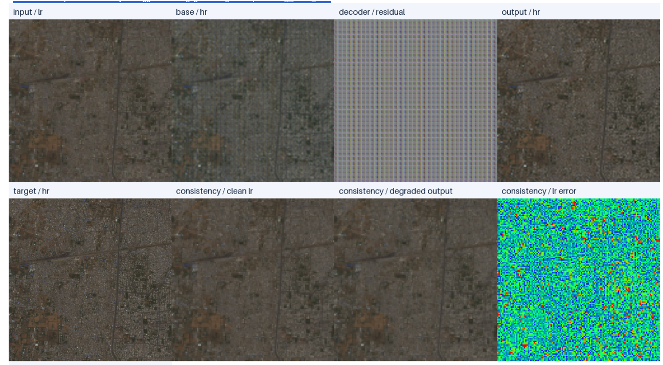
Figure 2. Representative six-product validation diagnostic: LR, base, residual, output, target, and consistency maps.

Twelve-product improved experiment
- Replaced residual-decoder PixelShuffle stages with bilinear resize-convolution to reduce lattice/checkerboard artifacts.
- Added spatial confidence-selectivity supervision to discourage nearly uniform evidence maps.
- Strengthened gradient and wavelet supervision while retaining a low adversarial weight.
- Added 0/1/3-step projection ablations, early stopping, and best-plus-latest checkpoint retention.
- Observed joint validation peaked early in one run, indicating overfitting or an overly aggressive joint phase; epoch 1 was retained as the best checkpoint.

8. Current Limitations and Risks
- Insufficient geographic diversity in early experiments limits generalization claims.
- High-frequency detail remains weaker than the HR target even when LR consistency is strong.
- Back-projection can repair LR consistency but cannot prove that inferred HR edges are correct.
- Evidence confidence may become globally conservative instead of spatially selective.
- Prompt captions generated from RGB alone can misclassify dark land as water; multispectral grounding is required.
- Synthetic 40 m degradation does not prove performance on native real 40 m imagery.
- Large capacity on small datasets increases overfitting risk and does not automatically fix decoder artifacts.

9. Benchmarking and Evaluation
A common evaluation framework has been prepared for GeoDiff-GAN and recent open-source SR architectures, including SwinIR, HAT, SRFormer, DAT, OmniSR, TTST, MFG-HMoE, and optional FreMamba. Saved checkpoints can now be evaluated without retraining using identical deterministic LR inputs.
Metric | Meaning | Direction
PSNR | Pixel-level fidelity; can favor smooth outputs | Higher
SSIM | Local luminance, contrast, and structural similarity | Higher
LPIPS | Deep-feature perceptual distance | Lower
DISTS | Structure and texture perceptual distance | Lower
Edge F1 | Agreement of reconstructed and target edges | Higher
Re-degradation L1 | Consistency of SR output with observed LR | Lower
Uncertainty correlation | Whether stochastic variance identifies difficult regions | Positive/error-aware

10. Next Work Plan
- Run saved-checkpoint comparison on the complete held-out split with LPIPS and DISTS enabled.
- Compare small improved and medium under identical data, updates, degradation seed, and early-stopping policy.
- Complete decoder, evidence-gate, text, wavelet-discriminator, degradation-conditioning, and projection ablations.
- Increase geographically diverse products while keeping validation and test tiles isolated.
- Audit grounded captions by spectral evidence and manually review high-risk water/cloud/forest cases.
- Report eight stochastic samples per test patch with uncertainty maps and selective-risk analysis.
- Use the large model only after medium demonstrates reliable held-out improvement.

11. Supervisor Decisions Requested
- Approve the medium model as the next capacity experiment before committing compute to the large model.
- Confirm that final claims should focus on synthetic Sentinel-2 40 m to 10 m reconstruction, with real native-resolution transfer treated as future validation.
- Confirm the minimum number and geographic distribution of tiles required for thesis-level evaluation.
- Review whether prompt-guided edit mode should remain a secondary synthetic-visualization contribution or be excluded from the first paper.

12. Current Defensible Research Statement
GeoDiff-GAN is an evidence-controlled residual super-resolution framework that combines a deterministic transformer base, conditional latent diffusion, dual reconstruction/edit policies, adversarial high-frequency supervision, uncertainty abstention, and sensor back-projection. Current experiments show stable execution, improved reconstruction over the base, and strong LR consistency, while also revealing insufficient high-frequency recovery and the need for broader geographic validation and controlled ablation.

