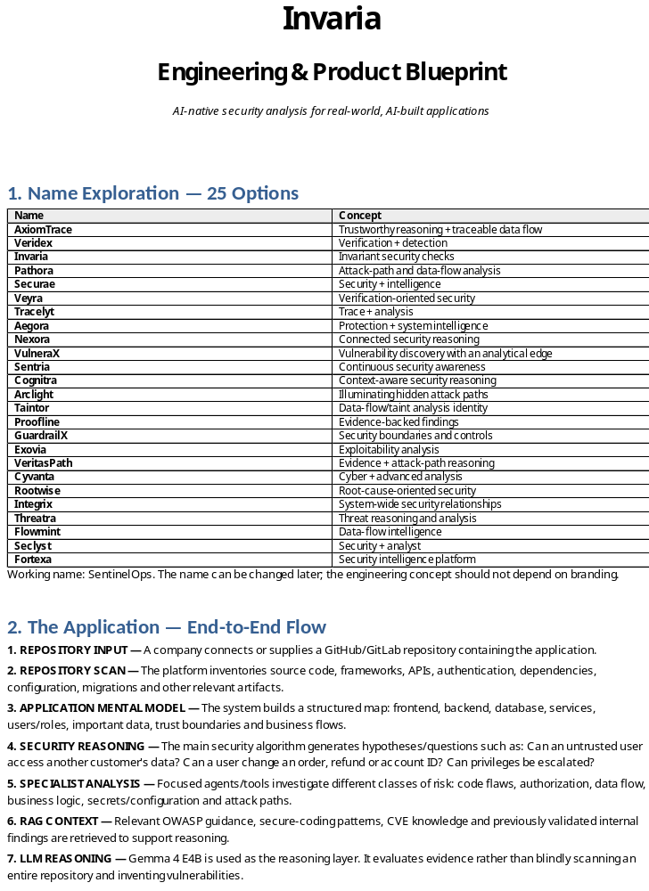Engineering & Product Blueprint
AI-native security analysis for real-world, AI-built applications

1. Name Exploration — 25 Options
Name | Concept
AxiomTrace | Trustworthy reasoning + traceable data flow
Veridex | Verification + detection
Invaria | Invariant security checks
Pathora | Attack-path and data-flow analysis
Securae | Security + intelligence
Veyra | Verification-oriented security
Tracelyt | Trace + analysis
Aegora | Protection + system intelligence
Nexora | Connected security reasoning
VulneraX | Vulnerability discovery with an analytical edge
Sentria | Continuous security awareness
Cognitra | Context-aware security reasoning
Arclight | Illuminating hidden attack paths
Taintor | Data-flow/taint analysis identity
Proofline | Evidence-backed findings
GuardrailX | Security boundaries and controls
Exovia | Exploitability analysis
VeritasPath | Evidence + attack-path reasoning
Cyvanta | Cyber + advanced analysis
Rootwise | Root-cause-oriented security
Integrix | System-wide security relationships
Threatra | Threat reasoning and analysis
Flowmint | Data-flow intelligence
Seclyst | Security + analyst
Fortexa | Security intelligence platform
Working name: SentinelOps. The name can be changed later; the engineering concept should not depend on branding.

2. The Application — End-to-End Flow
1. REPOSITORY INPUT — A company connects or supplies a GitHub/GitLab repository containing the application.
2. REPOSITORY SCAN — The platform inventories source code, frameworks, APIs, authentication, dependencies, configuration, migrations and other relevant artifacts.
3. APPLICATION MENTAL MODEL — The system builds a structured map: frontend, backend, database, services, users/roles, important data, trust boundaries and business flows.
4. SECURITY REASONING — The main security algorithm generates hypotheses/questions such as: Can an untrusted user access another customer's data? Can a user change an order, refund or account ID? Can privileges be escalated?
5. SPECIALIST ANALYSIS — Focused agents/tools investigate different classes of risk: code flaws, authorization, data flow, business logic, secrets/configuration and attack paths.
6. RAG CONTEXT — Relevant OWASP guidance, secure-coding patterns, CVE knowledge and previously validated internal findings are retrieved to support reasoning.
7. LLM REASONING — Gemma 4 E4B is used as the reasoning layer. It evaluates evidence rather than blindly scanning an entire repository and inventing vulnerabilities.
8. VERIFICATION — Findings are checked against code/data-flow evidence. Proposed fixes are also validated before being presented as trustworthy.
9. RISK & IMPACT — The system translates technical flaws into business consequences: data exposure, unauthorized actions, financial loss, privilege escalation or service disruption.
10. REPORT & REMEDIATION — The final report explains the vulnerability, attack path, evidence, severity, business impact and recommended/automated fix. Future versions can open a PR with the fix.
Core idea: the product is not trying to be a better general-purpose coding model. It owns the security reasoning process and uses an LLM as one component inside that process.

3. How This Fits the Real World
Fintech / payments — A payment or wallet application may correctly implement individual APIs while still allowing a sequence such as modify → refund → withdraw to produce an unauthorized financial outcome. The platform looks for broken authorization, state transitions, race/double-spend opportunities and dangerous money flows.
Healthcare — A patient portal may expose records because an endpoint trusts a patient ID supplied by the browser. The platform maps users, roles, endpoints and database records to ask whether one patient can reach another patient's data.
Multi-tenant SaaS — A startup may correctly authenticate users but fail to enforce tenant isolation. Changing an object identifier or API parameter could expose another company's invoices, documents or customer records. The platform focuses on cross-tenant paths.
E-commerce — Discount, cart, payment and inventory logic can interact in unexpected ways. A user may manipulate quantities, coupons, prices or order states to create an outcome the individual functions never intended.
AI-built startup / internal tool — A rapidly built application may contain hard-coded secrets, weak authorization, unsafe database access and missing server-side checks. The platform provides a security review without requiring a dedicated security team.
The important output is not merely “SQL injection at line 42.” It is: “Here is how an attacker can reach a sensitive operation, why the application permits it, what business asset is exposed, and how to fix it.”

4. Proposed Architecture
Conceptual pipeline:
Repository → Ingestion → Code/Schema Understanding → Application Mental Model → Security Algorithm → Specialist Analysis → RAG → LLM Reasoning → Verification → Risk/Impact → Report/Remediation

Major components
Component | Purpose
Ingestion | GitHub/GitLab connector, repository snapshot/diff, language/framework detection.
Code intelligence | Tree-sitter AST parsing; optional Semgrep/rules for deterministic checks.
Schema intelligence | SQL/migration/ORM schema extraction and database-entity mapping.
Knowledge graph | Relationships between endpoints, functions, services, users, tables, columns and data flows.
Security engine | The project's proprietary algorithm for generating hypotheses, selecting evidence and coordinating analysis.
Agent layer | Specialized investigators, exploitability reasoning, remediation and validation agents.
RAG layer | Security standards, attack patterns, secure coding references and validated historical findings.
LLM layer | Gemma 4 E4B initially; fine-tuning only after useful evaluation data exists.
Verification | Static checks, graph evidence, tests/builds and fix validation.
Reporting | Human-readable report, severity, confidence, attack path, business impact and remediation.

5. Technology Evaluation & Recommendation
Technology | Role | Why | Decision
Python + FastAPI | Core backend | Strong ecosystem for security/AI tooling; fast to prototype | FINALIZE
TypeScript + Next.js | Dashboard/UI | Good GitHub-style developer UX | FINALIZE
Tree-sitter | AST parsing | Fast, multi-language structural parsing | FINALIZE
Semgrep | Deterministic security rules | Mature baseline checks; reduces reliance on LLM | USE AS BASELINE
PostgreSQL | Application metadata/results | Reliable, simple, relational | FINALIZE
Neo4j | Code/data-flow graph | Natural representation of attack paths and relationships | STRONG OPTION
pgvector | Embeddings/RAG | Keeps vector search inside PostgreSQL initially | PREFER EARLY
Redis | Queues/cache | Useful for jobs and temporary state | OPTIONAL / LIKELY
Gemma 4 E4B | LLM reasoning | Local/open model route; supports experimentation | INITIAL MODEL
RAG | External knowledge/context | Useful for OWASP, CVEs, secure coding and prior findings | USE
LangChain | Agent framework | Can help with integrations, but adds abstraction | AVOID INITIALLY
LangGraph | Stateful agent orchestration | Useful for complex branching/loops | ADD WHEN NEEDED
Docker | Isolation/deployment | Practical for reproducible services | USE
GitHub App | Repository integration | Natural entry point for GitHub users | FINALIZE
GitLab integration | Alternative repository provider | Extends reach beyond GitHub | PHASE 2
Important design decision: do not build the project around a framework simply because it is called “agentic.” The proprietary security algorithm should remain understandable and testable even if the underlying LLM or orchestration library changes.

6. Backend & Data Design
API service — Authentication, repository registration, scan requests, report retrieval and user/project management.
Repository worker — Clones/snapshots repositories and prepares analysis inputs.
Parser workers — Extract ASTs and identify frameworks, routes, functions and dependencies.
Schema worker — Extracts database schema from migrations/ORM definitions.
Graph worker — Creates/updates the code-schema relationship graph.
Security orchestrator — Runs the proprietary reasoning workflow and delegates specialist investigations.
RAG service — Indexes/retrieves trusted security knowledge and internal validated findings.
LLM worker — Runs Gemma inference and returns structured reasoning/results.
Verification worker — Re-checks evidence and proposed remediation.
Report service — Stores and renders findings and creates future PR remediation artifacts.

7. Database Strategy
Use PostgreSQL as the system of record. Store users, organizations, repositories, scans, findings, evidence, reports, feedback and audit events there.
Use Neo4j only for relationship-heavy security analysis: endpoint → function → function → database query → table → sensitive column, plus service-to-service trust relationships.
Use pgvector for RAG embeddings initially. This avoids introducing a separate vector database before scale requires it.

8. Multi-Agent Model
The system can be genuinely multi-agent, but agents should have clear jobs rather than simply multiplying LLM calls.
Security Lead / Orchestrator — Chooses investigations and maintains the overall case.
Code Security Agent — Finds conventional code-level weaknesses and unsafe patterns.
Authorization Agent — Tests authentication, authorization, object ownership and tenant isolation.
Business Logic Agent — Analyzes multi-step workflows and state transitions.
Attack Agent — Constructs realistic attack paths from available evidence.
Exploitability Agent — Determines whether a candidate is actually exploitable.
Remediation Agent — Proposes a concrete fix.
Validation Agent — Checks that the finding and fix are supported by evidence and do not introduce obvious regressions.
Not every agent needs an LLM. Deterministic analysis should do deterministic work. Agents should spend model inference on ambiguity, reasoning and cross-context interpretation.

9. RAG, Fine-Tuning & Learning
RAG is a supporting layer, not the core intelligence. Useful sources include OWASP material, CWE/CVE descriptions, secure coding guidance, framework-specific security documentation and the project's own validated findings.
Fine-tuning should come later. First collect a benchmark of vulnerable repositories, known flaws, expected findings, false positives, accepted/rejected findings and validated fixes. Then determine whether fine-tuning actually improves measurable performance.
The long-term learning loop is: finding → human feedback → validated outcome → dataset → evaluation → improved rules/prompts/model.

10. Security Knowledge the Project Must Understand
The project should be grounded in established security concepts rather than inventing its own definitions. The study set should include:
- OWASP Top 10 and OWASP API Security Top 10
- CWE weakness categories
- Authentication vs. authorization and access-control failures
- Broken object-level authorization / IDOR-style flaws
- Injection and unsafe database access
- Secrets and configuration exposure
- Session management and privilege escalation
- Data-flow / taint analysis
- Threat modeling and trust boundaries
- Business-logic and state-machine vulnerabilities
- Secure coding and remediation patterns
- CVEs and vulnerability evidence

11. What the Final Report Should Look Like
- Finding title and one-line business consequence
- Severity + confidence
- Affected application component / endpoint
- Attacker prerequisites
- Step-by-step attack path
- Relevant code and data-flow evidence
- Sensitive asset affected
- Why existing controls failed
- Recommended fix
- Optional generated patch
- Verification status
- References to relevant security guidance

12. What We Should Avoid
Scanning the entire repository with one giant LLM prompt — High cost, weak evidence, poor reproducibility and hallucination risk.
Making the LLM the security authority — Models can be wrong. Evidence and deterministic checks must constrain conclusions.
Using too many agents just to call it multi-agent — More agents can mean more latency, cost and failure modes without more security.
Fine-tuning before building evaluation data — Without a benchmark, there is no meaningful way to prove improvement.
Starting with every vulnerability class — A smaller set of deep, demonstrable capabilities is stronger than a huge unreliable checklist.
Adding LangChain/LangGraph by default — Use them when orchestration complexity actually justifies them.
Replacing PostgreSQL with many specialized databases too early — Operational complexity will distract from the security engine.

13. Final Project Definition
SentinelOps is an AI-assisted security analysis platform that accepts a real application repository, constructs a structured mental model of how the application works, uses a proprietary security-reasoning algorithm to generate and investigate attack hypotheses, enriches those investigations with trusted security knowledge, uses an LLM for contextual reasoning, verifies findings with evidence, and reports technical vulnerabilities in terms of real business impact with actionable remediation.

The differentiator is not the base model. The differentiator is the security analysis process: what the system chooses to ask, what evidence it gathers, how it connects code to data and business operations, how it verifies an attack path, and how it converts that into a defensible finding.

Source Note
This blueprint substantially reframes the uploaded SentinelOps founder material into the engineering/product direction discussed in the conversation. The original material describes an AI security agent, code-schema graph, taint analysis, LLM reasoning, PR remediation, Tree-sitter, Semgrep, Neo4j, PostgreSQL, Redis and related components. fileciteturn0file5L146-L264
The uploaded project README also describes the repository-to-AST/schema-to-graph-to-taint-to-LLM-to-PR flow. fileciteturn0file7L9-L13

