Regarding submissions:

* The **“Last Modified”** date displayed on Drive is **not** the **submission date**.
* The date between Drive and Colab **can be different**.
* Therefore, it is best to **open the notebook and check the date of the last version.**
* The team has been **revisiting previous files** in order to decide on our next steps.

**Milestone 1:** Due Oct 27, 11:59 PM

* Milestone 1: Data Extraction - Last version on Oct 27, 10:56 PM



**Milestone 2:** Due Nov 10, 11:59 PM

* Milestone 2: Baseline Learning



* Milestone 2: Data Exploration



**Milestone 3:** Due Nov 17, 11:59 PM

* Milestone 3: Deep Learning

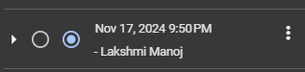

**Milestone 4:** Due Dec 1, 11:59 PM

* Milestone 4: Feature Importance