MarketSense Financial Report Comprehensive Analysis

Amazon (AMZN) Market Report Summary

Executive Overview:
This report provides a comprehensive analysis of Amazon (AMZN) for investors holding Apple (AAPL), Microsoft (MSFT), Alphabet (GOOGL), and NVIDIA (NVDA), offering insights into its financial health, market performance, and strategic positioning.
Amazon exhibits a robust and evolving financial profile, characterized by consistent revenue growth and increasing profitability driven by key segments like cloud computing and advertising.

0:00 / 0:08

Executive Summary Video: A brief overview of Amazon's financial landscape.

Amazon's Financial Health

Revenue Growth

For the twelve months ending September 30, 2025, Amazon reported $691.33 billion in revenue, an 11.48% increase year-over-year. Annual revenue growth rates have ranged from 37.62% in 2020 to 10.99% in 2024, with a five-year average of 14.72%.

Key Growth Engines

Amazon Web Services (AWS):

AWS is a significant profit driver. In Q3 2025, AWS revenue reached $33.01 billion, a 20.23% year-over-year increase. For the full year 2024, AWS revenue was $107.6 billion, growing 19%.
Operating margins for AWS, while strong, saw a dip from nearly 40% in Q1 2025 to 32.9% in Q2 2025, attributed to substantial investments in AI infrastructure, seasonal compensation, and foreign exchange rates. These investments are expected to yield long-term benefits.

Advertising Segment:

Amazon's advertising business is rapidly expanding with high profit margins. In Q3 2025, advertising services revenue grew by 24% year-over-year.
Global advertising revenue is projected to reach $94 billion by 2026 and $141.7 billion by 2030, with an anticipated annual growth rate of 16%. The introduction of Prime Video ads is expected to be a major contributor.

Profitability

Figure 1: Amazon's Consistent Revenue Growth (Annual & TTM)

**Gross Profit Margin:** Steadily climbing from 39.6% in 2020 to 50.0% for the twelve months ending September 30, 2025, indicating improved efficiency.
**Operating Profit Margin:** Recovered strongly after a dip in 2022, reaching 10.75% in 2024 and for the trailing twelve months as of January 2026, suggesting better cost management and operational leverage.

Cash Flow and Investments

**Free Cash Flow (FCF):** Has been volatile. For the twelve months ending September 30, 2025, FCF was $10.56 billion, a 75.41% decrease from the prior year.
**Capital Expenditures (CapEx):** Aggressive investment strategy is a key factor in FCF fluctuations. Amazon spent $120.131 billion on CapEx for the twelve months ending September 2025, with plans for over $100 billion in 2025, primarily for AWS AI infrastructure.
**Earnings Quality:** The decrease in FCF despite rising net income suggests a significant amount of "non-cash earnings," common for companies making large, long-term investments expensed over time.

Figure 2: Amazon's Improving Gross and Operating Profit Margins Figure 3: Amazon's Volatile Free Cash Flow Trends

Valuation and Efficiency Ratios (as of January 2026)

**P/E Ratio (TTM):** Approximately 33.64-33.65, indicating investor expectation of high future growth.
**PEG Ratio:** Around 1.91, suggesting the stock is priced for significant future growth.
**EV/EBITDA (TTM):** 17.17, used for valuation considering capital structure.
**Debt-to-Equity Ratio:** 0.37 as of September 2025, a reduction from previous years (from 40.8% to 16.9% in 2024), indicating a conservative capital structure.
**ROE (TTM):** 23.62%, showing strong efficiency in generating profits from shareholder equity.
**ROA (TTM): 9.48%**, indicating good asset utilization.

Recent News and Market Trends

The past 6-12 months have seen significant developments for Amazon across its business segments.

Corporate Strategy and AWS Innovations

AI and Robotics:

Deployed its one millionth robot and a new AI foundation model for its robotics fleet in July 2025. Leaked documents suggest potential replacement of 600,000 jobs with robots by 2027.

AWS Investments:

Announced up to $50 billion expansion for AI and supercomputing for the U.S. government sector in 2026. Committed over $200 billion in global investments in 2025.

AWS Technology:

At re:Invent 2025, launched Graviton5 (powerful CPU), expanded Amazon Nova model family, and introduced Trainium3 UltraServers to reduce AI training costs.

Global Cloud Expansion:

AWS European Sovereign Cloud became generally available in January 2026. Partnered with Rio Tinto for low-carbon copper for data centers.

Retail and Labor

Grocery Expansion:

Debuted branded grocery products (under $5) and expanded same-day grocery delivery in mid-2025. Plans include a proposed big-box store in Orland Park, Illinois.

Labor Relations:

An NLRB judge ruled in July 2025 that Amazon violated federal labor laws regarding union activities. Unionization efforts continue.

Regulatory and Antitrust

Figure 4: AWS Global Infrastructure and Expansion

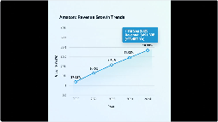

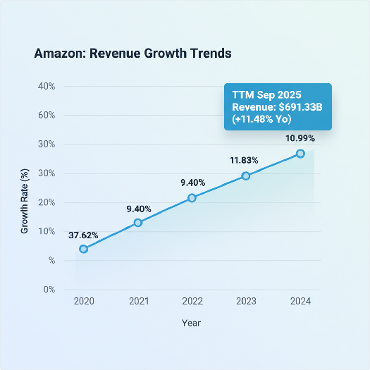
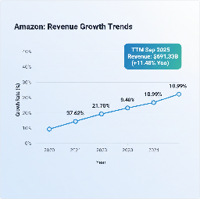
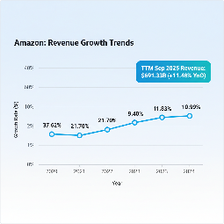
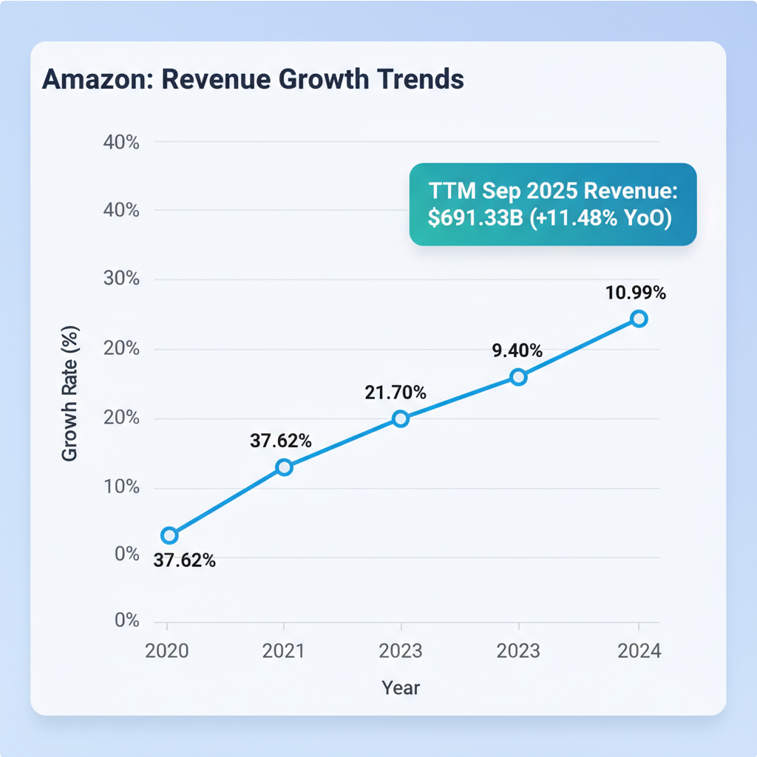
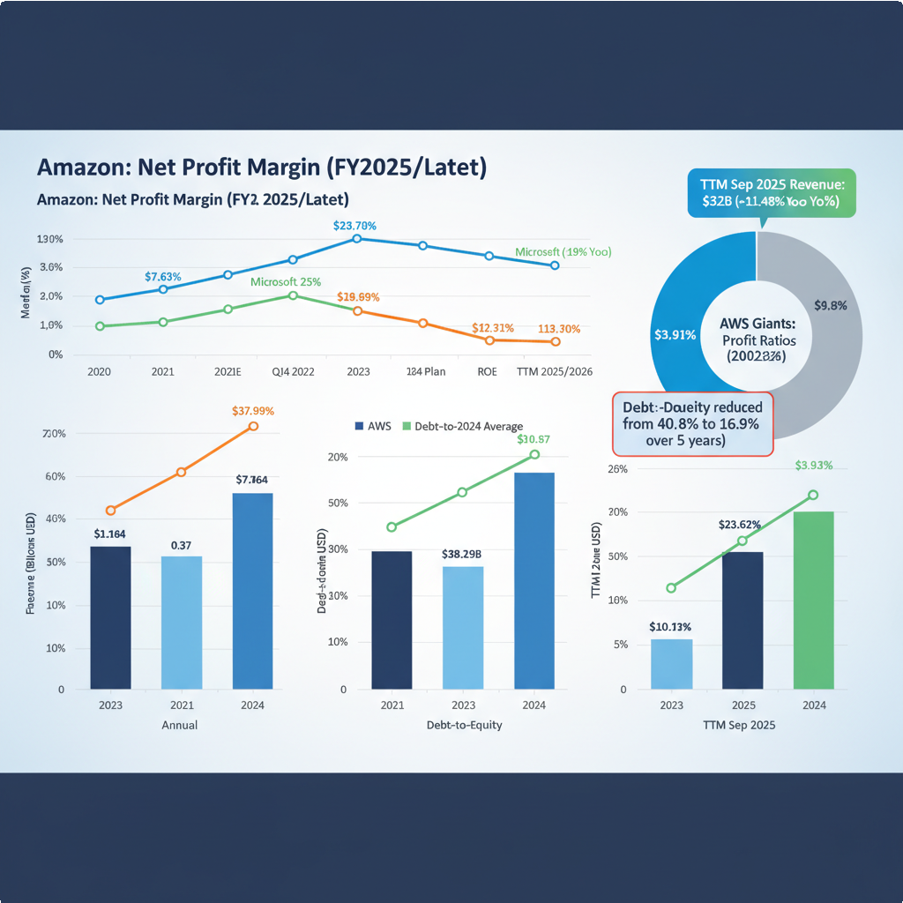
**FTC Lawsuits:** A federal judge allowed the FTC's antitrust lawsuit to proceed in January 2026, with a trial set for October 2026.
**European Fines:** Italy reduced an antitrust fine from 1.13 billion euros to 752.4 million euros in January 2026, which Amazon plans to challenge.
**FTC Settlement:** Secured a $2.5 billion settlement in September 2025 ($1 billion civil penalty, $1.5 billion in refunds) for alleged Prime enrollment without consent and difficult cancellation processes.

Amazon's Market Performance and Volatility

Amazon's stock performance reflects its status as a growth company in the tech sector.

Stock Performance

**YTD 2026:** Returned 3% to 3.60%.
**1-Year:** Returned 6.55% to 8.37%, underperforming the S&P 500 (18.39%) and NASDAQ 100 ETF (11.13%).
**3-Year:** Delivered a 148.95% return (40.10% annualized), significantly outpacing the S&P 500 and NASDAQ 100 ETF.
**5-Year:** Returned 53.13-53.25% annualized, exceeding the S&P 500 and NASDAQ 100 ETF.

Figure 5: Amazon Stock Performance vs. Benchmarks (1, 3, 5 Year Returns)

Volatility and Risk Profile (as of January 16, 2026)

**Volatility (Annualized Standard Deviation):** 27.29%, indicating wider price swings.
**Beta:** 1.38-1.46 (5-year period), suggesting higher volatility than the broader market.
**Dividends:** Amazon does not historically pay dividends and does not expect to in the foreseeable future.

Amazon's Fit within Your Tech-Heavy Portfolio

Adding Amazon to your existing portfolio of tech giants (Apple (AAPL), Microsoft (MSFT), Alphabet (GOOGL), and NVIDIA (NVDA)) would reinforce themes of cloud computing and advertising while offering diversification through its e-commerce dominance.

Synergies and Diversification

**Cloud Exposure:** Strengthens exposure to the cloud market alongside Microsoft Azure and Google Cloud, investing across the top "hyperscalers."
**E-commerce:** Provides a strong consumer retail segment, distinct from Apple's hardware focus or NVIDIA's chip design.
**Advertising:** Adds a high-margin revenue stream, complementing Alphabet's advertising business and Microsoft's growing ad presence.

Shared Tech Sector Dynamics

**Growth Drivers:** All companies benefit from the AI revolution, cloud computing expansion, expanding ecosystems, and significant capital expenditures in data centers.
**Risk Factors:** Face high valuations, intense AI competition, increasing regulatory scrutiny (antitrust, data privacy), and the short-term pressure of high capital expenditures on free cash flow.

Correlation and Differentiation
While historically correlated, individual company fundamentals and AI strategies are leading to more differentiated performance. Amazon's retail arm offers a layer of differentiation, while AWS places it in direct competition with Microsoft and Alphabet.

Investment Suggestion for Amazon (AMZN)
WATCH with a "Buy" Bias
Amazon is a powerhouse with strong long-term growth prospects, driven by AWS and its advertising segment. Significant investments in AI and automation are strategic for future profitability, despite temporary impacts on FCF and margins. The strong analyst "Strong Buy" consensus and average price targets suggest significant upside.

Strengths:

Dominant AWS and advertising segments. Strong e-commerce presence.
Leadership in AI investments. Manageable debt.
Portfolio fit for cloud diversification.

Areas to Monitor:

**Free Cash Flow Recovery:** Track FCF evolution for signs of stabilization.
**AWS Margin Stabilization:** Observe AWS operating margins as AI investments mature.
**Regulatory Outcomes:** Monitor antitrust lawsuits and potential fines.

This approach allows for continued engagement with Amazon's developments, enabling a purchase if positive trends solidify or market conditions become more favorable, while acknowledging current short-term pressures.

