Software Requirements Specification
for
Neuro – Spine Medical Data Analytics
Prepared by
Shashank Kapile
Hrushikesh Baravkar
Sarthak Gophane
Saurabh Koshatwar

VIIT, Pune

18 / 09 / 2018

Introduction

Purpose
The purpose of this document is to illustrate how ‘Neuro – Spine Medical Data Analytics System’ would provide doctors with deeper analysis and insights into data generated through monitoring the posture in day to day activities. In addition to the monitoring and analysis, the system would also suggest effective and efficient remedies to overcome issues raised due to bad posture which is detected by the system.

Product Scope
The Neuro – Spine Medical Data Analytics System(NSMDAS) is a system which would assist doctors and patients get effective analysis and deeper insights about the issues raised due to poor body posture. NSMDAS will provide detailed analysis related to various problems occurring at different spinal regions and would also suggest effective remedies to temporarily overcome the pain in the affected regions. The NSMDAS would also train itself from the data collected from upcoming patients and would also predict the problem the patient is likely to face in the near future. The system would also provide various visualizations which would also help doctors to make effective and informed decisions.

The NSMDAS would consists of a portable mobile-application which would be suitable for both patients and doctors to use. The system would consist of centralized client-server architecture where all the processing and analysis will be performed. The main objectives of NSMDAS are as follows :-

- Data Acquisition :- To gather detailed data related to spines from multiple sources like previous hospital records, personalized multiple choice questions, etc.
- Patient Profiling :- Creation and analysis of personalized patient profiles and reports visualization.
- Pattern Recognition on data :- Analysis of the data collected to recognize multiple patterns and trends to tackle various spine related issues.
- Remedy Recommendation :- Recommending remedies for issues recognized through patterns and individual patient profiles.
The mobile – application would also communicate with ‘Posture Detection System’ via Bluetooth to gather data generated through sensors which is to be provided to the NSMDAS.

References
[1] A. Hermanis, K. Nesenbergs, R. Cacurs, and M. Greitans, “Wearable Posture Monitoring System with Biofeedback via Smartphone”, Journal of Medical and Bioengineering Vol. 2, No. 1, March 2013

[2] Da-Yin Liao, “Collaborative, Social-networked Posture Training (CSPT) through Head-and-Neck Posture Monitoring and Biofeedbacks”, Straight & Up Intelligent Innovations Group Co., San Jose, California, U.S.A.

[3] Department of Health and Human Services, “Observation based Posture Assessment”, U.S. Department of Health and Human Services, Centers for Disease Control and Prevention, National Institute for Occupational Safety and Health, DHHS (NIOSH) Publication No. 2014–131.

[4] E Widerstro, F Biering-Sørensen, TN Bryce, DD Cardenas, NB Finnerup, MP Jensen, JS Richards and PJ Siddal, “The International Spinal Cord Injury Pain Basic Data Set (version 2.0)”, Spinal Cord (2014) 52, 282–286

[5] Harsh Gupta,”Smartphone Based Cervical Spine Stress Prevention”, Journal of Software Engineering and Applications, 2018, 11, 110-120

Overall Description

Product Perspective
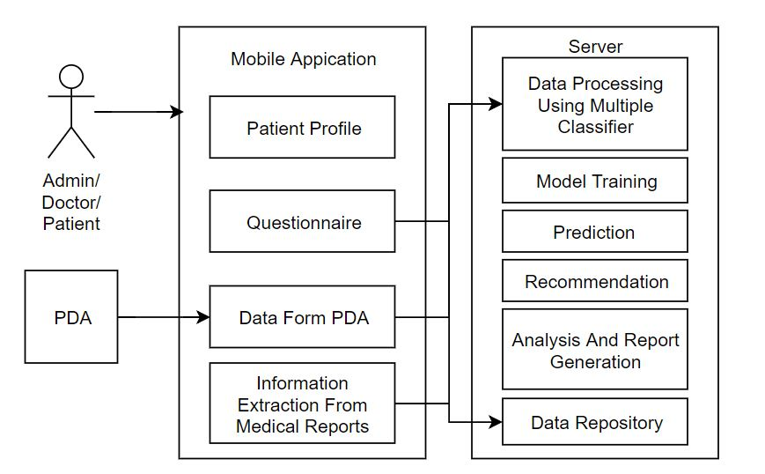
The Neuro – Spine Medical Data Analytics System consists of analytics done on data gathered from two components : a mobile application and posture detection machine. The mobile application is the main component as major analysis would be provided on mobile application itself. The posture detection machine is used the get the real time data of the posture the patient is currently wearing. The system would consist of a centralized server where all the pre-processing and analysis would be done and the output would be transferred back to mobile application.

The users of the system which would include admin, doctor or the patient would interact using a mobile application.
The mobile application would provide an easy and user friendly interface for various functionalities as follows :-
- Individual Patient Profiling would be provided so that doctors can monitor and analyze each patient individually.
- Gather current information about the patient problem through questionnaire and graphical representations.
- Get dynamic and real time data through Posture Detection System (PDS) for more effective analysis.
- Analyze various medical reports and doctors comments through information extraction technique.
The server would be the main area where all the processing, analysis, training and prediction would be done. It also includes various components as follows :-
- The data received through various sources would be first pre – processed using multiple classifier algorithms.
- This processed data would be used to train the model which would provide various solutions depending upon the input provided.
- The model will also analyze the current data to find patterns and traits and generate reports for the solutions. The model would allow doctors to effectively map various types of patients to different categories and take more informed decisions.
- Depending upon the analysis done remedy recommendations will be provided which will include multiple exercise suggestion and generic medical remedies that are easily available. The recommendations will also be in the form of which doctors the patients may or need to visit depending upon the problem and its seriousness.
- The data which will be received or used by the system for training, analysis and predictions will be stored in the data repository.
The doctors would be able to get insights through various visualizations and graphical representations for multiple categories of patients.

Product Functions
The NSMDAS would include various functionalities staring with data gathering in the form of MCQ’s, graphical representation, IE module and Posture detection system. The Posture detection system would be paired with the mobile application through a Bluetooth module to get real time data in timeframes for pattern analysis. The IE would analyze the comments given by the doctors after attending the patients.
The doctors would be able to register a new patient to the system or would be able retrieve the history of patient if he/she is already registered to get better analysis. The data would be sent to the centralized system where the input data would be analyzed for patterns and traits would be recognized using various data analysis and machine learning algorithms. The system would constantly train itself through machine learning algorithm through new data provided by numerous patients every time.
The model would use multiple classifier algorithms to categorize the data into multiple general and specialized problems that have raised due to the input analyzed.
The system would provide various exercise suggestions and temporal medical remedies based on the patterns detected and the issue faced by the patient to the doctors. It would also provide visualizations to the doctors so that they can take more efficient decision to the problem faced by the patient due to bad posture. At the patient end the recommendations would be in the form of list of doctors the patient can visit depending upon the seriousness of the problem faced by the patient.

Use Case Diagram :-

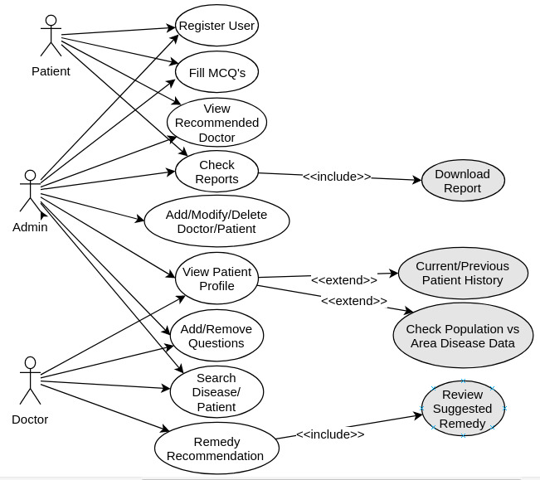

User Classes and Characteristics
There are basically 3 types of users who would use the system : the patients, the doctors and the administrators. Each of the user has a has different type of access to the system.
The patients would register to the system and can take simple test through MCQ’s and graphical images. This access would only provide analysis to general types of problems faced due to bad posture. The analysis would only recommend doctors to visit for the problem faced by the patient.
The doctors would also register themselves as well as the patients to the system and can gather data through MCQ’s, graphical images, hospital data and the PDS. This types of access would provide a detailed analysis and visualization of the data gathered into the system. The analysis would recommend exercises and medicinal suggestions to be done for the problem faced by the patient.
The administrator would have priority access to the system in order to add. modify and delete users, improve datasets, add medicines, etc

Operating Environment
The mobile application would be operated on android lollipop and above. Also various programming languages like Python / R, Java, Spring Boot will be used to process and analyze data produced. A centralized Linux server would provide an environment to process and provide analytics for the data.

Design and Implementation Constraints
The main constraint in the system is the Internet connection. This is because the processing and analysis of the data in performed completely on the centralized server from where the processed output is delivered back to the mobile application.
Also working Bluetooth module in respective phone in which the app is installed is a constraint. This is because low-powered Bluetooth will be used to pair with mobile application and transmit data.

Assumptions and Dependencies
The system assumes that the sensors in the PDS are functioning correctly and data is transferred effectively over Bluetooth without any data loss. One assumption about the product is that it will always be used on mobile phones that have enough performance. If the phone does not have enough hardware resources available for the application, for example the users might have allocated them with other applications, there may be scenarios where the application does not work as intended or even at all.

External Interface Requirements

User Interfaces
The user interfaces would include the login page to the system. The patient would have a list of question to understand the pain. A graphical representation would a be included to determine the zone of pain. The response visualizations would be displayed to the doctors in various graphs and charts. Also the application would include the analysis done through interfacing with the posture detection system.

Hardware Interfaces
The mobile application is needed to be paired with a low – powered Bluetooth mounted on the Posture Detection System. The sensor data would be transmitted back to the mobile application continuously as there is change in movement or in blocks of timeframes.

Software Interfaces
The mobile application communicates with the server over various network protocols for transmission of data between each other. Also the server has all the rights to read and write to the database server it has connected to. The data gathered by the application locally would be sent to the server for processing and the processed output can then be visualized over the application.

Communications Interfaces
The communication between the different parts of the system is important since they depend on each other. However, in what way the communication is achieved is not important for the system and is therefore handled by the underlying operating systems for both the mobile application and the PDS.

System Features
Login:
- Admin, doctor, patient login
- Provide access to system.

User Class: Admin
- Can add/remove/modify doctor and patient.
- Can view data of all patients and doctors.
- Report generation and analytics.

User Class: Doctor
- Doctors can view history of patient.
- Doctors can add/update/review patient data.
- See predictions of data analyzed by model.

User Class: Patient
- Patient can view recommended doctors for further treatment.
- Can fill the answers of questionnaire.

Data from sensors:
- Data coming from PDS via Bluetooth will be stored and uploaded to server for processing.

Other Nonfunctional Requirements

Performance Requirements
The system must be interactive and the delays must be less. So in every action-response of the system, there are no immediate delays. In case of window forms, popping errors messages, saving the settings and sessions delay must be below 3 seconds. Also when connecting to the server the delay is based editing on the distance of the 2 systems and the configuration between them so there is high probability that there will be or not a successful connection in less than 20 seconds for sake of good communication. While pairing with the PDS via Bluetooth the time required should be less than 10 seconds and device should be within the Bluetooth range.

Safety Requirements
Information transmission should be securely transmitted to the server without any changes in the information.

Security Requirements
The main security concern is the user accounts and hence proper login mechanism should be used to avoid hacking. Also the proper protection should be provided to the dataset in order to properly train the model.

Software Quality Attributes

Usability :- As the system is easy to handle and navigates in the most expected way with no delays. In that case the system program reacts accordingly and transverses quickly between its states.
Availability :- If the internet service gets disrupted while sending information to the server, the information can be send again for verification.

