Report on

Deep Learning and Applications (CS671)

Assignment 2



Submitted by:

GROUP - 9

Shashank Kapoor (S22022)

Shubham Patwar (T22108)

Syed Rizwan Ali Quadri (T22113)

Table of Content

Topic Page No.

1. Classification Task…………………………………………………………………………….......3

1.1. Linearly separable……………………………………………………………………………...3

1.1.1 Dataset……………………………………………………………………………… 3

1.1.2 Neural Architecture………………………………………………………………… 4

1.1.3 Training……………………………………………………………………………...6

1.1.4 Testing……………………………………………………………………………….7

1.2. Non Linearly separable………………………………………………………………………...8

1.2.1 Dataset………………………………………………………………………………..8

1.2.2 Neural Architecture…………………………………………………………………..9

1.2.3 Training………………………………………………………………………………10

1.2.4 Testing………………………………………………………………………………..11

1. Regression Task…………………………………………………………………………………...13

2.1.Univariate…………………………………………………………………………………….. 13

2.1.1 Dataset………………………………………………………………………………..13

2.1.2 Neural Architecture…………………………………………………………………..13

2.1.3 Training………………………………………………………………………………15

2.1.4 Testing………………………………………………………………………………..15

2.2.Bivariate…………………………………………………………………………………….…17

2.2.1 Dataset……………………………………………………………………………….17

2.2.2 Neural Architecture…………………………………………………………………..17

2.2.3 Training………………………………………………………………………………18

2.2.4 Testing………………………………………………………………………………..19

Figure of Content

Fig. 1. Linearly separable dataset

Fig. 2. Linearly separable data for a) Training 60% b) Validation 20% c) Testing 20% .

Fig. 3. FCNN with one hidden layer for linearly separable data.

Fig. 4. Average Error vs epochs for training model of linear separable data .

Fig. 5. Decision region plot for linearly separable classes .

Fig.6. Confusion matrix for linearly separable classes.

Fig.7. Classification of the class1 (magenta), class2 (orange) and class 3 (pink) by

a) neuron 1 b) neuron 2 c) neuron 3

Fig.8. Classification of the class1 (magenta), class2 (orange) and class 3 (pink) by

a) neuron 4 b) neuron 5 c) neuron 6

Fig.9 Non Linearly separable dataset.

Fig.10. Non Linearly separable data for a) Training 60% b) Validation 20% c) Testing 20%.

Fig. 11. FCNN with two hidden layers for Non linearly separable data.

Fig. 12. Average Error vs Epochs for non linearly separable data.

Fig.14. Confusion matrix for Non linearly separable classes.

Fig.15. Classification of the class1 ,class2 and class 3 by a) neuron 1 b) neuron 2 c) neuron 3 .

Fig.16. Classification of the class1 ,class2 and class 3 by a) neuron 4 b) neuron 5 c) neuron 6 .

Fig.17. Classification of the class1 ,class2 and class 3 by a) neuron 7 b) neuron 8 c) neuron 9.

Fig.18. Univariate dataset.

Fig.19 . Univariate dataset for a) Training 60% b) Validation 20% c) Testing 20%.

Fig. 20. FCNN with a single hidden layer for univariate data.

Fig. 21. Average Error vs Epochs for univariate dataset.

Fig.22. Mean Squared error computed for Training, Validation and Testing Phase .

Assignment Problem Statement

In this assignment , the key objective is to classify linearly separable data and non linearly separable data by training the fully connected neural network having single hidden layer and multi hidden layer respectively and infer the results by changing the hyperparameters.

Similarly, a regression task also needs to be done on the data provided,univariate and bivariate on a fully connected neural network on a single hidden layer and multi hidden layer and infer the results by updating the hyperparameters.

In this assignment we use a fully connected neural network (FCNN) with a stochastic gradient descent approach to update the weights for classification tasks and regression tasks.

1. **Classification tasks:**

In classification tasks we have to classify the linearly separable and non linearly separable data by most optimal neural architecture.

**1.1. Linearly Separable:**

In Linearly separable , we have been provided with three classes, class1, class2 and class3 respectively. We need to classify with single hidden layer neural architecture and infer the results on the bases of average error, decision region plot, accuracy and neuron output. 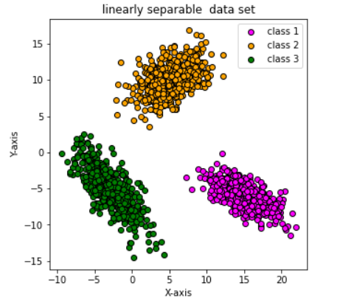

**1.1.1.Dataset:**

In linearly separable data we have been provided

with the three classes consisting, two features

for each class respectively.

* Class 1: 500 data points
* Class 2: 500 data points
* Class 3: 500 data points

**Fig. 1. Linearly separable dataset**

In each class of linearly separable data we have been provided with the 500 data points in which we have to take 60% of the training data and 20% for validation and the remaining 20% is for testing .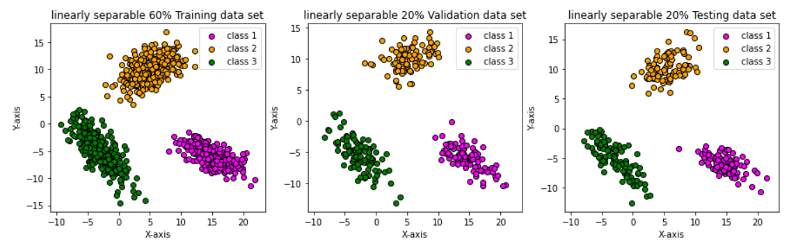



**a) b) c)**

**Fig. 2: Linearly separable data for a) Training 60% b) Validation 20% c) Testing 20%**

**1.1.2. Neural Architecture:**

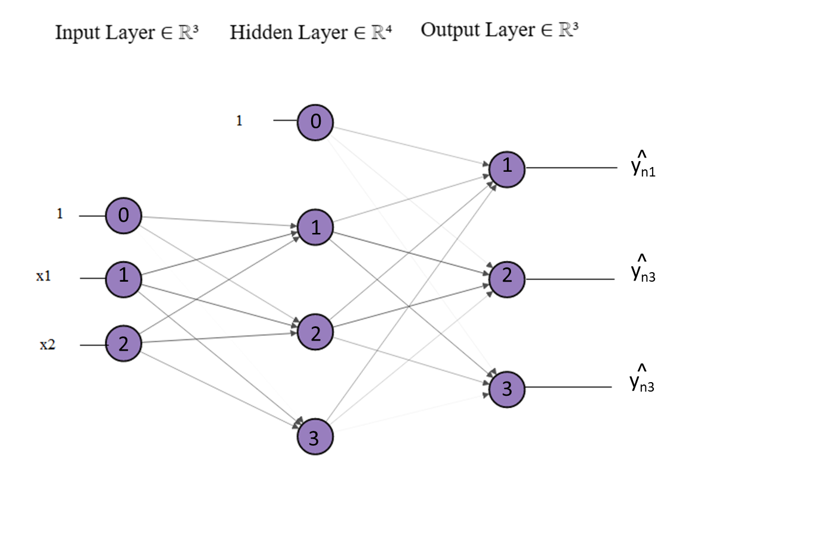

**Fig. 3. FCNN with one hidden layer for linearly separable data.**



* Given-training data:
* Architecture:

- Input layer:**2** neurons

- Hidden layer one: **3** neurons

- Output layer: **3** neurons

* Goal: Estimate parameters **Wij[h]** and **Wjk[o]** for FCNN.
* **Wij[h]** is the weight matrix of size **(2 + 1) x 3:**
* Indicate the weights ***Wij[h]*** in the connections between input and hidden layers.
* ***Wij[h]*** is the weight from ***ith*** input neuron to ***jth*** neuron in the hidden layer.

- **Wjk[o]** is the weight matrix of size **(3 + 1) x 3:**

* Indicate the weights ***Wjk[o]*** in the connections between hidden and output layers.
* ***Wjk[o]*** is the weight from ***jth*** hidden neuron to the ***kth***  neuron of the output layer.
* Steps followed:

1. Initially the given data is labeled with the one hot notation i.e, for class1 to [1,0,0], class2 to [0,1,0] and class3 to [0,0,1], this is to represent the actual class. And the Wij[h] and Wjk[o] with random values.
2. Randomly chosen the training example **xn.**

3. Forward propagation:

Compute output of all output neuron: **Y^nk**

In each forward propagation the activation value and the Logistic function is evaluated.

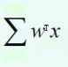

Activation value = a = logistic =

4. Backward propagation: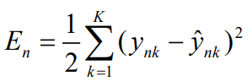

Compute instantaneous error:

Update weights between *hidden* and *output* layer (j = 1,2,3 and k = 1,2,3)



Update weights between *input* and *hidden* layer (i=1, 2 and j=1, 2, 3):



5. Repeat the steps 2 to 4 till all the training examples are presented once (Epoch)

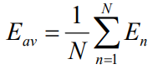

6. Compute the average error:

7. Now repeat steps 2 to 6 till the convergence criterion is satisfied.

**1.1.3. Training:**

In training we have used a sigmoidal activation function for each neuron to get the predicted output and thus calculate the instantaneous error which further helps in updating the weights in every iteration and average error in each epoch and also to backpropagate the updated weights in the network.

**Parameters :**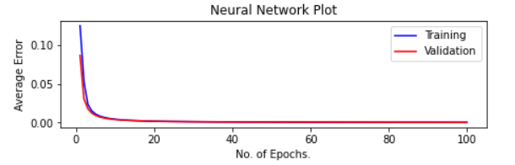

* No. of epochs : 100
* learning Factor : 0.05
* Training Data : 60% (900 data

points)

* Validation Data: 20% (300 data

points)

**Fig. 4. Average Error vs epochs for training model of linear separable data**

**Observation:** It is clearly seen that the model converges in 100 epochs and here average error is monotonically decreasing from that we can infer that there is a rapid change in the weights to the optimal weights.

**1.1.4. Testing:** 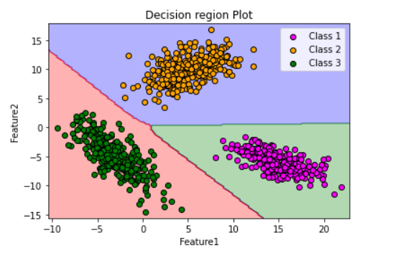

* **Decision Region Plot:**

After the training has been done and get the

optimal weights, we classify the training data

into different class region and also form the

decision boundary between the classes from

the trained model.

**Fig.5. Decision region plot for linearly separable classes**

**Observation:** It is clearly seen that our model is classifying the dataset into different classes and

also forming the boundary region between the classes.

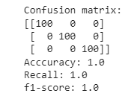

* **Confusion matrix :**

In testing of the linearly separable data with the

current neural architecture, It is found that we are

getting accuracy of 100% ,recall of 100% and

F1 score of 100%.

**Fig.6. Confusion matrix for linearly separable classes**

**Observation:** It is seen that our model is classifying the dataset into different classes and giving the accurate result with the ground truth value and hence giving 100% accuracy, similar we are getting 100%

for recall and F1 score for all the classes in the dataset.

* **Hidden layer Neuron:**

We have 3 neurons in the hidden layer for the classification of the linearly separable data. output is shown for each neuron providing the sample from the trained dataset.

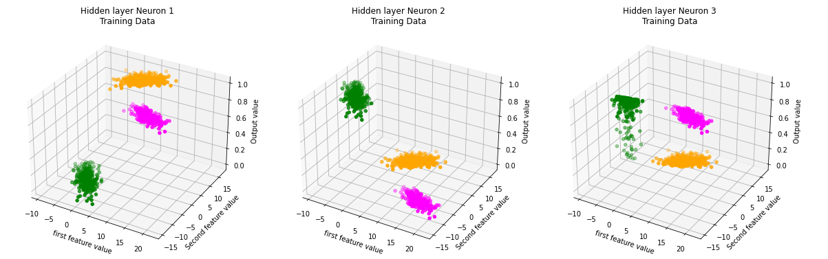

**a) b) c)**

**Fig.7. Classification of the class1 (magenta), class2 (orange) and class 3 (pink) by a) neuron 1 b) neuron 2 c) neuron 3**

* **Output layer Neuron:**

We have 3 neurons in the outer layer corresponding to each class for the classification of the linearly separable data. output is shown for each neuron providing the sample from the trained dataset.

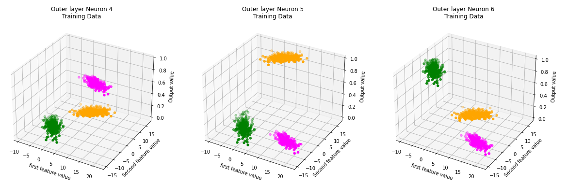

**a) b) c)**

**Fig.8. Classification of the class1 (magenta), class2 (orange) and class 3 (pink) by a) neuron 4 b) neuron 5 c) neuron 6**

**1.2. Non -Linearly Separable:**

In Non- Linearly separable , we have been provided with three classes, class1, class2 and class3 respectively. We need to classify with two hidden layer neural architecture and infer the results on the bases of average error, decision region plot, accuracy and neuron output.

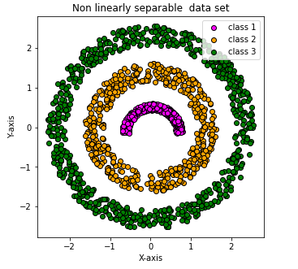

**1.2.1.Dataset:**

In Non linearly separable data we have been provided

with the three classes consisting, two features

for each class respectively.

* Class 1: 500 data points
* Class 2: 500 data points
* Class 3: 700 data points

**Fig.9 . Non Linearly separable dataset**

In each class of Non linearly separable data we have been provided with the 500, 500 and 700 data points respectively in which we have to take 60% of the training data and 20% for validation and the remaining 20% is for testing .

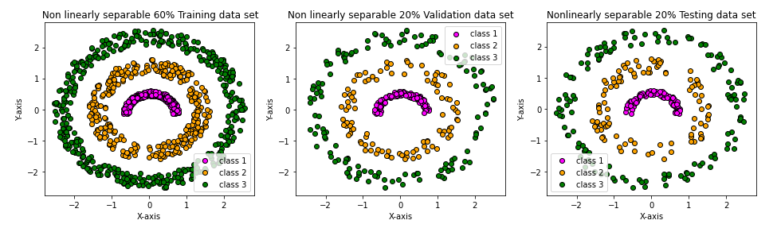

**a) b) c)**

**Fig. 10. Non Linearly separable data for a) Training 60% b) Validation 20% c) Testing 20%**

**1.2.2. Neural Architecture:**

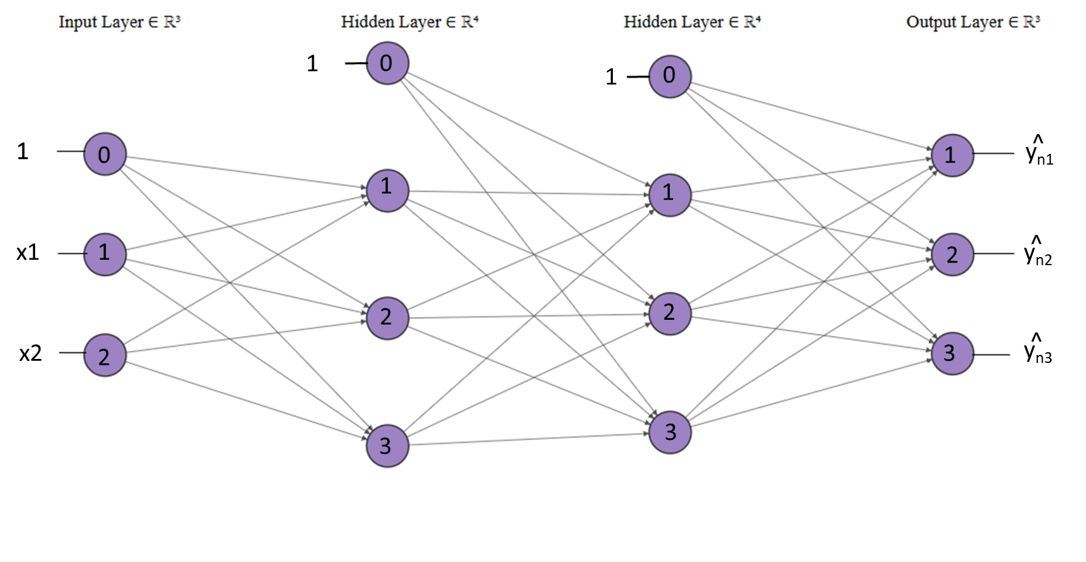

**Fig. 11. FCNN with two hidden layers for Non linearly separable data.**

* Given-training data:
* Architecture:

- Input layer:**2** neurons

- Hidden layer one: **3** neurons

- Hidden layer Two: **3** neuron

- Output layer: **3** neurons

* Goal: Estimate parameters **Wij[h]** and **Wjk[o]** for FCNN.
* **Wij[h1]** is the weight matrix of size **(2 + 1) x 3:**
* Indicate the weights ***Wij[h1]*** in the connections between input and hidden layer 1.
* ***Wij[h1]*** is the weight from ***ith*** input neuron to ***jth*** neuron in the hidden layer 1.
* **Wjl[h2]** is the weight matrix of size **(3 + 1) x 3:**
* Indicate the weights ***Wjl[h2]*** in the connections between hidden layer 1 and hidden layer 2.
* ***Wjl[h2]*** is the weight from ***jth*** hidden layer 1 neurons to ***lth*** neurons in the hidden layer 2.

* **Wlk[o]** is the weight matrix of size **(3 + 1) x 3:**
* Indicate the weights ***Wlk[o]*** in the connections between hidden layer 2 and output layer.
* ***Wlk[o]*** is the weight from ***lth*** hidden layer 2 neurons to the ***kth***  neurons of the output layer.
* Steps followed:

1. Initially the given data is labeled with the one hot notation i.e, for class1 to [1,0,0], class2 to [0,1,0] and class3 to [0,0,1], this is to represent the actual class. And the Wij[h1] , Wjl[h2]and Wlk[o] with random values.
2. Randomly chosen the training example **xn.**

3. Forward propagation:

Compute output of all output neuron: **Y^nk**

In each forward propagation the activation value and the Logistic function is evaluated.



Activation value = a = logistic =

4. Backward propagation:

Compute instantaneous error:

5. Repeat the steps 2 to 4 till all the training examples are presented once (Epoch)



6. Compute the average error:

7. Now repeat steps 2 to 6 till the convergence criterion is satisfied.

**1.2.3. Training:**

In training we have used for each neuron a sigmoidal activation function to get the predicted output and thus calculate the instantaneous error which further helps in updating the weights and average error for each epoch and also to backpropagate the updated weights in the network.

**Parameters :**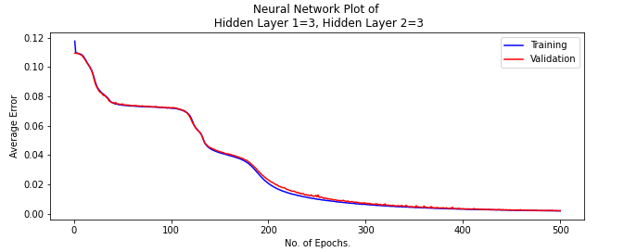

* No. of epochs : 500
* learning Factor : 0.05
* Training Data : 60% (1020 data

points)

* Validation Data: 20% (340 data

points)

**Fig. 12. Average Error vs Epochs for non linearly separable data**

**Observation:** It is clearly seen that the model is converging to get the average error of the model on prediction tends to zero and hence successfully classifies the non linear separable data by updating the optimal weights.

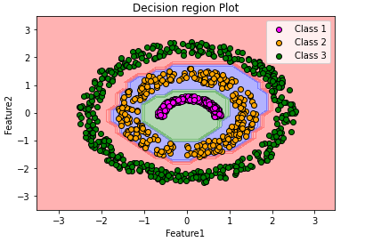

**1.2.4. Testing:**

* **Decision Region Plot:**

After the training has been done and get the

optimal weights, we classify the training data

into different class region and also form the

decision boundary between the classes from

the trained model.

**Fig.13. Decision region plot for Non linearly separable classes**

**Observation:** It is clearly seen that our model is accurately classifying the dataset into different classes and also forming the boundary region between the classes.

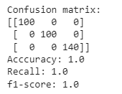

* **Confusion matrix :**

In testing of the Non linearly separable data with the

current neural architecture, It is found that we are

getting accuracy of 100% ,recall of 100% and

F1 score of 100%.

**Fig.14. Confusion matrix for Non linearly separable classes**

**Observation:** It is seen that our model is classifying the dataset into different classes and giving the accurate result with the ground truth value and hence giving 100% accuracy, similar we are getting 100%

for recall and F1 score for all the classes in the dataset.

* **Hidden layer 1 Neuron:**

We have 3 neurons in the hidden layer 1 for the classification of the Non linearly separable data. output is shown for each neuron providing the sample from the trained dataset.

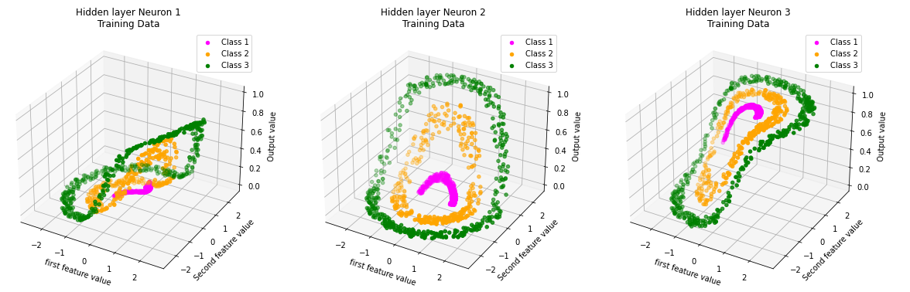

**a) b) c)**

**Fig.15. Classification of the class1 ,class2 and class 3 by a) neuron 1 b) neuron 2 c) neuron 3**

* **Hidden layer 2 Neuron:**

We have 3 neurons in the hidden layer 2 for the classification of the Non linearly separable data. output is shown for each neuron providing the sample from the trained dataset.

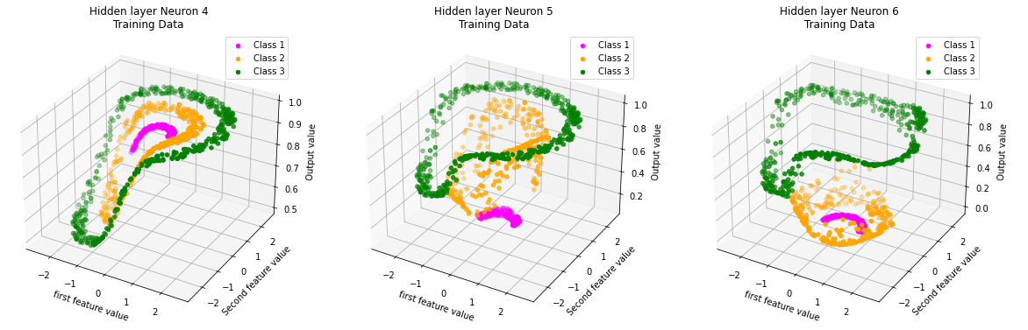

**a) b) c)**

**Fig.16. Classification of the class1 ,class2 and class 3 by a) neuron 4 b) neuron 5 c) neuron 6**

* **Output layer Neuron:**

We have 3 neurons in the outer layer corresponding to each class for the classification of the Non linearly separable data. output is shown for each neuron providing the sample from the trained dataset.

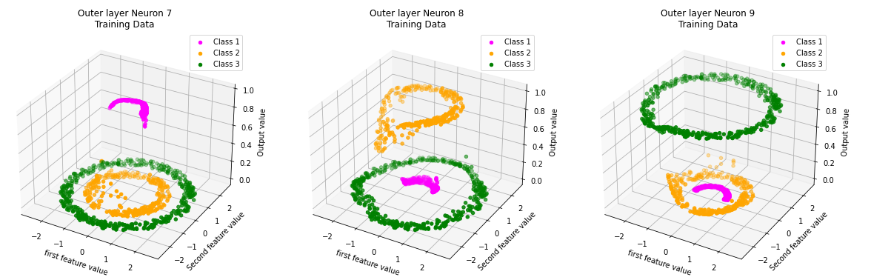

**a) b) c)**

**Fig.17. Classification of the class1 ,class2 and class 3 by a) neuron 7 b) neuron 8 c) neuron 9**

1. **Regression tasks:**

In Regression tasks we have to predict the output from the trained neural architecture by giving the training dataset for the model to learn and get .

**2.1. Univariate:**

In Univariate , we have been provided with the single feature and the actual output. We need to predict with single hidden layer neural architecture and infer the results on the bases of average error, decision region plot, accuracy and neuron output.

**2.1.1.Dataset:**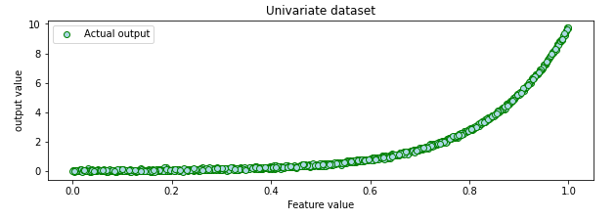

In univariate data we have been provided

with the feature and corresponding

actual output.

* Univariate : 1000 data points

**Fig.18. Univariate dataset**

In a univariate dataset, we have been provided with the 1000 data points in which we have to have take 60% as the training data and 20% for validation and the remaining 20% is for testing .

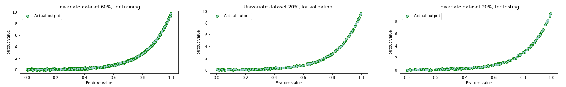

**a) b) c)**

**Fig.18. Classification of the class1 ,class2 and class 3 by a) neuron 7 b) neuron 8 c) neuron 9**

**a) b) c)**

**Fig.19 . Univariate dataset for a) Training 60% b) Validation 20% c) Testing 20%**

**2.1.2. Neural Architecture:**

**Fig. 20. FCNN with a single hidden layer for univariate data.**



* Given-training data:
* Architecture:

- Input layer:**2** neurons

- Hidden layer one: **3** neurons

- Output layer: **3** neurons

* Goal: Estimate parameters **Wij[h]** and **Wjk[o]** for FCNN.
* **Wij[h]** is the weight matrix of size **(2 + 1) x 3:**
* Indicate the weights ***Wij[h]*** in the connections between input and hidden layers.
* ***Wij[h]*** is the weight from ***ith*** input neuron to ***jth*** neuron in the hidden layer.

- **Wjk[o]** is the weight matrix of size **(3 + 1) x 3:**

* Indicate the weights ***Wjk[o]*** in the connections between hidden and output layers.
* ***Wjk[o]*** is the weight from ***jth*** hidden neuron to the ***kth***  neuron of the output layer.
* Steps followed:

1. Initially the given data is labeled with the one hot notation i.e, for class1 to [1,0,0], class2 to [0,1,0] and class3 to [0,0,1], this is to represent the actual class. And the Wij[h] and Wjk[o] with random values.
2. Randomly chosen the training example **xn.**

3. Forward propagation:

Compute output of all output neuron: **Y^nk**

In each forward propagation the activation value and the Logistic function is evaluated.



Activation value = a = logistic =

4. Backward propagation:

Compute instantaneous error:

Update weights between *hidden* and *output* layer (j = 1,2,3 and k = 1,2,3)



Update weights between *input* and *hidden* layer (i=1, 2 and j=1, 2, 3):



5. Repeat the steps 2 to 4 till all the training examples are presented once (Epoch)



6. Compute the average error:

7. Now repeat steps 2 to 6 till the convergence criterion is satisfied.

**2.1.3. Training:**

In training we have used for each neuron a sigmoidal activation function to get the predicted output and thus calculate the instantaneous error which further helps in updating the weights and average error for each epoch and also to backpropagate the updated weights in the network.

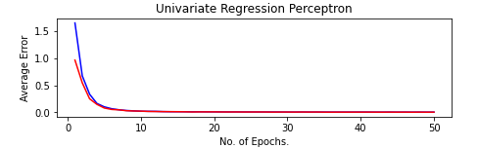

**Parameters :**

* No. of epochs : 100
* learning Factor : 0.05
* Training Data : 60% (900 data

points)

* Validation Data: 20% (300 data

points)

**Fig. 21.Average Error vs Epochs for univariate dataset**

**Observation:**It is clearly seen that the model is converging to get the average error of the model on

prediction tends to zero and hence successfully predicts the model output data by updating the optimal weights.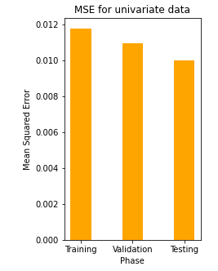

**2.1.4. Testing:**

* **Mean Squared Error:**

After the training has been done and get the

optimal weights, we calculated mean squared error

on the optimal weights for training validation and

testing dataset.

**Fig.22. Mean Squared error computed for Training, Validation and Testing Phase**

**Observation:** It is observed that the testing have the minimum Mean squared error then the training and validation set which is correct as in training the model try to learn and make error and on that error it updates optimal weight and after training is done, model has learn there is minimum chance now to make the model error therefore it has less MSE in testing.

* **Model vs Actual output**

After the model is trained on the training dataset,we computed the optimal weights and on that weight we predicted the model output for the corresponding training ,validation and testing dataset.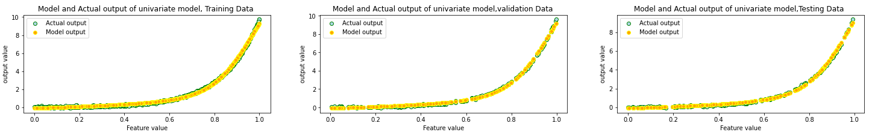

**a) b) c)**

**Fig.23. Features vs output for both model and actual output for a) Training b)Validation c) Testing**

**Observation:** It is clearly seen that the model is accurately predicting the output value to the actual value for the corresponding Training , validation and testing dataset. Hence we can say that our model will nearly predict the actual output.

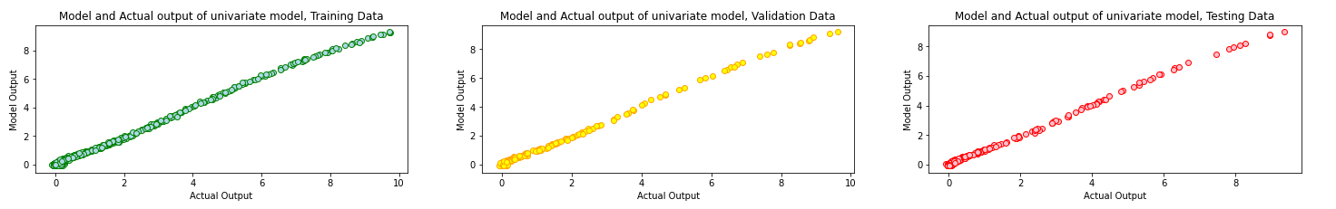

**a) b) c)**

**Fig.24. Model vs Actual output for a) Training b)Validation and c) Testing dataset**

**Observation:** It is seen that model output is nearly equal to the actual output, which stats that it is following (y=x) line equation and Hence our model is nearly predicting the actual output.

* **Hidden layer Neuron:**

We have taken 3 neurons in the hidden layer 1 for the prediction of the model output. Output is shown for each neuron provided the sample is from the trained dataset.

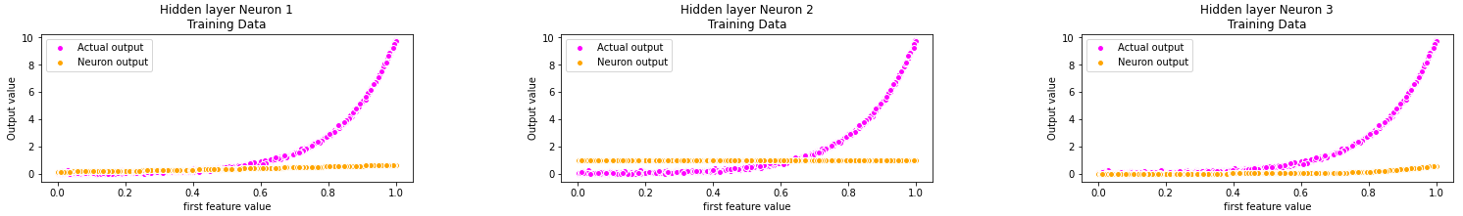

**a) b) c)**

**Fig.25. Model output from first hidden layer of a) neuron 1 b) neuron 2 c) neuron 3**

* **Output layer Neuron:**

We have taken single neurons in the outer layer of the network architecture for the prediction of the model output . Output is shown for each neuron provided the sample is from the trained dataset.

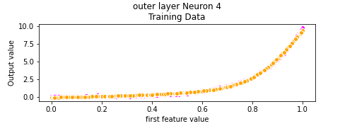

**Fig.26. Model output from outer layer neuron 4**

**2.2. Bivariate:**

In Bivariate , we have been provided with the two features and the actual output. We need to predict with multi hidden layer neural architecture and infer the results on the bases of average error, decision region plot, accuracy and neuron output. 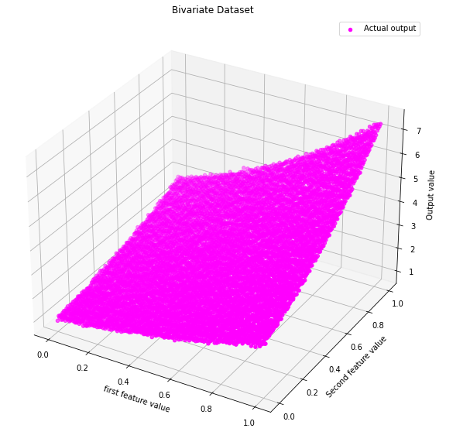

**2.2.1.Dataset:**

In bivariate data we have been provided

with the feature and corresponding

actual output.

* Bivariate : 10200 data points

**Fig.27. Bivariate dataset**

In a bivariate dataset, we have been provided with the 10200 data points in which we have to have taken 60% as the training data and 20% for validation and the remaining 20% is for testing .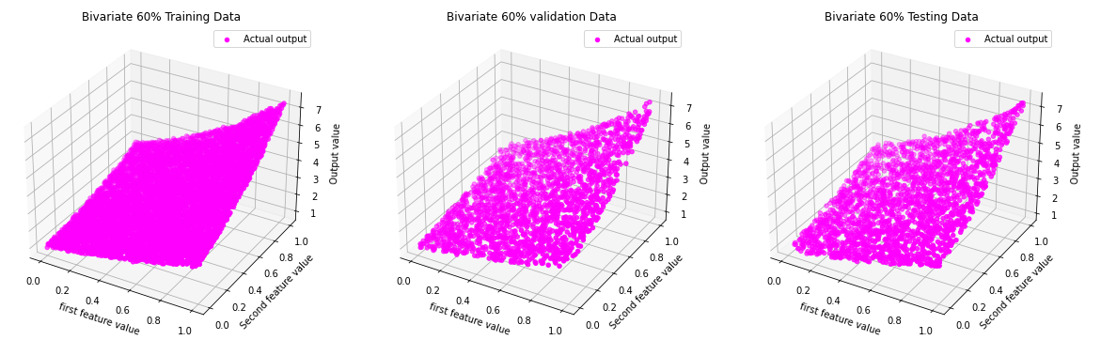

**a) b) c)**

**Fig.28 . Bivariate dataset for a) Training 60% b) Validation 20% c) Testing 20%**

**2.1.2. Neural Architecture:**



**Fig. 29. FCNN with two hidden layers for Bivariate data.**

* Given-training data:
* Architecture:

- Input layer:**2** neurons

- Hidden layer one: **3** neurons

- Hidden layer Two: **3** neuron

- Output layer: **3** neurons

* Goal: Estimate parameters **Wij[h]** and **Wjk[o]** for FCNN.
* **Wij[h1]** is the weight matrix of size **(2 + 1) x 3:**
* Indicate the weights ***Wij[h1]*** in the connections between input and hidden layer 1.
* ***Wij[h1]*** is the weight from ***ith*** input neuron to ***jth*** neuron in the hidden layer 1.
* **Wjl[h2]** is the weight matrix of size **(3 + 1) x 3:**
* Indicate the weights ***Wjl[h2]*** in the connections between hidden layer 1 and hidden layer 2.
* ***Wjl[h2]*** is the weight from ***jth*** hidden layer 1 neurons to ***lth*** neurons in the hidden layer 2.

* **Wlk[o]** is the weight matrix of size **(3 + 1) x 3:**
* Indicate the weights ***Wlk[o]*** in the connections between hidden layer 2 and output layer.
* ***Wlk[o]*** is the weight from ***lth*** hidden layer 2 neurons to the ***kth***  neurons of the output layer.
* Steps followed:

1. Initially the given data is labeled with the one hot notation i.e, for class1 to [1,0,0], class2 to [0,1,0] and class3 to [0,0,1], this is to represent the actual class. And the Wij[h1] , Wjl[h2]and Wlk[o] with random values.
2. Randomly chosen the training example **xn.**

3. Forward propagation:

Compute output of all output neuron: **Y^nk**

In each forward propagation the activation value and the Logistic function is evaluated.



Activation value = a = logistic =

4. Backward propagation:

Compute instantaneous error:

5. Repeat the steps 2 to 4 till all the training examples are presented once (Epoch)



6. Compute the average error:

7. Now repeat steps 2 to 6 till the convergence criterion is satisfied.

**2.1.3. Training:**

In training we have used for each hidden layer neuron a sigmoidal activation function and for outer neuron, linear activation function to get the predicted output and thus calculate the instantaneous error which further helps in updating the weights and average error for each epoch and also to backpropagate the updated weights in the network.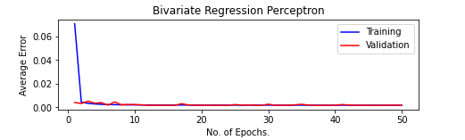

**Parameters :**

* No. of epochs : 100
* learning Factor : 0.05
* Training Data : 60% (900 data

points)

* Validation Data: 20% (300 data

points)

**Fig. 30.Average Error vs Epochs for bivariate dataset**

**Observation:**It is clearly seen that the model is converging to get the average error of the model on

prediction tends to zero and hence successfully predicts the model output data by updating the optimal weights.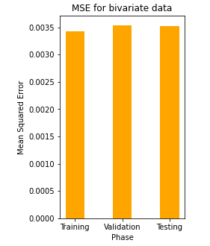

**2.1.4. Testing:**

* **Mean Squared Error:**

After the training has been done and get the

optimal weights, we calculated mean squared error

on the optimal weights for training validation and

testing dataset.

**Fig.31. Mean Squared error computed for Training, Validation and Testing Phase**

**Observation:** It is observed that the testing have the minimum

* **Model vs Actual output**

After the model is trained on the training dataset,we computed the optimal weights and on that weight we predicted the model output for the corresponding training ,validation and testing dataset.

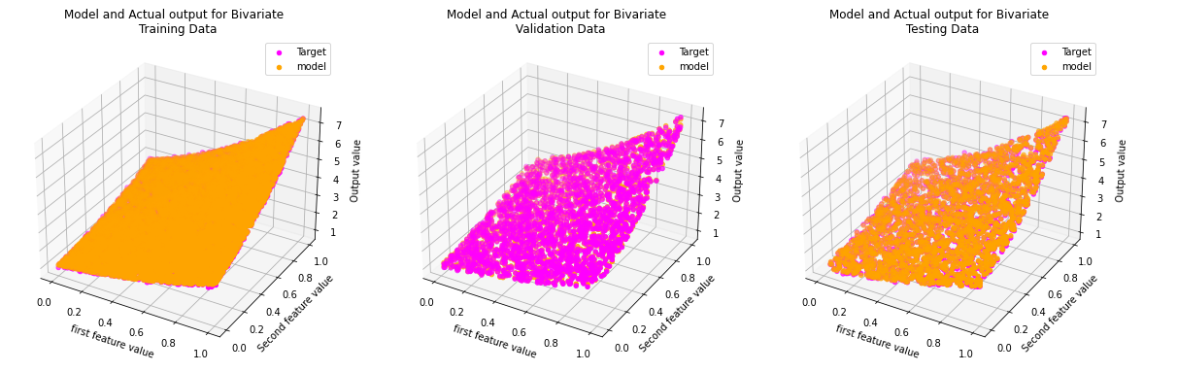

**a) b) c)**

**Fig.23. Features vs output for both model and actual output for a) Training b)Validation c) Testing**

**Observation:** It is clearly seen that the model is accurately predicting the output value to the actual value for the corresponding Training , validation and testing dataset. Hence we can say that our model will nearly predict the actual output.



**a) b) c)**

**Fig.23. Model vs Actual output for a) Training b)Validation and c) Testing dataset**

**Observation:** It is seen that model output is nearly equal to the actual output, which stats that it is following (y=x) line equation and Hence our model is nearly predicting the actual output.

* **Hidden layer Neuron:**

In the univariate



* **Output layer Neuron:**