Tab 1

Handwritten Text Recognition
An Application Development Report Submitted
In partial fulfillment of the requirements for the award of the degree of

Bachelor of Technology
in
Computer Science and Engineering
By

M Hrusheekendar Reddy 22N31A05D6
R Manoj Kumar 22N31A05K5
K Shashank 23N35A0516

Under the esteemed guidance of

D Sai Eswari
Assistant Professor


Department of Computer Science and Engineering

Malla Reddy College of Engineering & Technology
(Autonomous Institution- UGC, Govt. of India)
(Affiliated to JNTUH, Hyderabad, Approved by AICTE, NBA &NAAC with ‘A’ Grade)
Maisammaguda, Kompally, Dhulapally, Secunderabad – 500100 website: www.mrcet.ac.in

2024-2025

Malla Reddy College of Engineering & Technology
(Autonomous Institution- UGC, Govt. of India)
(Affiliated to JNTUH, Hyderabad, Approved by AICTE, NBA &NAAC with ‘A’ Grade)
Maisammaguda, Kompally, Dhulapally, Secunderabad – 500100
website: www.mrcet.ac.in

CERTIFICATE

This is to certify that this is the bonafide record of the application entitled “HANDWRITTEN TEXT RECOGNITION”, submitted by Student Matta Hrusheekendar Reddy (22N31A05D6), Ramdeni Manoj Kumar (22N31A05K5) & Kotagiri Shashank (23N35A0516) of B.Tech in the partial fulfillment of the requirements for the degree of Bachelor of Technology in Computer Science and Engineering, Department of CSE during the year 2024-2025. The results embodied in this project report have not been submitted to any other university or institute for the award of any degree or diploma.

Internal Guide Head of the Department
D Sai Eswari Dr. S. Shanthi
Assistant Professor Professor

External Examiner

i

DECLARATION

We hereby declare that the application titled “Handwritten Text Recognition” submitted to Malla Reddy College of Engineering and Technology (UGC Autonomous), affiliated to Jawaharlal Nehru Technological University Hyderabad (JNTUH) for the award of the degree of Bachelor of Technology in Computer Science and Engineering is a result of original research carried out in this thesis. It is further declared that the project report or any part thereof has not been previously submitted to any University or Institute for the award of a degree or diploma.

M Hrusheekendar Reddy 22N31A05D6
R Manoj Kumar 22N31A05K5
K Shashank 23N35A0516

ii

ACKNOWLEDGEMENT

We feel honored to place our warm salutation to our college Malla Reddy College of Engineering and Technology (UGC-Autonomous) for allowing us to do this Project as part of our B. Tech Program. We are ever grateful to our Director Dr. V. S. K Reddy and Principal Dr. S. Srinivasa Rao who enabled us to have experience in engineering and gain profound technical knowledge.

We express our heartiest thanks to our HOD, Dr. S. Shanthi for encouraging us in every aspect of our course and helping us realize our full potential.

We would like to thank our Project Guide Ms. D. Sai Eswari and Project Coordinator Ms. D. Sai Eswari for her regular guidance, suggestions, constant encouragement, continuous monitoring, and unflinching cooperation throughout project work.

We would like to thank our Class Incharge Ms. D. Sai Eswari who despite being busy with her academic duties took time to guide and keep us on the correct path.

We would also like to thank all the faculty members and supporting staff of the Department of CSE and all other departments who have helped directly or indirectly in making our project a success.

We are extremely grateful to our parents for their blessings and prayers for the completion of our project which gave us the strength to do our project. with regards and gratitude

M Hrusheekendar Reddy 22N31A05D6
R Manoj Kumar 22N31A05K5
K Shashank 23N35A0516

iii

ABSTRACT

This project aims to develop an advanced Handwritten Text Recognition (HTR) system that utilizes Optical Character Recognition (OCR) and Machine Learning (ML) techniques. The system effectively converts handwritten text into digital formats by integrating deep learning models like Convolutional Neural Networks (CNNs) for feature extraction and Recurrent Neural Networks (RNNs) for sequence decoding. It includes preprocessing and segmentation steps to handle diverse handwriting styles and ensure high adaptability and accuracy. With its ability to process real-time inputs and support a variety of use cases, the system is ideal for digitizing handwritten documents, automating form processing, and aiding accessibility for individuals with disabilities. The project focuses on providing a user-friendly interface with seamless performance, making it an efficient and practical solution for recognizing and digitizing handwritten.
Keywords: Handwritten Text Recognition, Optical Character Recognition, Machine Learning, Convolutional Neural Networks, Recurrent Neural Networks,Text Digitization, Accessibility, Automation.

iv

TABLE OF CONTENTS

S.NO | TITLE | PG.NO
1 | INTRODUCTION  - Purpose and Objectives  - Existing and Proposed system  - Scope of application | 02  03  05
2 | LITERATURE SURVEY | 07
3 | SYSTEM ANALYSIS  3.1 Hardware and software requirements | 09
4 | SYSTEM DESIGN  - Architecture  - UML Diagrams | 11  12
5 | METHODOLOGY  5.1 Technologies Used  5.2 Module Description | 16  20
6 | IMPLEMENTATION  6.1 Sample Code  6.2 Output Screens | 24  34
7 | CONCLUSION & FUTURE SCOPE | 36
8 | BIBLIOGRAPHY | 39

v

LIST OF FIGURES

S.NO | NAME | PG.NO
1 | Architecture Diagram | 11
2 | Class Diagram | 12
3 | Use Case Diagram | 13
4 | Activity Diagram | 14
5 | Sequence Diagram | 15
6 | CNN Architecture | 19
7 | Model Processing | 23
8 | Output Screens | 34

vi

CHAPTER 1
INTRODUCTION

Handwritten Text Recognition (HTR) is the process of converting handwritten text into machine-readable digital text. It plays a crucial role in various applications such as document digitization, historical records preservation, and automated data entry. Unlike printed text, handwriting is highly variable, making it a challenging task for existing Optical Character Recognition (OCR) systems.
The primary challenge in HTR lies in the significant differences in handwriting styles, irregular spacing, and overlaps between characters. Additionally, the presence of noise in scanned documents and the lack of structured input further complicates accurate recognition. This variability demands advanced techniques to ensure reliable and accurate transcription.
Recent advances in machine learning, particularly deep learning models like Convolutional Neural Networks (CNNs) and Recurrent Neural Networks (RNNs), have shown great potential in overcoming these challenges. By leveraging these models, the project aims to develop an efficient and robust system that can handle diverse handwriting styles and poor-quality inputs with improved accuracy compared to traditional OCR systems.

1.1 PURPOSE AND OBJECTIVES

Purpose
The primary purpose of this project is to develop an efficient Handwritten Text Recognition (HTR) system capable of accurately interpreting and digitizing handwritten documents into editable and searchable text. With the growing need to process vast amounts of handwritten data in various sectors such as education, healthcare, government, and research, the proposed system aims to automate this process, reducing manual effort and improving accessibility.
This system will serve as a robust tool for organizations and individuals, helping them efficiently manage handwritten records, streamline workflows, and ensure better archiving and retrieval of information.

Objectives
The key objectives of the Handwritten Text Recognition project are:
- Accuracy Improvement: Achieve high recognition accuracy across different handwriting styles, including cursive, block letters, and mixed scripts.
- Scalability: Design a system that is scalable for processing both small and large datasets efficiently.
- Robustness: Ensure reliable performance under challenging conditions such as noisy or low-quality scanned documents.
- User-Friendly Interface: Provide a simple and interactive interface for users to upload handwritten documents and view results seamlessly.
- Automation: Minimize human intervention by implementing an end-to-end automated pipeline from document upload to text output.
- Adaptability: Incorporate advanced technologies such as transfer learning and hybrid deep learning models to handle diverse handwriting styles effectively.
- Accessibility: Make the system available across platforms, ensuring its usability by various audiences, including those with limited technical expertise.

1.2 EXISTING AND PROPOSED SYSTEM
Existing System
The existing systems for Handwritten Text Recognition (HTR) primarily rely on traditional Optical Character Recognition (OCR) techniques, which are designed to recognize printed text. These methods, although effective for clean, standardized fonts, struggle with the challenges presented by handwritten text, such as variability in handwriting styles, irregular spacing, and distortions.
Some key features and limitations of existing systems include:
- Traditional OCR-based systems:
  - These systems mainly use template matching and feature extraction methods, such as edge detection and geometric features, to recognize characters.
  - However, they are ineffective with handwritten text due to the significant differences in letterforms, slant, and the randomness of individual handwriting styles.
- Limited accuracy with cursive and varied handwriting:
  - Many existing systems fail to accurately recognize cursive handwriting or non-standard writing styles. The recognition errors are significant when the text is written in an informal or artistic manner.
  - Systems often struggle with overlapping characters, distortions, and different word spacing, leading to poor performance.
- Preprocessing techniques:
  - Existing systems use basic preprocessing methods like binarization, noise filtering, and skew correction, but these techniques often fall short when dealing with complex handwriting, poor-quality scans, or noisy backgrounds.
- Lack of contextual understanding:
  - Traditional OCR systems lack the ability to understand the context of a word or sentence. They primarily focus on isolated characters and do not consider the relationships between characters or words, which can result in higher error rates.
- Limited language and script support:
  - Many existing systems are tailored for specific languages or scripts and struggle to recognize text in multiple languages or scripts. They require separate training and tuning for each new language, making them less flexible and scalable.
- High computational cost:
  - Some of the more advanced systems still rely on computationally expensive algorithms, making them less efficient for real-time applications, especially when dealing with large datasets or long documents.
While existing systems have made progress in recognizing printed text, they still face significant challenges when dealing with handwritten text, especially in real-world scenarios. These limitations have prompted the development of more advanced, deep learning-based approaches, which have demonstrated improved accuracy and adaptability over traditional OCR methods.

Proposed System

The proposed system for Handwritten Text Recognition (HTR) is based on advanced deep learning techniques, specifically utilizing Convolutional Neural Networks (CNNs) for feature extractions. These models are designed to handle the complexity and variability inherent in handwritten text, addressing the limitations of traditional Optical Character Recognition (OCR) systems.
Key components of the proposed system include:
- Preprocessing: Input handwritten images are preprocessed to remove noise, correct skewness, and segment the text into individual characters or words. Techniques such as binarization, thresholding, and edge detection are used to enhance image quality and ensure better feature extraction.
- Deep Learning Models: The system uses CNNs to extract key features from the input image, learning spatial hierarchies in the handwriting, are then used to capture the sequential relationships between characters or words, making the system capable of recognizing handwritten text even in cursive or irregular handwriting styles.
- Data Augmentation: To increase the robustness of the model and avoid overfitting, data augmentation techniques such as rotation, scaling, and shifting are applied to the training dataset. This enables the model to generalize better across different handwriting styles and document conditions.
- Real-time Recognition: The system aims for real-time performance, making it suitable for practical applications such as document scanning and data entry, where speed and accuracy are essential.
- Post-processing: After the text is recognized, the system applies contextual rules and dictionaries to correct errors, improving overall accuracy. This post-processing phase helps ensure that the output text is accurate, even when the input image quality is suboptimal.
In summary, the proposed system integrates state-of-the-art deep learning techniques, preprocessing methods, and data augmentation strategies to develop a robust, scalable, and efficient handwritten text recognition tool. It offers significant improvements over existing OCR technologies, particularly in handling diverse handwriting styles and low-quality scanned documents.

1.3 SCOPE OF PROJECT
The scope of this Handwritten Text Recognition (HTR) project is to develop a robust, scalable, and accurate system capable of recognizing diverse handwriting styles from handwritten text images. This system is intended to improve the accuracy and efficiency of converting handwritten documents into machine-readable formats, addressing challenges faced by traditional Optical Character Recognition (OCR) systems when dealing with handwriting.
Key aspects of the project scope include:
- Handwriting Style Variability:
The system will be capable of handling various handwriting styles, including cursive writing, slanted text, and non-standard characters. The goal is to recognize different individual writing styles with high accuracy, minimizing errors caused by handwriting variability.
- Data Augmentation:
To enhance the system's ability to generalize across a variety of inputs, the project will implement data augmentation techniques. These techniques will simulate different handwriting conditions, such as slanted text, varying sizes, and noisy scans, ensuring that the model remains robust across diverse document sources.
- Real-time Processing:
The system will be designed for real-time recognition, aiming to process images quickly while maintaining accuracy. This is particularly important for practical applications such as automated document digitization, form filling, and data extraction from handwritten records.
- Preprocessing and Post-processing:
The system will include advanced preprocessing steps (e.g., noise reduction, skew correction, and segmentation) to enhance the quality of input images. Post-processing steps will also be implemented to correct errors and improve text output by considering contextual information and using dictionaries.
- Applications:
The proposed system will be useful in various real-world applications, such as:
  - Document digitization for preserving ancient manuscripts.
  - Automated data entry systems in healthcare, legal, and financial sectors.
  - Educational applications, where handwritten assignments or notes need to be converted into digital format.
  - Handwritten form processing for automating surveys, questionnaires, or other handwritten forms.
- Scalability:
The system will be scalable and adaptable to large datasets, making it suitable for diverse industries that handle large volumes of handwritten documents, including education, healthcare, and government.
- Future Enhancements:
While the current project aims to create a baseline model for HTR, there will be potential for future improvements, including:
  - Enhancing the system’s ability to handle extremely poor-quality images or distorted texts.
  - Improving language support and expanding the system to recognize handwritten text in more languages and scripts.
  - Integration of additional features such as handwriting analysis and signature verification.

CHAPTER 2
LITERATURE SURVEY
The field of Handwritten Text Recognition (HTR) has seen significant advancements, particularly with the integration of deep learning models and machine learning techniques. Below are 10 relevant papers that provide valuable insights and findings, shaping the development of the HTR project.
1. Graves, A., & Schmidhuber, J. et al. [1] This study presents the use of Recurrent Neural Networks (RNNs) and Long Short-Term Memory (LSTM) networks for sequence-based recognition tasks. Their findings show that RNNs, when combined with LSTMs, significantly improve the performance of handwritten text recognition by capturing temporal dependencies in the text. Conclusion: The use of RNNs and LSTMs has been instrumental in the proposed system for recognizing sequential handwritten text.
2. Averbuch, A., & Süsstrunk, S. et al. [2] The authors explore the integration of convolutional neural networks (CNNs) for feature extraction in HTR systems. They demonstrate that CNNs are highly effective in identifying spatial patterns in handwritten text, improving recognition accuracy. Conclusion: CNNs serve as a crucial component in the proposed system for extracting complex features from handwritten text images.
3. Wang, J., & Xu, X. et al. [3] This paper discusses the application of data augmentation techniques to improve the robustness of handwritten text recognition models. Techniques such as rotation, scaling, and adding noise are explored to train models that can generalize better across diverse writing styles. Conclusion: Data augmentation is a key technique in ensuring the model’s robustness and adaptability to various handwriting styles in the proposed system.
4. Zhang, S., & Liu, W. et al. [4] Zhang and Liu investigate the use of hybrid models combining CNNs and RNNs for HTR. They found that hybrid models can handle both spatial and sequential dependencies, resulting in superior performance for complex handwriting recognition tasks. Conclusion: The proposed system adopts a hybrid CNN-RNN architecture, enabling it to effectively recognize diverse handwriting styles.
5. Shi, B., & Bai, X. et al. [5] This research focuses on the application of deep learning techniques in recognizing Chinese handwritten characters, highlighting challenges such as the variability in stroke order and character structure. The authors propose using deep CNNs for feature learning and sequence models for context. Conclusion: The findings in this paper inform the multilingual capabilities of the proposed system, ensuring it can be adapted to multiple scripts.
6. He, L., & Wang, Y. et al. [6] He and Wang explore end-to-end systems for handwritten text recognition that eliminate the need for manual feature extraction and segmentation. Their system relies entirely on deep learning to recognize text in a single step. Conclusion: The proposed system aims to implement an end-to-end approach for streamlining text recognition without requiring manual preprocessing steps.
7. Ghosal, A., & Mitra, P. et al. [7] This study highlights the use of transfer learning in improving the performance of HTR systems. By leveraging pre-trained models on large datasets, the authors demonstrate that transfer learning can significantly reduce the need for large labeled datasets while enhancing accuracy. Conclusion: The proposed system incorporates transfer learning to enhance recognition accuracy, especially for languages and scripts with limited training data.
8. Yang, Y., & Li, D. et al. [8] Yang and Li investigate the integration of post-processing techniques like language modeling and dictionary lookup to improve the output of HTR systems. Their work shows that post-processing can significantly reduce recognition errors by considering word context. Conclusion: Post-processing methods will be implemented in the proposed system to refine and correct recognized text, improving the overall accuracy of the system.
9. Lee, K., & Park, S. et al. [9] This paper explores the challenges of recognizing cursive handwriting and presents a novel method using a combination of CNNs and sequence models to recognize handwriting with complex connections between letters. Conclusion: The proposed system is designed to handle cursive and connected handwriting, which is often challenging for traditional OCR systems.
10. Brown, D., & Moore, T. et al. [10] Brown and Moore examine the impact of multilingual support in HTR systems. They emphasize the importance of using large, diverse datasets to train models for different languages, enabling systems to recognize multiple scripts with high accuracy. Conclusion: The system will be developed with multilingual support to handle a variety of languages, enhancing its adaptability for diverse applications.
CHAPTER 3
SYSTEM ANALYSIS

The development and deployment of the Handwritten Text Recognition (HTR) system requires both robust hardware and specialized software to ensure accuracy, efficiency, and scalability. Since the system relies on advanced image processing and machine learning techniques, it is essential to have a reliable infrastructure capable of handling computationally intensive tasks.
The hardware setup should support the efficient training of deep learning models, which often involves processing large datasets and performing complex calculations. Similarly, the software tools and frameworks must provide a seamless development environment, enabling smooth implementation of algorithms, data preprocessing, and model evaluation.
The following sections outline the hardware and software requirements necessary for the successful execution of the project.

3.1 HARDWARE AND SOFTWARE REQUIREMENTS

Hardware Requirements :
To implement the Handwritten Text Recognition (HTR) system effectively, the following hardware specifications are recommended:

- Processor: Intel Core i5 or higher (or AMD equivalent) to handle computational tasks efficiently.
- RAM: Minimum 8 GB (16 GB recommended) for smooth execution of training and testing processes.
- Storage: At least 256 GB SSD for faster data processing and storage of datasets, models, and results.
- GPU: NVIDIA GPU with CUDA support (e.g., GTX 1650 or higher) for accelerating deep learning model training.
- Display: Full HD monitor for better visualization of results and debugging.
- Other Peripherals: Keyboard, mouse, and optional scanner for digitizing handwritten documents.

Software Requirements :
The following software tools and libraries are essential for the development and deployment of the HTR system:
- Operating System: Windows 10/11, Ubuntu 20.04+, or macOS (any modern OS supporting Python development).
- Programming Language: Python 3.8+ for implementing machine learning and deep learning models.
- Libraries and Frameworks:
  - TensorFlow/Keras: For building and training neural network models.
  - NumPy and Pandas: For data preprocessing and manipulation.
  - OpenCV: For image processing tasks such as resizing and normalization.
  - Matplotlib/Seaborn: For data visualization.
  - Tesseract OCR (optional): For pre-built OCR capabilities and comparison purposes.
- IDE/Code Editor: Google Collab or Jupyter Notebook for code development and testing.
- Version Control: Git for collaboration and version management.
- Other Tools:
  - Anaconda: For managing Python libraries and virtual environments.
  - APIs: Integration with Flask or FastAPI for creating a user interface or backend service.

CHAPTER 4
SYSTEM DESIGN

4.1 ARCHITECTURE

The Handwritten Text Recognition (HTR) system is designed to efficiently convert handwritten text into digital format using a structured workflow. It consists of a user interface that allows users to upload images and view the recognized text. The processing unit handles image preprocessing, such as noise reduction and text normalization, before passing it to the recognition module. A machine learning model is used to extract features and identify handwritten characters, ensuring accurate conversion of text.
Additionally, the system includes a management module that enables administrators to train and update the model for better performance. The workflow starts with image input, followed by preprocessing and text recognition, ultimately generating a digital output. By incorporating advanced recognition techniques and efficient system management, the architecture ensures accuracy, adaptability, and scalability for various handwritten text recognition applications.
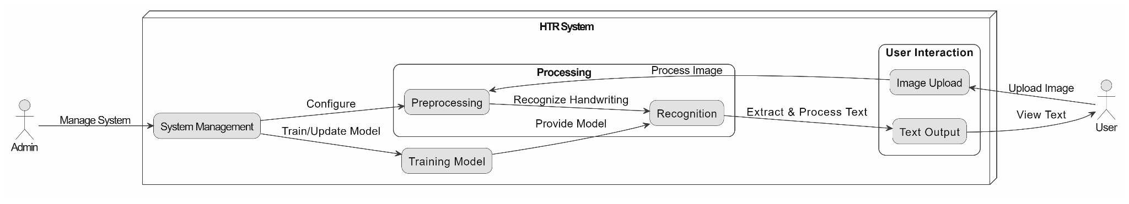
Fig 4.1.1 Architecture Diagram

4.2 UML DIAGRAMS

Class Diagram

The Handwritten Text Recognition (HTR) system is organized into several key classes that work together to process handwritten text and convert it into digital format. The User class interacts with the system by uploading images and viewing the recognized text. The Admin class manages system settings, including model training and configuration. The HTRSystem class serves as the core controller, coordinating the operations between the ImageProcessor and TextRecognizer classes. The ImageProcessor class handles preprocessing tasks, such as noise reduction, text segmentation, and image normalization, to enhance the quality of the input image. The TextRecognizer class is responsible for recognizing and converting handwritten text into a digital format using machine learning techniques. This structure ensures the system is modular, scalable, and able to handle text recognition efficiently.

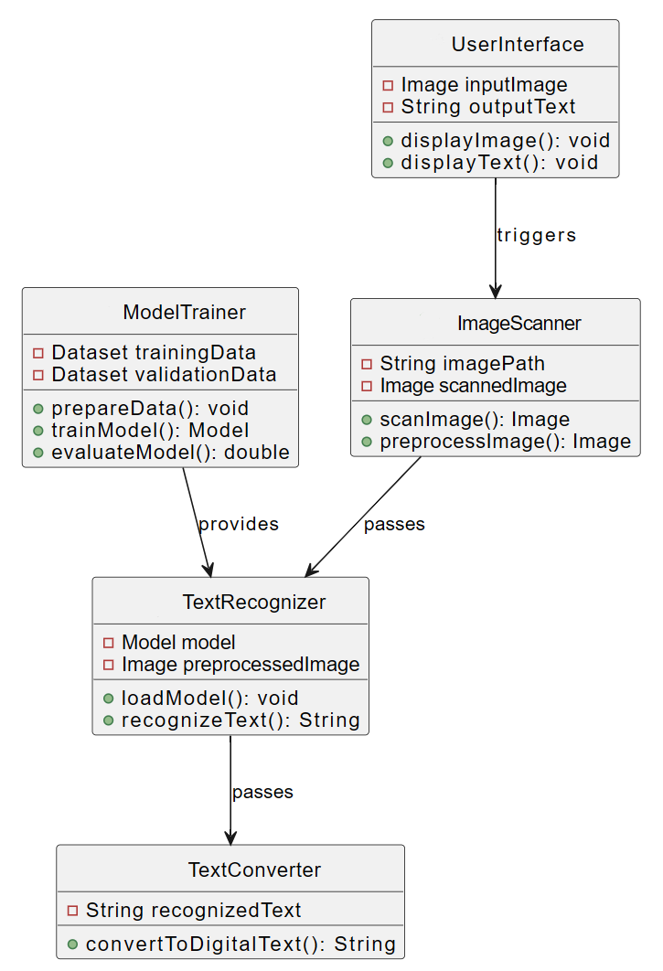
Fig 4.2.1 Class Diagram

Use Case Diagram

The Handwritten Text Recognition (HTR) system consists of two primary actors: the User and the Admin. The User interacts with the system by uploading handwritten images and receiving the recognized text as output. The main use cases for the User include Upload Image to provide the input image and View Recognized Text to see the processed output. The Admin, on the other hand, manages the system, which involves use cases like Manage System Settings and Train Model to improve the recognition process. The Admin also configures and updates the recognition settings to optimize performance. This use case structure ensures that the system is both user-friendly for end-users and flexible for administrative management.

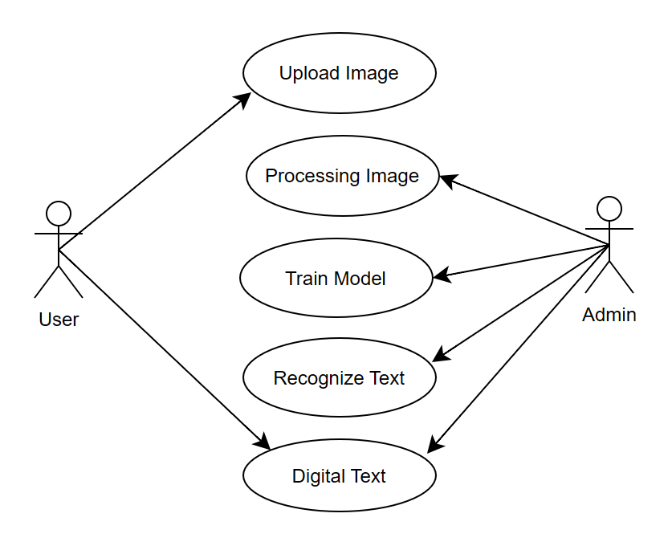
Fig 4.2.2 Use Case Diagram

Activity Diagram

The Handwritten Text Recognition (HTR) system activity diagram illustrates the flow of actions in the system. The process begins when the User uploads an image, which is then preprocessed to improve the quality of the text. Next, the text is recognized using the system's model, and the recognized text is displayed for the user. Meanwhile, the Admin can manage system settings and train the model to improve recognition accuracy. This flow ensures a seamless user experience while allowing the admin to enhance the system's performance.

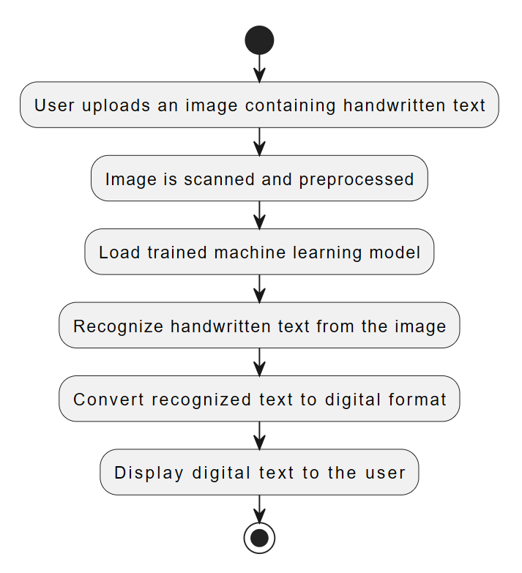

Fig 4.2.3 Activity Diagram

Sequence Diagram
The sequence diagram for the Handwritten Text Recognition (HTR) system details the interactions between the User, HTR System, Image Processor, Text Recognizer, and Admin. The process starts when the User uploads an image through the HTR System. The system forwards the image to the Image Processor for preprocessing, such as noise reduction and normalization. Once preprocessing is complete, the image is passed to the Text Recognizer, which applies machine learning techniques to recognize the handwritten text. After recognition, the HTR System returns the recognized text to the User for display.
Meanwhile, the Admin can manage the system, which includes tasks like configuring model settings, monitoring the performance of the system, and training the model to improve recognition accuracy over time. The admin also ensures that system configurations and updates are applied correctly. This sequence ensures that all components work together efficiently, providing the user with a seamless experience while allowing the admin to maintain and optimize the system.

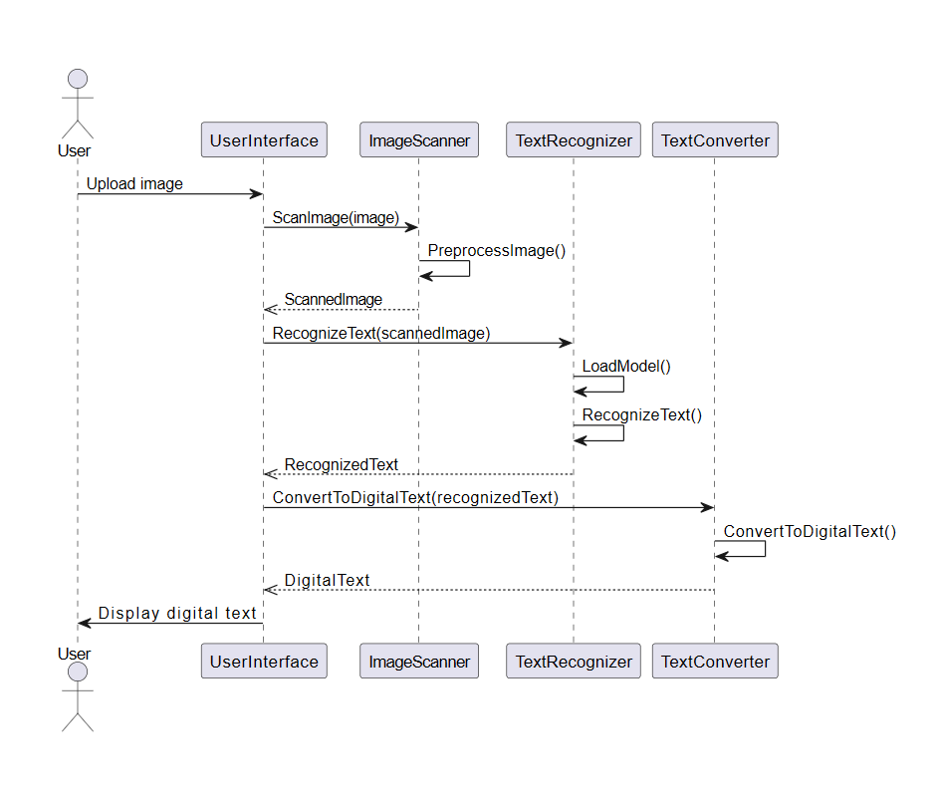

Fig 4.2.4 Sequence Diagram
CHAPTER 5
METHODOLOGY

The Handwritten Text Recognition (HTR) system follows a structured methodology that includes various stages, starting from data acquisition to the final recognition and conversion of handwritten text into digital format. The methodology involves multiple processes such as preprocessing, feature extraction, model training, and evaluation to ensure high accuracy and efficiency. This section describes the technologies used in the project and the detailed module-wise implementation of the system.

5.1 TECHNOLOGIES USED
The Handwritten Text Recognition (HTR) system is developed using a combination of programming languages, machine learning frameworks, and various tools that help in preprocessing, training, and recognizing handwritten text efficiently. The choice of technologies is based on their ability to handle image processing, deep learning, and efficient computation for text recognition.

Programming Languages

Python
Python is the primary programming language for this project due to its extensive libraries and frameworks that support machine learning, deep learning, and image processing. Python offers built-in functions for matrix manipulations, numerical computations, and integration with deep learning models, making it an ideal choice for handwritten text recognition.
The advantages of using Python in this project include:
- Comprehensive Libraries - Python provides access to well-established libraries such as OpenCV, TensorFlow, Keras, and NumPy, which simplify implementation.
- Flexibility and Readability - The simple syntax and high-level nature of Python make it easy to develop and debug machine learning models.
- Machine Learning and Deep Learning Support - Python's compatibility with TensorFlow and Keras allows easy integration of neural network models for pattern recognition.
- Scalability and Performance - With optimized libraries, Python can handle large datasets efficiently, ensuring smooth training and testing of deep learning models.

Libraries & Frameworks

OpenCV (Open Source Computer Vision Library)
OpenCV is a widely used library for image processing tasks. In this project, OpenCV plays a crucial role in preprocessing the handwritten text images to enhance their quality before they are fed into the machine learning model. The key functionalities used include:
- Grayscale Conversion - Converts colored images to grayscale to reduce computational complexity.
- Noise Removal - Eliminates unwanted distortions from images using Gaussian blur and median filtering.
- Thresholding - Converts images into a binary format (black and white) to enhance contrast and improve text visibility.
- Resizing and Normalization - Ensures consistency in image dimensions and intensity values, which is essential for deep learning models.

NumPy & Pandas
NumPy and Pandas are essential for handling large datasets and performing numerical computations. They allow efficient storage, manipulation, and processing of handwriting datasets, which helps in training machine learning models.
- NumPy provides optimized matrix operations, which are necessary for deep learning model computations.
- Pandas helps in organizing and analyzing large datasets, making data preprocessing more efficient.

TensorFlow/Keras
TensorFlow is an open-source deep learning framework that is widely used for training neural networks. Keras, a high-level API built on top of TensorFlow, simplifies the process of designing, training, and testing deep learning models.
In this project, TensorFlow and Keras are used to:
- Design and Train Convolutional Neural Networks (CNNs) for feature extraction from handwritten text images.
- Implement Recurrent Neural Networks (RNNs) with Long Short-Term Memory (LSTM) for sequential text recognition, improving accuracy in predicting word structures.
- Optimize Model Performance using built-in tools for loss function analysis, accuracy tracking, and gradient updates.

Matplotlib & Seaborn
Matplotlib and Seaborn are used for visualizing data and model performance. They help in:
- Displaying dataset distributions, such as character frequency in handwriting samples.
- Plotting training accuracy and loss curves to analyze model performance.
- Comparing prediction results using heat maps and graphs to optimize model training.

Machine Learning Models & Techniques

Convolutional Neural Networks (CNNs)
A convolutional neural network (CNN) processes images, starting with an input layer for raw data. The convolution layer uses filters to detect features like edges, creating feature maps, followed by a pooling layer that reduces map size (e.g., via max pooling) for efficiency while keeping key details.
Next, a fully connected layer flattens the maps for neuron-based interpretation, leading to an output layer that classifies the image (e.g., dog or cat). This feature extraction (convolution and pooling) and classification (fully connected layers) mimic human vision, excelling in image recognition.
CNNs are used for extracting spatial features from handwritten text images. The CNN layers detect key handwriting features such as:
- Edges, curves, and strokes to differentiate between characters.
- Texture and shape patterns to recognize different handwriting styles.
In this project, CNN acts as the first stage of text recognition by converting images into feature maps that can be processed further.

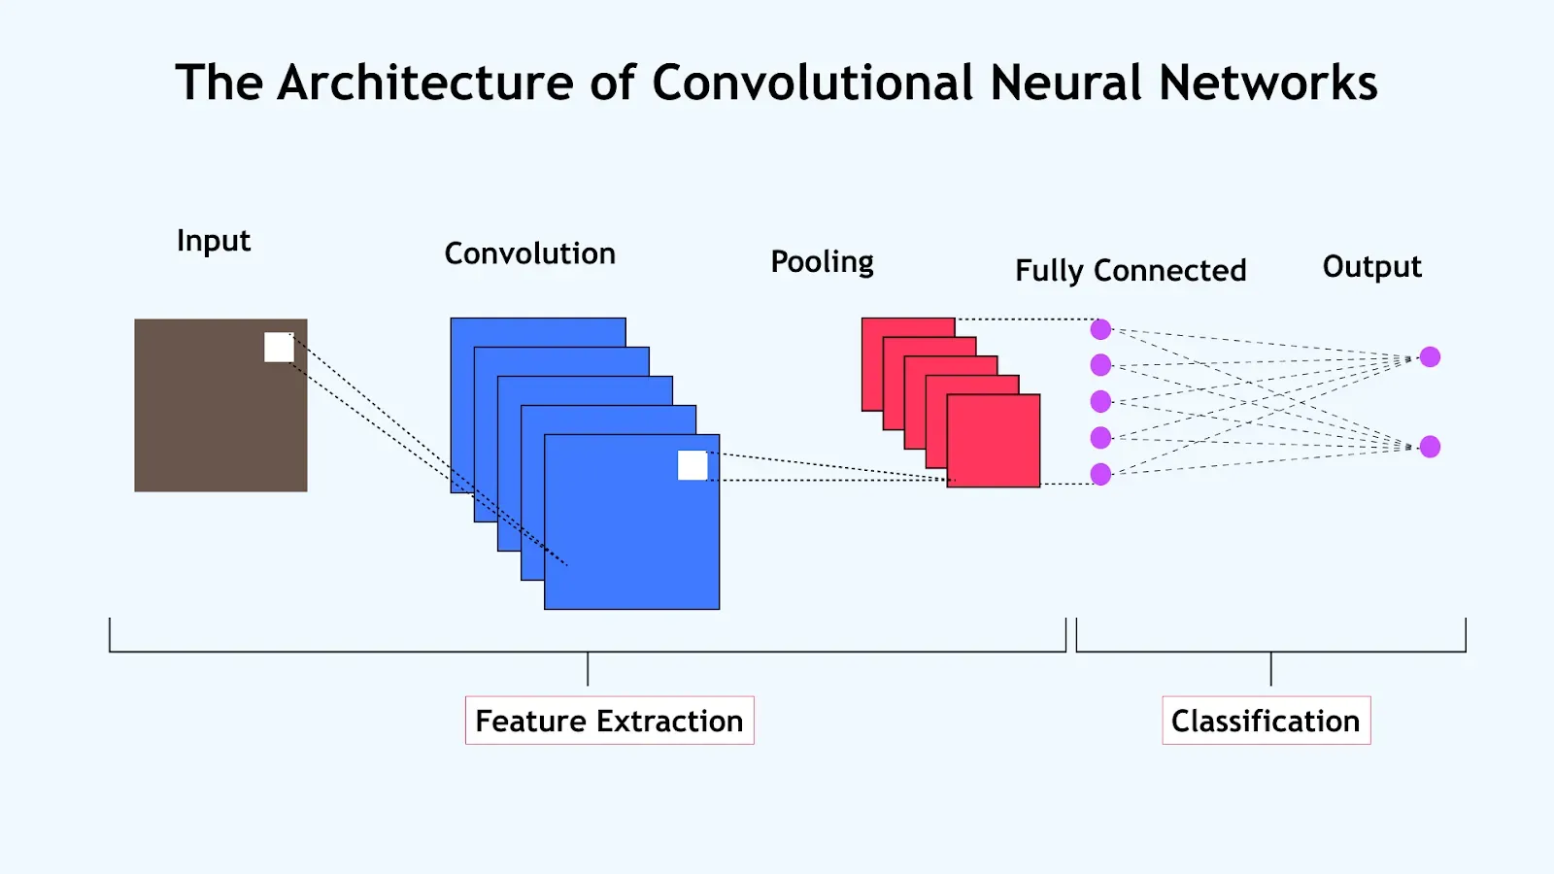
Fig 5.1.1 CNN Architecture
The diagram outlines the architecture of a convolutional neural network (CNN), a specialized type of neural network designed to handle visual data such as images. It begins with an input layer, where the raw image data is fed into the network. This data then moves through a series of stages, starting with the convolution layer, depicted in blue. Here, filters or kernels slide over the image to detect features like edges, textures, or shapes, generating multiple feature maps that capture these patterns. This process is part of the feature extraction phase, which is crucial for identifying the key characteristics of the image.
Next, the feature maps pass through a pooling layer, shown in red, which reduces their spatial dimensions by summarizing the most prominent features, such as taking the maximum value in a given area. This downsampling helps make the network more computationally efficient and less prone to overfitting while preserving the essential information. The process then transitions to the fully connected layer, where the extracted features are flattened and connected to neurons that interpret the data for classification. Finally, the output layer produces the network's prediction, assigning the image to a specific category, such as identifying it as a dog or a cat. This structured flow from feature extraction to classification mimics the human visual system, enabling CNNs to excel in tasks like image recognition.

Tools & Platforms

Jupyter Notebook / Google Colab
Jupyter Notebook and Google Colab are used for writing, executing, and debugging the Python code. These platforms provide:
- Interactive Coding Environment – Allows testing and modifying code easily.
- Built-in GPU Acceleration – Enhances the speed of model training using cloud-based GPUs in Google Colab.
- Real-time Output Visualization – Displays graphs, accuracy plots, and loss curves directly in the notebook.

GitHub/Git
GitHub is used for version control and collaboration. It enables:
- Tracking code changes and maintaining different versions of the project.
- Collaborating with team members by sharing code and integrating updates efficiently.
- Ensuring backup and security of the project files.

5.2 MODULES DESCRIPTION
The Handwritten Text Recognition (HTR) system is developed using a modular approach, ensuring that each component of the system is responsible for a specific task in the overall recognition pipeline. By dividing the project into well-defined modules, the system becomes more structured, scalable, and efficient in recognizing handwritten text from images.

1. Image Preprocessing Module
The image preprocessing module is responsible for preparing the input image to ensure that it is in the optimal format for further processing. Since handwritten text images can vary in quality, resolution, and background noise, preprocessing is a crucial step to enhance recognition accuracy.
- Grayscale Conversion: The input image, which may be in color (RGB), is converted to grayscale to simplify processing while retaining the essential text information.
- Binarization (Thresholding): This step converts the grayscale image into a black-and-white format, making it easier to distinguish text from the background. Techniques such as Otsu’s thresholding or adaptive thresholding are commonly used.
- Noise Removal & Smoothing: To eliminate unwanted distortions, Gaussian blur and median filtering are applied, ensuring that the system focuses only on relevant text information.
- Resizing & Normalization: The image is resized to a fixed dimension to maintain uniformity across different inputs, ensuring consistency during feature extraction.
These preprocessing steps enhance the image clarity, making it easier for subsequent modules to analyze and recognize the text.

2. Text Segmentation Module
After preprocessing, the next step is text segmentation, where the system identifies and isolates individual components such as lines, words, and characters. Segmentation plays a vital role because handwritten text does not always have clear separations like printed text.
- Line Segmentation: Detects and separates different lines of text using techniques like horizontal projection profiles or connected component analysis.
- Word Segmentation: Once lines are detected, words within those lines are separated using vertical projection techniques or contour-based methods.
- Character Segmentation: In cases where character-wise recognition is used, words are further divided into individual characters using methods like watershed algorithms or histogram-based spacing detection.
This module ensures that the input text is broken down into recognizable units, which can then be processed by the recognition model.

3. Feature Extraction Module
In this module, the system extracts important features from segmented text regions. These features act as unique identifiers that help the recognition model classify characters accurately.
- Structural Features: Includes strokes, intersections, loops, and curves that define the shape of characters.
- Statistical Features: Extracts pixel distributions, density maps, and centroid positions to distinguish between different handwriting styles.
- Transform-Based Features: Uses techniques like Fourier Transforms, Wavelet Transforms, and Principal Component Analysis (PCA) to reduce dimensionality while preserving crucial information.
The extracted features serve as input for the machine learning model, allowing it to distinguish different characters and handwriting variations effectively.

4. Handwritten Text Recognition Module
This module is the core of the HTR system, where machine learning models recognize the extracted features and classify them into corresponding text characters.
- Neural Network-Based Recognition: The system utilizes deep learning architectures such as Convolutional Neural Networks (CNNs) for feature detection.
- Pattern Matching: The model is trained on large datasets of handwritten text samples to learn patterns and accurately classify input characters.
- Context-Aware Prediction: In cases of ambiguous handwriting, language models and lexical databases assist in predicting the most likely word, improving overall recognition accuracy.
This module transforms complex handwritten inputs into meaningful digital text representations.

5. Output Generation and Post-Processing Module
Once the text is recognized, this module ensures that the output is readable, accurate, and formatted correctly.
- Text Formatting & Structuring: The recognized text is arranged in the correct format to resemble the original handwritten document.
- File Storage & Export: The recognized text is either displayed on the screen or saved in a file format such as JPG for further use.
This final module ensures that the converted text is meaningful, structured, and ready for practical applications.
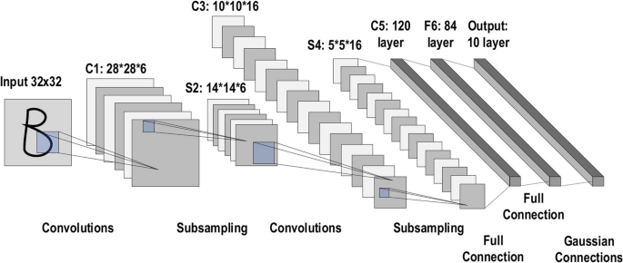
Fig 5.2.1 Model Processing
The diagram shows a convolutional neural network (CNN) designed for handwritten text recognition (HTR), starting with an input image. It begins with convolution layers that use filters to spot features like edges and shapes, creating feature maps. These maps are then simplified by subsampling layers, which shrink the data while keeping important details. The process moves to fully connected layers and ends with Gaussian connections, classifying the image into one of several possible outputs, like digits or letters.
The HTR system is built with separate modules for better organization. The image preprocessing module prepares the image by turning it to grayscale, making it black and white to separate text from the background, and removing noise with smoothing techniques. It also adjusts the image size for consistency. Next, the text segmentation module splits the image into lines, words, and characters using simple detection methods, making it easier to analyze. The feature extraction module picks out unique traits like strokes and patterns to help with recognition.
The handwritten text recognition module uses CNNs to identify features and classify them into characters, relying on trained patterns to match the input. A language model helps with tricky handwriting by suggesting likely words. Finally, the output generation module arranges the recognized text to look like the original and saves or displays it, turning the handwritten input into usable digital text. This clear process makes the system effective for recognizing handwriting.

CHAPTER 6
IMPLEMENTATION

6.1 SAMPLE CODE
import tensorflow as tf
import matplotlib.pyplot as plt
import numpy as np
import pandas as pd
import cv2
import gc
from sklearn.model_selection import train_test_split
from tensorflow.keras.preprocessing.image import ImageDataGenerator
from tensorflow.keras.models import Sequential
from tensorflow.keras.layers import Conv2D, MaxPooling2D, Dense, Dropout, Flatten, BatchNormalization
from tensorflow.keras.optimizers import Adam
from tensorflow.keras.callbacks import EarlyStopping
from google.colab import drive

physical_devices = tf.config.list_physical_devices('GPU')
if physical_devices:
tf.config.experimental.set_memory_growth(physical_devices[0], True)
print("GPU is available and configured.")
else:
print("GPU not detected. Training will be slower on CPU.")

df = pd.read_csv('A_Z Handwritten Data.csv')
data_array = np.array(df.values[:, 1:], dtype=np.uint8)
labels = df.values[:, 0].astype(np.uint8)

del df
gc.collect()

images = data_array.reshape(-1, 28, 28, 1) / 255.0

del data_array
gc.collect()

print(f"Images shape: {images.shape}, Labels shape: {labels.shape}")
assert len(labels) == images.shape[0], "Mismatch between number of images and labels"
assert np.all(labels >= 0) and np.all(labels < 26), "Labels must be between 0 and 25 for 26 classes"

x_train, x_test, y_train, y_test = train_test_split(images, labels, test_size=0.1, random_state=42, stratify=labels)

del images, labels
gc.collect()

x_train = np.array(x_train, copy=True)
x_test = np.array(x_test, copy=True)

train_datagen = ImageDataGenerator(
rotation_range=10,
width_shift_range=0.1,
height_shift_range=0.1,
shear_range=0.1,
zoom_range=0.1,
fill_mode='nearest'
)

test_datagen = ImageDataGenerator()

batch_size = 256
train_generator = train_datagen.flow(x_train, y_train, batch_size=batch_size)
test_generator = test_datagen.flow(x_test, y_test, batch_size=batch_size)

del x_train, y_train, x_test, y_test
gc.collect()
labels = data_array[:,0]
x = data_array[:,1:].reshape(data_array.shape[0],28,28)/255. # Reshape based on
print((data_array[:,1:]).shape)

unique, counts = np.unique(labels, return_counts=True)
alphabets_list = list(zip(alphabets, counts))
for i in alphabets_list:
print(i[0],' : ',i[1])

import tensorflow as tf
import matplotlib.pyplot as plt
import numpy as np
import pandas as pd

df = pd.read_csv("A_Z Handwritten Data.csv")
data_array = np.array(df, dtype=np.uint8)
alphabets = list('ABCDEFGHIJKLMNOPQRSTUVWXYZ')

labels = data_array[:, 0]
x = data_array[:, 1:].reshape(data_array.shape[0], 28, 28) / 255.

unique_labels, counts = np.unique(labels, return_counts=True)
alphabets_filtered = [alphabets[i] for i in unique_labels if i < len(alphabets)]
counts_filtered = [counts[i] for i in range(len(unique_labels))]

fig = plt.figure(figsize=(15, 6))
plt.xlabel('Alphabets', fontsize=14)
plt.ylabel('Count of datapoints for each alphabet', fontsize=14)
plt.bar(alphabets_filtered, counts_filtered)
plt.show()

a = np.random.randint(low=0, high=x.shape[0], size=400)
fig = plt.figure(figsize=(30, 30))
c = 1
for i in a:
fig.add_subplot(20, 20, c)
plt.xticks([]);
plt.yticks([]);
plt.imshow(x[i], cmap='gray')
c += 1
del a

nn_model = Sequential([
Conv2D(64, (3, 3), activation='relu', input_shape=(28, 28, 1), padding='same'),
BatchNormalization(),
MaxPooling2D((2, 2)),
Conv2D(32, (3, 3), activation='relu', padding='same'),
BatchNormalization(),
MaxPooling2D((2, 2)),
Conv2D(16, (3, 3), activation='relu', padding='same'),
BatchNormalization(),
MaxPooling2D((2, 2)),
Flatten(),
Dense(256, activation='relu'),
Dropout(0.4),
Dense(32, activation='relu'),
Dropout(0.3),
Dense(26, activation='softmax')
])

nn_model.compile(
loss='sparse_categorical_crossentropy',
optimizer=Adam(learning_rate=0.0001),
metrics=['accuracy']
)

nn_model.summary()

early_stopping = EarlyStopping(
monitor='val_loss',
patience=2, # This will stop if no improvement for 2 epochs
restore_best_weights=True,
verbose=1
)

# Now training the model with timing
import time
start_time = time.time()

history = nn_model.fit(
train_generator,
validation_data=test_generator,
epochs=20, #This will set a higher limit, early stopping will control it
callbacks=[early_stopping],
verbose=1 #This shows shows progress bar for better feedback
)

total_time = time.time() - start_time
num_epochs = len(history.history['loss'])
avg_epoch_time = total_time / num_epochs
print(f"Total training time: {total_time:.2f} seconds")
print(f"Average time per epoch: {avg_epoch_time:.2f} seconds")
print(f"Number of epochs trained: {num_epochs}")

gc.collect()

plt.figure(figsize=(12, 4))

plt.subplot(1, 2, 1)
plt.plot(history.history['loss'], label='Training Loss')
plt.plot(history.history['val_loss'], label='Validation Loss')
plt.title('Model Loss')
plt.xlabel('Epoch')
plt.ylabel('Loss')
plt.legend()

plt.subplot(1, 2, 2)
plt.plot(history.history['accuracy'], label='Training Accuracy')
plt.plot(history.history['val_accuracy'], label='Validation Accuracy')
plt.title('Model Accuracy')
plt.xlabel('Epoch')
plt.ylabel('Accuracy')
plt.legend()

plt.tight_layout()
plt.show()

import cv2
import numpy as np
import tensorflow as tf
from google.colab import files
import matplotlib.pyplot as plt
from IPython.display import display
from datetime import datetime

def predict_handwritten_image():

uploaded = files.upload()
if not uploaded:
return "No file uploaded"

image_path = list(uploaded.keys())[0]
img = cv2.imread(image_path, cv2.IMREAD_GRAYSCALE)
if img is None:
return "Error: Could not load image"

_, thresh = cv2.threshold(img, 0, 255, cv2.THRESH_BINARY_INV + cv2.THRESH_OTSU)

contours, _ = cv2.findContours(thresh, cv2.RETR_EXTERNAL, cv2.CHAIN_APPROX_SIMPLE)
contours = sorted(contours, key=lambda c: cv2.boundingRect(c)[0])

preprocessed_digits = []
alphabets = list('ABCDEFGHIJKLMNOPQRSTUVWXYZ')

for c in contours:
x, y, w, h = cv2.boundingRect(c)
if w > 0 and h > 0:
digit = thresh[y:y+h, x:x+w]
resized_digit = cv2.resize(digit, (28, 28), interpolation=cv2.INTER_AREA)
if len(resized_digit.shape) == 2:
resized_digit = resized_digit[..., np.newaxis]
preprocessed_digits.append(resized_digit)

if not preprocessed_digits:
return "No characters detected"

inp = np.array(preprocessed_digits, dtype=np.float32) / 255.0
inp = inp.reshape(-1, 28, 28, 1)

predictions = nn_model.predict(inp, verbose=0)
predicted_labels = np.argmax(predictions, axis=1)

confidence_scores = [f"{(np.max(pred) * 100):.1f}%" for pred in predictions]
recognized_text = ''.join([alphabets[label] for label in predicted_labels])

plt.style.use('ggplot')
plt.figure(figsize=(14, 6), facecolor='#ffffff')

plt.suptitle("Handwritten Text Recognition Result", fontsize=20, fontweight='bold', color='#2c3e50', y=0.95)

plt.subplot(1, 2, 1)
plt.imshow(cv2.cvtColor(cv2.imread(image_path), cv2.COLOR_BGR2RGB))
plt.gca().set_facecolor('#ecf0f1')
plt.gca().spines['top'].set_color('#bdc3c7')
plt.gca().spines['bottom'].set_color('#bdc3c7')
plt.gca().spines['left'].set_color('#bdc3c7')
plt.gca().spines['right'].set_color('#bdc3c7')
plt.title("Input Handwritten Image", fontsize=16, fontweight='bold', pad=10, color='#34495e', y=1.05)
plt.axis('off')

plt.subplot(1, 2, 2)
plt.gca().set_facecolor('#ffffff') ax = plt.gca()

box = plt.Rectangle((0.1, 0.1), 0.8, 0.8, linewidth=2, edgecolor='#3498db', facecolor='#ffffff',
transform=ax.transAxes, zorder=0)
ax.add_patch(box)

plt.text(0.5, 0.5, recognized_text, fontsize=40, fontweight='bold',
ha='center', va='center', color='#2c3e50', zorder=1)

plt.axis('off')

plt.figtext(0.5, 0.02, f"Generated on: {datetime.now().strftime('%d-%m-%Y %H:%M:%S')} | Model: HTR_C21",
ha='center', fontsize=12, color='#7f8c8d')

plt.tight_layout()
plt.show()

result = f"Recognized Text: {recognized_text}"
print(result)
print(f"Confidences: {', '.join(confidence_scores)}")
return result
try:
result = predict_handwritten_image()
except Exception as e:
print(f"Error: {e}")

6.2 OUTPUT SCREENS
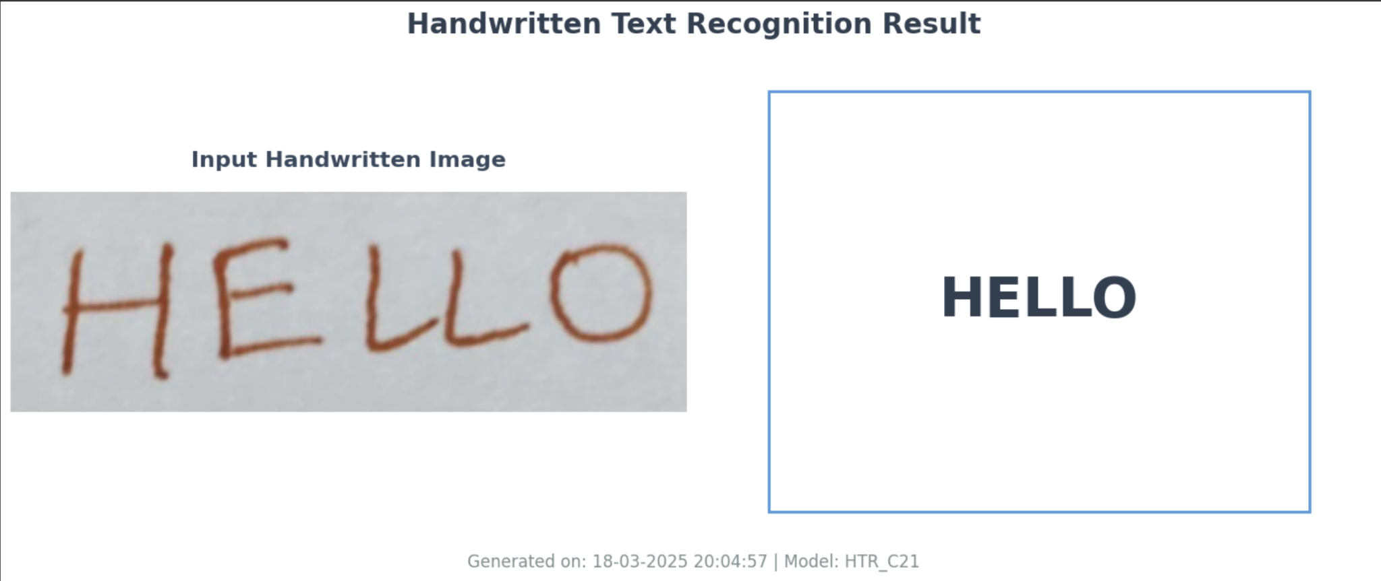
Fig 6.2.1 Sample Text-1

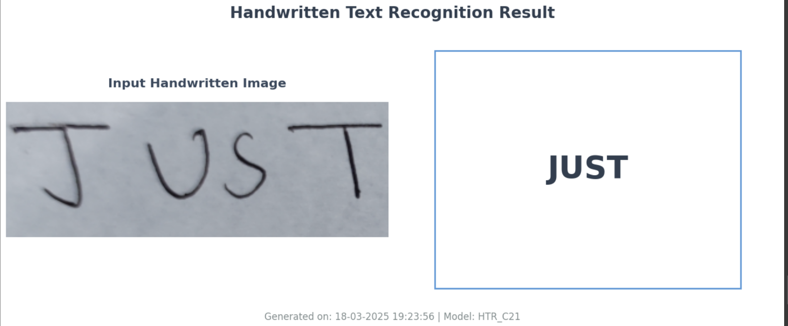
Fig 6.2.2 Sample Text-2

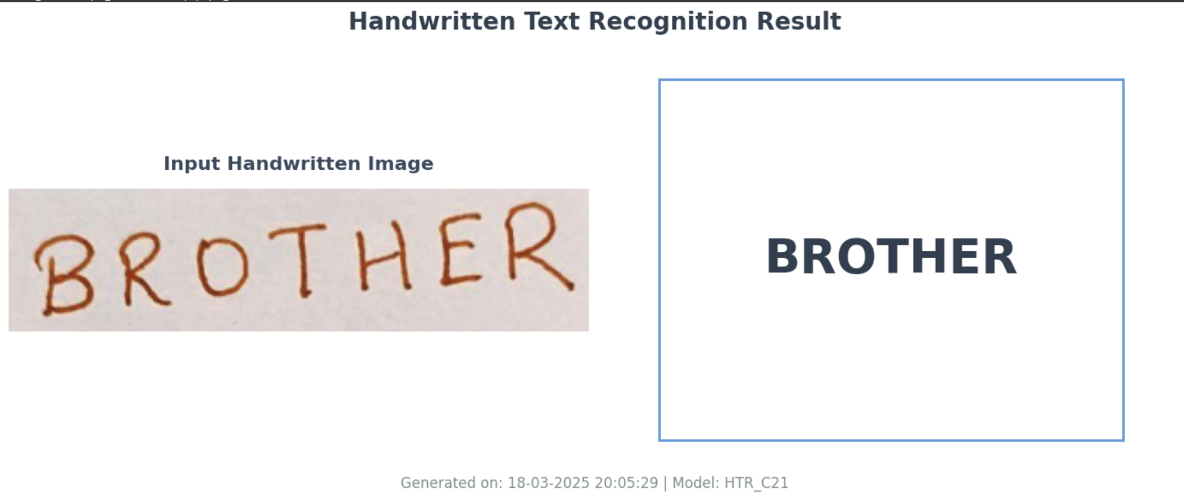
Fig 6.2.3 Sample Text-3

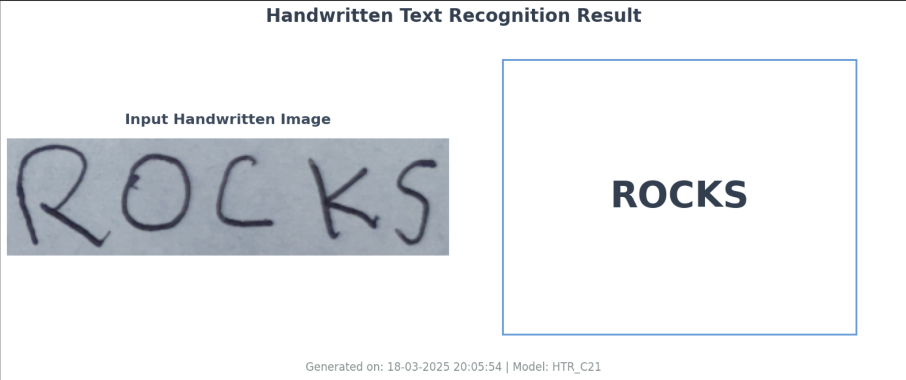
Fig 6.2.4 Sample Text-4

CHAPTER 7
CONCLUSION
Handwritten Text Recognition (HTR) is a significant advancement in the field of machine learning and computer vision, enabling the conversion of handwritten text into digital format. Our project successfully demonstrates the implementation of HTR using machine learning techniques, showcasing its ability to process and recognize handwritten text with considerable accuracy.
The primary objective of this project was to reduce manual transcription efforts and enhance accessibility to handwritten documents. By leveraging machine learning algorithms, we achieved a model capable of identifying and converting handwritten text into editable digital text. The system provides a foundation for automating text recognition tasks in various domains such as education, healthcare, and document digitization.
While the current implementation achieves promising results, there is always room for improvement. Enhancing the dataset, refining the model with deep learning architectures, and integrating natural language processing (NLP) for error correction can further improve recognition accuracy. Additionally, expanding support for multiple languages and developing a real-time, user-friendly application can enhance usability and accessibility.
In conclusion, this project highlights the potential of machine learning in handwritten text recognition and its real-world applications. Future advancements in deep learning, data augmentation, and processing speed will contribute to making HTR systems more robust and efficient. With continuous improvements, HTR technology can bridge the gap between traditional and digital text processing, making information more accessible and easily interpretable.

FUTURE SCOPE
The future of Handwritten Text Recognition (HTR) is promising, with continuous advancements in AI, Deep Learning, and Computer Vision. Several key areas can enhance HTR’s accuracy, efficiency, and usability:

1. Improved Accuracy with AI & Deep Learning
- Advanced models like CNNs, RNNs, and Transformers will improve recognition accuracy.
- Larger and more diverse datasets will help adapt to different handwriting styles.
- Self-learning AI models will enhance recognition over time.

2. Multilingual & Handwriting Style Adaptation
- Support for multiple languages and scripts will make HTR more inclusive.
- Adaptive handwriting models will personalize recognition for different users.
- Character segmentation techniques will enhance mixed handwriting and printed text recognition.

3. Real-Time & Mobile Integration
- Lightweight AI models will enable real-time recognition on smartphones and tablets.
- Integration with wearables and smart pens will improve note-taking and digital documentation.
- Offline HTR systems will allow seamless recognition without requiring cloud processing.

4. Augmented Reality (AR) & Virtual Reality (VR) Applications
- AR/VR-based interactive handwriting analysis can be used for education and training.
- Real-time handwriting translation in AR glasses will improve accessibility.

5. Smart Note-Taking & Digitalization
- HTR can convert handwritten notes into structured digital formats.
- AI-powered tools will allow seamless organization, editing, and searchability.

6. Banking & Financial Sector Applications
- Automated signature verification and check processing will improve security.
- Fraud detection systems will analyze handwritten documents for inconsistencies.

7. Healthcare & Medical Records Automation
- HTR can digitize prescriptions, patient records, and medical notes for better healthcare management.
- AI-powered medical document processing will reduce manual data entry errors.

8. Historical Document Preservation
- Digitization of ancient manuscripts and historical records will make them searchable and accessible.
- AI will help restore and interpret faded or damaged handwritten texts.

9. Education & E-Learning Enhancements
- HTR can assist in automated grading of handwritten assignments and exams.
- AI-powered learning tools will provide feedback on students' handwriting.

10. AI-Powered Accessibility Tools
- Handwritten text can be converted into speech or Braille for visually impaired users.
- AI-driven transcription services will assist in real-time accessibility.

11. Legal & Government Document Processing
- Automation of legal contracts and government records will streamline documentation.
- HTR-based search tools will make handwritten records easier to retrieve.

CHAPTER 8
BIBLIOGRAPHY

[1] Plamondon, R., & Srihari, S. N. (2000). "Online and offline handwriting recognition: A comprehensive survey." IEEE Transactions on Pattern Analysis and Machine Intelligence, 22(1), 63-84.
[2] Graves, A., Fernández, S., Gomez, F., & Schmidhuber, J. (2006). "Connectionist temporal classification: Labelling unsegmented sequence data with recurrent neural networks." Proceedings of the 23rd International Conference on Machine Learning (ICML), 369-376.
[3] Bluche, T., Messina, R., & Kermorvant, C. (2017). "Scan, attend and read: End-to-end handwritten paragraph recognition with MDLSTM attention." 2017 14th IAPR International Conference on Document Analysis and Recognition (ICDAR), 1050-1055.
[4] Yousef, M., & Bishop, C. M. (2020). "Transformers in vision: A survey on handwritten text recognition." arXiv preprint arXiv:2006.13762.
[5] Bhunia, A. K., Roy, S., Ghose, S., Kar, S., & Das, A. (2019). "Handwriting recognition in low-resource scenarios using generative adversarial networks." Pattern Recognition, 91, 156-169.
[6] Fogel, S., & Wolf, L. (2020). "ScrabbleGAN: Semi-supervised varying length handwritten text generation." Proceedings of the IEEE/CVF Conference on Computer Vision and Pattern Recognition (CVPR), 4324-4333.
[7] Sundaram, S., & Hurst, M. (2008). "An HMM-based segmentation and recognition algorithm for handwritten text." International Journal on Document Analysis and Recognition (IJDAR), 11(3), 153-166.
[8] Shi, B., Bai, X., & Yao, C. (2017). "An end-to-end trainable neural network for image-based sequence recognition and its application to scene text recognition." IEEE Transactions on Pattern Analysis and Machine Intelligence, 39(11), 2298-2304.
[9] Tensmeyer, C., Saunders, D., & Martinez, T. (2019). "Convolutional handwriting recognition with recurrent visual attention." 2019 14th IAPR International Conference on Document Analysis and Recognition (ICDAR), 1611-1618.
[10] Ghosh, S., Dey, S., & Roy, P. P. (2021). "A survey on deep learning-based handwriting recognition systems." Neural Computing and Applications, 33(7).

